EMBARGO DATE: APRIL 14TH AT 8:30AM CET

JOIA DE BAUME & MERCIER

FROM HERITAGE TO MODERNITY

At the heart of the new Joia de Baume & Mercier collection, one piece stands out. Inspired by a historical timepiece created by the Maison in the 1980s and adorned with diamonds, this design comes to life in an elegant, feminine, resolutely contemporary interpretation. This jewelry watch carries forward the legacy that has tied Baume & Mercier to women for more than two centuries. The Joia de Baume & Mercier M0A10850 fascinates the eye with its silvery dial, featuring criss-crossed satin-brushed finishes which echo its steel flattened link strap and its bezel set with 40 brilliant-cut diamonds. The refinement of this timepiece is heightened by its dainty 28 mm diameter and its case without lugs, emphasizing the soft, rounded curves of its assertive femininity and quest for authentic self-expression.

* * * * *

In 2026, the Maison launched a new women’s collection: Joia de Baume & Mercier. Among the four first models, one exceptional piece embodies the collection and the ties between heritage and modernity. Inspired by a historical model and the strong Maison design codes, this jewelry piece adorned with 40 brilliant-cut diamonds offers an elegant, feminine, modern interpretation of watchmaking.



The spirit of the collection

The Joia de Baume & Mercier collection embodies a watch that seeks to reveal itself. It is the delicate, precious, bright showcase for confident femininity and desirable freedom: the freedom to be yourself. Its muse is an inspiring, modern young woman with a hint of defiance. Moving from casual to elegant with innate ease, she perfectly masters social codes and breaks them with grace. She takes a playful approach to style, both soft and bold. From contemporary freshness to timeless heritage, this jewelry watch is a refined creation entirely crafted in the spirit of a meaningful moment, which Baume & Mercier has been celebrating since 1830.

The heritage of Baume & Mercier at the heart of a contemporary masterpiece

The Joia de Baume & Mercier watch M0A10850 captures the eye and highlights the Maison’s heritage, encapsulating its full DNA of savoir-faire and elegance. Designed as an object of desire, this jewelry watch is inspired by a historical piece dating from the 1980s and revealed within a 24 mm case. Elevating the beauty and force of the Joia de Baume & Mercier watch are 40 diamonds studded in its bezel and a silvery dial with criss-crossed satin finishes, echoing its flattened-link strap decoration. This timepiece expresses an exacting level of detail and perfectly masterful savoir-faire.

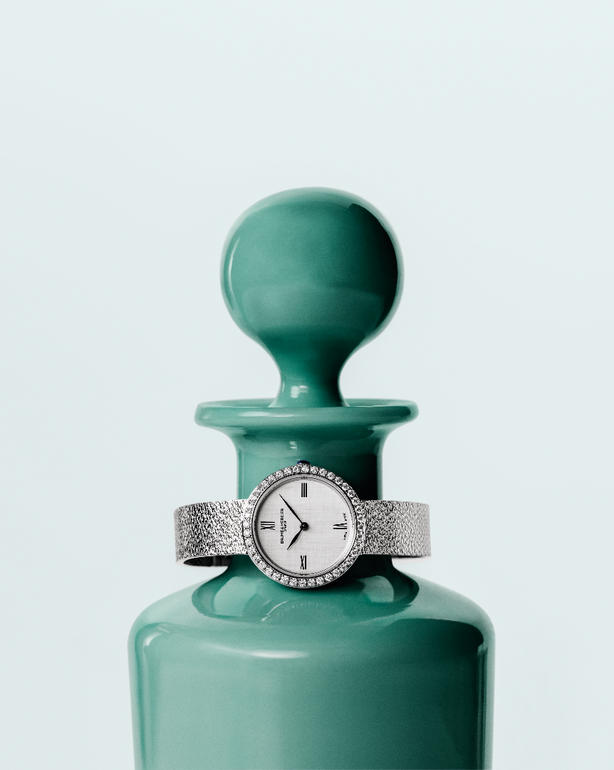

The history of Baume & Mercier

The long history that links Baume & Mercier to women began in 1918 when the aesthete Paul Mercier joined forces with the pragmatic William Baume. They pertinently observed the emancipation of women emerging at the time. These women were showing a clear interest in watches, and they were intent on more than telling the time. The Maison began creating ladies’ timepieces that were remarkable for their beauty and creativity, including sensational jewelry watches that were seen as jewels. In fact, those designs were featured in the 1920 Davoine General Indicator of Watchmaking, which praises the “haute Fantaisie pour Dames” (or “high fantasy for women”) of Baume & Mercier.

Early on, Baume & Mercier highlighted the strong, active, independent modern woman determined to break away from codes and conventions while maintaining her femininity. In fact, she was portrayed as a doctor in a 1950s advertisement. The 1970s, 1980s and 1990s inspired spectacular gold jewelry pieces, including cuff watches adorned with mother-of-pearl, onyx, lapis lazuli, and turquoise.

The historical 1980s piece, and the Joia M0A10850 by Baume & Mercier, follow these footsteps.

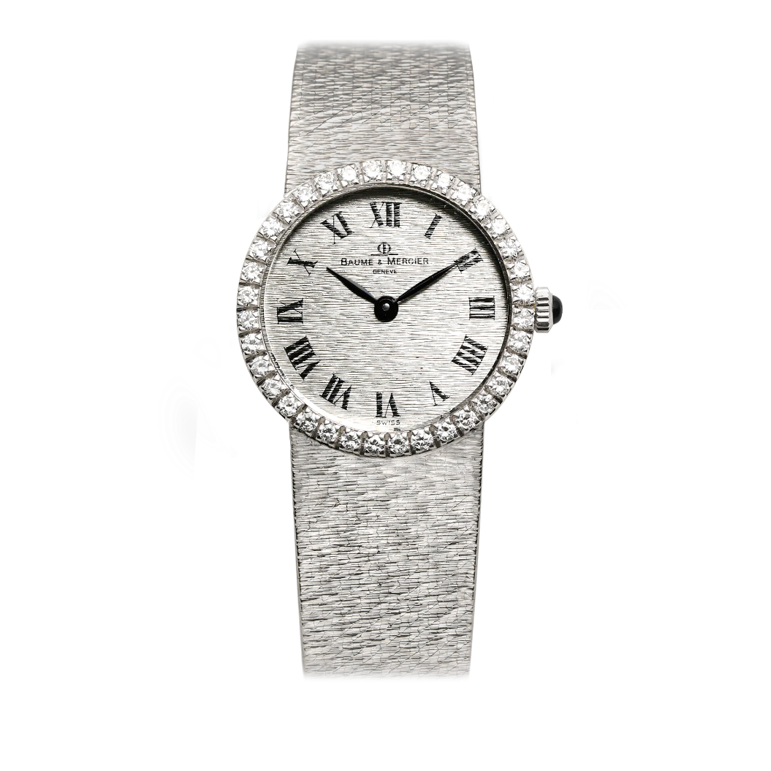

Joia de Baume & Mercier M0A10850: a brilliant jewelry piece

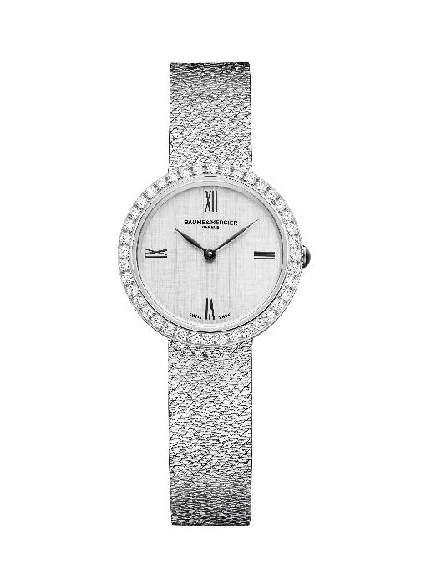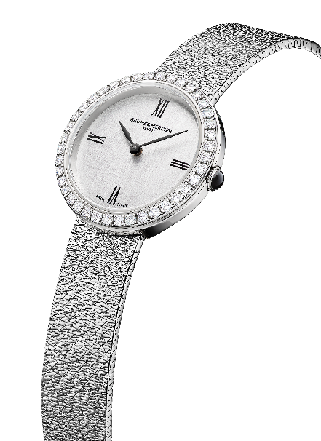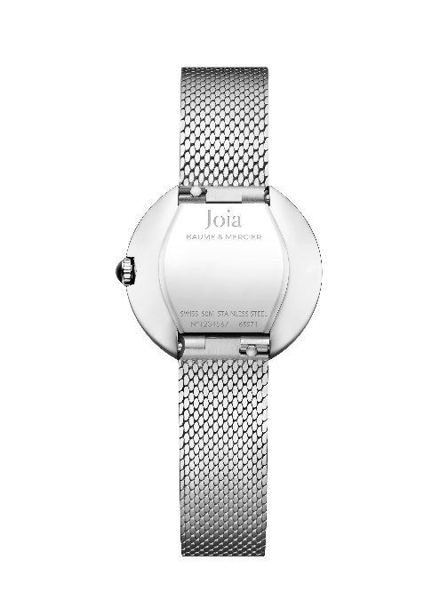

- Movement
Quartz (Ronda 751)
5-year autonomy
- Functions
H/M
- Case
Round, without lugs
Dimensions: 28mm
Thickness: 7.2mm
Polished stainless steel case
Polished stainless steel bezel set with 40 diamonds (brilliant-cut, Top Wesselton, VS quality, 0.81 cts)
Domed, scratch-resistant, anti-glare sapphire crystal
Domed crown in polished stainless steel case set with a black agate
Solid case back in polished stainless steel (may be engraved)
- Dial
Silvery dial with criss-crossed satin-brushed finish
Black Roman numeral transfers
Ruthenium leaf hands
- Strap
Interchangeable strap in stainless steel with embossed flattened link decoration
Interchangeable spring-bar system making it possible to change the bracelet without the need for tools
- Clasp
Triple folding clasp in polished stainless steel
- Water-resistance
50m (approx. 5 ATM)

This model is in limited production.

This new Joia de Baume & Mercier marks a significant step for the Maison, carrying forward the independent, innovative spirit deeply rooted in the Baume & Mercier DNA and the historical heritage of women’s watches, which played a major role in the development of the Maison.

