EMBARGO March 30st / 8.30am CET

WATCHES & WONDERS 2022

NEW IN 2022 AND STILL DISTINCTIVE OF
BAUME & MERCIER EXPERTISE IN WATCHMAKING DESIGN

To design a timepiece like an art object… It takes a visionary spirit with a love for shapes and volumes to conceive of ultra-slim pocket watches for men and jewelry watches for women to wear as rings or necklaces. Beginning in the 1920s, Paul Mercier, backed by the technical expertise of William Baume, captured the essence of the social progress of the times. The Maison’s inherent creativity and modernity have brought it resounding success, marking the signature look of Baume & Mercier that is still visible today.

“Why not combine the dependability and precision of a watch of the highest quality with the lightness and appeal of contemporary esthetics?
People want freshness, beauty, lightness.”

Quote from The Saga – The history book of Baume & Mercier

Born from an innovative, modern spirit, the collections of yesteryear continue to assert their contemporary spirit and avant-garde shapes, joining today’s collection in the creative momentum that the Brand never ceases to renew. Each one in its own way demonstrates a love for design, a passion for shape, and a desire to make a bold statement, which Baume & Mercier has been carrying in its DNA since William Baume met Paul Mercier. The Studio Design – the Maison’s in-house creative studio – has always enthusiastically created each new collection, setting itself the challenge of mastering a great variety of shapes, from the simplest to the most complex. The constant pursuit for perfect proportions and precise lines; attention to detail; the harmony of materials and colors; the concurrence of classicism and design; the mingling of rectangular and rounded lines; and the balance between men’s and women’s watchmaking all enter into the creative process. By choosing the Greek letter Phi – a reference to the divine proportion and its natural balance – as its emblem, Baume & Mercier has clearly hitched its wagon to the star of artistic aspiration.

****

THE RIVIERA COLLECTION

First released in 1973 and reinterpreted last year, the Riviera watch expresses the Maison’s expertise in design and use of materials. A Baume & Mercier lifestyle icon, this timepiece with pure, slender lines and an immediately recognizable twelve-sided bezel comes into its full maturity. 2022 herald a 42 mm men’s version (Baumatic and self-winding), as well as 33 mm (self-winding) and 36 mm (self-winding and quartz) women’s versions... And the Riviera has not had its last word. It’s about time for enjoyment and joie de vivre.

With almost fifty years behind it, the Riviera is no newcomer. Inspired by the carefree lifestyle of the French Riviera, this is the watch of casual elegance, symbolizing an easygoing view of refined watchmaking. It was first developed in 1973 and has adapted to every era, year after year, while staying true to its special style. Its steel adornments and strong shape have always represented a form of freedom, an offbeat elegance. And now it represents renewal. In 2021, Baume & Mercier presented the fifth-generation Riviera, which continues to uphold the Maison’s expertise, capturing the signs of our modern times to better revisit them. This year does not mark a revolution, but rather a gentle-yet-assertive evolution, continuing to bring distinctive Baume & Mercier expertise to the design through its elaborate shapes and bold statement.

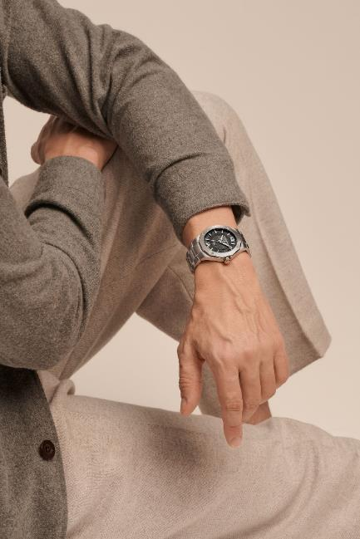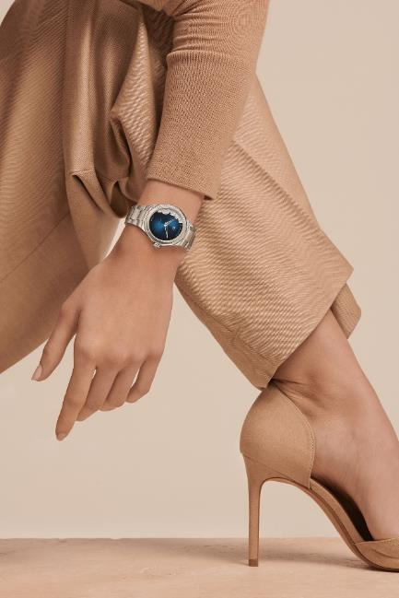

Riviera 10702 / Riviera 10677
THE SOPHISTICATION OF GRAY
FOR THE NEW RIVIERA 42 MM MODELS

The new men’s versions of the 42 mm Riviera – the stars of 2022 – reinterpret the signs of the times and leave their mark on the present day. Athletic and exquisite, they carry forth the Baume & Mercier expertise in design and attention to shape with their uncompromising style. It’s time for renewal! The new Rivieras are here to prove it.

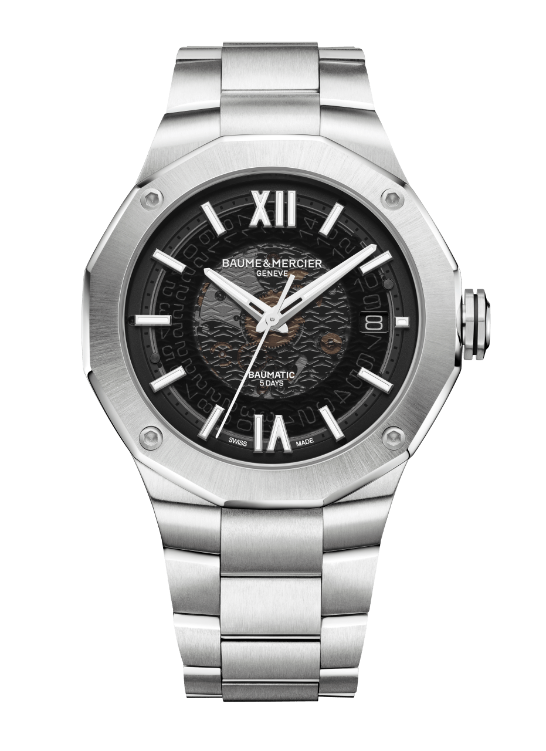
RIVIERA BAUMATIC - M0A10702
The legacy of athletic elegance

A steel case with a universal diameter of 42 mm, a dodecagonal bezel with twelve sides and four screws, a Baumatic movement, and an interchangeable steel strap. The original design is still there, but so is the desire to adapt to our times. The latest addition to the family – the new men’s version of the Riviera – still carries in its genes the silhouette and evocative power of the original 1973 model. It has the shape and spirit of its forbearer. The 2022 version of the Riviera Baumatic is available in a version with a smoky gray sapphire dial and an integrated steel strap. The decoration introduced in 2021 has become the distinctive mark of these models, each of which is equipped with a Baumatic manufacture movement. Its transparency offers a view of the gear trains of the Baumatic caliber and its tried-and-true performance: a five-day power reserve, a daily precision of -5 s / +10 s, and a magnetic resistance of 1500 Gauss, which provides solid protection against magnetic fields. With a power reserve of 120 hours, this new Riviera Baumatic plays in the major leagues. It may be forgotten on a night table from a Thursday evening to a Tuesday morning and still be on time and full of energy. Of course, its scratch-proof sapphire crystal has anti-glare coating on both sides, while its octagonal crown asserts a Phi logo engraving in relief. Not only technically flawless, it seeks to address the expectations of its future owners, seeking excellence, style, comfort and overall cohesion. It embodies the Maison’s vision of men’s watchmaking.
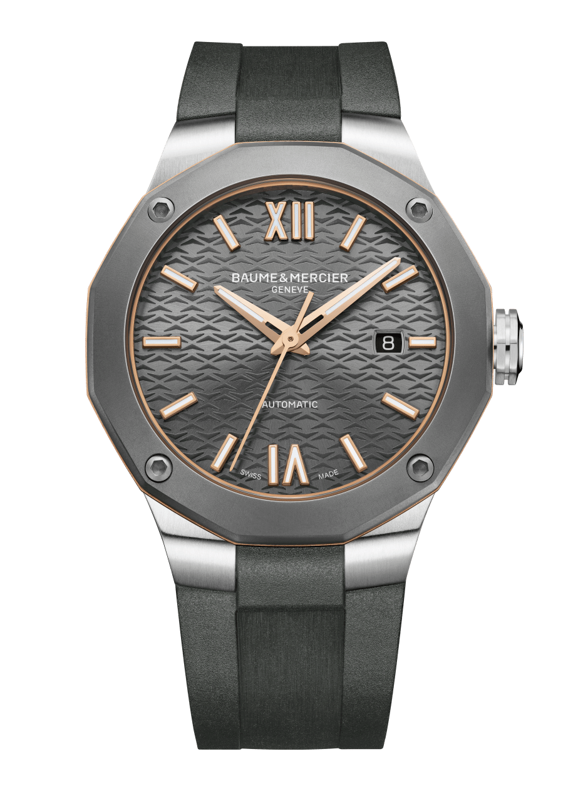
RIVIERA AUTOMATIC - M0A10660
Athletic and elegant!

More than any other, the Riviera collection demonstrates the expertise of Baume & Mercier design in the field of watches with athletic shapes. Its uncompromisingly creative approach and recreational aspirations – which are the essence of the Maison’s style – are still in the minds of those who love this model. And there are a lot of those. The Riviera is back again this year in subtly grayish hues, with a variation on the “Swiss-made” 42 mm automatic Riviera with a steel case and a slate dial on an interchangeable steel or gray rubber strap. The sand-blasted titanium bezel, fastened to the case with four functional screws, brings this contemporary piece a stealthy, driven look. A distinctive look reinforced by a gold-plated PVD ring, which provides luminosity in a perfect juxtaposition of the matte hue of the bezel and strap. There’s no mistaking its sporty pedigree. It is subtly softened by a dial in a beautifully lacquered “slate” hue, highlighted by tone-on-tone “wave” decorations, as well as Roman numerals and indexes in gold-plated steel. This back-and-forth play between classic style and a casual spirit is also expressed through the strap. Thanks to the reliable, robust Fast Strap interchangeability system – available for the entire collection –, it is easy to change the timepiece’s look with no need for tools. The new Riviera is sporty yet chic!

****

THE NEW RIVIERA WATCHES,
MORE FEMININE THAN EVER

This year, the sport-chic icon of Baume & Mercier challenges conventions for a uniquely distinctive style. Conservative or wild, gem-set or understated, the Riviera keeps moving, choosing its own destiny. It might feature the French Riviera on its dial, bedazzle its bezel with diamonds, or blush with a refined pink. The Riviera enjoys life... To the delight of women who love watches.
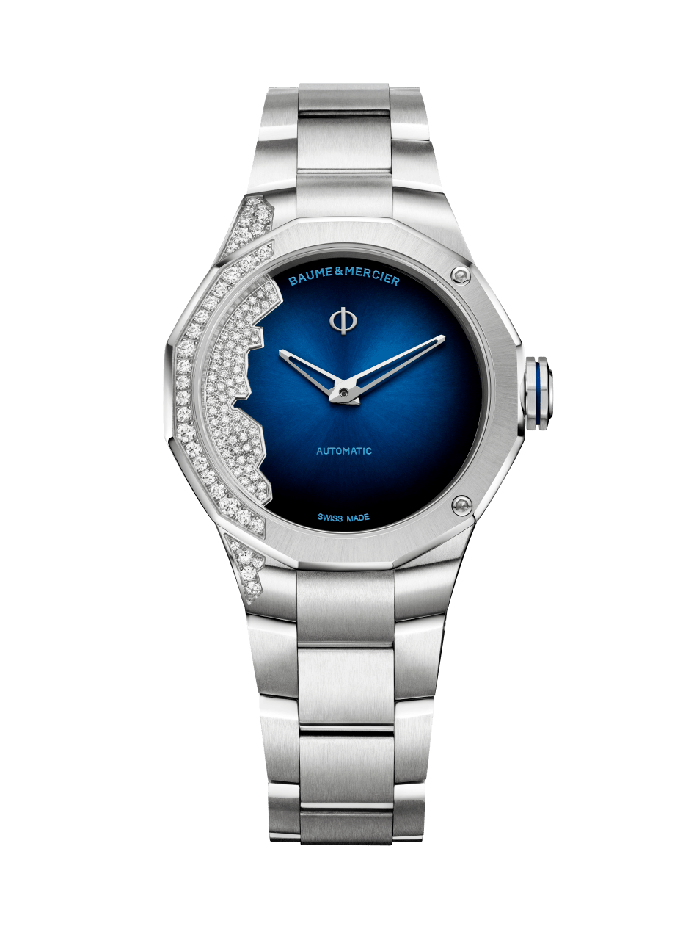
“Coastline” RIVIERA 33mm - M0A10677:
A French Riviera to wear on the wrist

The Riviera has never forgotten women. Far from it. In 2022, several versions join the women’s collection, including the “Swiss-made” self-winding “Coastline” model in a 33-mm diameter. In its steel case, this almost cheeky Riviera asserts a particularly unique design with a gradated midnight blue lacquer dial set with 63 diamonds. The diamonds portray the seaboard of the French Riviera, beckoning to an adventure from Monaco to Saint Tropez. The asymmetry introduced by this gem-setting, which could be described as topographic – an effect made possible through the combination of precious stones in seven different sizes –, is a first for the Riviera collection. Indeed, it is a first for this Maison, which continues to push back the lines of the design and bold spirit that have made it world famous. Like a sparkling summer wave, the exclusive gem-setting extends to a portion of the bezel, case and integrated steel strap. This design is unafraid to venture into the unexpected. That’s the Riviera spirit!
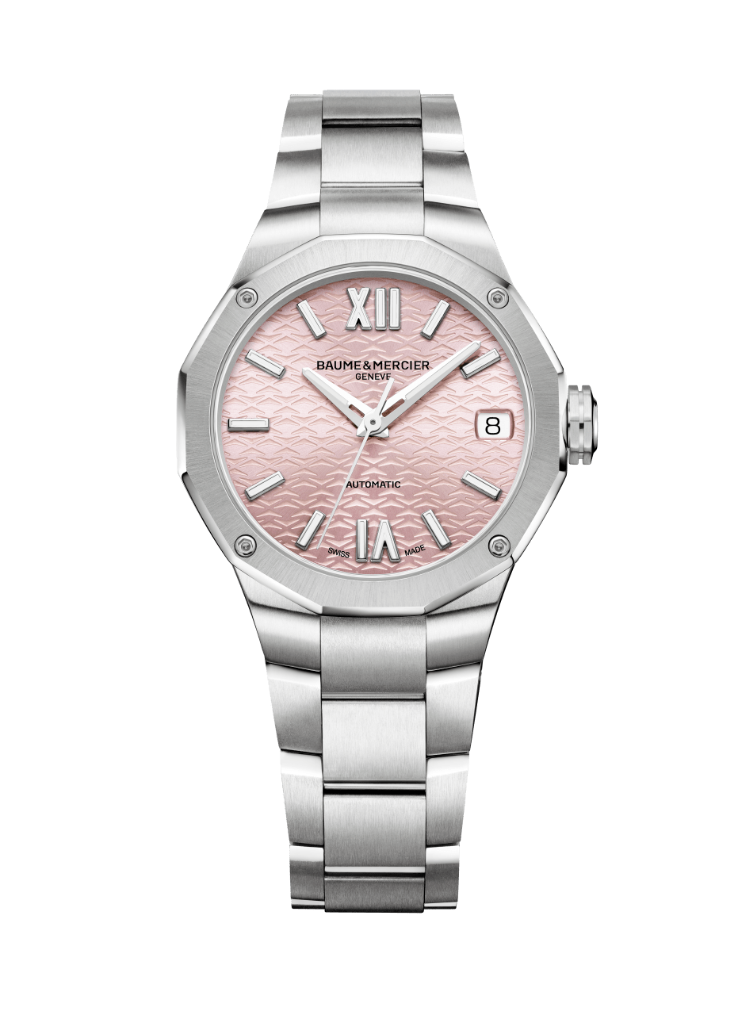
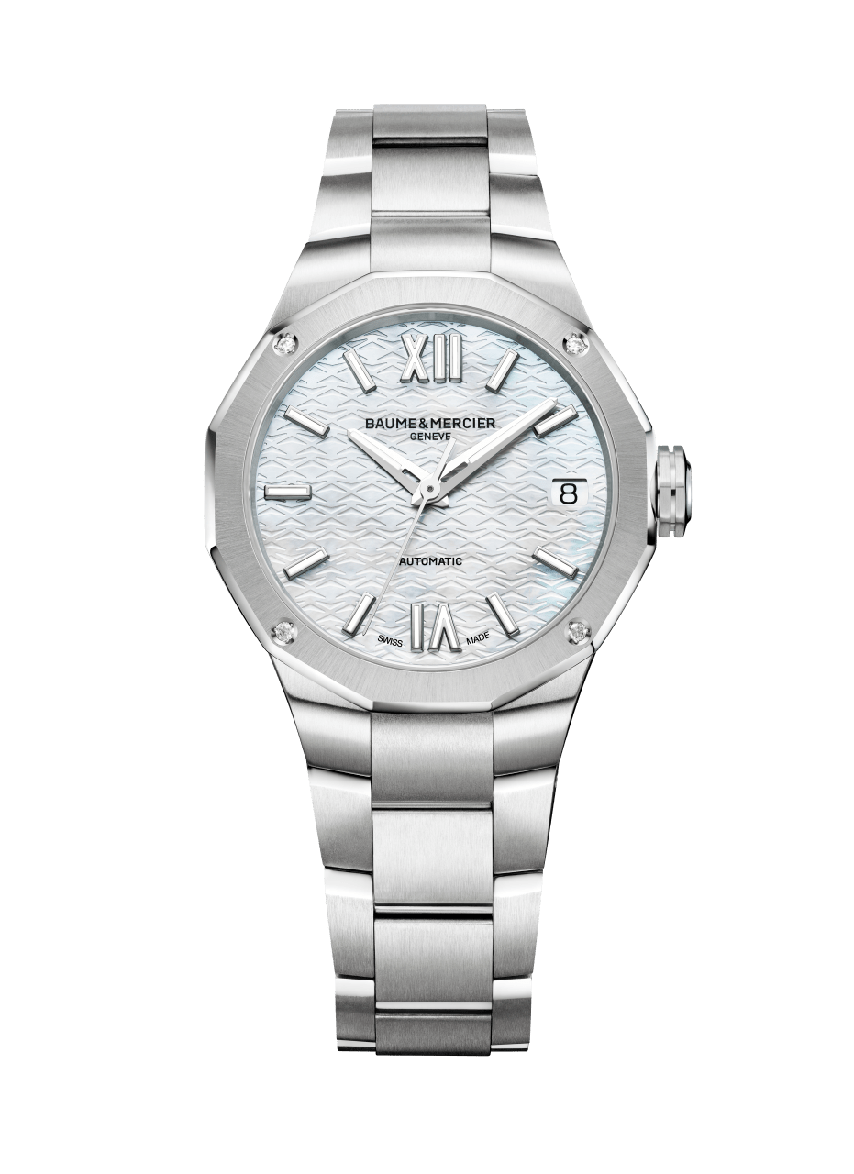
RIVIERA 33mm - M0A10675 & M0A10676
The new Baume & Mercier femininity

Baume & Mercier presents two new, ultra-feminine versions of the Riviera, each in an elegant 33 mm diameter, with a “Swiss-made” self-winding movement and an interchangeable integrated steel bracelet. The first is adorned with a pink “sun satin” dial, while the second asserts a white mother-of-pearl dial. The new palette of 33 mm ladies’ Riviera watches keeps it pared down to the essential: assertive femininity, supreme style and natural flair. The polished / satin-finished strap – featuring a reliable, robust interchangeability system for use without tools – makes it possible to change looks on a whim. Each one is unique, trustworthy, athletic, elegant and authentic. Each is distinctive of the Riviera style. For today’s woman.
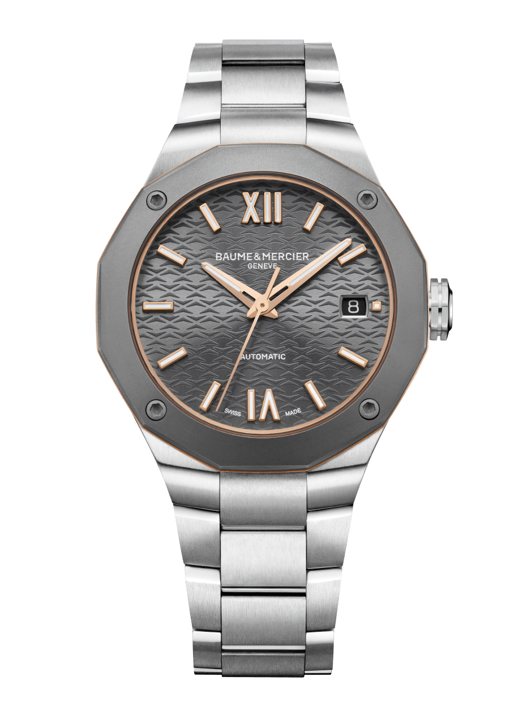
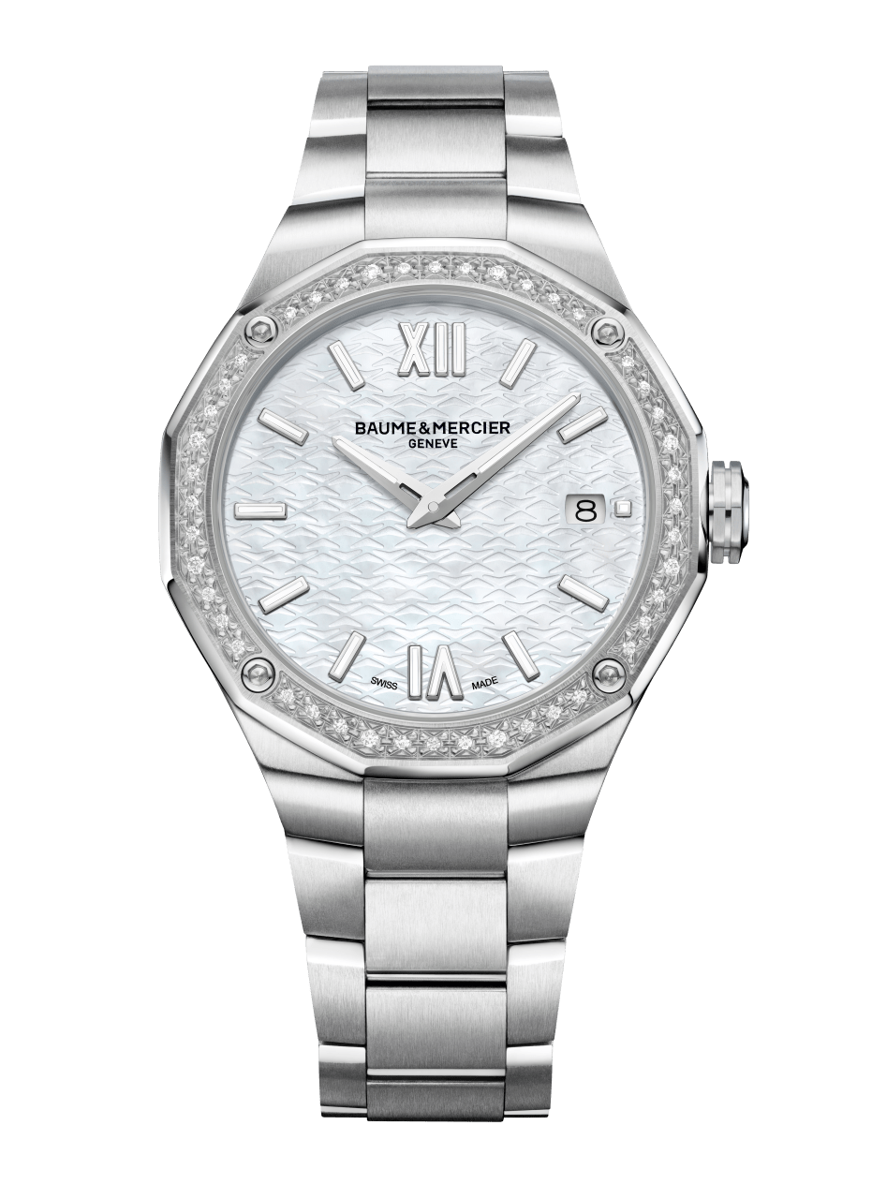
RIVIERA 36mm - M0A10661 & M0A10662
Versatile elegance for the everyday

In a 36 mm diameter with a steel strap, two new unisex Riviera models are pulling out all the stops. The first is a feminine version of the Riviera Automatic Ref M0A10660 in steel with a titanium bezel. Here it is in a totally versatile 36 mm diameter for women seeking a timepiece with character in a bi-material spirit. It echoes the new men’s model presented this year, with a steel case, a titanium bezel, a ring in gold-plated PVD, a “Swiss-made” self-winding movement, and an integrated steel strap. An assertive yet understated piece.

Also in a 36 mm diameter, Baume & Mercier presents another ultra-feminine Riviera in 2022, featuring a quartz movement, a white mother-of-pearl dial, an integrated steel strap, and a bezel set with 44 diamonds in a snow-setting style, fastened with four screws in polished steel. In this version, the Riviera addresses women seeking a precious watch that is smart, beautiful and simple. An understated luxury that the Maison perfectly masters.

****

ABOUT BAUME & MERCIER:

Founded in 1830 at the heart of Swiss Jura, Baume & Mercier enjoys international renown. From its workshops at the heart of Swiss Jura to its headquarters based in Geneva, the Maison offers its clients the very finest timepieces. Born by a complementary balance between an artistic approach to shape and watchmaking innovation in the service of the client, the Baume & Mercier House continues to mark the history of watchmaking by passing down the design and watchmaking expertise that is the Brand’s legacy. This savoir-faire perfectly corresponds with the spirit of cooperation between the Brand’s founders William Baume & Paul Mercier: where classicism meets creativity, tradition meets modernity, and elegance meets character... In a more contemporary way than ever.

www.baume-et-mercier.com

****

