DATE EMBARGO : RELEASE at 8:30 a.m. on April 1st

THE NEW CHRONOGRAPHS OF THE RIVIERA COLLECTION

THE ART OF ENHANCING THE BALANCE BETWEEN MODERNITY AND VINTAGE

Through timepieces mingling technical performance and remarkable aesthetics, Baume & Mercier captures each second in a unique instant and celebrates life’s precious moments. Through the Riviera collection, the House enshrines life’s most cherished moments like a photographer seizing the fleeting nature of an action, bringing to light its emotional intensity. Time becomes a perspective, an angle, a focus; a decisive click, an artistic exploration. Precision is a challenge; technical achievement, a strength; attention to detail, an excellence; style, a signature. Since it was founded in 1830, Baume & Mercier has been dedicating its technical savoir-faire and spirit of design to all of life’s moments. And what could make them resonate more precisely than a chronograph? To express the intensity of fractioning time, the Riviera collection welcomes four new chronographs, available from June, in both modern and vintage versions.

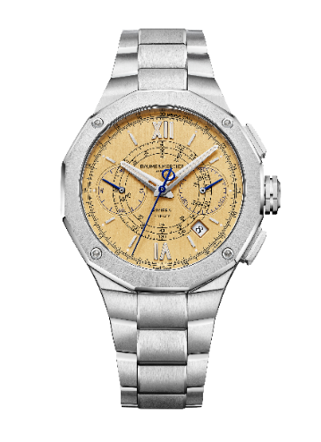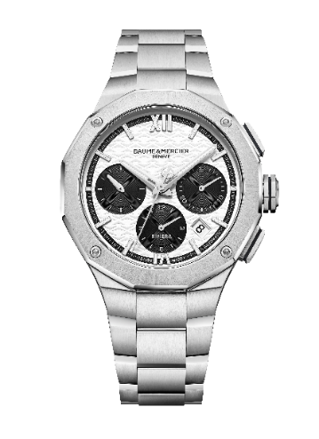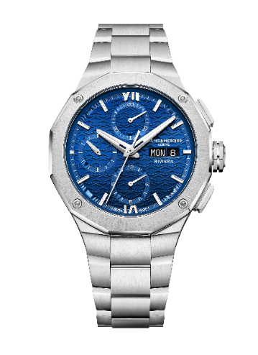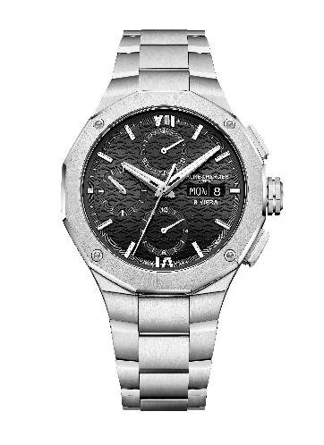

Revealing the strength of each moment and the magic of emotion; designing the relief of time

Dedicated to the personal moments lived for oneself, the Riviera Chronograph Flyback (M0A10828), the Riviera Chronograph (M0A10827), and two versions of the Riviera Chronographs 41 mm (M0A10825 and M0A10826) eloquently reveal the individual aficionado’s perception of time. That of a man who feels like the master of his own time and of his own life. A confident man who knows what he wants and what he expects from the watch that he has chosen to accompany him in each of life’s occasions. He is certain of his choice because he recognizes the reliability, quality, and heritage of this House whose watchmaking excellence has been shining for nearly 200 years.

For this modern man, time is precious. He knows that a single second can make a difference. He seizes the acuity of an instant with emotion, its momentum, its pause; the race against time, which he activates on the ultra-luxury chronograph of his vintage-style Riviera M0A10828, featuring a flyback function, tachymeter, and telemeter. This is a promise, spurring him on and making his heart race. He feels so alive.

The 1950s-style black-and-white dial of the Riviera M0A10827 represents balance, harmony, and the beauty of life’s contrasts. The rhythm of this chronograph challenges the one who wears it, and he eagerly rises to the challenge, embracing it, captivated by its irresistible flair.

Any chronograph lover will make the Riviera M0A10825, with its black dial, or the Riviera M0A10826, in a blue version, his favorite playground. All heirs to an existing 43 mm model that has been reworked for a sleeker fit, these timepieces passionately join the race, the hands of their counters setting the pace for their 41 mm case.

The incarnation of a sport-chic world inspired by the French Riviera

The sport-chic spirit of the Riviera collection is inspired by the French Riviera itself, bringing life to the various facets of this legendary destination. Its dodecagonal case and bezel powerfully echo its sculptural relief. Each subtle reflection of its luminous dials captures contrasting hues, evoking the region’s natural elements – vegetation, minerals, and the sea –, as well as its bohemian-chic atmosphere. The art of living on the Riviera is one of releasing one’s cares, feeling good, enjoying freedom, and seeking out beauty, refinement, purity, and harmony with a natural yet sophisticated elegance.

The new Riviera chronographs seize the beauty and intensity of life’s moments that this magical spot offers, between leisurely relaxation, exhilarating water sports, and vibrant, opulent celebrations. The precision and reliability of these high-tech timepieces make them simply unforgettable.

The art of the chronograph at Baume & Mercier

The history of Baume & Mercier is marked by a constant development of its chronograph expertise. The House triumphed in the most exacting chronometry competitions, including the most prestigious among them: that of the Kew Observatory in England. In 1887, Baume & Mercier was awarded the best score of the competition – 85.1 points out of 100 – with a split-seconds chronograph. In 1892 it set a record with a score of 91.9 points for a keyless chronometer with a tourbillon escapement. This early success laid the foundation for its reputation in precision and innovation.

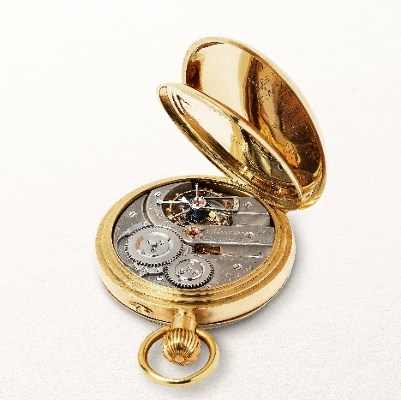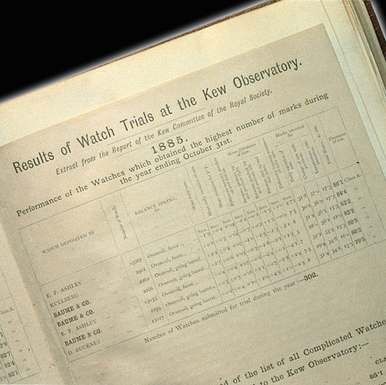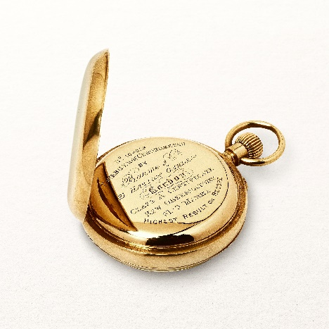

The House continued to refine its chronograph competences throughout the late 1930s and on into the 1940s and 1950s, developing chronographs with tachymeter and telemeter scales, culminating in a model featuring a triple date complication and moon phases. These technically advanced timepieces were associated with elegant designs, often in gold, with cushion-shaped or square cases.
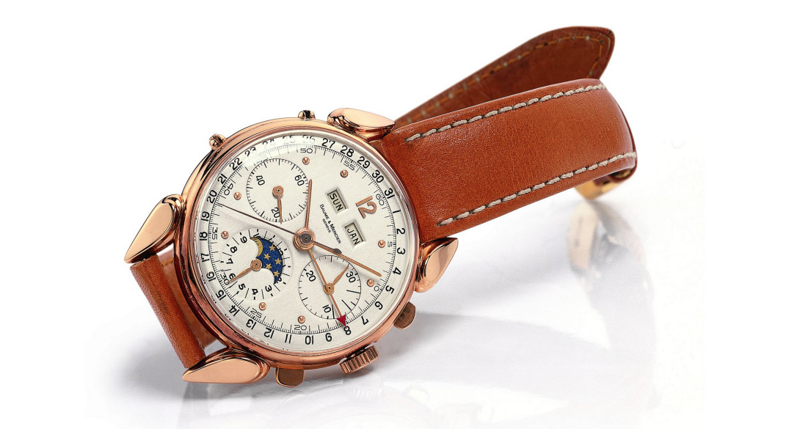
The acquisition of C.H. Meylan Watch SA in 1952 enabled the in-house production of movements, significantly ramping up the development process. Baume & Mercier produces chronographs with increasingly complex complications, including full-date functions, moon phases, and specialized totalizers. All these are integrated into its own movements at its Manufacture in Le Brassus. These timepieces, demonstrating the House commitment to technical precision and elegant design, constitute a heritage of very sought-after chronographs.

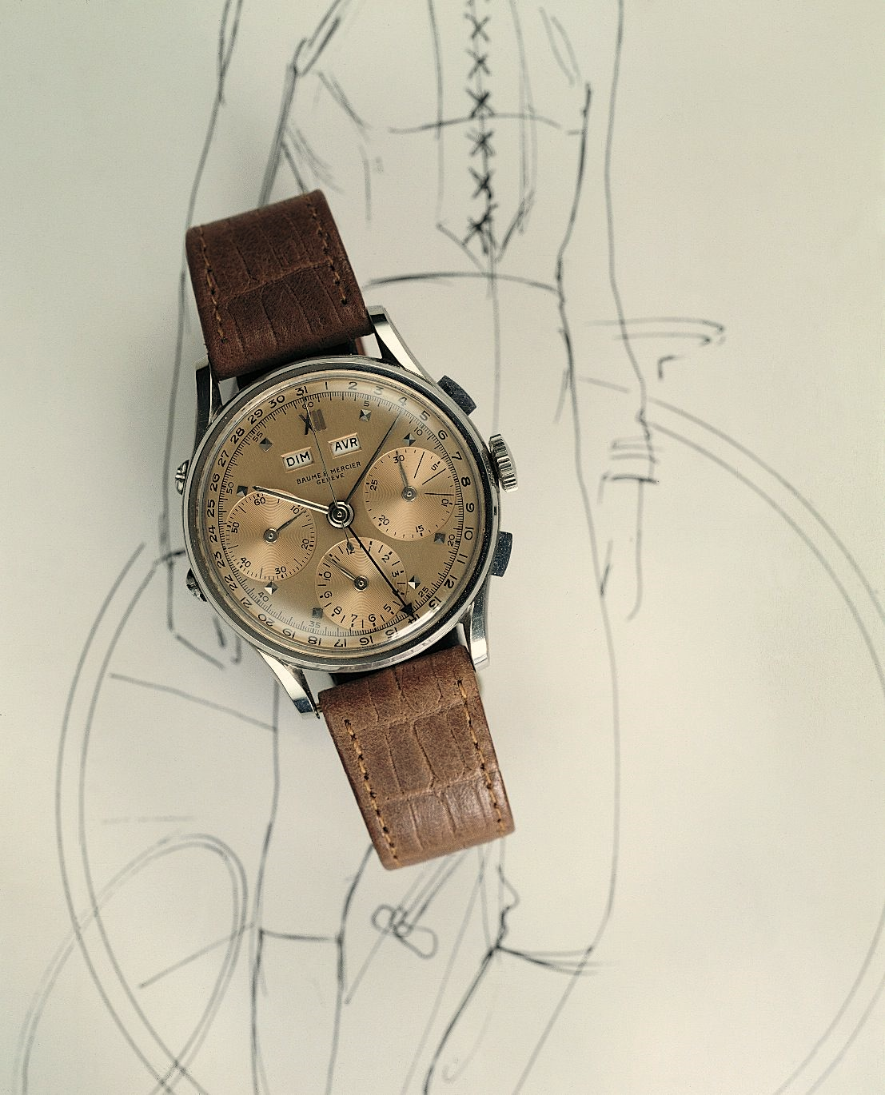

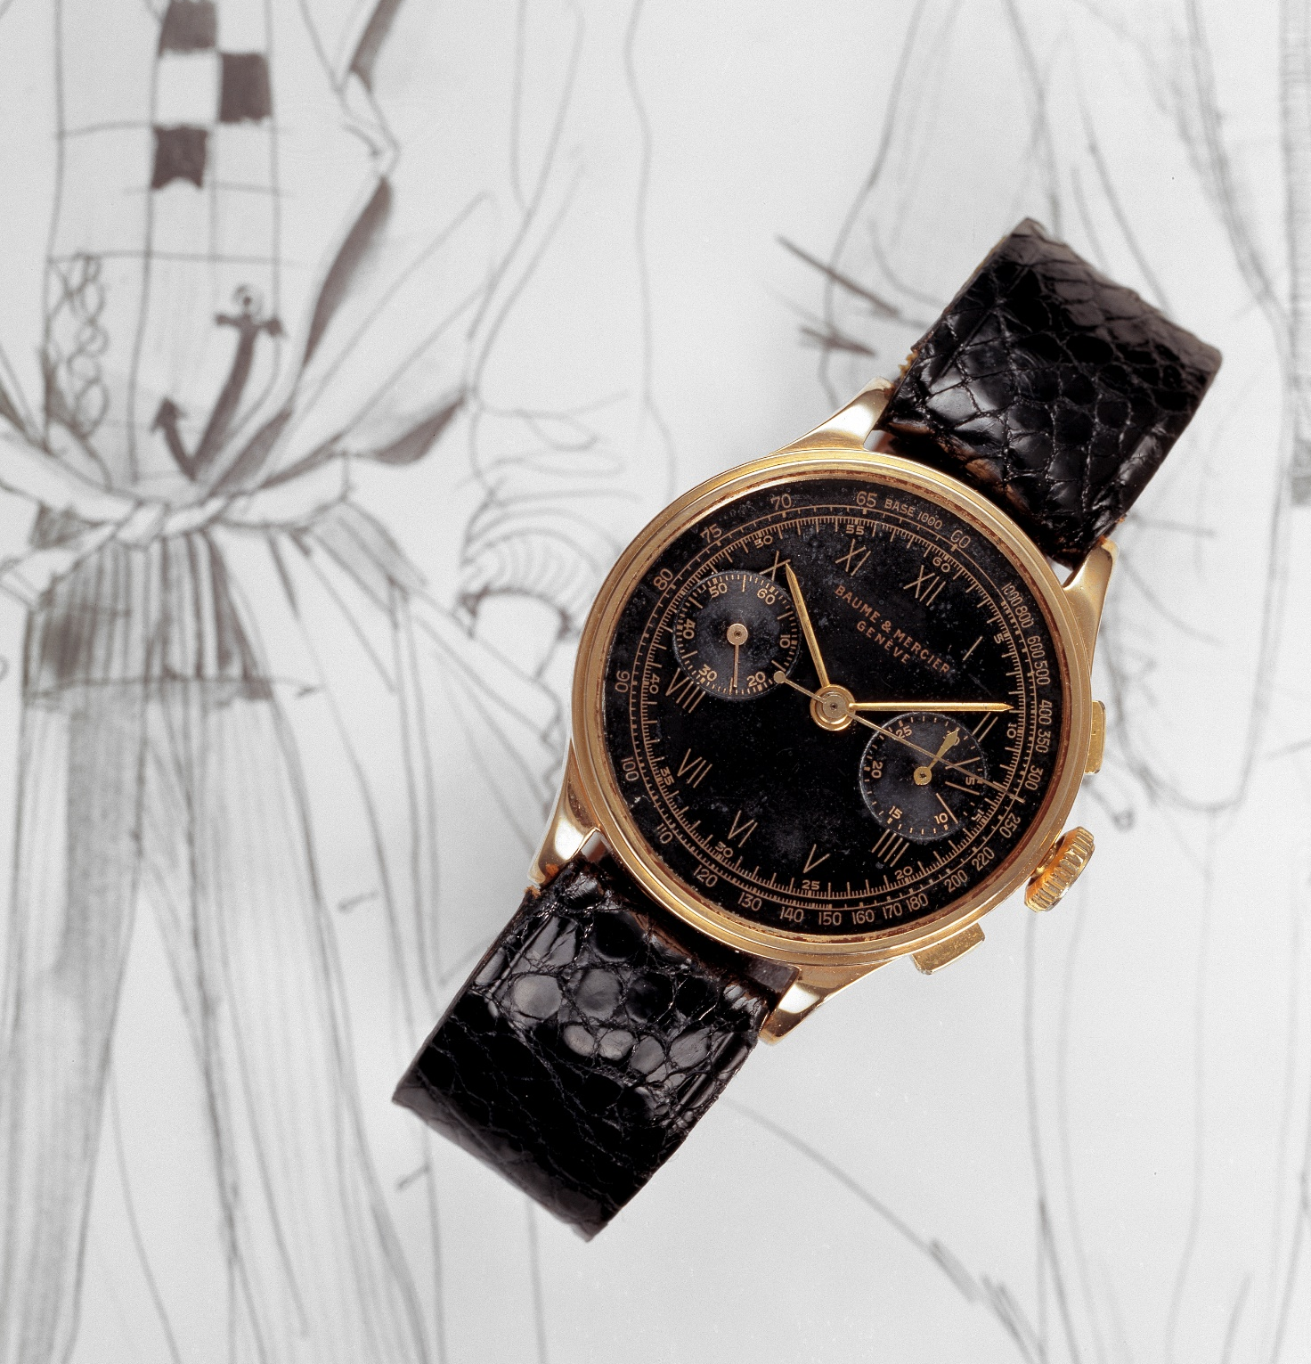
The chronograph development continued throughout the following decades with sporty modern collections such as the Malibu line and the Capeland model, representing a revival of the athletic technical chronographs from the early 1990s. The chronograph also made an appearance in the Riviera collection in 1993 to celebrate the 20th anniversary of this watch icon. In 1997 it emerged in the Classima Executive line, and in 2024 it made a comeback in the same collection, demonstrating the lasting legacy of Baume & Mercier expertise in chronograph crafting.

Such is the heritage that brings its momentum to the new Riviera models.
Riviera M0A10828: a Flyback chronograph with a vintage aesthetic

This limited edition of just 73 timepieces – a number that pays tribute to the launch year of the Riviera collection, 1973 – embodies the quintessence of the chronograph. Its flyback function – which allows the chronograph to be stopped, reset, and restarted at a simple press of a second, identical push button at 4 o'clock –, as well as its telemeter and tachymeter, make it a precious tool, complementing the indication of hours, minutes, small seconds, and date. Its sophisticated mechanism is beautifully crafted with a luminous brushed vertical gold dial that asserts a vintage touch, precise lines, and exceptional readability. The fine concentric detailing of the chronograph, telemeter, and tachymeter counters is edged with Roman numerals and riveted, rhodium-plated indexes coated with beige Superluminova (blue glow). The faceted, rhodium-plated hour and minute hands, coated with beige Superluminova (blue glow), contrast with the blued steel chronograph seconds hand, which bears the Phi logo as a counterweight, and with the polished blued steel hands of the counters. A white aperture at 4:30 reveals the date.

With a diameter of 41 mm and a thickness of 14.34 mm, the polished and satin-finished stainless steel dodecagonal case of this luxury piece, so emblematic of this collection, is protected by a scratch-resistant sapphire crystal with an anti-glare coating on both sides. The twelve-sided bezel secured by four screws is also crafted in polished and satin-finished stainless steel. Also fastened by four screws, the dodecagonal case back bears a special “Limited Edition One of 73” engraving, and may also be custom-engraved. The free octagonal crown is adorned with a delicately embossed Phi logo, emblem of the House, and wreathed with a fine blue line. The self-winding movement offers a 42-hour power reserve and oscillates at a frequency of 4Hz (28,800 vph). It is water-resistant to 10 ATM (approximately 100 m). The integrated three-row strap features a central link highlighted by decorative bevels in polished and satin-finished stainless steel and is equipped with a robust, highly reliable, interchangeable system, making it possible to change the strap without any tools. The triple folding clasp with security push-pieces is also crafted in stainless steel.
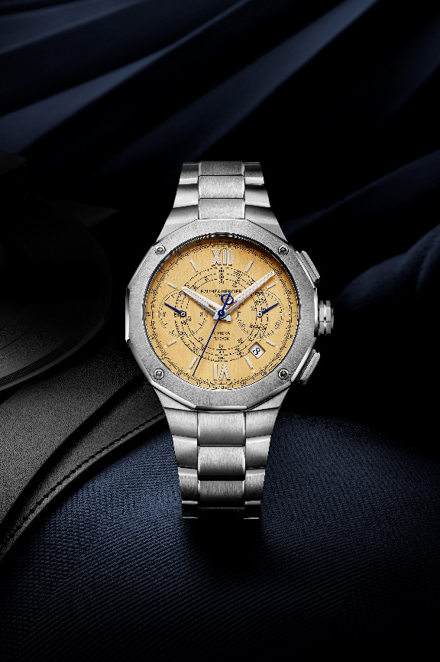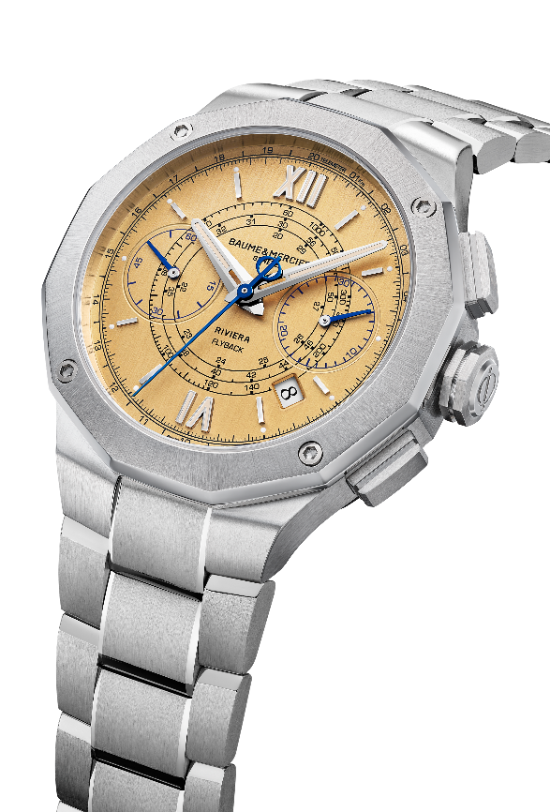

Riviera M0A10827: A chronograph with a style full of contrasts

This version of the Riviera, with its 1950 style, plays on radical yet harmonious black-and-white contrasts. At Baume & Mercier, elegance and understatement always accompany creative freedom. Here, a white dial with a wave decor is edged with a black outer flange that complements the azure black counters. In contrast with these dark finishes, the Roman numerals and riveted indexes, as well as the faceted hour and minute hands, are rhodium-plated and coated with white Superluminova (blue glow), highlighting the bicolor contrast. The chronograph seconds hand, featuring the Phi logo counterweight, is also rhodium-plated like the hands of the counters. That of the counter at 9 o’clock is coated with white Superluminova (blue glow). The date aperture (to be adjusted with the corrector tool) appears at 4:30.

The polished and satin-finished stainless steel case, with a diameter of 41mm and a thickness of 13.94mm, is protected with a scratch-resistant sapphire crystal treated with an anti-glare coating on both sides. The polished and sun-satin stainless steel bezel and dodecagonal case back – which is protected by a sapphire crystal, and which may be engraved – are fastened with four screws. The embossed Phi logo and black line bring finesse to the free octagonal crown.

Equipped with a self-winding movement, this model offers a 48-hour power reserve, oscillates at a frequency of 4 Hz (28,800 vph), and offers water resistance to 10 ATM (approximately 100m).

Its integrated three-row satin-finished stainless steel strap further heightens the refinement and character of the timepiece. This interchangeable strap may be removed and replaced – without the use of tools, thanks to a very reliable, robust system – with an array of rubber straps that offer the piece unparalleled versatility. Its stainless steel triple folding clasp is equipped with security push-pieces.

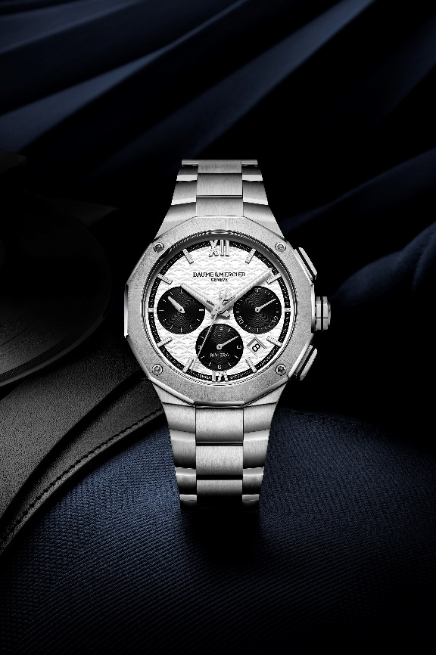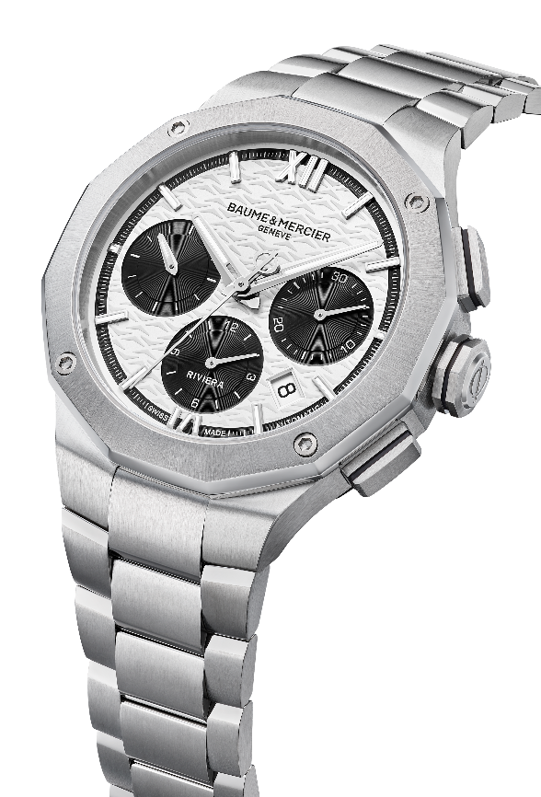

Riviera M0A10825: a black day-date chronograph with white accents

This model, resembling the existing 43-mm version, joins the collection in a 41-mm diameter with a thickness of 13.94 mm. Reworked for a sleeker fit, its dodecagonal satin-finished stainless steel case is protected by a scratch-resistant sapphire crystal treated with an anti-glare coating on both sides. The equally dodecagonal bezel in polished and sun-satin stainless steel, as well as the twelve-sided case back with its sapphire crystal, are secured with four screws. The case back may be custom-engraved. The free octagonal crown is crafted in steel, highlighting the House’s embossed Phi logo, the symbol of balance and quality crafting.

This watch, with the exquisitely fine codes of its time and date indications, demonstrates the design savoir-faire so distinctive of Baume & Mercier. Set against a black wave decor backdrop with an azure flange and counters, the features visually stand out in alternating finer and thicker lines: the Roman numerals and riveted rhodium-plated indexes coated with white Superluminova (C1, blue glow), the faceted rhodium-plated hour and minute hands coated with white Superluminova (blue glow), the rhodium-plated counter hands, the hand of the counter at 9 o'clock coated with white Superluminova (blue glow), and the day and date apertures at 3 o'clock.

The functions are driven by a self-winding movement with a 48-hour power reserve that oscillates at a frequency of 4 Hz (28,800 vph). The piece is water-resistant to 10 ATM (approximately 100 m).

The interchangeable strap visually extends this fully satin-finished stainless steel design. It may be changed without the need for tools thanks to a very robust, reliable mechanism.
Its triple folding clasp with security push-pieces is also crafted in stainless steel.

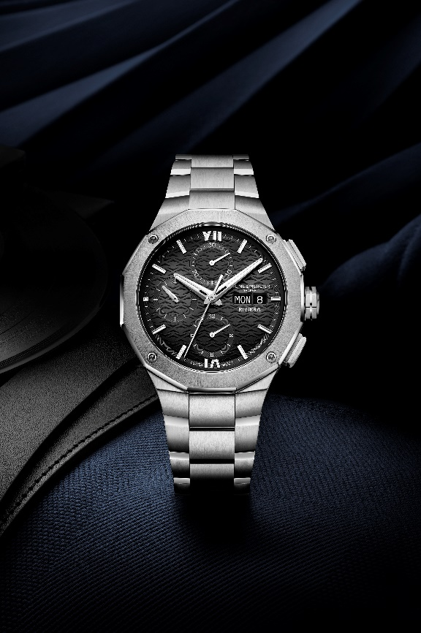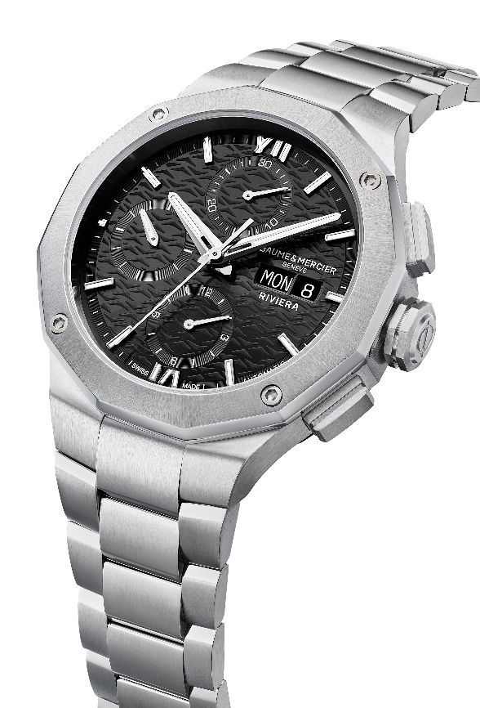

Riviera M0A10826: a blue day-date chronograph with white accents

The blue version of this model, which exists in 43mm and has been reworked to refine its proportions, is now available in a 41 mm diameter with a thickness of 13.94 mm. The finishes play on the subtle blend of its blue sun-satin dial, featuring a wave decor, an azure flange, and azure counters. The interplay of Roman numerals and riveted rhodium-plated indexes, coated with white Superluminova (C1, blue glow); the faceted rhodium-plated hour and minute hands and the counter hand at 9 o'clock, all coated with white Superluminova (blue emission); the rhodium-plated counter hands; and the day and date windows at 3 o'clock come together in a harmonious, elegant dynamic, offering a clear, delightful readability that showcases the meticulous craftsmanship of the dial.

In these luminous tonalities, the satin-finished stainless steel case radiantly reveals its twelve sides. The scratch-resistant sapphire crystal protecting it is treated with an anti-glare coating on both sides. The bezel, crafted in polished and sun-satin stainless steel, is secured by four screws, as is the dodecagonal case back, also protected by a sapphire crystal. The case back may be custom-engraved by request. The free octagonal steel crown is stamped with the embossed Phi logo.

The timepiece offers a 38-hour power reserve, oscillates at a frequency of 4Hz (28,800 vph), and offers water-resistance to 10 ATM (approximately 100 m).

In satin-polished stainless steel, its integrated three-row steel strap features a robust, very reliable interchangeability mechanism that makes it possible to change straps without the use of tools.
The triple folding clasp with security push-pieces is crafted in stainless steel.

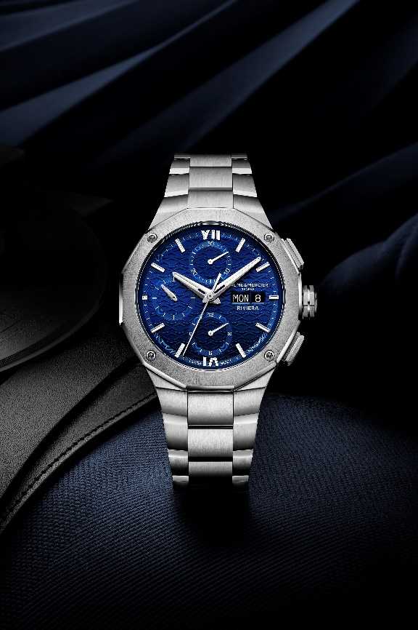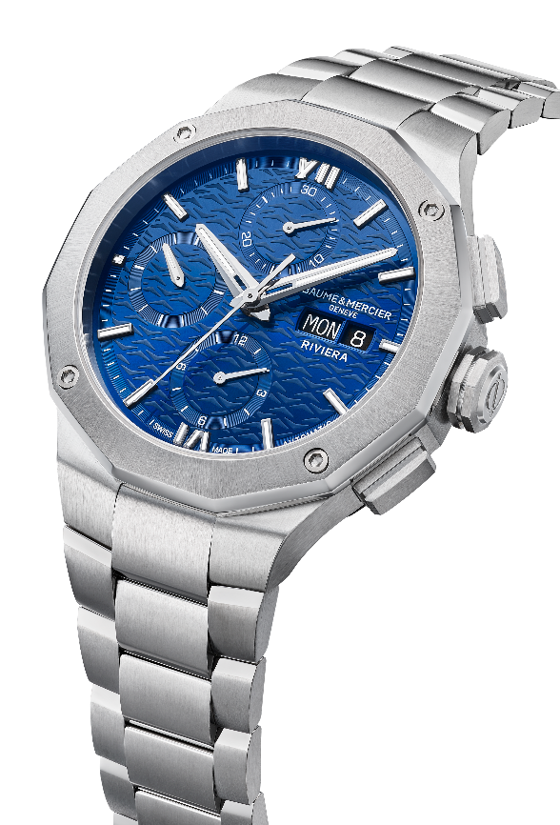

The saga of the Riviera continues. The pioneering spirit of this stylish, dynamic sport chic watch accompanies aficionados in each moment of their lives, with an allure that adapts to each individual to take them ever further.

ABOUT BAUME & MERCIER:

Founded in 1830 at the heart of Swiss Jura, the Baume & Mercier watch manufacture enjoys international renown. From its workshops at the heart of Swiss Jura to its headquarters based in Geneva, the Brand offers its clients the very finest timepieces. Borne by a complementary balance between an artistic approach to shape and watchmaking innovation in the service of the client, the Baume & Mercier House continues to mark the history of watchmaking by passing down the design and watchmaking expertise that is the Brand’s legacy. This savoir-faire perfectly corresponds with the spirit of cooperation between the Brand’s founders William Baume & Paul Mercier: where classicism meets creativity, tradition meets modernity, and elegance meets character... In a more contemporary way than ever.

www.baume-et-mercier.com

