EMBARGO March 30st / 8.30am CET

WATCHES & WONDERS 2022

NEW IN 2022 AND STILL DISTINCTIVE OF
BAUME & MERCIER EXPERTISE IN WATCHMAKING DESIGN

To design a timepiece like an art object… It takes a visionary spirit with a love for shapes and volumes to conceive of ultra-slim pocket watches for men and jewelry watches for women to wear as rings or necklaces. Beginning in the 1920s, Paul Mercier, backed by the technical expertise of William Baume, captured the essence of the social progress of the times. The Maison’s inherent creativity and modernity have brought it resounding success, marking the signature look of Baume & Mercier that is still visible today.

“Why not combine the dependability and precision of a watch of the highest quality with the lightness and appeal of contemporary esthetics?
People want freshness, beauty, lightness.”

Quote from The Saga – The history book of Baume & Mercier

Born from an innovative, modern spirit, the collections of yesteryear continue to assert their contemporary spirit and avant-garde shapes, joining today’s collection in the creative momentum that the Brand never ceases to renew. Each one in its own way demonstrates a love for design, a passion for shape, and a desire to make a bold statement, which Baume & Mercier has been carrying in its DNA since William Baume met Paul Mercier. The Studio Design – the Maison’s in-house creative studio – has always enthusiastically created each new collection, setting itself the challenge of mastering a great variety of shapes, from the simplest to the most complex. The constant pursuit for perfect proportions and precise lines; attention to detail; the harmony of materials and colors; the concurrence of classicism and design; the mingling of rectangular and rounded lines; and the balance between men’s and women’s watchmaking all enter into the creative process. By choosing the Greek letter Phi – a reference to the divine proportion and its natural balance – as its emblem, Baume & Mercier has clearly hitched its wagon to the star of artistic aspiration.

****

A NEW LOOK FOR THE ICONIC CLASSIMA

The Classima is the round watch with perfect proportions that is so delightful to wear that it becomes a second skin. It is a classic that has been perennially fashionable since 2004, and Baume & Mercier is delighted to reveal trendy new looks for it each year. Innovative materials are combined to create contrast, while various fresh colors offer a creative touch. The Baume & Mercier Design Studio plays with the composition, experimenting and making special variations on the Classima collection each year. The Classima is back in 2022 with four new self-winding watches for men and women, to mix or match. Round without being focused on shape, modern yet original, elegant yet casual: with the Classima, it’s all about enjoying yourself. The Classima, the ideal first Swiss timepiece for watch newcomers.

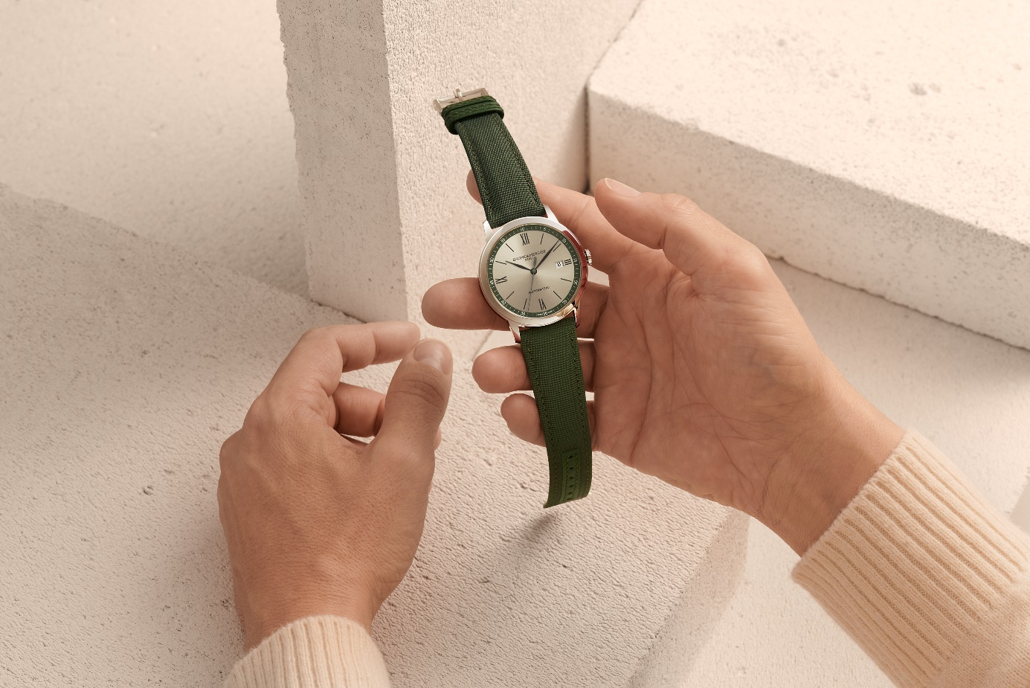

Classima 10696
****

A STREET STYLE LOOK
INSPIRED BY THE NATURE

Baume & Mercier revisits the street style codes in a play of materials and timeless shades. Khaki is in the spotlight, with a versatile palette ranging from sand beige to olive green, offering a natural effect that adapts to every style. With two large-sized models for a casual yet refined look, Classima explores this trend with elegance and understatement: khaki and sand hues, and a mixture of canvas, slate and steel... The Brand unveils two looks that will become essential for the summer season, evoking adventure and nature.

Each watch features a 42 mm polished steel case with a screwed back and a self-winding movement with a 38-hour power reserve.

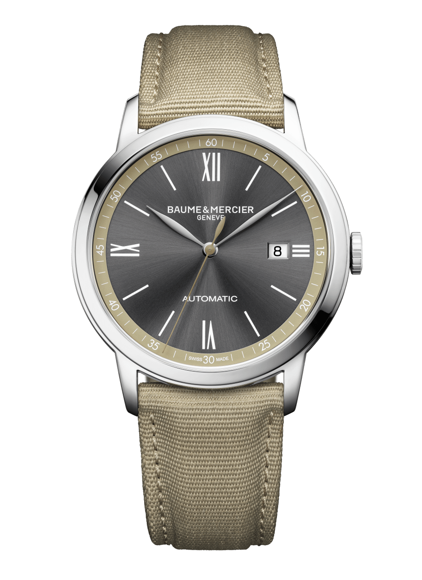
CLASSIMA - M0A10695

The first model evokes the desert with a slate sun satin dial and sand-colored flange which coordinates with the hue of the solid canvas strap. Rhodium-plated leaf hands delicately sweep along the enchanting undertones of the slate, pointing to the white Roman numerals and indexes which adorn the round dial. A date aperture appears at 3 o’clock. For an aesthetic touch, the seconds hand is beige, the dominating color of this model.

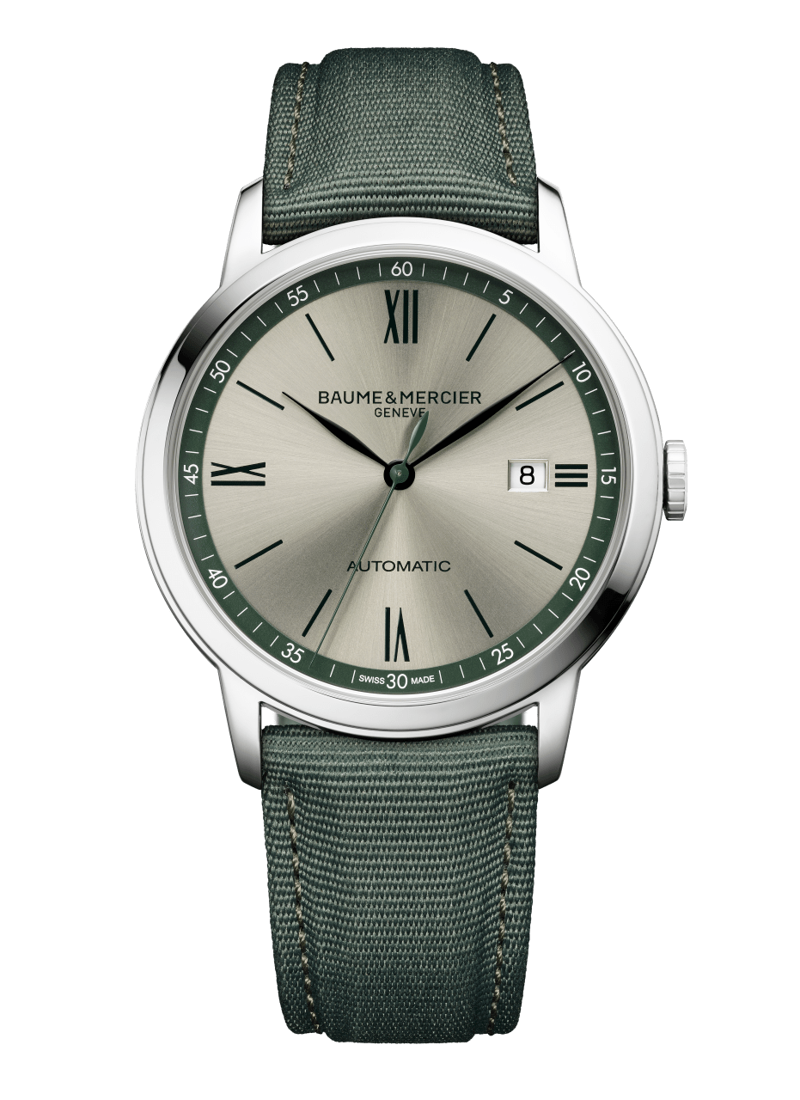
CLASSIMA - M0A10696

The second model makes an expedition into a more verdant land. The sapphire crystal reveals a warm silver sun satin dial, with a green flange that emphasizes the perfect roundness of this adventurous Classima. Black Roman numerals and indexes are indicated by black leaf hour and minute hands. The seconds hand is green, like a camouflage for this setting. The interchangeable green canvas strap provides casual character, but the timepiece remains a smart, understated, contemporary watch.

A CITY LOOK
IN BURGUNDY X BLUE

Top picks of the classic chic wardrobe, these two timeless colors are not to be missed. This season, burgundy always goes with blue! The Classima has gotten the message, and it unveils two models that perfect the City look, the watchword of the moment for fashion lovers.

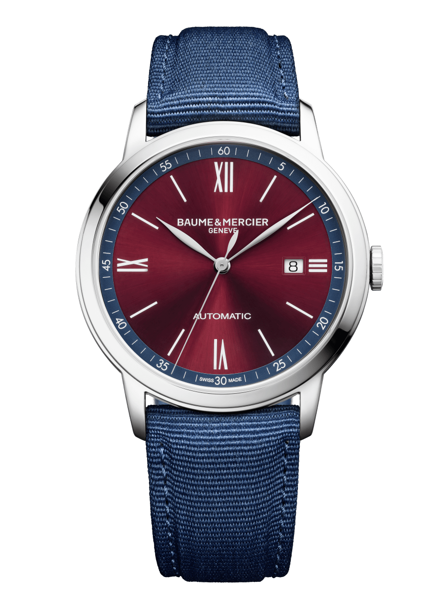
CLASSIMA - M0A10694

For Him, the City look goes into XL format, with a polished 42 mm steel case. It features a large burgundy sun satin dial with a blue flange which brings the minute track a more pronounced depth. In turn, it emphasizes the perfectly balanced circle. The three rhodium-plated leaf hands delicately point to the white Roman numerals and indexes. An elegant date aperture is unveiled at 3 o’clock. The self-winding movement, which offers a 38-hour power reserve, is nestled within the case. Its solid back offers room for the creativity of a personalized engraving. A straight spring-bar system makes it possible to change the strap easily, on a whim.

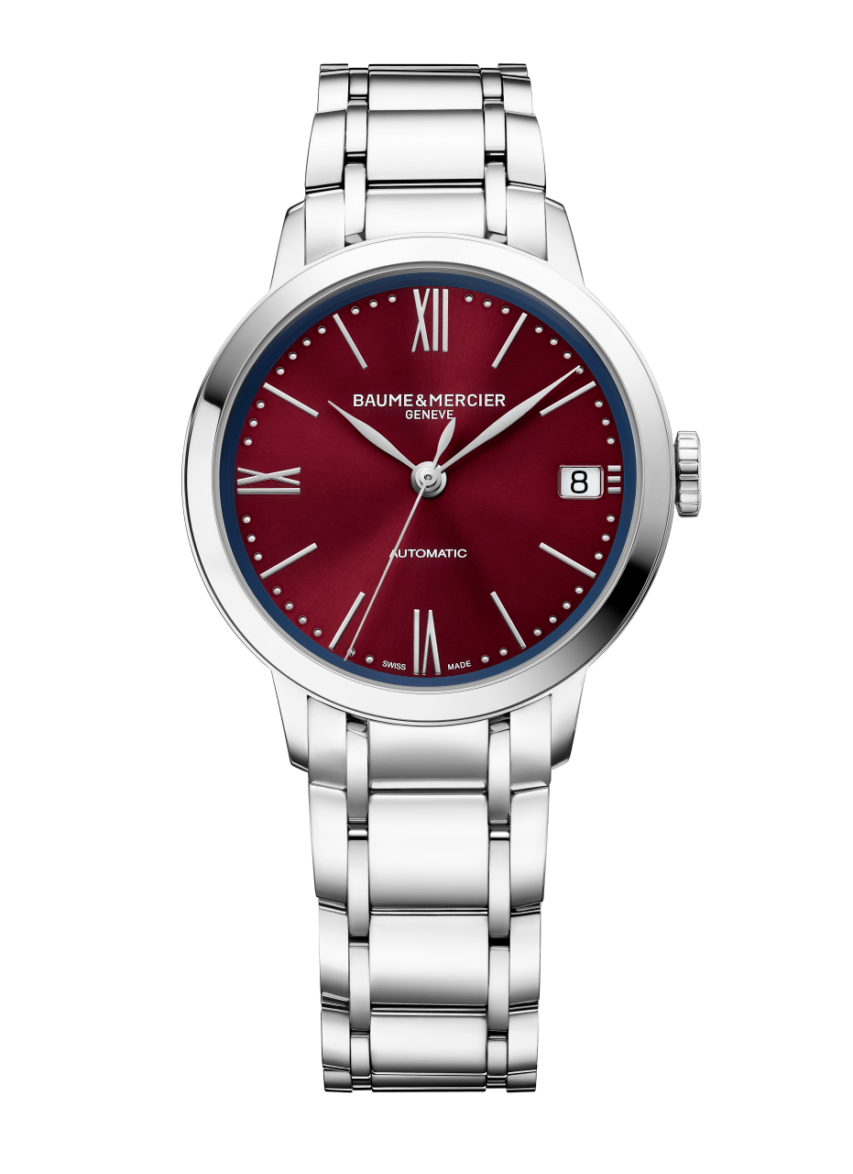
CLASSIMA - M0A10691

For Her, an adorable 34 mm watch is irresistible in polished steel, mounted on a five-row metal strap that elegantly nestles against the wrist. The quick, simple interchangeability system makes it easy to switch to the blue canvas version, offering a versatile look. The small, perfectly round case is incredibly slender, and it reveals a sun satin dial with hypnotic burgundy and blue undertones. The eye is then drawn along the iridescent minute track that curves along the edge. It features the rhodium-plated Roman numerals and indexes characteristic of this collection. Leaf hands sweep lightly along them. A date aperture appears at 3 o’clock. The sapphire crystal on the back offers a view of the beating watch movement. The self-winding caliber offers 42 hours of autonomy.

****

ABOUT BAUME & MERCIER:

Founded in 1830 at the heart of Swiss Jura, Baume & Mercier enjoys international renown. From its workshops at the heart of Swiss Jura to its headquarters based in Geneva, the Maison offers its clients the very finest timepieces. Born by a complementary balance between an artistic approach to shape and watchmaking innovation in the service of the client, the Baume & Mercier House continues to mark the history of watchmaking by passing down the design and watchmaking expertise that is the Brand’s legacy. This savoir-faire perfectly corresponds with the spirit of cooperation between the Brand’s founders William Baume & Paul Mercier: where classicism meets creativity, tradition meets modernity, and elegance meets character... In a more contemporary way than ever.

www.baume-et-mercier.com

****

