CHROMATIC VARIATIONS FOR THE LADIES’ HAMPTON BY BAUME & MERCIER

With its Art Deco-inspired rectangular case, streamlined look, and delicate curves, the Hampton Collection embodies the artistic spirit of Baume & Mercier and the demanding design of unusually shaped watches. Available in a women’s version, it is pulsing with color. Two new models, one burgundy in steel, the other blue in gold, will delight any woman who loves a radiant look and highly refined formal minimalism.

ART AND WOMEN AS MUSES

When it was launched in 1994, the Hampton Collection challenged the aesthetic codes of the time with its elegant geometric silhouette featuring curved lines reminiscent of the Art Deco look of the 1920s and inspired by an iconic model of the 1960s. Since then, it has explored this artistic dimension and made its rectangular case the ideal medium for watchmaking variations that highlight the balance of proportions, the harmony of lines, and the use of color and materials. The women’s collection lends itself to combining colors, emblazoning dials, crowns, and bracelets in very chic and contemporary pieces.

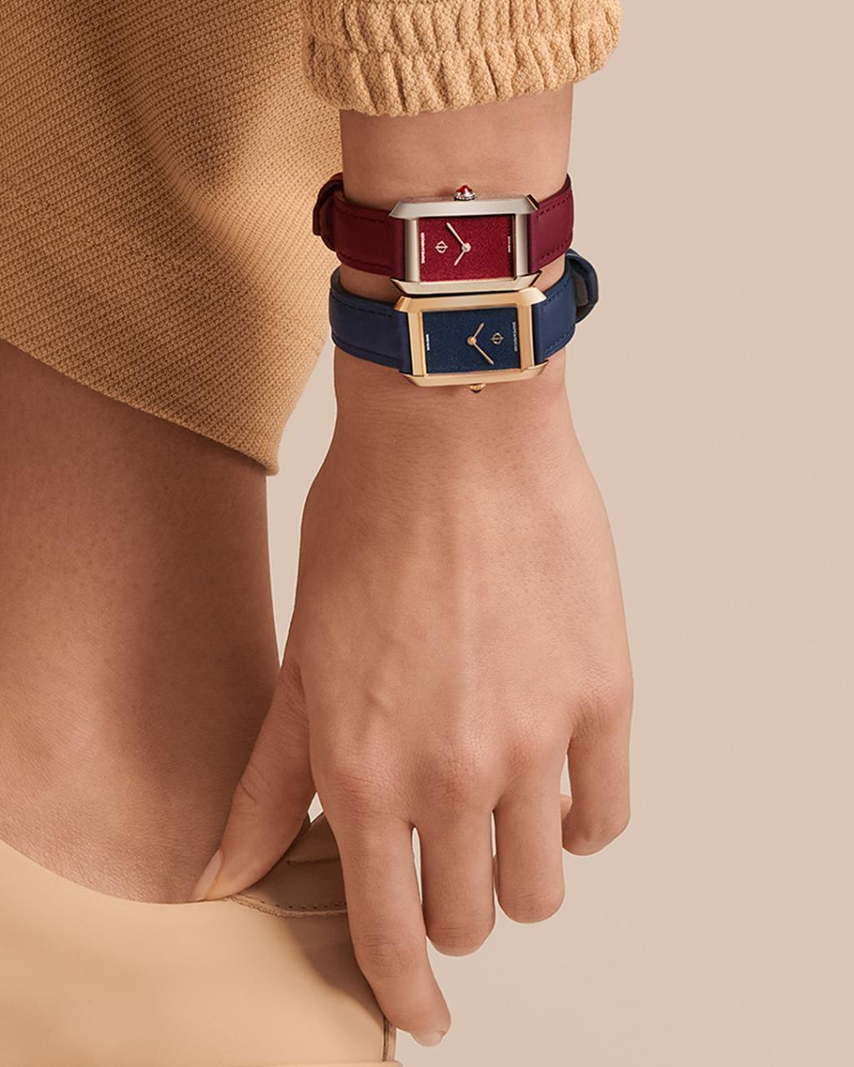
AN HOMAGE TO COLOR AND AN ODE TO MATERIAL

The two new Hampton models are the worthy heirs of this approach, with their slim, well-balanced 35 x 22.2 cm cases that are 6.9 mm thick. The first version comes in polished stainless steel, and the second in 18K (750/1000) pink gold and polished titanium. The case is protected by a domed scratch-resistant sapphire crystal and houses a new-generation quartz movement with eight years of autonomy, indicating the hours and minutes.

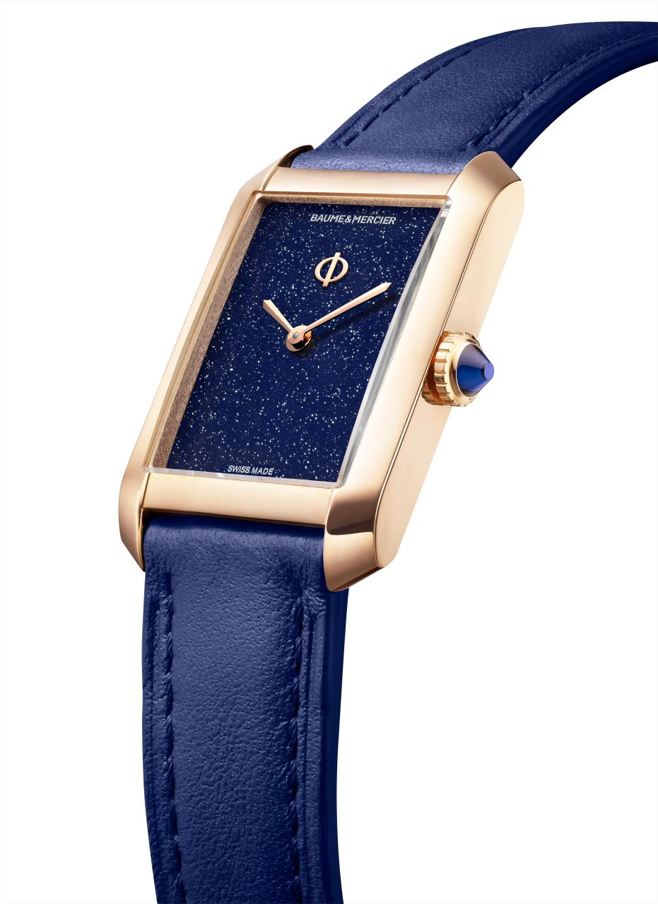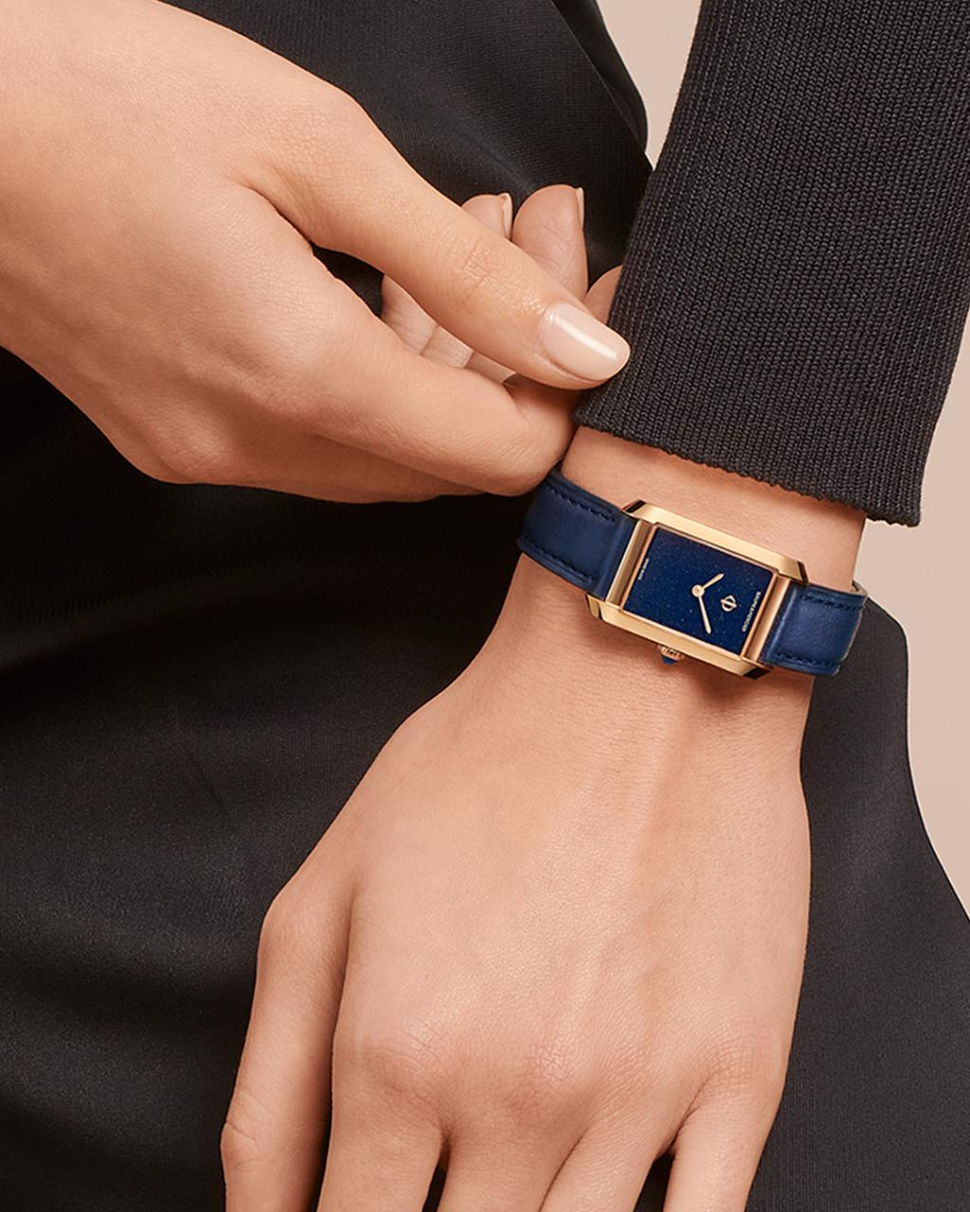

Hampton 10674

These models also reveal a harmonious combination of color and material. A burgundy dial has been designed for the steel case; a blue dial for the gold case. Both are covered with a delicately glittering varnish inspired by aventurine gemstones and star rubies, creating a sparkling effect that exalts the femininity of these elegant watches. The craftsmanship of the dial enhances the light that passes through the bezel, giving it life and depth. The quest for a streamlined design, a signature of Baume & Mercier timepieces, is reflected in the minimalist presence of two “glaive” hands and an elegant Phi, the company’s logo, as an appliqué at 12 o’clock. Delicate rhodium-plating for the burgundy dial and gilt for the blue dial, it symbolizes the absolute perfection of proportions in watches in reference to the “golden ratio” used by architects in classical Greece. Baume & Mercier made it the emblem of the House in 1964, asserting its attachment to shape and volume and their uncompromising balance.

The chromatic line that springs from these pieces extends to their cabochon-shaped crowns: steel crown set with a synthetic burgundy spinel for the steel model; PVD 5N steel crown set with a synthetic blue spinel for the gold model.

Hampton 10673

While the most recent Hampton watches were characterized by their elaborate Milano mesh straps, these two new models feature a calfskin strap: burgundy with tone-on-tone stitching and a steel pin buckle and blue with tone-on-tone stitching and a PVD 5N steel buckle, respectively. Their interchangeable straps can be released without tools, thanks to a very reliable straight spring-bar system. This restraint accentuates the monochrome aesthetic of these watches with great strength and clarity.

ABOUT BAUME & MERCIER:

Founded in 1830 at the heart of Swiss Jura, Baume & Mercier enjoys international renown. From its workshops at the heart of Swiss Jura to its headquarters based in Geneva, the Maison offers its clients the very finest timepieces. Born by a complementary balance between an artistic approach to shape and watchmaking innovation in the service of the client, the Baume & Mercier House continues to mark the history of watchmaking by passing down the design and watchmaking expertise that is the Brand’s legacy. This savoir-faire perfectly corresponds with the spirit of cooperation between the Brand’s founders William Baume & Paul Mercier: where classicism meets creativity, tradition meets modernity, and elegance meets character... In a more contemporary way than ever.

www.baume-et-mercier.com

