Baume & Mercier Highlights Two Signature Riviera Models
at Jewellery Arabia 2025

Bahrain – November 2025 — Baume & Mercier is delighted to participate in Jewellery Arabia 2025, presenting two exceptional timepieces from its emblematic Riviera collection: the Riviera 10796 and the Riviera 10828. These models reflect the Maison’s fusion of refined Swiss craftsmanship, contemporary elegance, and distinctive design.

Riviera 10796
The Riviera 10796 is a radiant 33 mm quartz timepiece distinguished by its refined femininity and architectural presence. Its dodecagonal bezel is set with 44 diamonds of three different sizes, meticulously selected to follow the unique geometry of the iconic twelve-sided shape. The watch features a warm silver-toned dial with remarkable luminosity, enhanced by the transparent wave-pattern décor. Rose gold-colored roman numerals and riveted indexes, coated with white SuperLuminova, complete the composition, offering both elegance and readability.
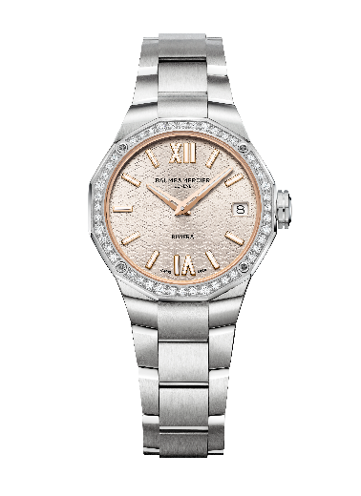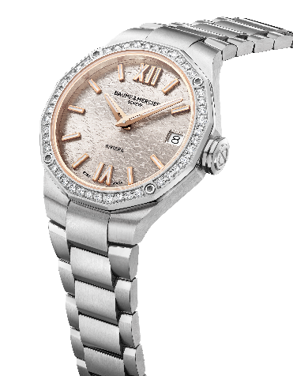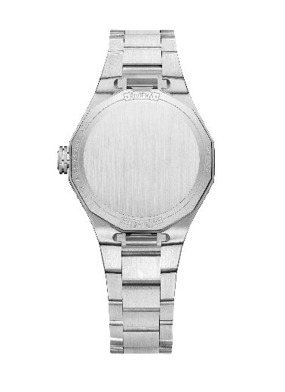
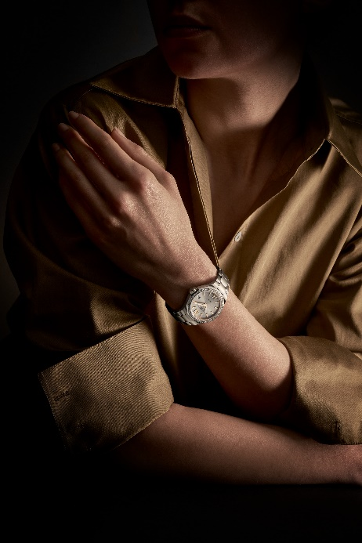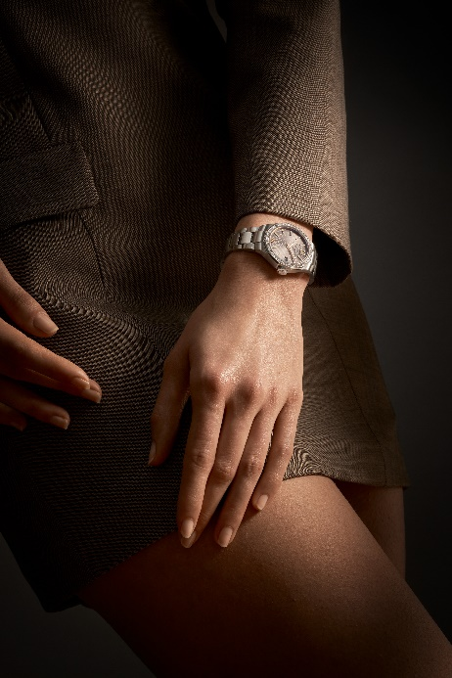
Riviera 10828
The Riviera 10828 is a limited-edition flyback chronograph of only 73 pieces worldwide, paying tribute to the 1973 debut of the Riviera collection. Housed in a 41 mm case, this exceptional model features a vertically brushed gold-toned dial with vintage appeal, showcasing the chronograph counters, telemetry and tachymeter scales, as well as rhodium-plated Roman numerals and indexes enhanced with beige SuperLuminova. The watch is powered by an automatic movement offering a 42-hour power reserve, combining technical performance with strong aesthetic character.
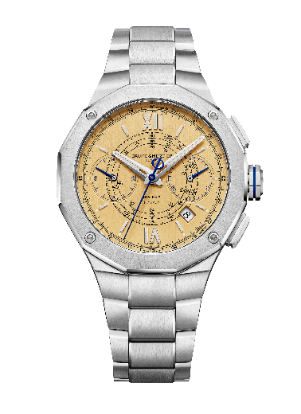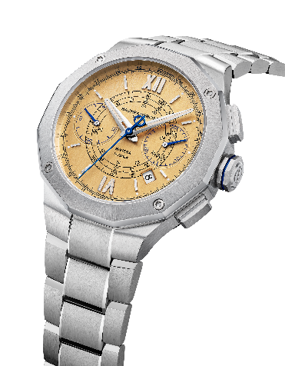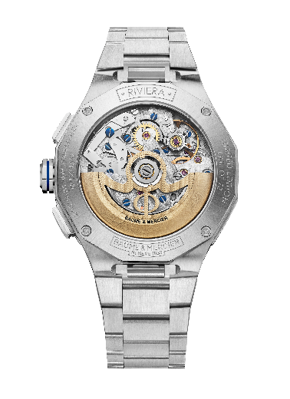
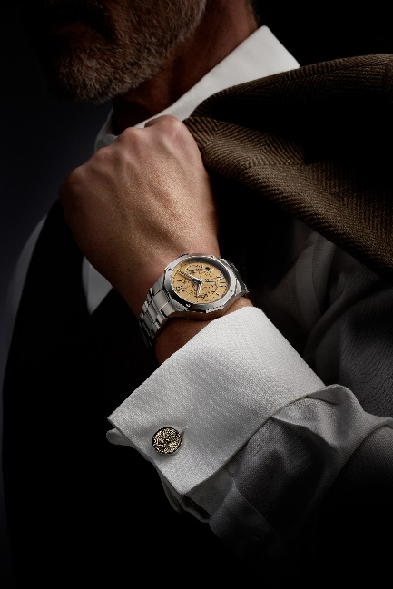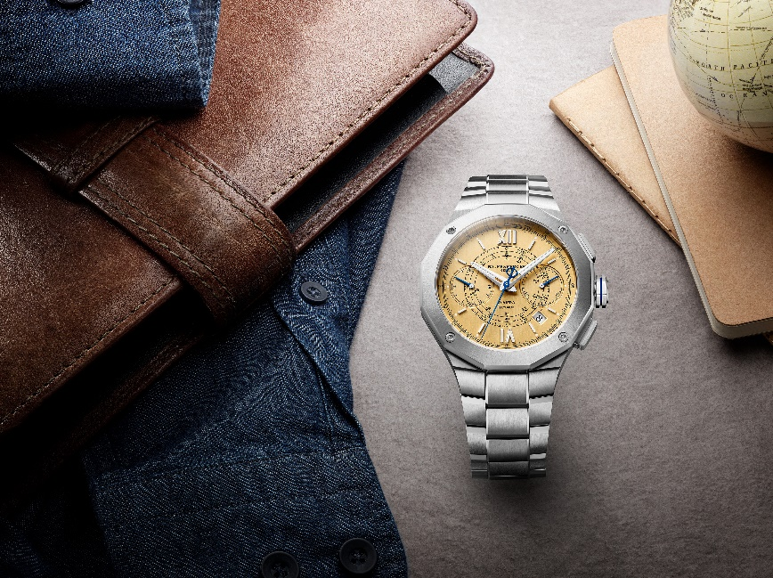

Together, these two creations embody the timeless, sport-chic spirit of the Riviera while highlighting Baume & Mercier’s dedication to excellence and expressive design.

