THE ODE TO NATURE’S COLORS OF THE RIVIERA
BY BAUME & MERCIER

The Riviera collection continues to reflect the many facets of the French Riviera through four very refined new models: two that emphasize the Riviera’s chic aesthetic, and two sportier models that focus on its well-known casual elegance. Each is a glowing tribute to the colors of the landscape, with a color scheme in the hues of greenery, rocks, and the sea.

With the assurance of authenticity and the passion of time that it has been asserting since 1973, the Riviera draws its admirers into diverse approaches to the same legendary destination with which it shares a sense of liberty and natural elegance, the pursuit of beauty, and a graceful vision of sport. Indeed, the Riviera emancipated itself from the watchmaking codes of the times when it first revealed its revolutionary twelve-sided case. It made the natural look an essential part of its subdued refinement in its quest for easy-to-wear yet authentic timepieces. The Riviera’s time-telling approach takes inspiration from a pursuit of harmony and aesthetic research. Each version carries with it the energy of the bohemian chic spirit distinctive of the world’s rivieras.

In it, the art of shape meets the art of living, wherever travel takes it, making the Riviera a unique timepiece: a watchmaking interpretation of liberty and style.

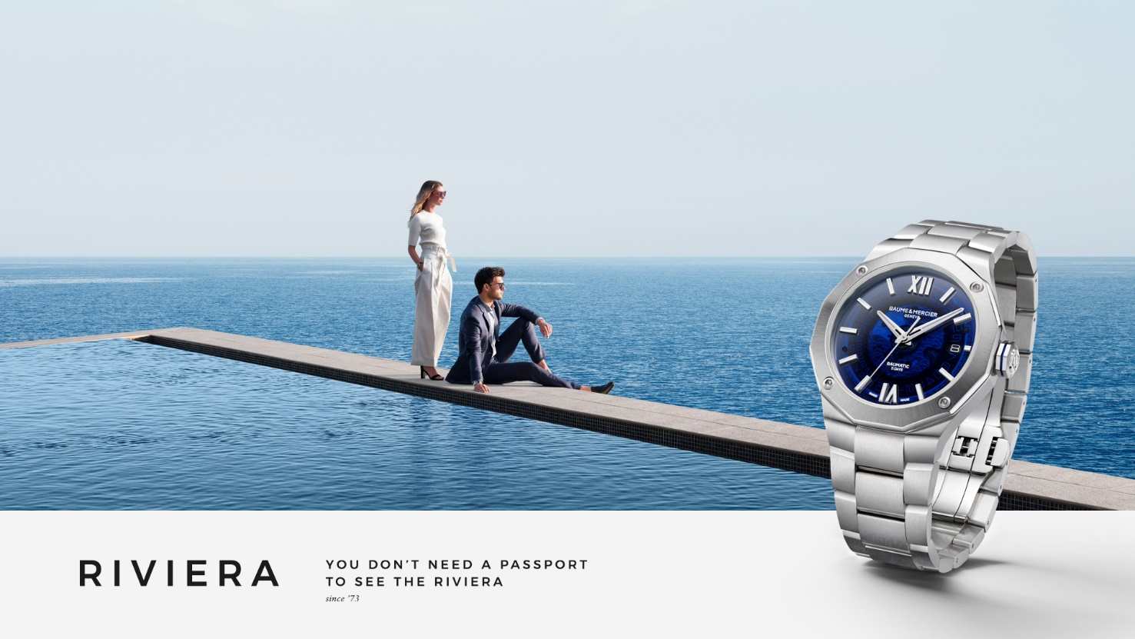

The chromatic inspiration of the French Riviera’s natural landscape

The new Riviera watches reflect the contrasting colors of this Mediterranean landscape, including greenery, minerals, and the sea. The green dials of the Riviera M0A10770 and Riviera M0A10763 evoke the pine groves that overlook the sea and line the wooded mountains along the coast, wind-swept silhouettes stretched towards the sky or slightly curved towards the horizon.
The terracotta dial – terracotta being Italian for “baked earth” – of the Riviera M0A10764 mirrors the intense, sun-drenched color of the earth, the Massif de l’Esterel and its chain of hillsides in incandescent volcanic rock. Iridescent in the sunlight with tones of ocher, pink and orange, these minerals scintillate like the glittering lights that appear along the coastline as the French Riviera’s legendary festive nightlife gets underway at nightfall.
The dark blue dial of the Riviera M0A10768 draws its inspiration from the sea’s mysterious, dreamy depths. It is an invitation to dive into the vivifying waters or to set sail on its dancing waves.

The meticulous craftsmanship of these dials brings out the subtle nuances of each of these colors, enhanced by the transparent or tone-on-tone transfer wave decorations of each model. The radiant light of the Riviera is sculpted into each detail.

The sport-chic versatility of the Riviera

Baume & Mercier launched the Riviera, a sports elegance watch, in 1973. In fact, it was one of the first sports watches in the world to be crafted in steel. It also brought a chic allure to steel, and not gold, contrary to the dictates of the time. Ever since, that dual identity has revealed many variations throughout the generations of its collection, alternating steel, gold/steel, and solid gold, and also embracing the codes of diving watches. In 2004, the fourth generation distinguished a “Classic” line which enriched its dial with various materials and arrangements; as well as a “Sport” line which reinforced its athletic side by adding four screws to its bezel. 2023 marked the creation of refined, gem-set feminine models.

The new Rivieras carry forward this aspiration.

The Riviera M0A10770 and M0A10764 models assert very elegant finishes: dials respectively crafted in smoked and sun-satin lacquered sapphire; a bezel in polished and sun-satin stainless steel; and a satin-polished stainless steel strap. The Riviera M0A10770 presents gold-tone Roman numerals, indexes, and hands. From a technical point of view, this model beats to the rhythm of a self-winding Baumatic manufacture movement, the epitome of sophistication. The terracotta color of the Riviera M0A10764 dial highlights the refinement of this unisex piece.

More masculine and sporty in their approach, the Riviera M0A10763 and M0A10768 each assert a sandblasted ADLC-coated steel bezel fastened with four screws, also in sandblasted ADLC-coated steel, and a rubber strap. This bold stylistic approach reinforces the athletic allure of both watches.

Riviera M0A10770: a green dial inspired by the pine groves that overlook the coast

A subtle play on dark and light – like the dappled shade of pine branches – adorns this smoked green sapphire dial. The Riviera’s iconic wave decor, in transparent transfers on this version, accentuates the impression of swaying shade. Time stretches out majestically between the gold-tone Roman numerals and riveted indexes coated with white Superluminova (blue glow), the faceted gold-tone hour and minute hands also coated with white Superluminova (blue glow), and the gold-tone seconds hand. The date appears in a broad aperture at 3 o’clock.

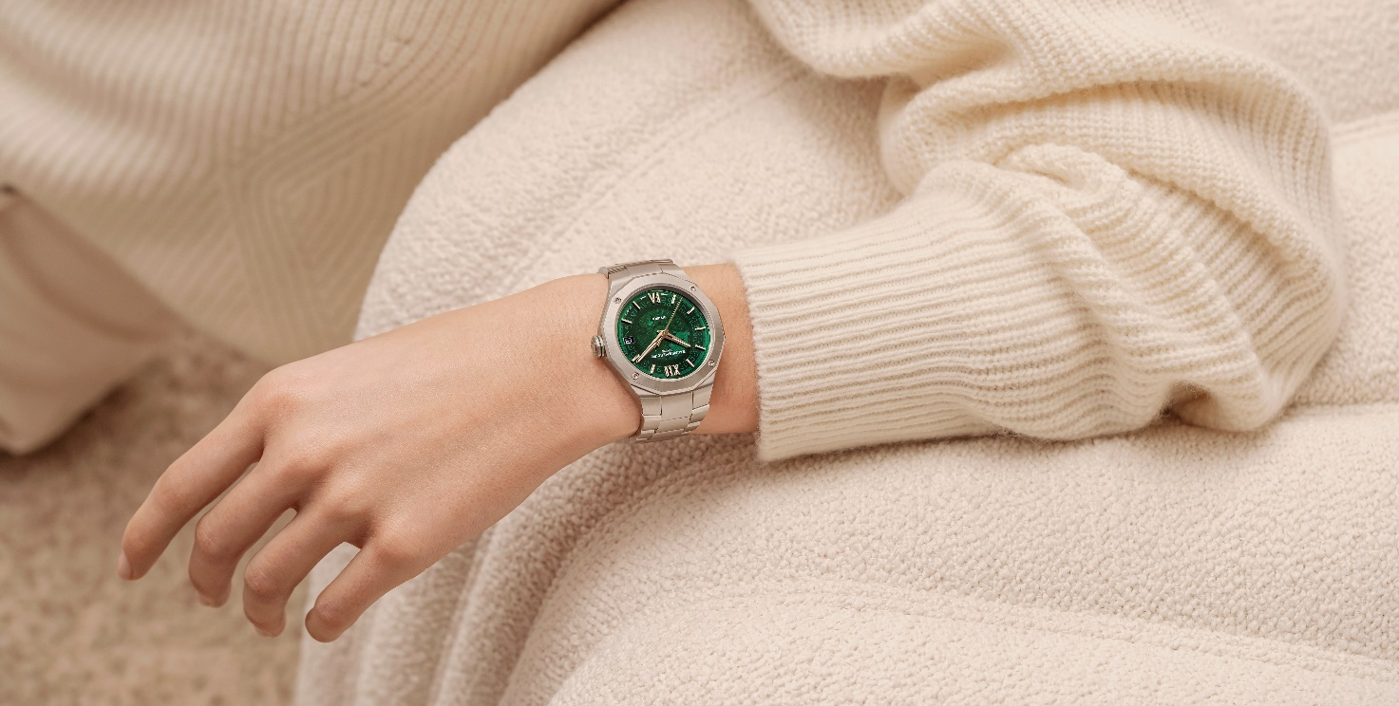

In satin-polished stainless steel, the case features the perfect proportions so distinctive of Baume & Mercier: 39 mm in diameter and 10.2 mm in thickness. It is protected by a scratch-resistant sapphire crystal with an anti-glare coating on both sides. Fastened by four polished steel screws, the bezel is finished with just as much refinement in polished and sun-satin stainless steel. The sapphire crystal of the dodecagonal case back, held in place by four steel screws, reveals the beauty of the watch mechanism. The case back may be engraved. Crafted in steel and delicately wreathed with a stylish green line that echoes the color of the dial, the free octagonal crown is engraved with the Brand’s emblem, the Phi logo.

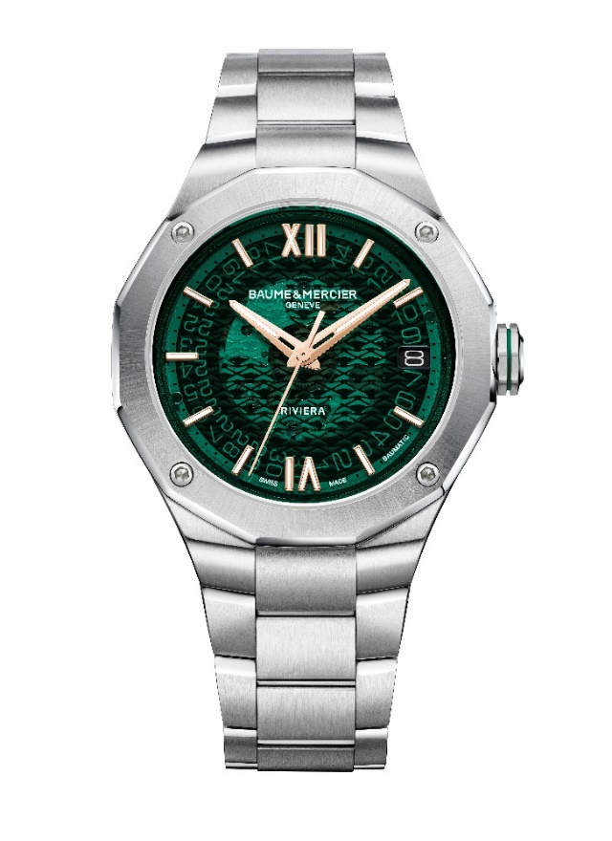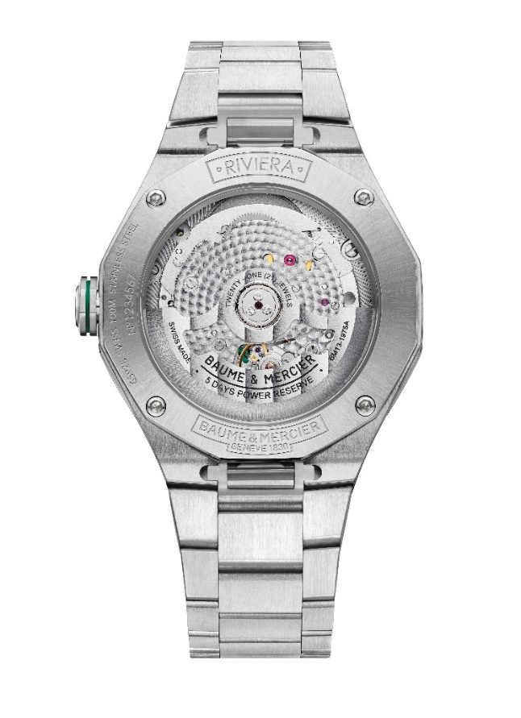

The strap extends the elegance of the watch with three rows of links in polished and satin-polished stainless steel. The strap may be changed without the use of tools thanks to a robust, reliable interchangeability mechanism.
Its stainless steel triple folding buckle is equipped with security push-pieces. Like all Riviera models, its strap may be adjusted for optimal comfort.

The beauty of this timepiece is not just skin-deep: it also emanates from the watchmaking excellence of its life force, a self-winding Baumatic manufacture movement. Ensuring precision, durability and robustness, it also guarantees a high level of precision, a five-day power reserve (120 hours), and protection against everyday magnetic fields. Moreover, the standard two-year international warranty is extended by six years, offering an eight-year guarantee to anyone registering on the Baume & Mercier website: www.baume-et-mercier.com. This model oscillates at a frequency of 4 Hz (28,800 vph) and offers water-resistance to 10 ATM (approximately 100m).

Riviera M0A10764: a terracotta dial in the image of the incandescent rock of the Massif de l’Esterel

The very structured twelve-sided design of the Riviera reflects the rugged relief of the Mediterranean landscape. The terracotta color of its lacquered sun-satin dial is a blazing symbolic representation of the rock that blazes within the mountains of the Esterel Massif. It is also a shimmering reflection of the sun and the glittering lights that bring magic to this destination. Against the background of a transparent transfer wave decor, the hours and minutes drift by on riveted and rhodium-plated Roman numerals and indexes, indicated by faceted and rhodium-plated hands: all these details are coated with white Superluminova (blue glow). The seconds hand is rhodium-plated. The date appears in an aperture at 3 o’clock.

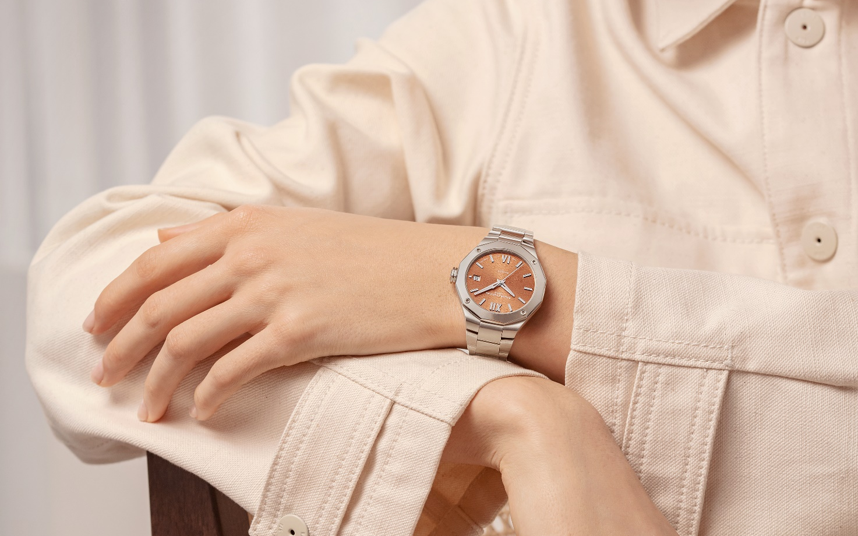

The fine case of this unisex model asserts perfectly harmonious proportions: 36 mm in diameter and 9.5 mm in thickness. The polished and satin-polished stainless steel case is protected by a scratch-resistant sapphire crystal with an anti-glare coating on both sides. Its bezel, also crafted in polished and sun-satin stainless steel, is fastened with four polished steel screws. The dodecagonal case back, which may be engraved, is topped with a sapphire crystal and fastened with four polished steel screws. The free octagonal crown is engraved with a Phi logo.

The integrated strap features three rows of satin-polished stainless steel links. It can easily be changed without tools thanks to a very reliable, robust interchangeability mechanism. Its triple folding buckle is crafted in stainless steel, and it features security push-pieces and an easy adjustment feature.

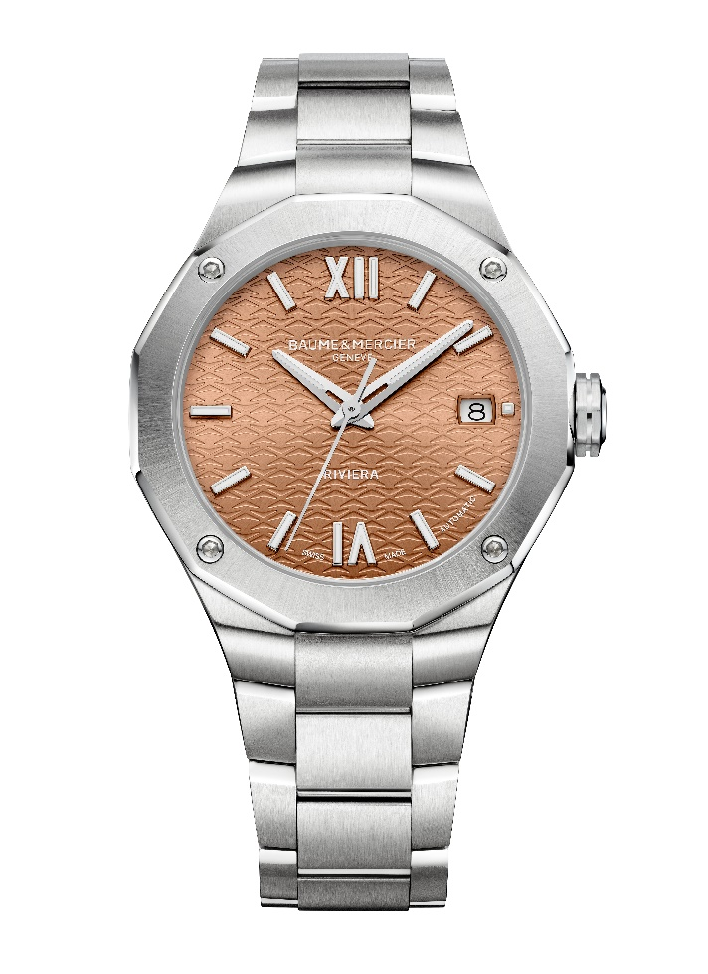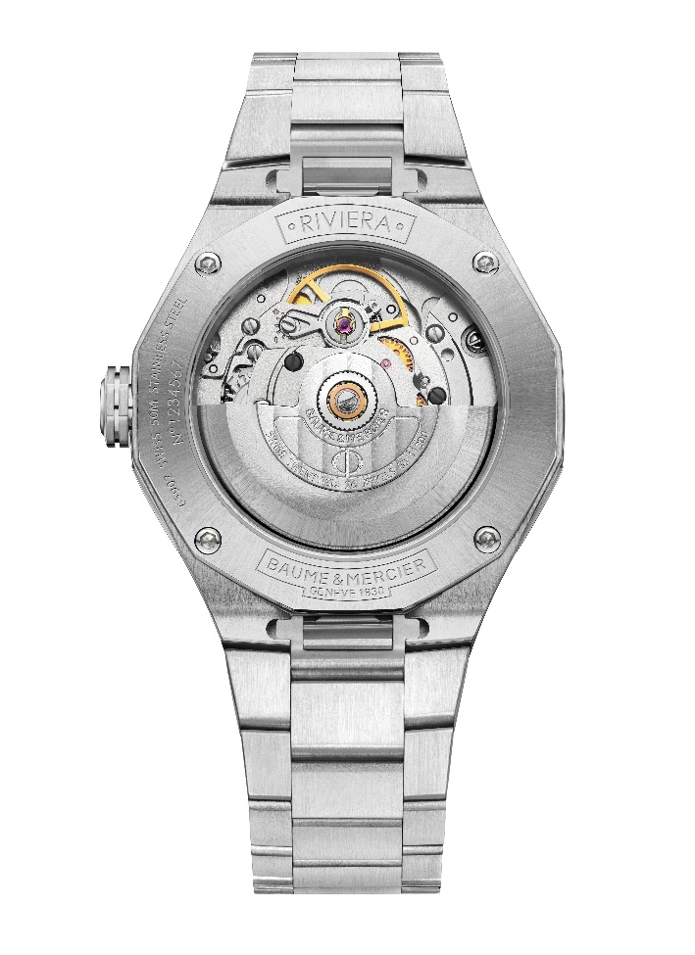

A self-winding movement beats at the heart of this delicate timepiece, offering a power reserve of 38 hours, a frequency of 4Hz (28,800 vph), and water-resistance to 5 ATM (approximatively 50 m).

Riviera M0A10763: a dark green dial evoking the lush foliage of the Mediterranean

Another tone of green inspired by nature adorns the Riviera, paying tribute to the enchanting foliage of the region. The sun-satin, lacquered, tinted finishes of this dark green dial, with a tone-on-tone wave decor, reflects the idyllic landscape. The time indications stand out very clearly against it. Its riveted and rhodium-plated Roman numerals and indexes are coated with Superluminova (blue glow), as are the faceted and rhodium-plated hour and minute hands. The seconds hand is also rhodium-plated. The date appears at 3 o’clock.
The lush setting for this watch is a case of measuring 42 mm in diameter and 10.6 mm in thickness, crafted in polished and satin-polished stainless steel. It is protected by a scratch-resistant sapphire crystal with an anti-glare coating on both sides. Its sportier aesthetic is enhanced by a sandblasted ADLC-coated steel bezel, fastened by four screws in sandblasted ADLC-coated steel. These materials and their hues enhance the contrasts among the watch case, bezel, and strap. Each element is counterbalanced in the equilibrium distinctive of Baume & Mercier’s creative approach. Attention to detail, another characteristic of the Brand, is revealed in the black line that adorns the free octagonal crown in steel, featuring the engraved Phi logo. The dodecagonal case back is protected by a sapphire crystal and fastened with four screws. It may be custom-engraved.

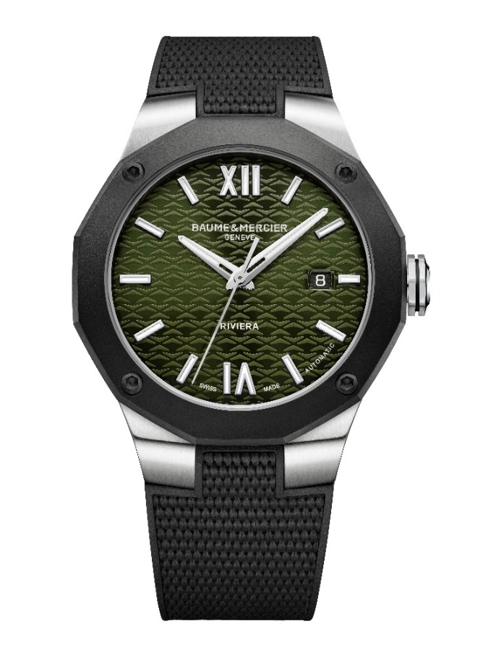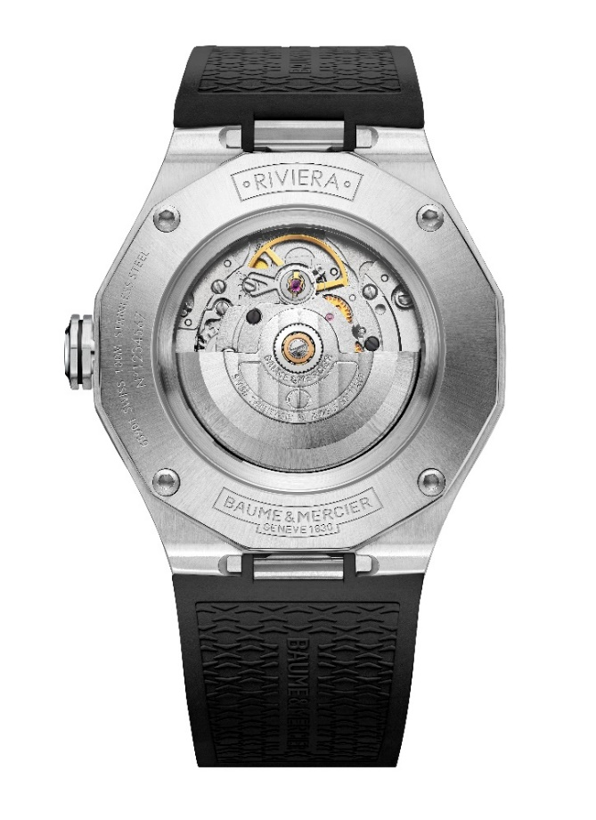
The more athletic allure of this watch is enhanced by a built-in strap in black rubber with a canvas texture. The strap is interchangeable without the use of tools thanks to a very reliable, robust system.
It fastens with a triple folding clasp in stainless steel with security push-pieces and an easy adjustment feature.

The self-winding movement offers a 38-hour power reserve and oscillates at a frequency of 4Hz (28,800 vph). It is water-resistant to 10 ATM (approximately 100 m).

Riviera M0A10768: a dark blue dial echoing the dreamy depths of the sea

Like an invitation to penetrate abyssal mysteries by diving into its watery marine hue, its dark blue lacquered and tinted sun-satin dial fascinates the eye and draws the imagination into the depths of a secret below the surface of its tone-on-tone wave decor. Here, time takes on a new dimension.

It materializes through Roman numerals, riveted indexes, and faceted hour and minute hands, all of which are rhodium-plated and coated with Superluminova (blue glow). The seconds hand is rhodium-plated. The date appears in an aperture at 3 o’clock.

With a diameter of 42 mm and a thickness of 10.6 mm, the case is crafted in polished and satin-polished stainless steel and topped with a scratch-resistant sapphire crystal of which both sides are treated with an anti-glare coating. The sandblasted ADLC-coated steel bezel – fastened by four screws in sandblasted ADLC-coated steel – creates a very assertive stylistic effect. Also protected by a sapphire crystal and fastened by four steel screws, the twelve-sided case back may be custom-engraved. The free octagonal crown is crafted in steel, adorned with a black line, and adorned with the Phi logo in relief.

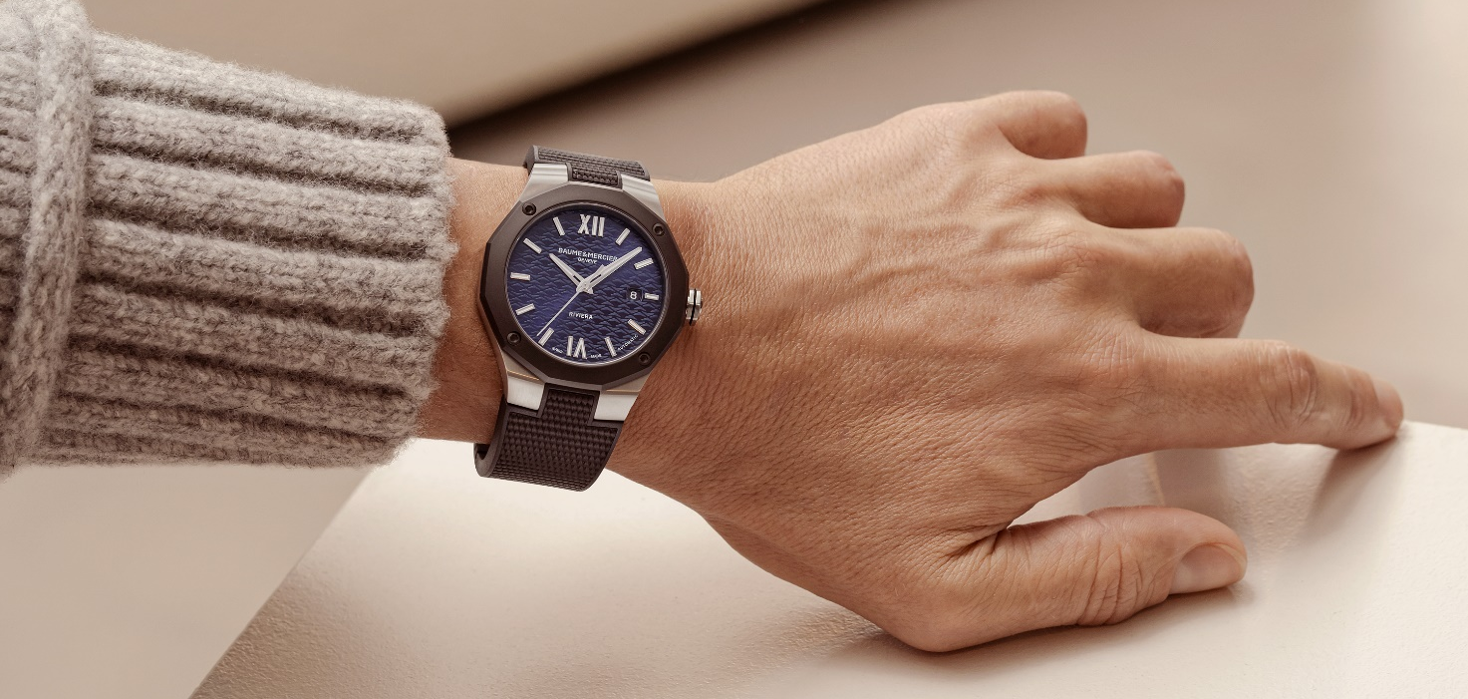

The built-in black rubber strap features a canvas pattern. It is interchangeable and may be removed without the use of tools thanks to a very reliable, robust mechanism.
Likewise, its triple folding clasp in stainless steel offers comfort and dependability with security push-pieces and an easy adjustment feature.

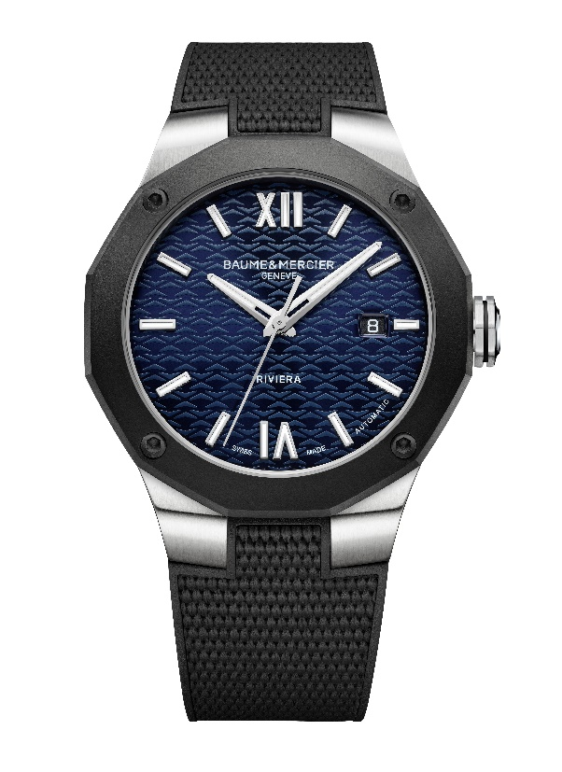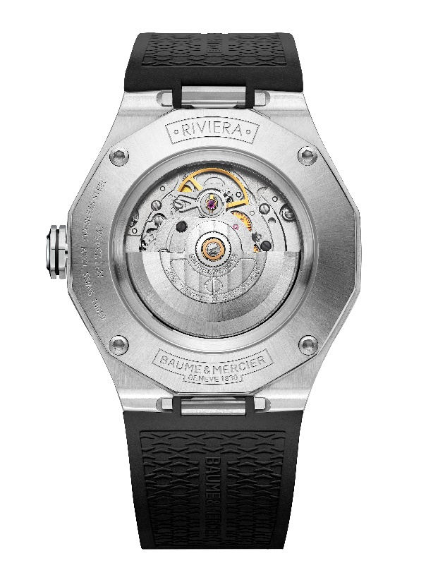
The timepiece offers a 38-hour power reserve, oscillates at a frequency of 4Hz (28,800 vph), and offers water-resistance to 10 ATM (approximately 100 m).

The Riviera collection excels in the art of recreating an atmosphere, and the emotion that emanates from it, through the use of colors that personalize it. The insatiable “timekeeper” shares the vision of meticulous, creative watchmaking that admirers have been acclaiming for more than 50 years.

Information:

Model: Riviera 10770
Availability: September 2024

Model: Riviera 10764
Availability: May 2024

Model: Riviera 10763
Availability: September 2024

Model: Riviera 10768
Availability: September 2024

ABOUT BAUME & MERCIER:

Founded in 1830 at the heart of Swiss Jura, the Baume & Mercier watch manufacture enjoys international renown. From its workshops at the heart of Swiss Jura to its headquarters based in Geneva, the Brand offers its clients the very finest timepieces. Borne by a complementary balance between an artistic approach to shape and watchmaking innovation in the service of the client, the Baume & Mercier House continues to mark the history of watchmaking by passing down the design and watchmaking expertise that is the Brand’s legacy. This savoir-faire perfectly corresponds with the spirit of cooperation between the Brand’s founders William Baume & Paul Mercier: where classicism meets creativity, tradition meets modernity, and elegance meets character... In a more contemporary way than ever.

www.baume-et-mercier.com

