THE SPARKLING FEMININE EXPRESSION
OF THE RIVIERA COLLECTION
BY BAUME & MERCIER

Red carpet for the women’s Riviera
To celebrate its 50 anniversary, Baume & Mercier’s Riviera collection pays tribute to women. This is the first time since the launch in 1973 that so many Riviera models have been dedicated to women in a single year. The inventive, formal structure of its dodecagonal case offers a casual yet elegant look: it tracks the flight of time on the slender feminine wrist. It is perfectly fitted to women’s finer arms, flattering them in a variety of radiant chromatic versions. In addition to being practical, the Riviera watch has a distinctive aesthetic: an attitude which reveals the personality of the woman wearing it, enhancing her every gesture. In 2023, the feminine 33- and 36-mm models are available with an array of five new dials, each offering sophisticated finishes, shimmering colors, diamonds and interchangeable straps. Women may choose among the many options to shape the aura of their own styles and coordinate with their wardrobes, reflecting the spirit of the Riviera as the ultimate shape watch that has emphasized its visual appeal since its beginnings.

A dazzling gold dial
At Watches & Wonders 2023, Baume & Mercier unveiled the new leading model of the collection: the Riviera M0A10730, a true halo of light. The warmth of its sun-satin gold dial, its transparent transfer waves, and its sunny radiance bring sculptural shape to the Roman numerals, the riveted indexes coated in Superluminova (C1, blue glow), and the faceted gold hands that indicate the hours, minutes and seconds. The date appears in a discreet aperture at 3 o’clock. The elegance of this timepiece, which is fascinating both by day and by night, is exalted by four brilliant-cut diamonds (Top Wesselton, VS quality, 0.05 ct) which are set into the polished stainless-steel bezel and sun-satin dodecagonal case.

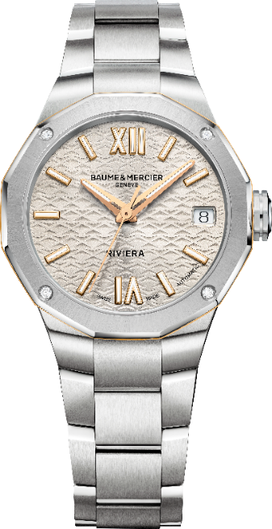
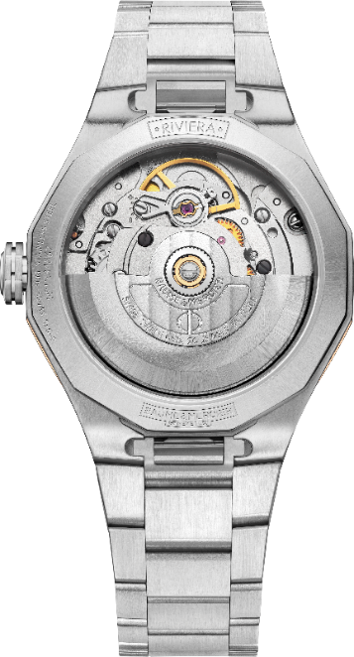

Riviera – 10730

An aesthetic with ideal dimensions

This watch is designed for women, with a 33-mm case that is ideal for the female wrist. It graces the wrist harmoniously in a balance distinctive of Baume & Mercier, which continually pursues the right proportions and flowing curves. It is this quest for natural balance that led the Brand to choose its emblem, the Greek letter Phi. This logo appears in relief on the free octagonal crown of this new model. The center of the polished, satin-finished stainless steel case is prettily adorned with a central ring in 5N gold-plated PVD steel.

The success of the dodecagonal case

The twelve sides of the case that are emblematic of the collection reflect the twelve hours on the dial. Fifty years after the creation of its first Riviera model, Baume & Mercier celebrates the perennial success of this designer watch and its innovative look. Its visually impactful aesthetic is even more emphasized in this particularly feminine version. The Baume & Mercier woman is proud to assert the character and originality of this elegant timepiece. The case back is also dodecagonal. Protected by a sapphire crystal, it may be personalized with an engraving. The model beats to the pace of a self-winding movement, offers a 38-hour power reserve, and is water-resistant to 5 ATM (approx. 50m).

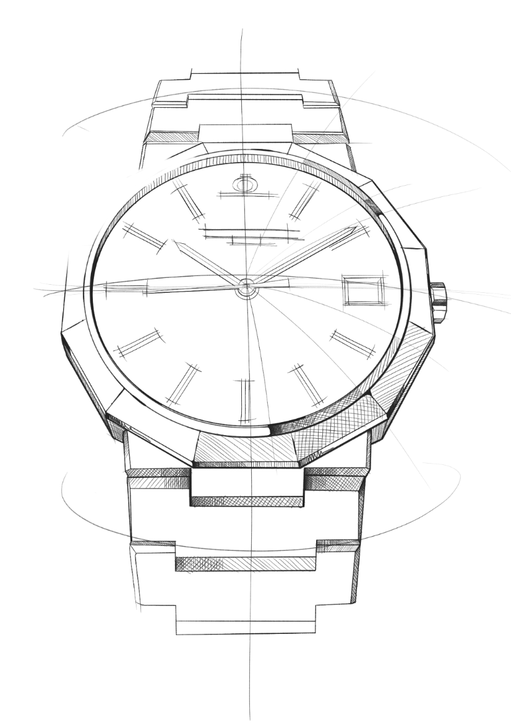
An integrated, interchangeable strap

This new version of the Riviera is mounted on the type of integrated metal strap which is distinctive to the collection. In polished and satin-finished stainless steel, it is made up of three rows of links that perfectly surround the case and visually extend it in the continuing pursuit of natural harmony. The strap is interchangeable, and it may be detached and replaced with no tools required thanks to a very reliable, robust system. All the models feature a triple folding buckle with security push-pieces and an easy adjustment system.

With this new model, Baume & Mercier pays tribute to women’s watchmaking with its perfect proportions, sophisticated dials, and delicate finishes. It brings a new dynamic to the Riviera collection, which has always aimed to play on shapes, raise creativity to new heights, and demonstrate that a designer watch can be a true object of desire. 2023 confirms the Brand’s intention to address women’s expectations by specially dedicating timepieces to them.

The Riviera collection: five generations, one legend

Geneva, March 2023 - The Riviera collection: five generations, one legend. This is the story of an illustrious watch: one like none other, one that has always been ahead of its time. The Riviera has been redesigned several times through the years, not only keeping up-to-date but truly setting the pace.

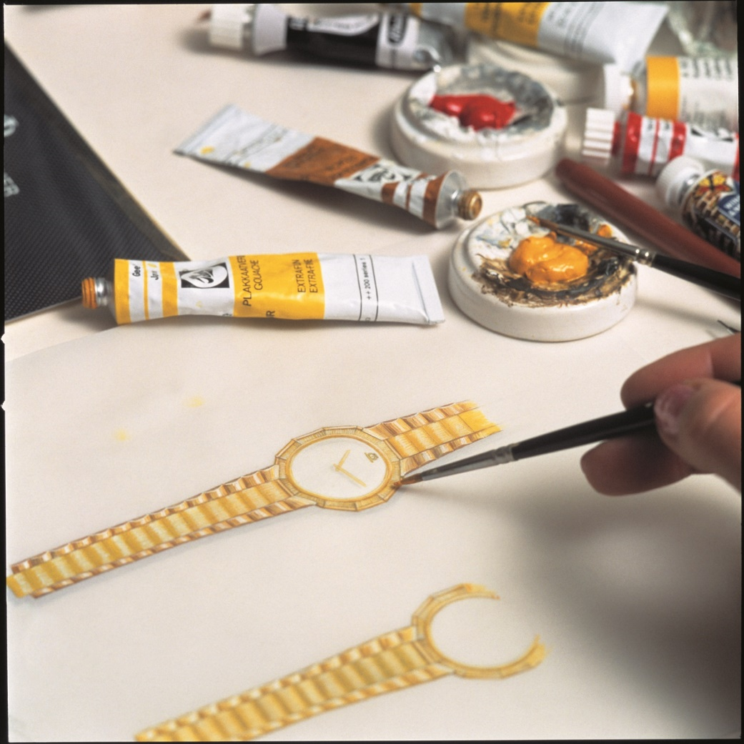

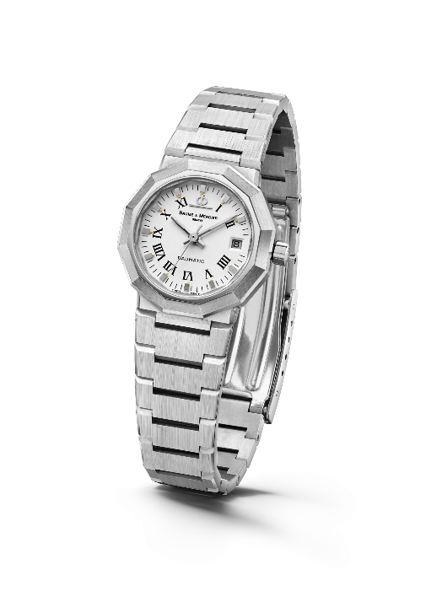
Launched in 1973, the Riviera immediately made a splash with its dodecagonal case and its slimline metal strap. It was already avant-gardist, though the Riviera name had yet to appear on the dial. In 1975, the concept was updated and made available with both self-winding and quartz movements: small, medium and large models were produced in steel, gold/steel, and solid gold.

A new generation was unveiled in the 1980s. The newly bicolor Riviera pursued its technical and aesthetic maturation, with its unmistakable name now appearing at 6 o’clock.

Riviera – 1st Generation - 1975
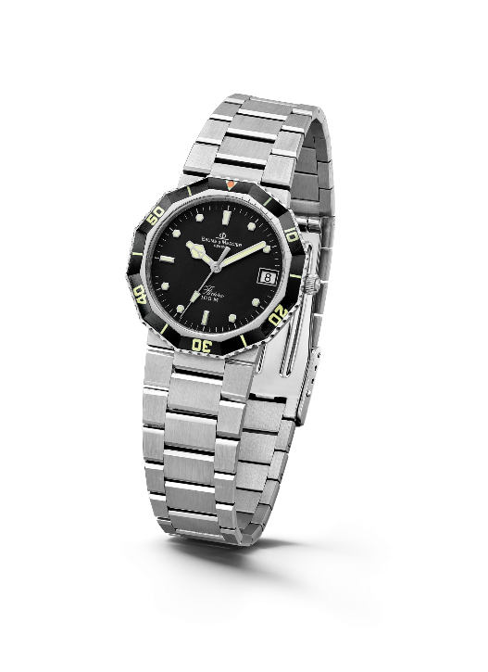

For the first time in 1981, it was made available as a diving watch in a style-pioneering sport-chic spirit. Its success was immediate.

Four years later, in 1985, the third generation of the collection was released. The bezel was reworked for a softer, less angular approach. The case and strap were also overhauled, and their polished and brushed surfaces helped create a more rounded look. The Riviera thus marked a turning point in terms of sophistication and reliability, including – among other features – a miniaturized screwed crown designed to improve its water-resistance.
Riviera - 2nd Generation – 1981

For its 20th anniversary in 1993, it strutted its style with a one-of-a-kind chronograph model. At the time, Baume & Mercier even created an unprecedented full-calendar Riviera in bicolor and solid gold versions, demonstrating its exceptional watchmaking savoir-faire. The Brand also introduced a version of the bicolor edition in a smaller diameter for ladies.

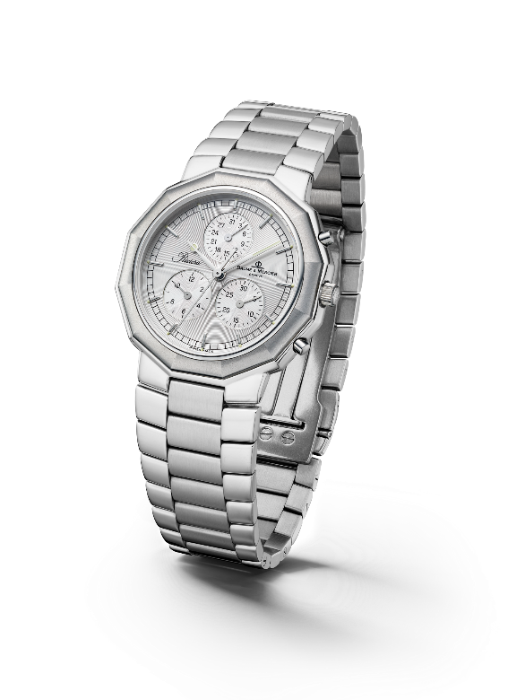
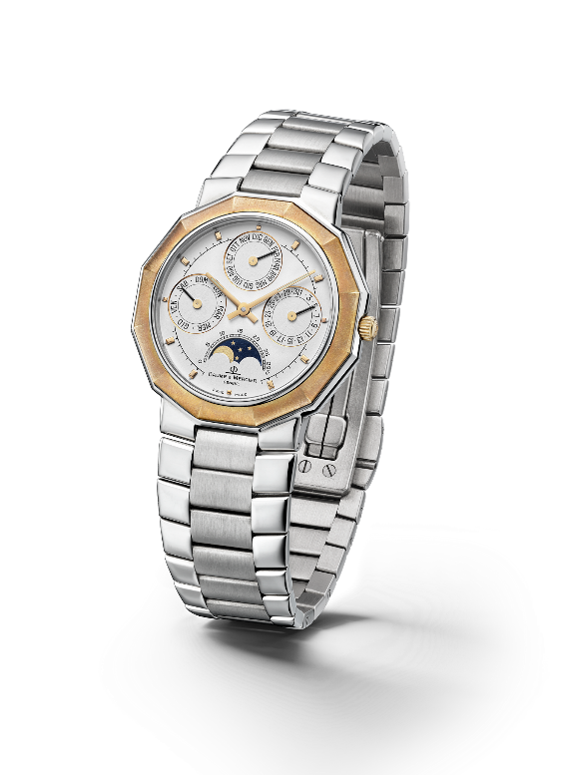

Riviera 3rd Generation – Complication 1985 & Chrono 1993

In 2004, the Riviera collection took on a twofold approach for its fourth generation with two variations, one classic and the other more athletic. For the “Classic” line, Baume & Mercier maintained the dodecagonal shape of the case, interpreting the dial with a variety of materials and configurations. As for the “Sport” range, the Riviera featured four screws on its bezel for the first time, asserting an athletic look that would stand the test of time.

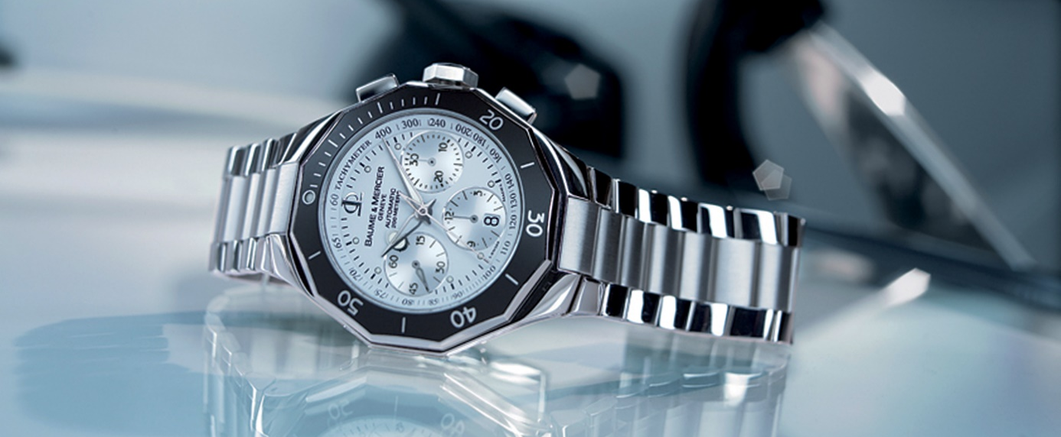

The fifth generation, launched in 2021, carried forward its perennially fashionable sport-chic personality with a number of variations that only added to its character. In 2023, it celebrates its 50th birthday. It has never appeared so new.

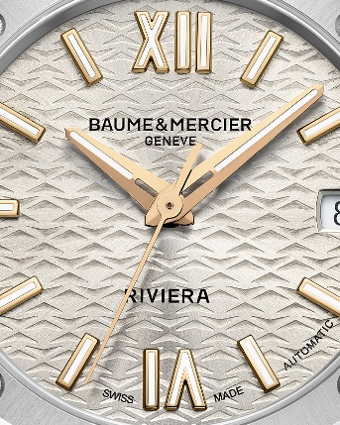

Information:

Model: Riviera 10730
Availability: April 2023

ABOUT BAUME & MERCIER:

Founded in 1830 at the heart of Swiss Jura, Baume & Mercier enjoys international renown. From its workshops at the heart of Swiss Jura to its headquarters based in Geneva, the Maison offers its clients the very finest timepieces. Born by a complementary balance between an artistic approach to shape and watchmaking innovation in the service of the client, the Baume & Mercier House continues to mark the history of watchmaking by passing down the design and watchmaking expertise that is the Brand’s legacy. This savoir-faire perfectly corresponds with the spirit of cooperation between the Brand’s founders William Baume & Paul Mercier: where classicism meets creativity, tradition meets modernity, and elegance meets character... In a more contemporary way than ever.

www.baume-et-mercier.com

