THE NEW COLLECTION JOIA DE BAUME & MERCIER

Baume & Mercier unveils a new collection, Joia de Baume & Mercier, dedicated to an inspiring, modern young woman with a hint of irreverence. Moving from casual to elegant with innate ease, she perfectly masters social codes and breaks them with grace. From contemporary freshness to timeless heritage, Joia de Baume & Mercier follows in the vein of creative and exacting watch designs that the Maison has been creating for women for nearly two centuries.

This collection features four models, including three that are unveiled here: Joia de Baume & Mercier M0A10847, M0A10848, and M0A10849. Each of these bijou-inspired watches are the perfect finishing touch that elevates an outfit. Their dainty 28-mm cases without lugs emphasize the finesse and beauty of their soft, rounded curves.

These timepieces celebrate those moments when you choose to bend the rules, venture into the unknown, or face a new challenge. My Joia Moment is a time to claim for yourself, to dare.

* * * * *



The Joia de Baume & Mercier collection highlights a modern & refined femininity

This new collection bears the distinction of a watch designed for a woman, just as William Baume and Paul Mercier began to do in 1918. Joia de Baume & Mercier is a celebration of emotion and light. Following the footsteps of the Maison’s historical avant-garde models for women, this delicate collection is a declaration for a modern young woman who embodies effortless elegance and whose discerning taste breaks free of convention. Easily moving from casual moments to elegant occasions, she perfectly masters social codes and knows when to break them, with her characteristic grace. She is fluent in style and straightforward in fantasy. Between contemporary freshness and timeless heritage, Joia de Baume & Mercier embodies an instinctive elegance, assertive femininity, and desirable freedom: the freedom to be yourself. More than a watch, it is a “bijou”: the perfect finishing touch that makes an outfit special. Joia de Baume & Mercier seeks to reveal itself without ever imposing.

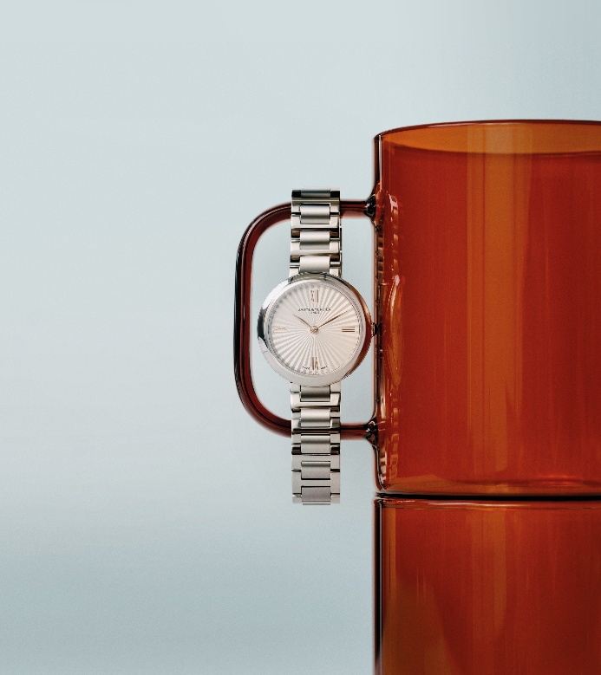
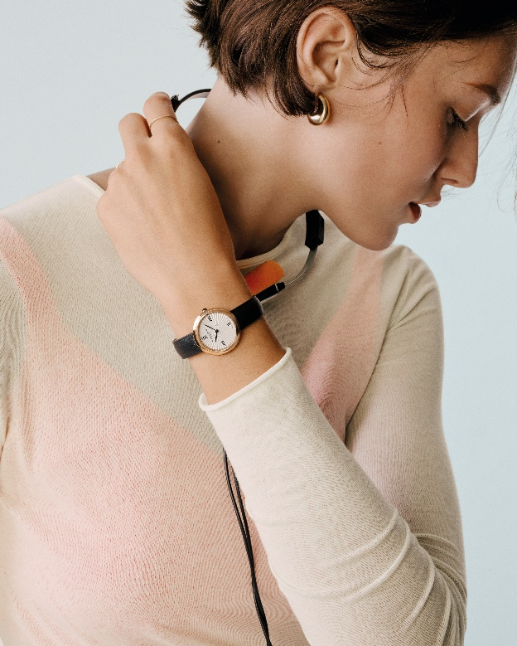

Three feminine timepieces and a harmoniously contrasted design

Joia de Baume & Mercier is an ode to defiant modern femininity. The elegance of its dainty 28 mm proportions and the absence of lugs demonstrate the casual everyday elegance of a jewel that tells the time. The black agate that adorns its crown adds a sophisticated, discreet touch of distinction. Its radiant, silvery sun-satin dial glows and fascinates the eye. Each detail reveals a perfectly masterful savoir-faire.
Inspired and inspiring, the Joia de Baume & Mercier collection is an invitation to play on styles, offering an array of additional leather straps in various colors that adapt to all three watches.

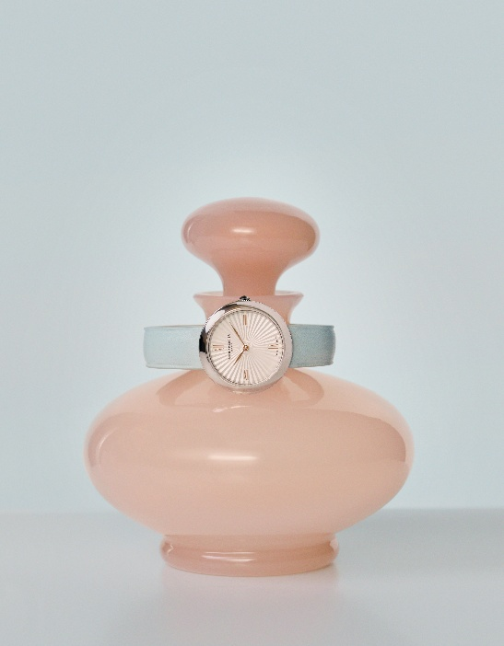

Joia de Baume & Mercier M0A10847: the radiance of a silvery sun-satin dial and a midnight blue strap

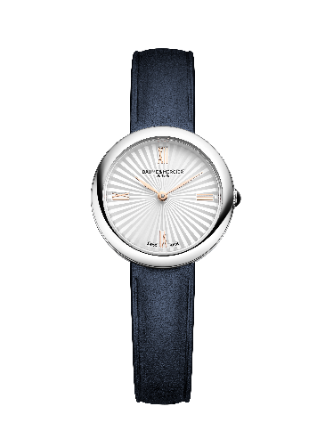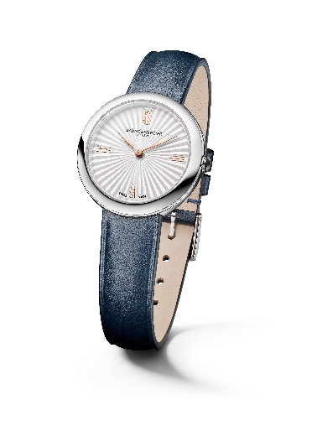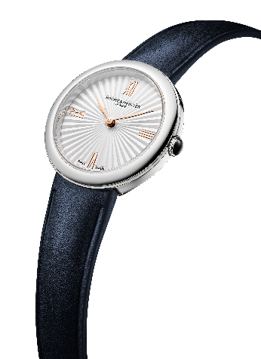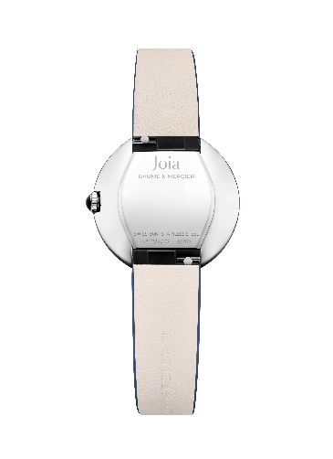

- Movement
Quartz (Ronda 751)
5-year autonomy
- Functions
H/M
- Case
Round, without lugs
Dimensions: 28mm
Thickness: 7.2mm
Polished stainless steel case and bezel
Scratch-resistant, anti-glare sapphire crystal
Domed crown in polished stainless steel set with a black agate
Solid case back in polished stainless steel (can be engraved)
- Dial
Silvery sun-satin dial
4N gold-plated Roman numerals
4N gold-plated leaf hands
- Strap
Midnight blue calfskin strap
Interchangeable spring-bar system making it possible to change the bracelet without the need for tools
- Buckle
Polished stainless steel pin buckle
- Water-resistance
50m (approx. 5 ATM)

Joia de Baume & Mercier M0A10848: a bright, sculptural silhouette

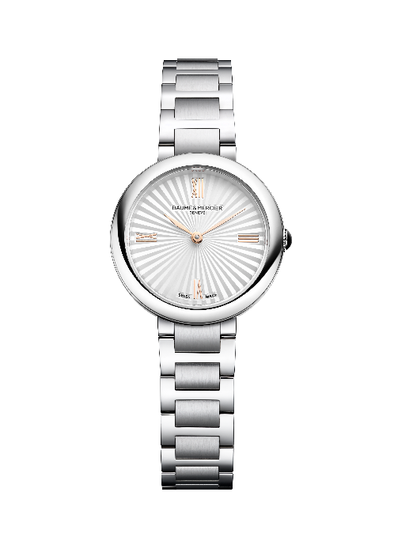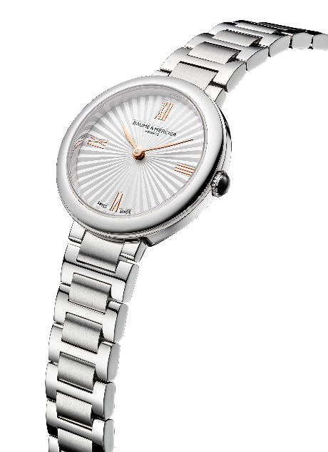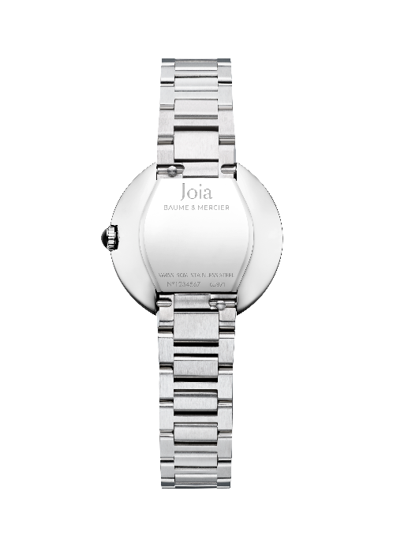

- Movement
Quartz (Ronda 751)
5-year autonomy
- Functions
H/M
- Case
Round, without lugs
Dimensions: 28mm
Thickness: 7.2mm
Polished stainless steel case and bezel
Scratch-resistant, anti-glare sapphire crystal
Domed crown in polished stainless steel set with a black agate
Solid case back in polished stainless steel (can be engraved)
- Dial
Silvery sun-satin dial
4N gold-plated Roman numerals
4N gold-plated leaf hands
- Strap
Integrated strap in polished and satin-finished stainless steel with three rows of H-shaped links
Interchangeable spring-bar system making it possible to change the bracelet without the need for tools
- Clasp
Triple folding clasp in satin-finished stainless steel
- Water-resistance
50m (approx. 5 ATM)

Joia de Baume & Mercier M0A10849: the power of chromatic contrast

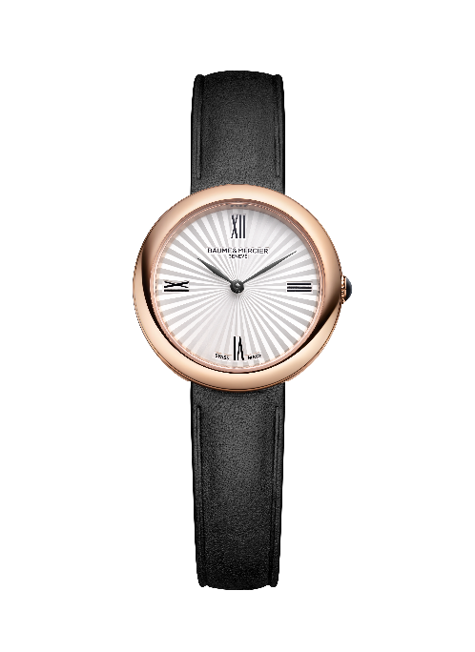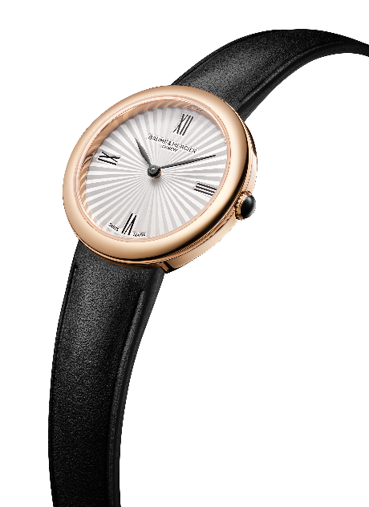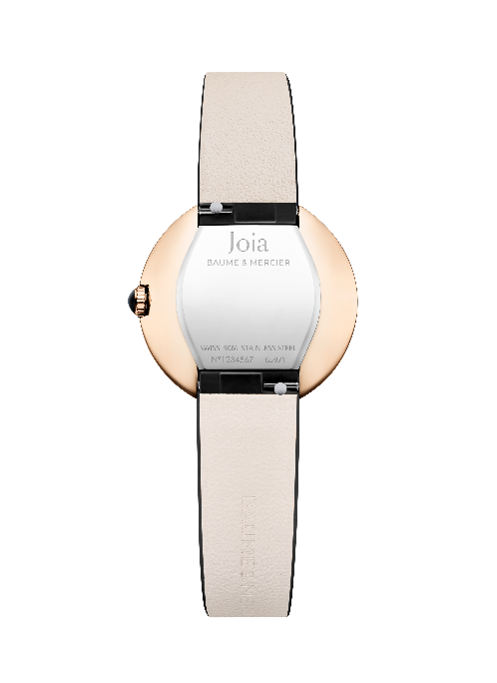

- Movement
Quartz (Ronda 751)
5-year autonomy
- Functions
H/M
- Case
Round, without lugs
Dimensions: 28mm
Thickness: 7.2mm
Polished 4N PVD stainless steel case and bezel
Scratch-resistant, anti-glare sapphire crystal
Domed crown in polished stainless steel set with a black agate
Solid case back in polished stainless steel (may be engraved)
- Dial
Silvery sun-satin dial
Black Roman numeral transfers
Ruthenium leaf hands
- Strap
Black calfskin strap
Interchangeable spring-bar system making it possible to change the bracelet without the need for tools
- Buckle
Polished 4N PVD stainless steel pin buckle
- Water-resistance
50m (approx. 5 ATM)

My Joia Moment. Whats’s yours?

Baume & Mercier has been celebrating meaningful moments since 1830. The Maion dedicates its modern spirit and watchmaking savoir-faire to them. Each collection - each watch - commemorates these magical, one-of-a-kind occasions, whatever they may be, as long as they count.

My Joia Moment is a time chosen to live life to the fullest: pausing to enjoy the moment, feel free, and break away from established codes. It is about savoring the instant with twinkling eyes and a knowing smile. How delightful it is to break the rules with a bold choice, leaving conventions aside to bring a touch of originality to a look! It is a time to dare.

How about you? Have you already felt slightly irreverent in the moment, irresistibly drawn to a bold choice?

What is your Joia Moment?

This new Joia de Baume & Mercier collection marks a significant step for the Maison, carrying forward the free, innovative spirit deeply rooted in the Baume & Mercier DNA and the historical heritage of women’s watches, which played a major role in the development of the Maison.

