THE ART OF GIFT GIVING AT BAUME & MERCIER

Christmas is an important time at Baume & Mercier, revealing it as a House of celebration that accompanies individuals on the special occasions in their lives.

A Baume & Mercier is more than a timepiece. It is a precious, elegant gift to give someone special, especially at this time of year dedicated to gestures of affection and generosity. It brings dreams to life and calls forth emotion.

A House of celebration

Baume & Mercier is delighted and proud to be the special witness to the most important moments of a lifetime. These timepieces set the pace for that eternal second, that legendary minute, or that intense hour: a birth, a graduation, a wedding or a birthday. That proximity is one of the fundamental House values. From the Les Brenets manufacture to points of sale across the globe, bringing attention to clients is essential. Accompanying them in these unique events is a way to uplift the beauty and intensity of such times, immortalizing them through refined watches that correspond with individual tastes thanks to an extensive array.

MORE THAN A WATCH, A CHRISTMAS GIFT

For Baume & Mercier, watches are “gifts that contain feelings.” The House continues to carry forward this tradition. It reflects its archives, which recount the gift of a gold pocket watch that one of the founders, Louis-Victor Baume, gave to his daughter Mélina for her first communion in 1869. He had the timepiece engraved with the words “To our dear child.”

The gift of a watch seals a deep connection, representing a magnificent declaration and a promise of longevity.

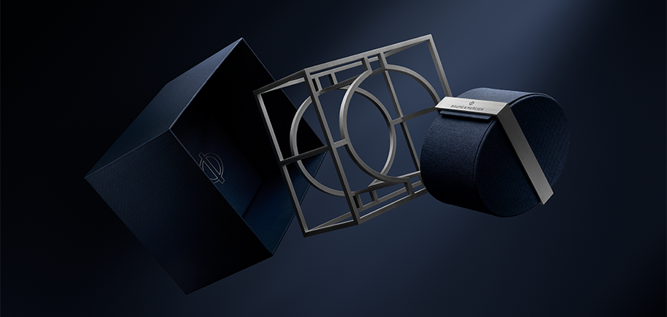

A Baume & Mercier is more than a timepiece. It is a gift to give for Christmas, because it embodies a beautiful story: that of a lasting, authentic House whose creative, innovative aesthetic choices and technical excellence are reflected in each of its creations. It also represents the quintessence of a first Swiss watch experience while also being accessible to as many people as possible.

A Baume & Mercier watch is a gift to give at Christmas because it is an object of desire and a reliable value for a loved one.

The only question is which one to choose as a special gift to place delicately beneath the tree.

Each collection pays tribute to the art of shape, an area in which Baume & Mercier has excelled since Paul Mercier made it the House signature in 1918, as a complement to the watchmaking expertise of William Baume. This pursuit of ever more modern, aesthetic styles with a mastery of the perfect proportions and balanced lines comes to life again this year for Christmas, highlighted by a charming snowman named Baumy. Baumy lends his generous, curvaceous silhouette to the enchanting celebration of the House spirit of design and passion for shape.



The RIVIERA collection has been unveiling the many facets of the French Riviera for several months through spectacular watchmaking complications – skeleton, tideograph, perpetual calendar – and brightly colored dials, optionally set with diamonds, inspired by this legendary destination. The watch case, with its twelve-sided bezel, sets the pace for chic casual style in a festive sporty atmosphere that resonates with the mountains, shoreline and sea.

The ultimate design watch that revolutionized watch codes when it was launched in 1973, the Riviera line includes steel pieces both self-winding and quartz in four different sizes, and in a range of colors encompassing dazzling, deep, lively and pastel hues. It alternates between sporty masculine lines and a refined feminine silhouette in the ideal dimensions of 33 mm. Certain models are equipped with the in-house Baumatic movement, offering a high level of performance. It resists everyday magnetic fields up to 1,500 Gauss. It offers increased everyday precision and oscillates at a frequency of 4Hz (28 800 vph). It also features remarkable autonomy thanks to its five-day (120-hour) power reserve and is water-resistant to 5 ATM (approximately 50 m). The Baumatic models benefit from an extended six-year warranty, in addition to the standard international warranty, for a total of eight years of coverage. To activate this guarantee, simply register the piece on the Baume & Mercier website within 60 days after purchase: www.baume-et-mercier.com.



The CLIFTON collection, also equipped with the Baumatic manufacture movement, lends its round case to a variety of both classic and contemporary versions crafted in steel or gold (750/1000), with delicate curves and exquisite finishes for a discreet kind of luxury that may be worn on any occasion. It has all the qualities that distinguish everyday luxury watches in the very stylish technical savoir-faire that is the historical signature of Baume & Mercier.

The collection raises excellence to perfection by equipping certain models with the in-house Baumatic movement, guaranteeing durability, reliability and comfort. The scrupulous finishes of this movement heighten the polish of its circular-grained bridges, its sand-blasted and snailed baseplate, and its openworked oscillating weight with a snailed “Côtes de Genève" decor which is visible through the sapphire case back. This lavish territory accommodates various complications, such as day, date, moon phase, and perpetual calendar. These appear on meticulously crafted solid or subtly gradated dials in hues of white, beige, blue, black, gray, green and chocolate.

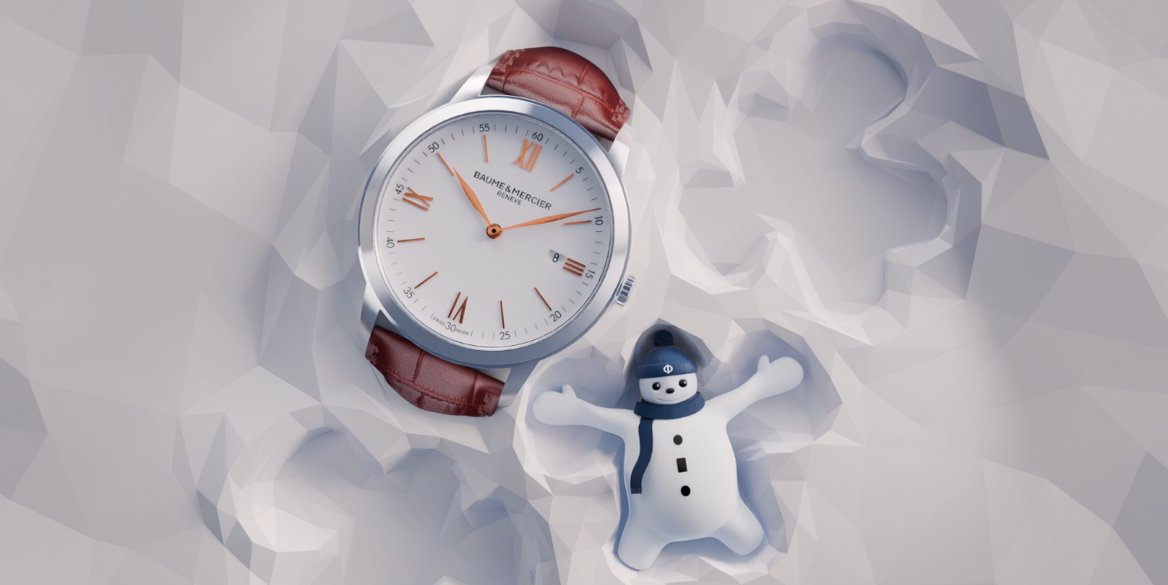

The CLASSIMA collection combines the tradition of lasting Swiss quality, understatement and discretion with unbridled creativity. Its round case is liberated in a play on colors and materials that it combines magnificently through a varied range of affordable pieces, including self-winding mechanical and quartz models.

The beauty of bright blue, sand, green or black dials flatters the technical craftsmanship of these new chronographs. The finesse of these recent models – available in a diameter of 42 mm and a thickness of 6 mm, and in a diameter of 39 mm and a thickness of 5 mm – reflects the slim and ultra-slim watches that have contributed to the excellent reputation of Baume & Mercier. The model is an idyllic playing field for everyday complications which bring each functional yet stylish timepiece to life: GMT display, visible balance wheel with power reserve, or skeleton with small seconds.

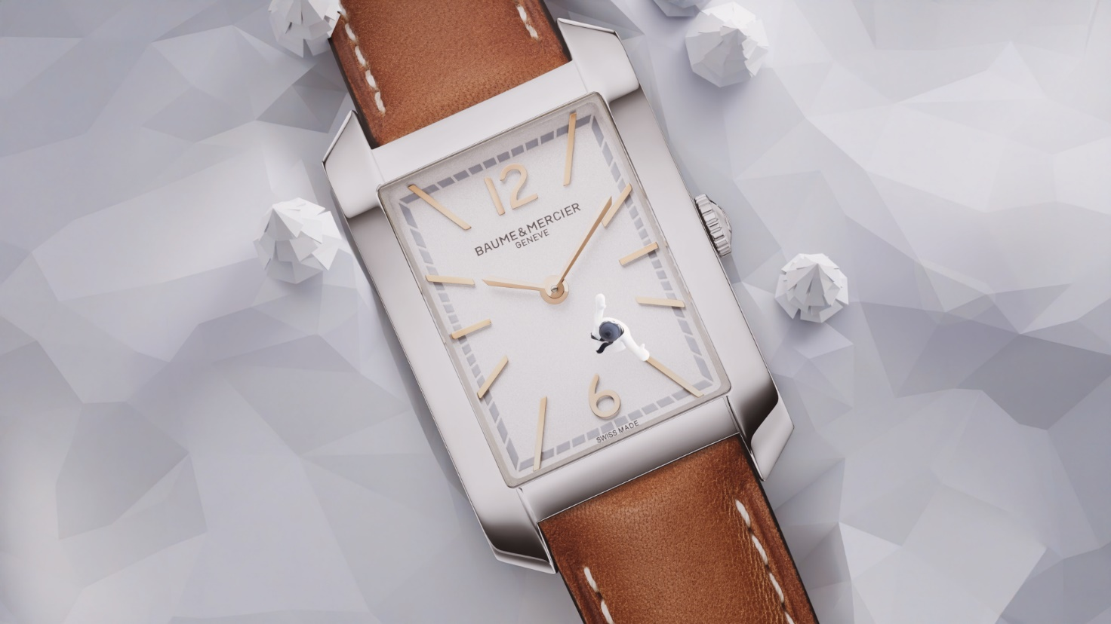

The HAMPTON collection is inspired by an artistic approach to illustrating time. It emerged with a groundbreaking aesthetic, as its rectangular shape created a surprise when it was first revealed in 1994.
Its vintage 1920s Art Deco look is inspired by an iconic piece from the 1960s, successfully combining simple lines and curves with softened corners and perfect proportions.

Its formal minimalism explores a fresh, harmonious color palette for women, with sculptural dials, crowns and straps. Recent models take the ultra-chic of contemporary glamor one step further. They include an all-black version with a black lacquered dial, a crown topped with a black agate cabochon, and a black strap; a rose gold (750/1000) version with a black leather strap; and a steel version with a bicolor mesh mingling steel and rose gold-plated steel (GC200). Pure refinement.

ABOUT BAUME & MERCIER

Founded in 1830 at the heart of Swiss Jura, the Baume & Mercier watch manufacture enjoys international renown. From its workshops at the heart of Swiss Jura to its headquarters based in Geneva, the Brand offers its clients the very finest timepieces. Borne by a complementary balance between an artistic approach to shape and watchmaking innovation in the service of the client, the Baume & Mercier House continues to mark the history of watchmaking by passing down the design and watchmaking expertise that is the Brand’s legacy. This savoir-faire perfectly corresponds with the spirit of cooperation between the Brand’s founders William Baume & Paul Mercier: where classicism meets creativity, tradition meets modernity, and elegance meets character... In a more contemporary way than ever.
www.baume-et-mercier.com

