A summer spirit for the new Riviera models!

The Riviera, lifestyle icon of Baume & Mercier, takes on a lively, bright blue this summer that energizes its dial. In 42 mm Baumatic and self-winding versions, or in a 36 mm quartz version, the Riviera redefines its Mediterranean personality. Inspired by the carefree lifestyle of the French Riviera, this is the watch of casual elegance, symbolizing an easygoing view of refined watchmaking. It expresses the Baume & Mercier spirit, in the city and at the beach.

Immediately recognizable with its twelve-sided bezel, the Riviera watch embodies the Baume & Mercier savoir-faire in design and in combining materials that it has demonstrated since it was first released in 1973. Relaunched last year, it has won over hearts and wrists with its steel silhouette, expressing a vision of freedom, an offbeat elegance, and a certain idea of watchmaking.

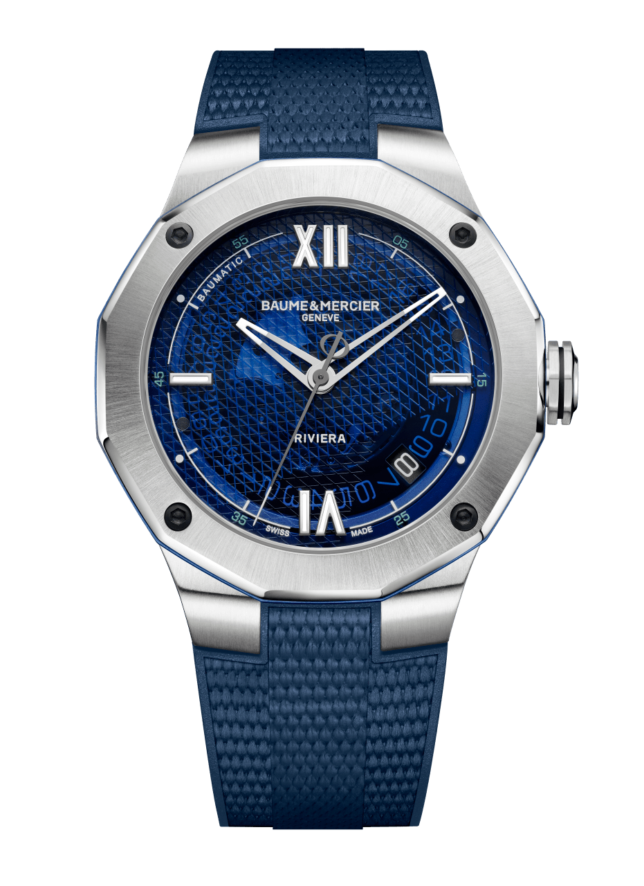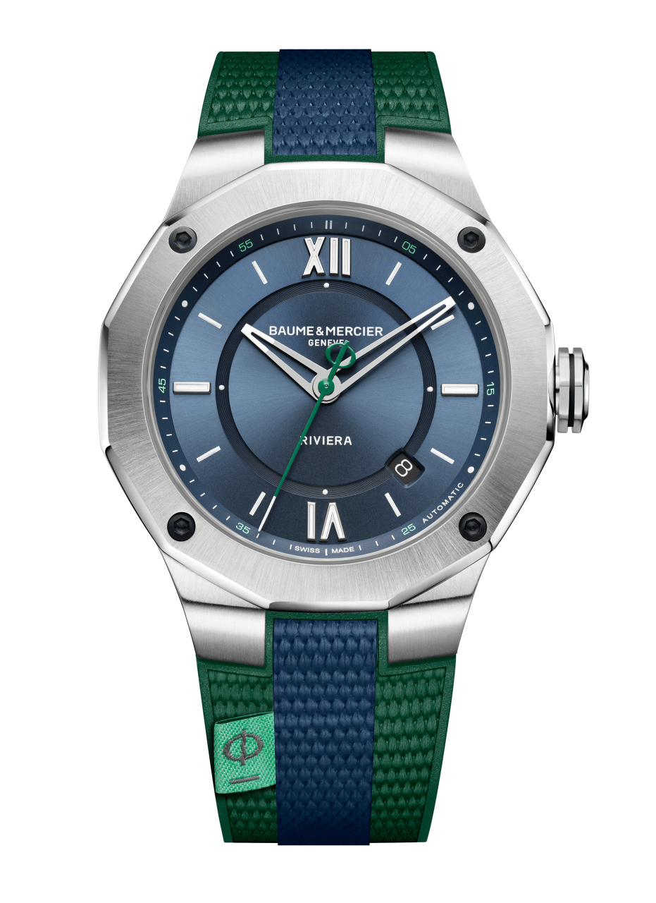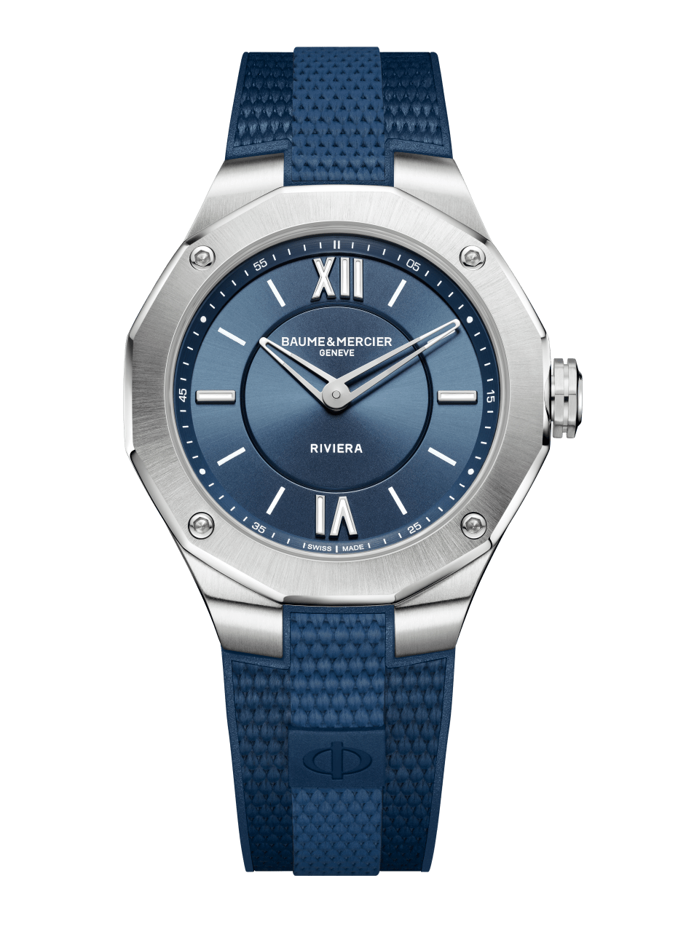
Riviera 10701 Riviera 10688 Riviera 10689

The 42 mm Riviera - Baumatic: taking the plunge into the blue

This summer, the emblematic model of the collection – the 42 mm Riviera Baumatic – embraces blue: a color associated with wide-open spaces, infinite horizons, and the passion of the ocean. This powerful, bright blue is a symbol of freshness but also serenity. In its 42 mm Baumatic version, the Riviera also takes the plunge with subtle technical and aesthetic developments. With a smoky blue sapphire dial featuring mesh decor with nautical accents, it immediately evokes the Baume & Mercier expertise in design, attention to shapes, and bold intention. It also asserts a certain number of distinctive features which set it apart from the other models from the collection, including openworked hands, four sand-blasted black DLC-coated steel screws, and the counter-balance of its seconds hand, which is stylized to depict the Phi symbol so emblematic of the House. Its steel case with slender, sporty lines was designed to be water-resistant up to 100 meters. Athletic and understated, the Riviera name appears at 6 o’clock, and the discreet Baumatic name appears between 10 and 11 o’clock.

The anodized blue aluminum ring on the sides of the case and the strip of color at the center of its crown add an unexpected touch of technical finesse that subtly coordinates with the hue of the dial. This summer’s 42 mm Riviera Baumatic is driven by a Baume & Mercier movement with proven performances: a five-day power reserve, a daily precision of -5 s/+10 s, and a solid protection against magnetic fields. With a power reserve of 120 hours, this new Riviera Baumatic plays in the major leagues. It may be forgotten on a night table from a Thursday evening to a Tuesday morning and still be on time and full of energy. Like an invitation to get away, travel, and discover something new. The versatile 42 mm Riviera Baumatic is mounted on an interchangeable integrated strap in blue rubber with a canvas decoration. Its design offers optimal comfort in wear, particularly with ergonomic curves at its attachment links.

***

The 36 mm Riviera - Quartz: elegant, timeless style

In the same spirit of casual elegance, the 36 mm Riviera breaks free from conventional codes to surf on a wave of freedom. In this universal diameter acclaimed by aficionados, it is designed for lovers of beautiful objects who know how to take their time. With a case in polished and satin-brushed steel, an emblematic dodecagonal bezel, and a “Swiss made” quartz movement with a ten-year autonomy, the new 36 mm Riviera isn’t splashy. Rather, it possesses an understated charm and a unique character. Its rubber strap in tones of blue with a canvas decor is immediately recognizable thanks to a small label featuring the Phi logo at its center, for a look that is both timeless and irresistible! The new “full blue” 36 mm Riviera is a timepiece with an assertive, balanced personality, reflecting a contemporary lifestyle. Its sun satin dial is like a window open to new horizons. Thanks to Baume & Mercier’s own reliable, robust interchangeability system, the strap of the new 36 mm Riviera may be changed simply, on a whim, with no tools required.

***

The 42 mm Riviera - Automatic: Baume & Mercier ventures into bicolor

The third variation on the Riviera summer collection lays down new lifestyle bases for Baume & Mercier, based on two colors: blue and green. Simple? Not quite. The art of the unexpected resides in the details. And there are a number of those on this steel self-winding Riviera Automatique, water-resistant to 100 meters, driven by a high-performance “Swiss made” movement. The modern, classic dial reveals various levels of sun satin blue. The playful seconds hand features a green counter-weight in the shape of a Phi symbol. Its 42 mm case is crafted in steel, and it features polished and satin-brushed surfaces to better capture the light. It is also adorned with four black screws, fastened to its dodecagonal bezel. The bicolor identity of this model is also distinctive for its integral rubber strap with a canvas pattern, decorated with two green bands and a central blue band. As a finishing touch, a small turquoise fabric label revealing the Phi logo is sewn onto the strap of this 42 mm Riviera Automatique. The sport-chic watch par excellence, to live an unforgettable summer.

***

