THE CLASSIMA COLLECTION BY BAUME & MERCIER CELEBRATES FATHER’S DAY

The Classima Collection by Baume & Mercier embodies the modern man – caught up in the whirlwind of life – who appreciates elegant, sporty timepieces that are both reliable and easy to wear for any occasion. The Brand presents four new models for Father’s Day. Each one would make a perfect gift to demonstrate love for the man who receives it. What could be more moving than to give him a precious object in his image? The Classima M0A10766, M0A10767, M0A10780 and M0A10762 models are an extension of this already very diverse range that offers something for every taste. Moreover, they represent high-quality traditional Swiss watchmaking made as widely accessible as possible.

Through this exercise in style that is important to the Brand, Baume & Mercier carries forth its historical expertise in very slender watches and its continually renewed creativity.

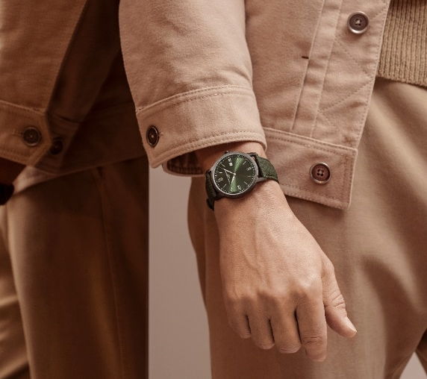

Slim and ultra-slim: the heritage of age-old savoir-faire

Baume & Mercier began to distinguish itself early in its history for the slenderness of its timepieces, among the slimmest in the world. When, in 1920, it appeared in the Code Davoine – the general directory for watchmakers in Switzerland and neighboring countries –, it was listed as a “Fine Watchmaking Manufacture” specializing in “highly creative women’s watches and slim and ultra-slim watches.” In 1923, an advertisement appeared in the same register bearing witness to that same expertise for men’s slim and ultra-slim watches. The Brand’s watchmaking art continued to be confirmed through the decades through its aesthetic and technical innovations, demonstrated by slim and ultra-slim watches as well as other models.

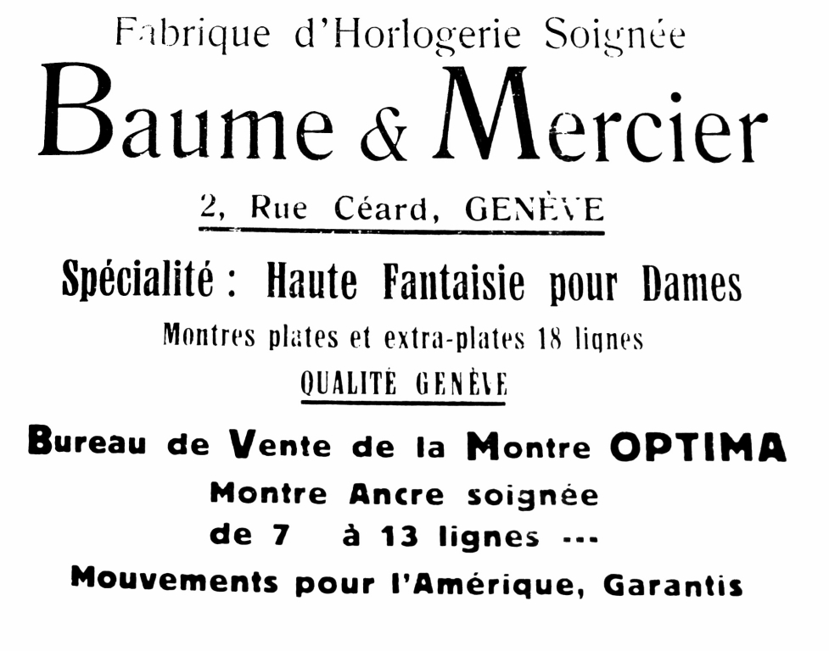

The new Classima timepieces carry forward this tradition through a slender, shapely round case with tight, precise lines. They express the design approach to shape watches in which Baume & Mercier has been excelling since Paul Mercier, in joining forces with the watchmaker William Baume in 1918, brought his artistic sensibility to the House. The models M0A10766, M0A10767, and M0A10780 have a diameter of 42 mm and a thickness of 6 mm; for model M0A10762, the measurements are 39 mm and 5 mm, respectively. These perfect proportions reflect the House’s uncompromising pursuit of perfection, showcasing the ideal balance in the formal design of its timepieces. Their finesse is the guarantee of a discreet elegance that gets noticed with admiring glances.

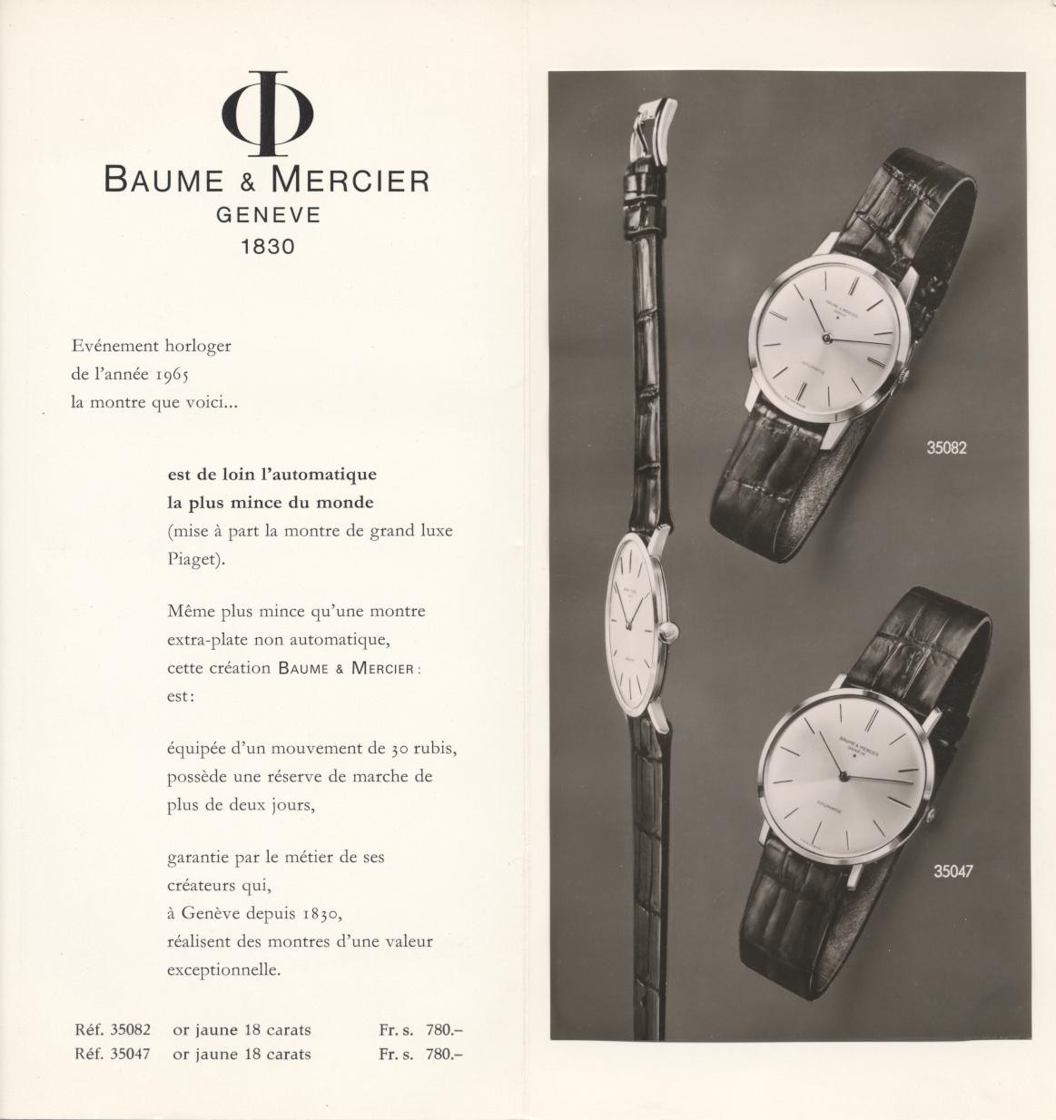

Abundant, exacting creativity

Each Classima model pursues this aspiration. The latest chronographs recently unveiled at Watches & Wonders are examples of this exacting, insatiable stylistic quest, combining structural finesse, elegance, and an athletic spirit. Their lacquered sun-satin dials – respectively blue, sand and green – feature azure subdials, edged with an inner colored flange, and hands and indexes that stretch out majestically; and their cases have stylish push-buttons placed at 2 o'clock and 4 o'clock, illustrating the signature of Baume & Mercier. The attention to detail that is so important to the House has given rise to the collection’s many variations.



The new Classima models M0A10766, M0A10767, M0A10780 and M0A10762 offer contrasts with their blue, sand, green, and black dials through the slender lines of their Roman numerals, hands, indexes, and minute track. They reflect the architecture of a tinted inner flange that edges the dial and provides further depth. The chromatic and spatial relationship between each of the time and calendar indications is meticulously considered by the watchmakers and artisans of the Les Brenets Manufacture so that they make an impression both individually and collectively, both aesthetically and technically. Their design, functioning, and readability form a coherent whole within the unique watch case. The four Classima watches are also distinctive for the lines of their dials, fashioned to resemble the Holland & Sherry fabric of the straps on which they are mounted, following the same direction as the fabric’s weave at a 45-degree angle.

Straps crafted in luxury English fabrics

The straps of the four new Classima models are adorned in wool, a fine fabric in natural fibers made by the prestigious British Holland & Sherry House, which has been supplying the greatest tailors and luxury brands since 1836. They are crafted in the same fabrics as the bespoke gentlemen’s suits fashioned in the London area of Savile Row, where the boutique has been established since 1982. Their diagonally-lined designs and colors, which reflect those of the dials, are truly the height of elegance.

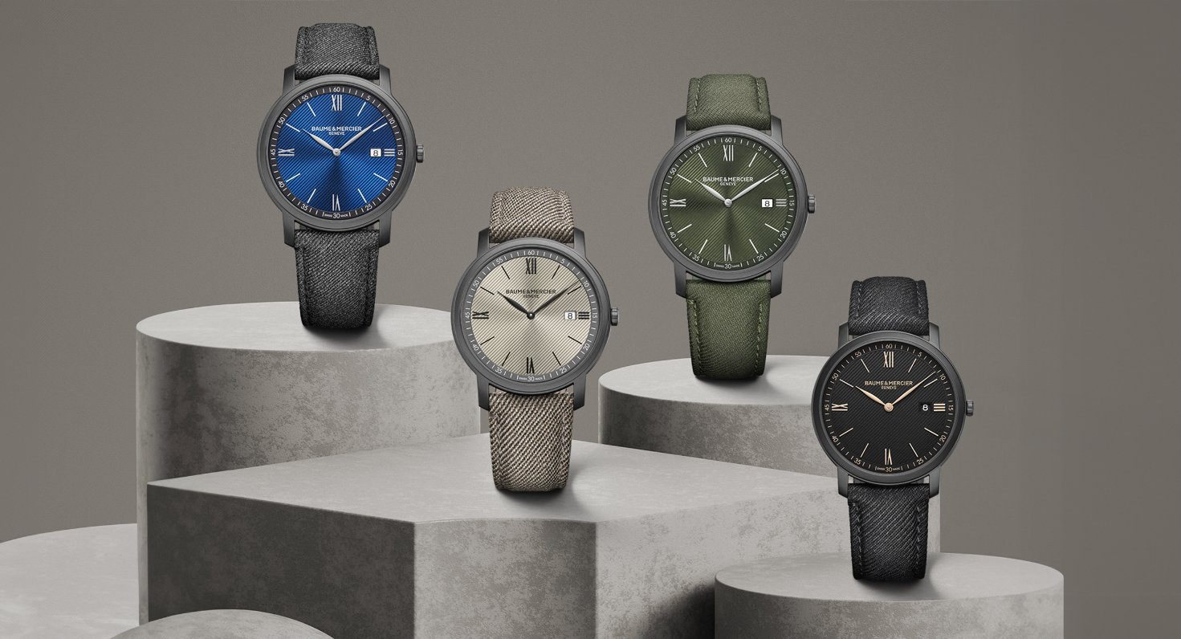
Classima M0A10766

The green sun-satin and opaline dial beams, adorned with a lined decoration and enhanced by the green flange surrounding it. The tight, delicate rhodium-plated Roman numerals, white indexes, rhodium-plated leaf hands, and white minute track indicate the hours and minutes in a magnificent chromatic alternation that offers great readability. The date appears in an aperture at 3 o’clock.

The emblematic round case of the Classima Collection is crafted in sand-blasted black ADLC-coated steel with a diameter of 42 mm and a thickness of 6 mm. A scratch-proof sapphire crystal protects it. The polished steel case back is solid and may be engraved.

This timepiece is driven by a quartz movement with five years of autonomy, demonstrating the quality and durability that the House brings each of its creations. It is water-resistant to 3 ATM (approximately 30 m).

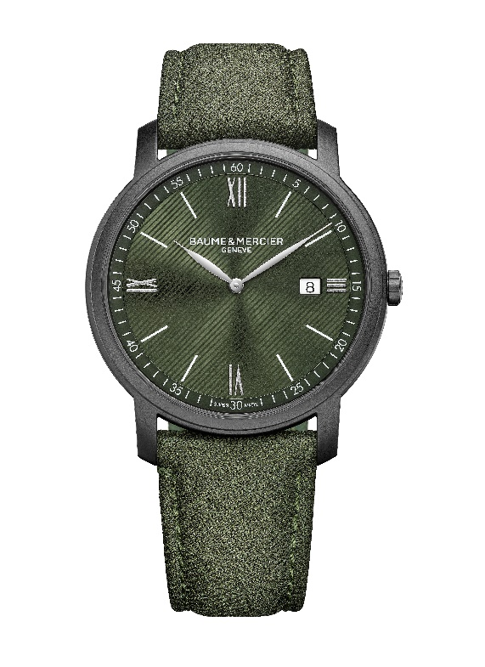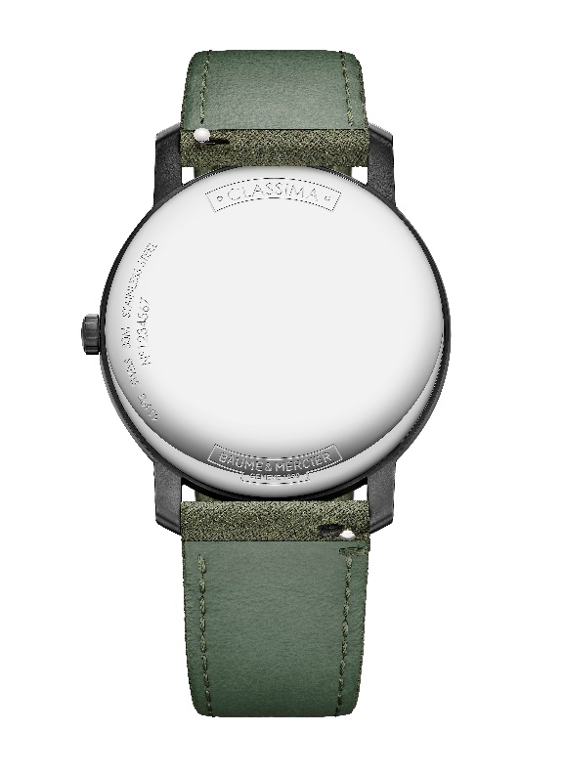
Its strap is in green (wool) fabric by Holland & Sherry. The stitching is tone-on-tone. It is interchangeable without the need for tools thanks to a very reliable spring bar system. The pin buckle is crafted in stainless steel.

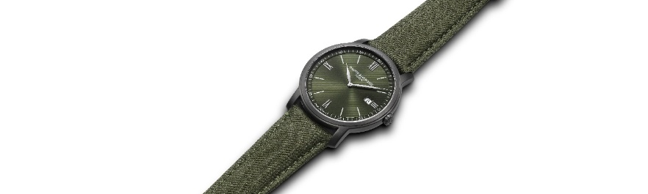

Classima M0A10767

In different tones with subtly considered contrasts, this sand-colored sun-satin dial is decorated with a lined design. Its flange is slate gray, its Roman numerals matte, its indexes and leaf hands black, and its minute track white. An aperture at 3 o’clock reveals the date.

In sand-blasted black ADLC-coated steel, the round case has a diameter of 42 mm and a thickness of 6 mm. It is protected by a scratch-resistant sapphire crystal. The polished steel back is solid. It may be engraved.

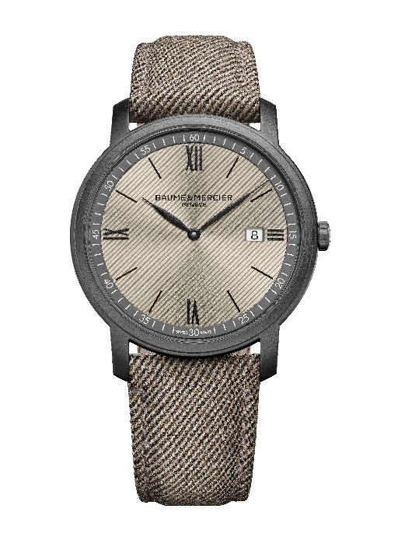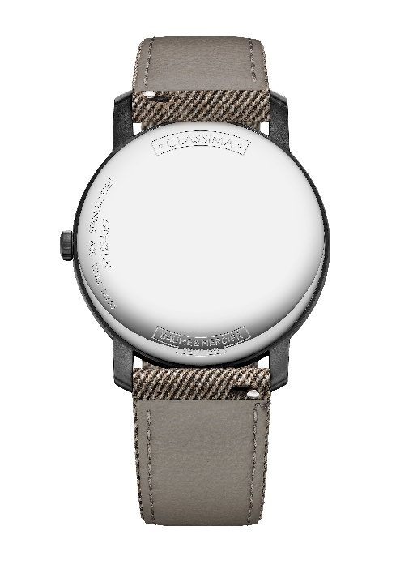
A quartz movement with a five-year autonomy drives this reliable timepiece, which indicates the hours, minutes and date, and is water-resistant to 3 ATM (approximately 30 m).

The Classima M0A10767 features an interchangeable strap in sand-colored Holland & Sherry (wool) fabric with tone-on-tone overstitching. The strap may be changed without the use of tools thanks to a very reliable spring bar system. It fastens with a stainless-steel pin buckle.

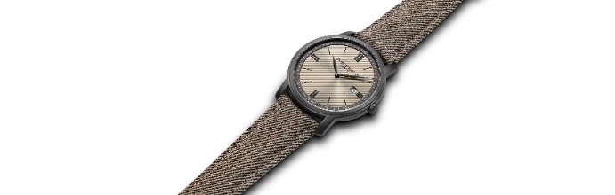

Classima M0A10780

In this equally luminous version featuring a blue sun-satin dial with a lined decoration, the flange is black, the Roman numerals rhodium-plated, the indexes white, the leaf hands rhodium-plated, and the minute track white. The date is easy to read in an aperture at 3 o’clock.

With a diameter of 42 mm and a thickness of 6 mm, the case is crafted in sand-blasted black ADLC-coated steel. A scratch-proof sapphire crystal protects it. The case back in polished steel is solid and may be engraved.

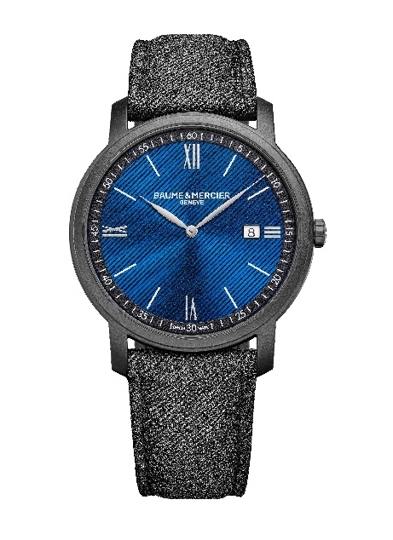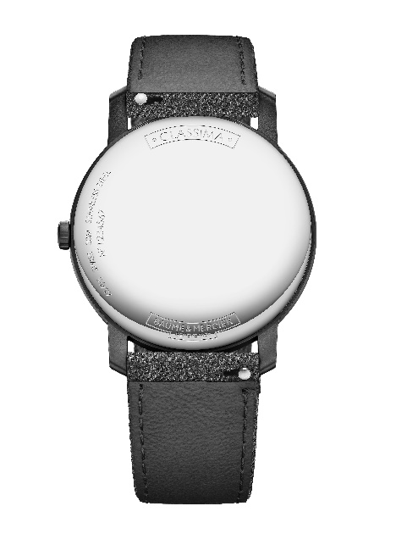

A quartz movement with a five-year autonomy tracks the hours, minutes and date with a remarkable precision.
The water-tightness of the timepiece is 3 ATM (approximately 30 m).

The Classima M0A10780 features an interchangeable strap in gray Holland & Sherry (wool) fabric with tone-on-tone overstitching. The strap may be changed without the use of tools thanks to a very reliable spring bar system. The pin buckle is crafted in stainless steel.

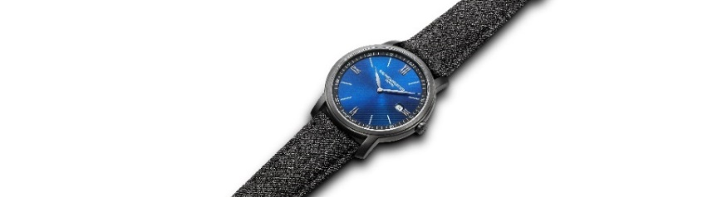

Classima M0A10762

The same harmony reigns in this version featuring a black opaline dial with a lined decoration and a black flange. The hours and minutes tick off the gold-tone Roman numerals and indexes on gold-tone leaf hands along a gold-tone minute track. The date appears in an aperture at 3 o’clock.

The round case is crafted in sand-blasted black ADLC-coated steel in a diameter of 39 mm and a thickness of 5 mm. A scratch-proof sapphire crystal protects it. The solid polished steel case back may be engraved.

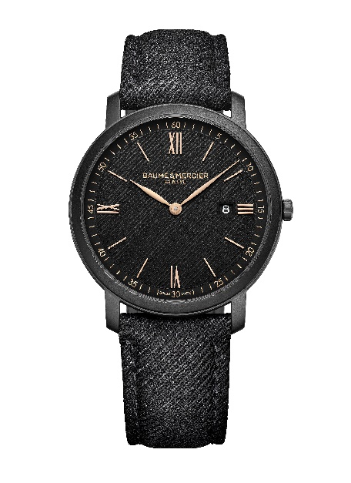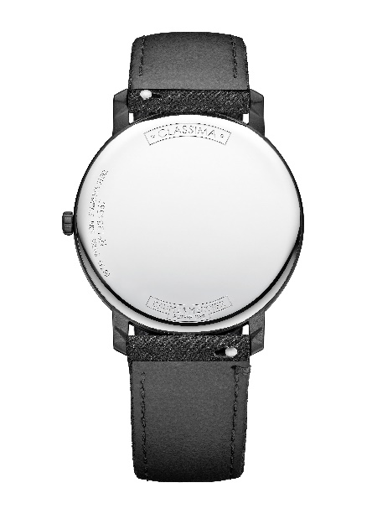
A quartz movement with a six-year autonomy guarantees a great deal of precision in this model with a water-tightness of 5 ATM (approximately 50 m).

The Classima M0A10762 features a strap in black Holland & Sherry (wool) fabric with tone-on-tone overstitching. It is easily interchangeable without the need for tools thanks to a very reliable spring bar system. It fastens with a stainless-steel pin buckle.

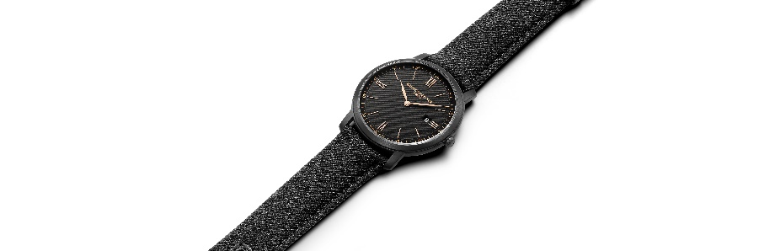

Baume & Mercier watches are companions for life’s happy moments. The House has been dedicating its savoir-faire to them since 1830. Today, it is delighted to honor Father’s Day with its excellence, making it an especially touching occasion. The Classima is the greatest declaration of love possible.

Information:

Model: Riviera 10766
Availability: May 2024

Model: Riviera 10767
Availability: May 2024

Model: Riviera 10780
Availability: May 2024

Model: Riviera 10762
Availability: May 2024

ABOUT BAUME & MERCIER:

Founded in 1830 at the heart of Swiss Jura, Baume & Mercier enjoys international renown. From its workshops at the heart of Swiss Jura to its headquarters based in Geneva, the Maison offers its clients the very finest timepieces. Born by a complementary balance between an artistic approach to shape and watchmaking innovation in the service of the client, the Baume & Mercier House continues to mark the history of watchmaking by passing down the design and watchmaking expertise that is the Brand’s legacy. This savoir-faire perfectly corresponds with the spirit of cooperation between the Brand’s founders William Baume & Paul Mercier: where classicism meets creativity, tradition meets modernity, and elegance meets character... In a more contemporary way than ever.

www.baume-et-mercier.com

