PERFORMANCE COMES FROM INSIDE

Last January at the Salon International de la Haute Horlogerie, Baume & Mercier revealed its very first in-house mechanical self-winding movement, the Baumatic™ caliber.

This new caliber responds to the real problems encountered by self-winding watches, and provides innovative solutions in four distinct fields:
- Power reserve
- Chronometric accuracy
- Sensitivity to magnetic fields
- Durability

Power reserve
The power reserve of a standard watch movement ranges from 40 to 70 hours when it is fully wound.

All the Baume & Mercier watches equipped with the Baumatic™ movement have a high-performance 120-hour power reserve, i.e. 5 days.

Chronometric accuracy
A standard watch requires regular time-setting, from the instance its daily variation in precision is around 20 to 30 seconds per day.

In addition to its COSC-certified chronometer model, all of the Baume & Mercier watches equipped with the Baumatic™ movement are adjusted to a precision rate of -4/+6 seconds per day and offer a stable level of precision throughout the whole of the power reserve.

Magnetic fields
There are many effects that may be caused by magnetic fields: the most common being the movement suddenly stopping or a loss of precision.

The Baume & Mercier Clifton Baumatic™ watch is resistant to at least 1,500 Gauss, a resistance 25x higher than the current ISO norm.

Durability
A watch movement is a complex mechanism comprising numerous mobile miniature components. Their perpetual interaction results in friction and wear, which can be minimized by lubrication, a delicate issue in any watch movement.

The quality of the various lubricants for the Baumatic™ movement make it possible to prolong the maintenance service intervals beyond the generally recommended five years.

Don’t wait a minute longer to discover the four incredible performances offered by the Baumatic™ movement and to view our four videos, which illustrate each of these innovations.

Power reserve Accuracy
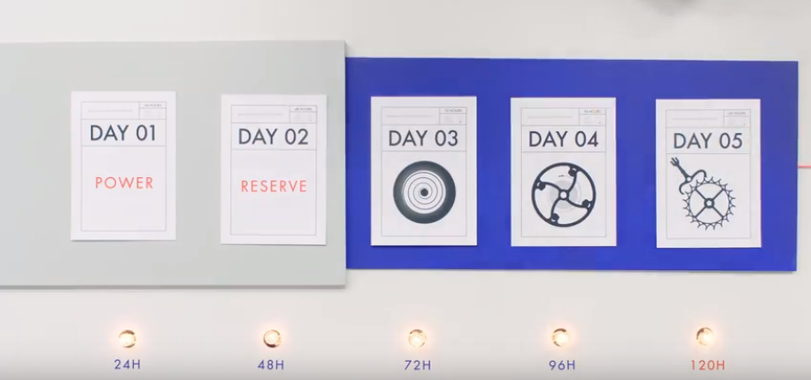

Antimagnetism Durability

