THE CLASSIMA COLLECTION SUSTAINS THE LOVE AFFAIR BETWEEN BAUME & MERCIER AND WOMEN

Intro: At Watches & Wonders Shanghai 2024, Baume & Mercier presented three exquisitely refined, diamond-studded new models, in an extension of the Baume & Mercier Classima collection, that are exclusively made available through TimeVallée: Classima Starry Sky Editions. Their elegance and femininity sustain the love affair that the Brand has shared with women for so long. These characteristics continue to give rise to exceptional timepieces like all those which have shaped the Brand’s identity, both in aesthetic and technical terms. Paul Mercier was at the origin of this delicate yet bold approach. His eminent legacy lives on, more than a century later, and is just as evident in the Brand’s latest watch creations.

The muses of avant-garde watchmaking


“I want watches to be integrated into bracelets, rings, pendants, and brooches! Geneva has always been a capital of gold artistry; this is the ideal place to combine watchmaking with jewelry craftsmanship.” With a perfect balance of technical quality and his own contemporary aesthetic of watchmaking, Paul Mercier took great inspiration from women. An elegant, cosmopolitan, trailblazing, sensitive aesthete who passionately loved art and had extensive experience in jewelry, he instigated Baume & Mercier’s orientation when he joined forces with the brilliant, pragmatic watchmaker William Baume in 1918. The Brand is still loyal to that approach today.

“We are finally talking about watchmaking as if there were more to this world than men. Women, my friend, women! They do not want to be relegated to the simple task of setting their husbands’ watches! They also want to be able to master time, and not simply by carrying a ridiculous men’s ‘turnip watch’! Thanks to the miniaturization of movements and the generalization of wrist-worn models, watches will become actual bracelets: true jewelry pieces. Look at how women are becoming liberated today! The suffragettes of England are demanding the right to vote. And the 1910 International Women’s Conference in Copenhagen has claimed – take note! – an International Women’s Day! I believe that we stand at the threshold of huge changes in this sector, which will reflect those being made in society. It might be too early to mention for the moment. We’ll talk about it again in five or six years, if you like.”

In his view, the Baume & Mercier watch would have to be very precise, but also elegant, modern, and always in step with its times. He immediately understood that women represented a blossoming market, and that they were sensitive to the beauty and whimsy of timepieces. He also knew that new technologies would release watches from certain limitations and pave the way for creativity. He began to design jewelry watches that caused a sensation. In the 1920 Davoine General Indicator of Watchmaking, an advertisement praises the Brand’s “haute Fantaisie pour Dames” (or “high fantasy for women”). A demonstration, if any were needed, that the House has always been a trailblazer in its feminine, artistic vision of watchmaking.

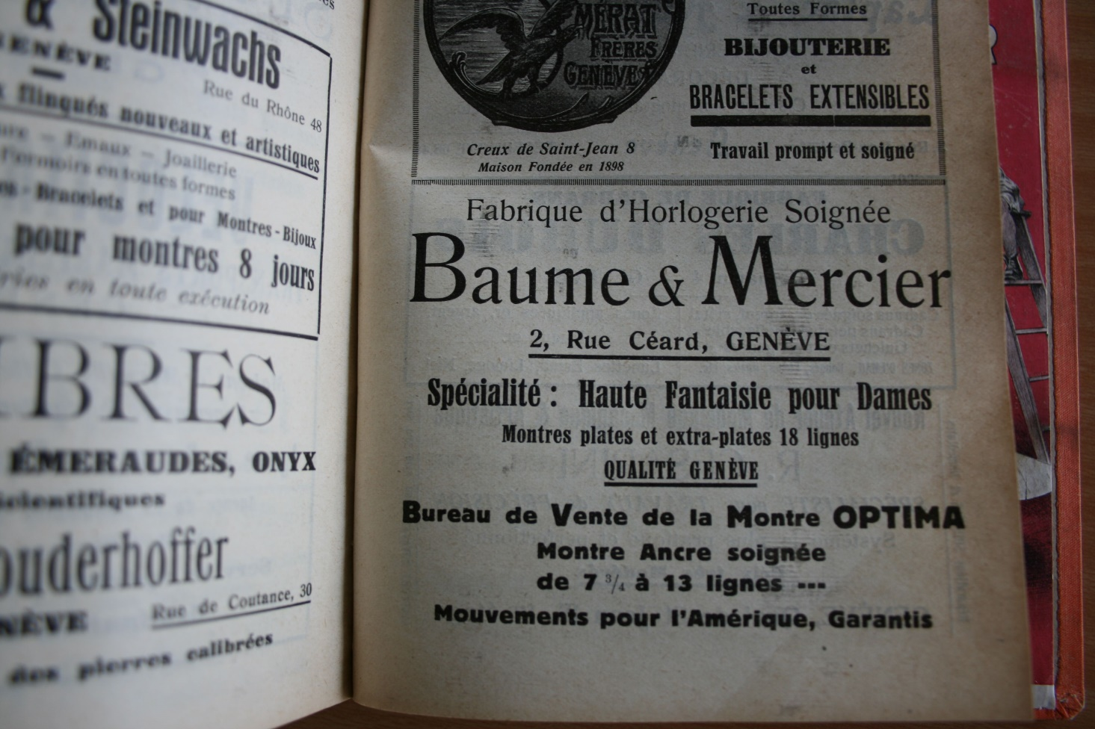

Early on, Baume & Mercier highlighted the active, self-reliant woman: one who broke with tradition and influenced the fashions of the times while maintaining a precious touch of femininity. The kind of woman who stepped out of her conventional role, aspired to her own freedom to choose, and demonstrated both pertinence and determination. In a 1950s advertisement, the House presented a female doctor as the embodiment of the potential client for the watch it was highlighting. The message emphasized the fact that the client was interested in more than just the aesthetic of the case: she also cared about the movement itself, and was ready to invest in a high-end mechanism. Because her responsibilities gave her a reason to possess a watch in which she could place her trust: one which would be precise and reliable for many years.

The House continued to assert its style throughout the Roaring Twenties and the Art Deco period. It launched the first “shape” wristwatches, dials in shimmering color ranges, and extra- and ultra-slim watches among the finest on the market. In particular, it specialized in what were known as “baguette” movements, ideal for original women’s watch cases in rectangular, square, barrel, and cushion shapes.

Ever since, with enthusiasm and inventiveness supported by discipline, Baume & Mercier has been thrilling women’s hearts by devoting timepieces to them, each more surprising, sophisticated, practical, original, casual, and precious than the last. All bear the seal of a design in perfect proportions and with precise lines, with an irreproachable, reliable Swiss technical quality.

The major women’s pieces by Baume & Mercier

The revolutionary “shackle”-type bracelet of the Marquise model, first presented in 1947, remained one of the House’s bestsellers until 1960.

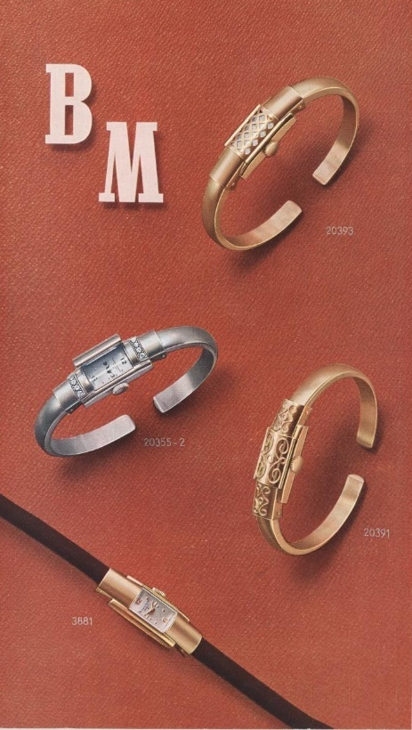

The 1970s, 1980s, and 1990s heralded new adornments for its unique savoir-faire: mother-of-pearl and ornamental stones such as onyx, lapis-lazuli, and turquoise, as well as spectacular jewelry models in gold, including some cuff versions. In 1972 and 1973, the refined extravagance of its Mimosa, Stardust (photo left) et Galaxie (photo right) watches was recognized at the prestigious Rose d’Or watchmaking and jewelry competition of Baden-Baden, held in Düsseldorf.

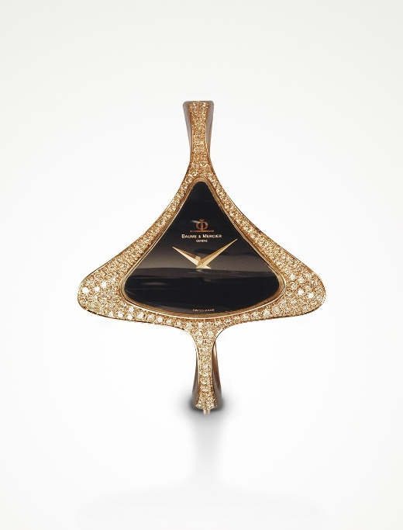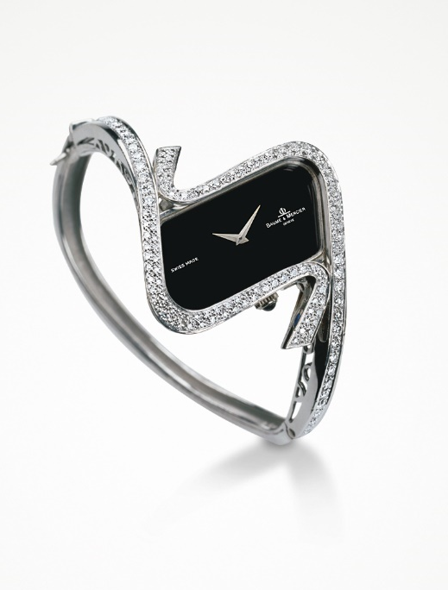

The iconic Riviera, with its surprising dodecagonal case, was first launched in 1973 and was beloved by women seeking sports elegance. For its 50th anniversary, its sculptural silhouette took on sophisticated finishes and brilliant colors, and was made available in 33 and 36 mm. 1987 marked the arrival on the watchmaking scene of the Linea, a timepiece with a simple, streamlined, perfectly round design. The rectangular case of the Hampton, with its vintage Art Deco look, challenged the established codes in 1994. Its pure, curved lines took on the most stylish blue, burgundy, or black tones for women seeking subtle plays on colors and materials. One year later, it was up to the Classima to reveal its round, understated, discreet case. Then, in 1997, for those enamored with luxury, the Catwalk appeared, with its cuff bracelet style. In 2004, the incredible Vice Versa made its entrance, with the time displayed not on the wrist, but beneath it. In 2005, the luminous Diamant dazzled, with its distinctive domed crystal and the personal diamond set into its crown. That sophisticated detail made a comeback in 2008, in the soft form of the Iléa, a round case with an inimitably curvaceous bezel. Promesse, released in 2014, rose to the same elegance and preciousness with its oval bezel – broader at 3 o’clock and 9 o’clock – within a polished or gem-set round watch case set with red gold or mother-of-pearl. Two years later, it was miniaturized in the form of the Petite Promesse, which asserted a very trendy allure with its double wraparound metal bracelet that echoed the radiance of its diamond-set bezel. In 2018, the fun Baume featured a bright flange in blue, red, purple or green, and each color coordinated with the small seconds hand and the overstitching of the model’s strap.

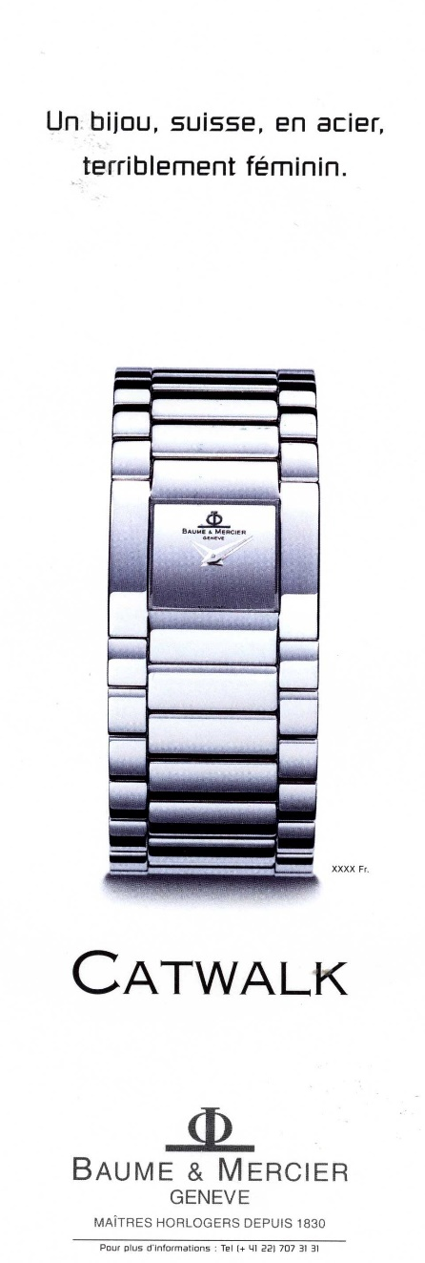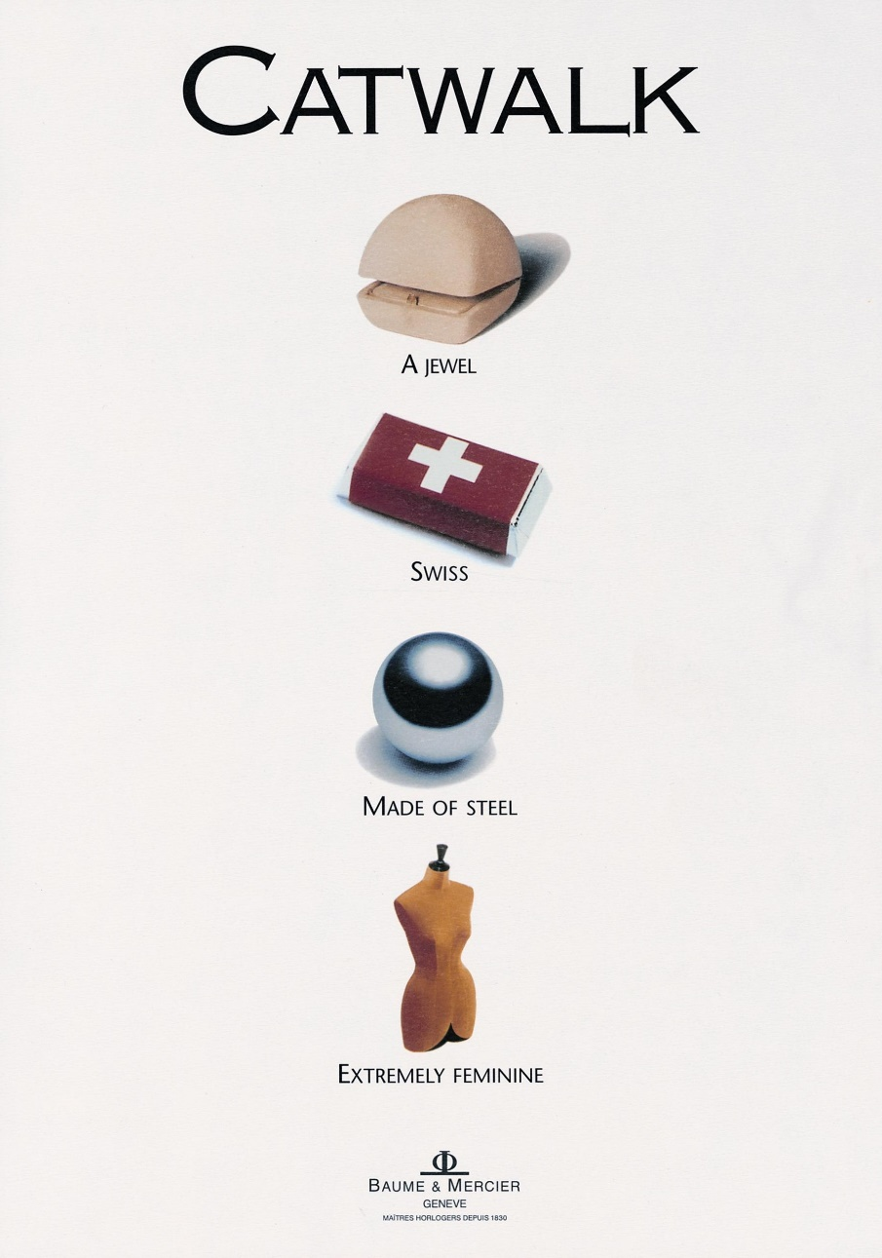

The authentic chic of the Classima collection

The understatement and discretion of its beautifully Swiss-made round case embodies the subdued yet assertive elegance so distinctive of Baume & Mercier. The Classima collection pays tribute to traditional watchmaking, demonstrating how technical excellence can elevate various everyday watchmaking complications. Attentive to women’s watchmaking desires, the House has brought aesthetic adornments to it in white mother-of-pearl, peacock blue, green, burgundy, and slate gray, alternating various materials. Its many faces make it easy to wear on a daily basis and for any occasion. The attractiveness of its price rounds out its profile, making it the ideal choice for a gift. There is a Classima for every woman.

The Classima Starry Sky Editions, an ode to a nigh under the stars

Between the Jura Mountains in Les Bois, Switzerland, Louis-Victor and Célestin Baume brother opened the legend of Baume & Mercier, which is also the beginning of the winter love story. Inspired by the sky of the Jura, Baume & Mercier releases the Classima TimeVallée Exclusive Edition in 2024. The brilliant-cut diamonds resemble the starlit sky, sparkling like wishes made under the stars, illuminated by the passage of time. The moon's cold glow, the moon-phase dial opens like a window to a starry night. The deep blue of the dial is taken from the night sky of the town in Jura Mountains as the sun sets and night falls. The moon-phase dial is placed at the 12 o’clock, surrounded by stars. Unspoken wishes from the day turn into a romantic and dreamlike moment.

True feelings and the authentic self are worthy of being cherished.

All three of the new, exquisitely refined gem-set pieces demonstrate the precious, authentic approach that is so important to Baume & Mercier. Their beautiful dials show the technical skill and meticulous, patient, precise work of its artisans. The diamond-set watch case reveals the gems’ radiance. The stones are set, and then the metal is hammered over to fasten them. Such craftsmanship requires precision to the millimeter and an adaptation to the requirements of shape and volume.

The scintillating blue dial of the Classima BMM0A10804 is achieved through the obtainment of a deep, uniform color that stands the test of time. A symbol of refinement and innovation, it forms the intense background against which the watch indications and complications are clearly legible.
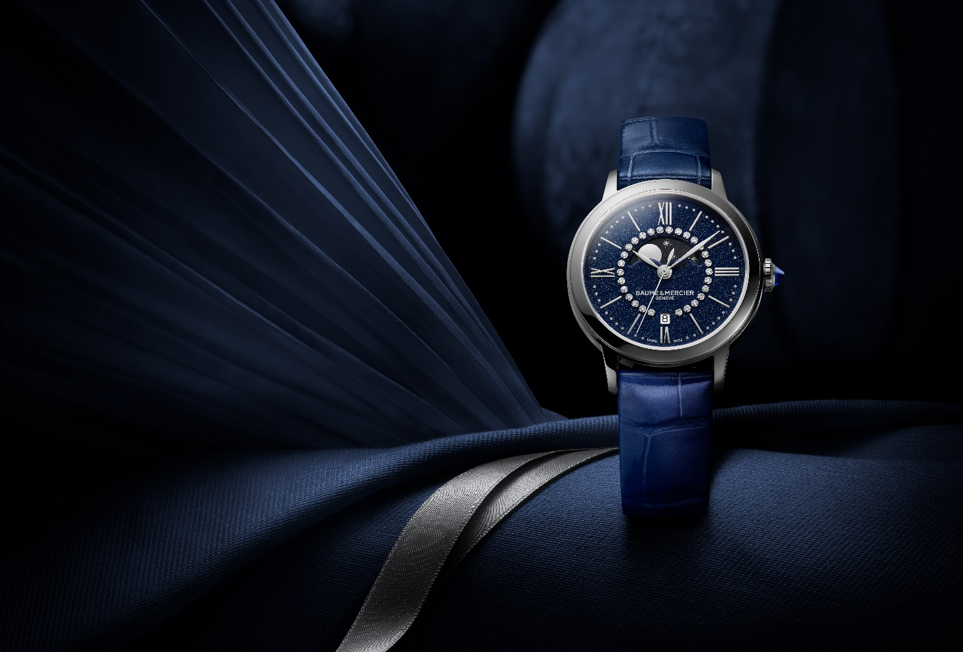

The white mother-of-pearl and the grace of its iridescent reflections are the center of a great deal of attention.
As a finishing touch for these elaborately designed watches, a blue spinel adorns each cabachon-shaped crown. This stone was first discovered in ancient times, in Afghanistan, and is believed to have the ability to stimulate love, vitality, and the intellect. It drives away negative vibes, regulates the blood’s circulation, and reinforces the cardiovascular system.

Classima Starry Sky Edition – Reference M0A10804

Its scintillating blue dial – set with 28 brilliant-cut diamonds (Top Wesselton, quality VS, 0.06 carat) – majestically sets the tone for the passing time, materialized by rhodium-plated Roman numerals, indexes, and leaf hands, as well as a finely grained silver minute track. The moon phase cycle appears on a starry black disk at 12 o’clock, while the date appears in an aperture at 6 o’clock. The contrasts between the two colors, and between curves and straight lines, bring it a great deal of character.

With a diameter of 31 mm and a thickness of 7.1 mm, its round case is crafted in polished stainless steel. A scratch-proof sapphire crystal protects it. Its steel crown is cabochon-shaped and set with a synthetic blue spinel. The polished steel case back is solid and may be engraved.

A quartz movement with a 3-year autonomy powers this model. It is water-resistant to 5 ATM (approximately 50 m).

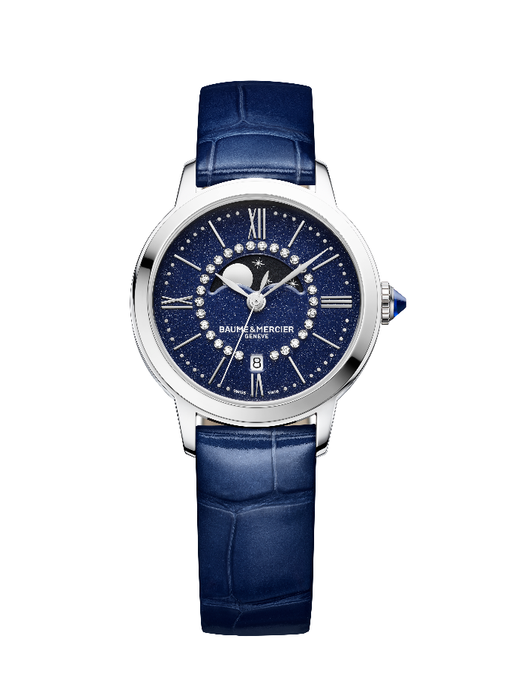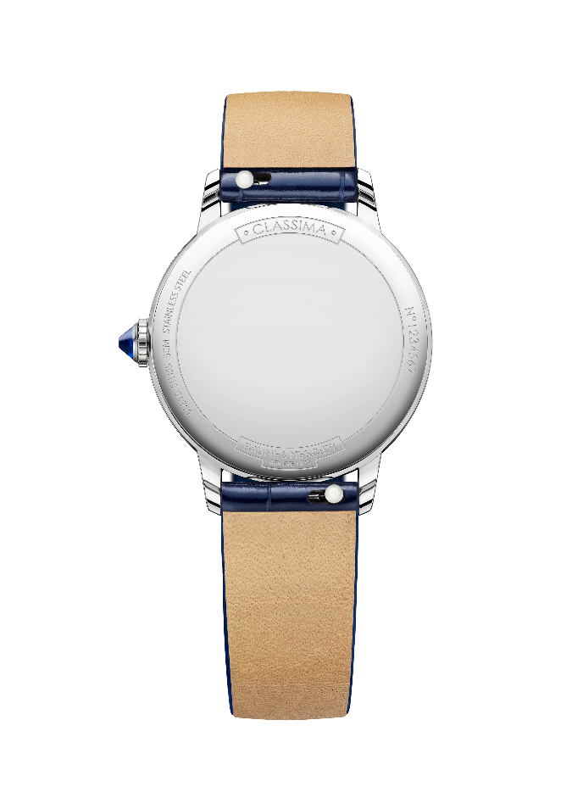
It is mounted on a blue alligator strap with all-square scales. It is interchangeable without the need for tools thanks to a very reliable spring bar system. The pin buckle is crafted in stainless steel.

The edition is exclusive to TimeVallée, and is limited to 150 timepieces.

Classima Starry Sky Edition – Reference M0A10806

The aesthetic appeal of this delicate white mother-of-pearl dial is set into motion by rhodium-plated Roman numerals and indexes, a pearl gray minute track, blue leaf hands, and the presence of 30 brilliant-cut diamonds (Top Wesselton, quality VS, 0.06 carat). The subtle shimmer of the material, which glistens with each movement of the wrist, brings this luminous timepiece to life. The date appears in a discreet aperture at 3 o’clock.

The round case, with a diameter of 31 mm and a thickness of 8.25 mm, is crafted in polished stainless steel and topped with a scratch-resistant sapphire crystal. Its steel crown is cabochon-shaped and set with a synthetic blue spinel. The back is also protected by a sapphire crystal.

The self-winding movement offers a 42-hour power reserve and oscillates at a frequency of 4 Hz (28,800 vph). It is water-resistant to 5 ATM (approximately 50 m).

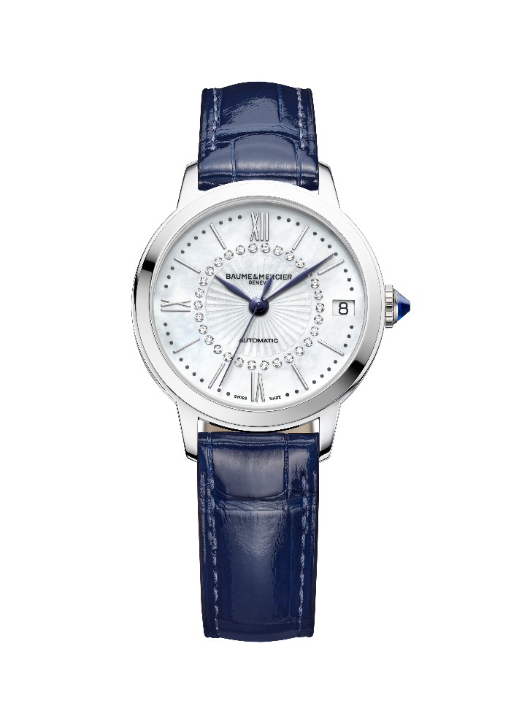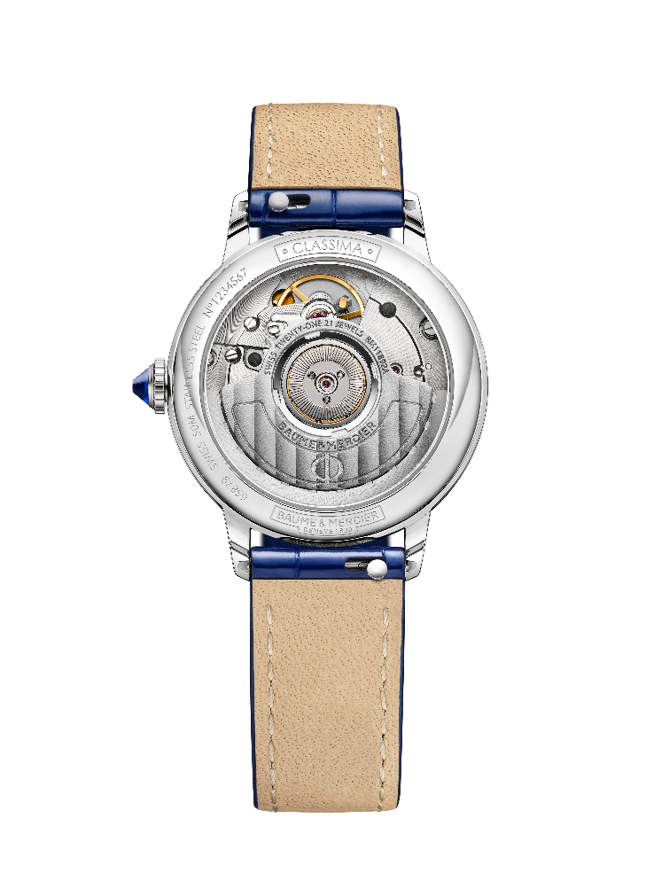

Its interchangeable strap is crafted in blue alligator with all-square scales featuring tone-on-tone overstitching on the top. A very robust, reliable spring bar system makes it possible to change the strap without the use of tools, on a whim. It fastens with a stainless steel pin buckle.

The edition is exclusive to TimeVallée, and is limited to 150 timepieces.

Classima Starry Sky Edition – Reference M0A10808

Precious and airy, its white mother-of-pearl dial is wreathed with 30 brilliant-cut diamonds (Top Wesselton, quality VS, 0.06 carat), meticulously aligned in a circular stream. They enhance the ring of rhodium-plated Roman numerals and indexes and the pearl gray minute track. Blue leaf hands spin within these concentric circles, edged by the case set with 60 brilliant-cut diamonds (Top Wesselton, quality VS, 0.29 carat). The date appears in an aperture at 3 o’clock.
The diamonds of the piece total 0.36 carat.

Protected by a scratch-proof sapphire crystal, the round, polished stainless steel case features the perfect proportions of 31 mm in diameters and 8.25 mm in thickness. Its steel crown is cabochon-shaped and set with a synthetic blue spinel. The back is also protected by a sapphire crystal.

The watch is driven by a self-winding movement with a 42-hour power reserve that oscillates at a frequency of 4 Hz (28,800 vph). It is water-resistant to 5 ATM (approximately 50 m).

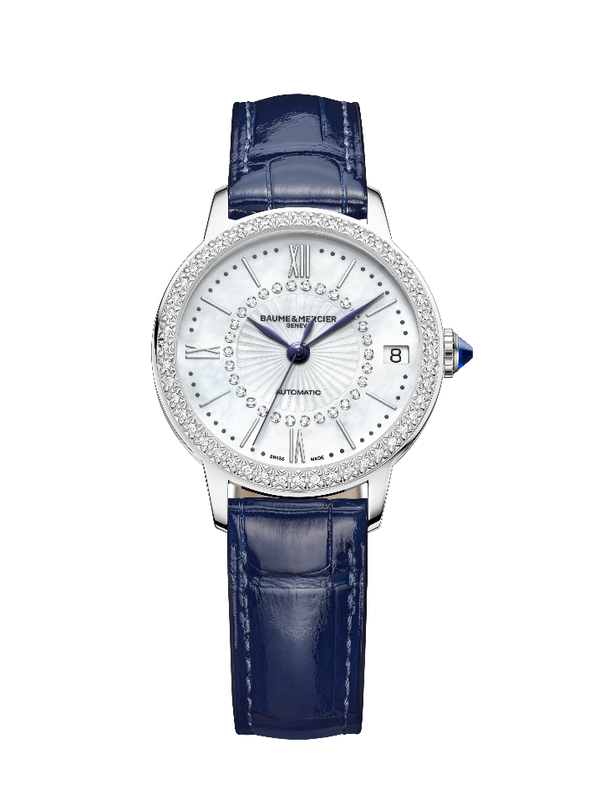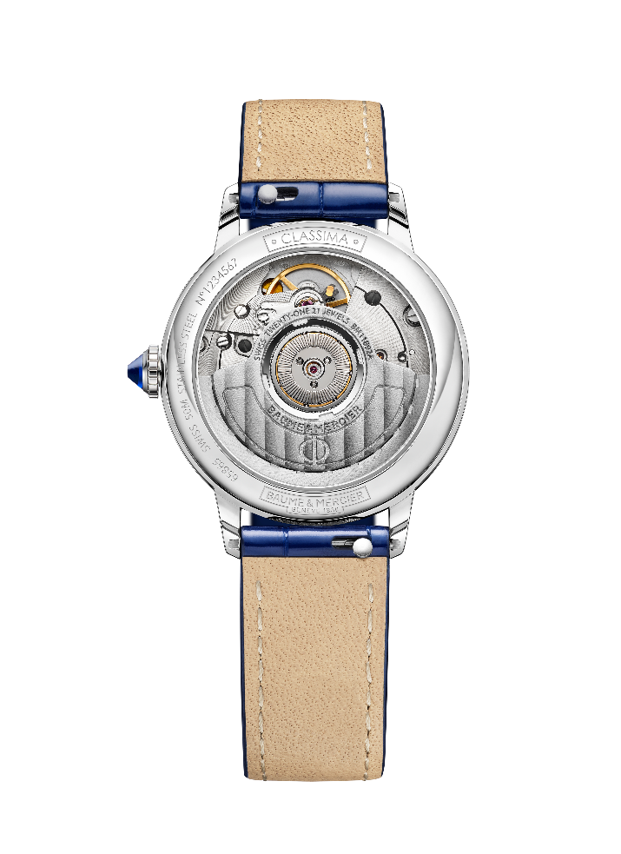
This model is mounted on a blue alligator strap with all-square scales featuring tone-on-tone overstitching on the top. The strap may be changed without the use of tools thanks to a very reliable spring bar system. The pin buckle is crafted in stainless steel.

The edition is exclusive to TimeVallée, and is limited to 70 timepieces.

“People want freshness, beauty, lightness,” Paul Mercier asserted. The Classima collection is the deserving heir to this legacy, since it remains a perennially chic, light, beautiful, easy-to-wear watch, even in its most luxurious expression.

---
About TimeVallée:
TimeVallée is a luxury and innovative watch multi-brand destination store offering clients access to a curated portfolio of prestigious Maisons with an ecosystem of services and experiences.
Created in 2014 with headquarters in Switzerland, TimeVallée is designed as an inspirational space mixing heritage and contemporary luxury that guides watch lovers to browse, learn, share and experience the fascinating world of watchmaking.
TimeVallée is operated by strategic partners in more than 50 boutiques all over the world.

Website: www.timevallee.com
Instagram: @timevallee
Official hashtags: #timevallee #heritageandbeyond #notyourusualretailer #luxurywatches

Information:

Model: Classima 10804
Availability: November 2024

Model: Classima 10806
Availability: November 2024

Model: Classima 10808
Availability: November 2024

ABOUT BAUME & MERCIER:

Founded in 1830 at the heart of Swiss Jura, the Baume & Mercier watch manufacture enjoys international renown. From its workshops at the heart of Swiss Jura to its headquarters based in Geneva, the Brand offers its clients the very finest timepieces. Borne by a complementary balance between an artistic approach to shape and watchmaking innovation in the service of the client, the Baume & Mercier House continues to mark the history of watchmaking by passing down the design and watchmaking expertise that is the Brand’s legacy. This savoir-faire perfectly corresponds with the spirit of cooperation between the Brand’s founders William Baume & Paul Mercier: where classicism meets creativity, tradition meets modernity, and elegance meets character... In a more contemporary way than ever.

www.baume-et-mercier.com

