DO NOT RELEASE UNTIL TUESDAY APRIL 14th 8.30 CET

RIVIERA 73, THE ELEGANCE OF ORIGINS

In 2026, Baume & Mercier enhances its iconic collection with Riviera 73, a new series featuring three new 39 mm models, each featuring a quartz movement, celebrating the original aesthetic of the first Riviera launched in 1973. In keeping with the spirit of the collection, Riviera 73 showcases design finesse, dial clarity, and balanced proportions for a timepiece that combines heritage and contemporary sophistication.

* * * * *

A contemporary vision of Riviera elegance

With the Riviera 73, Baume & Mercier reinterprets the aesthetic spirit of the first generation of the Riviera launched in 1973. Since its launch, this model stood out for its unique silhouette and a design approach that blends modernity and elegance. Its dodecagonal case - the collection’s signature - introduced a bold geometry to the watchmaking world of the time, while its balanced proportions and understated lines asserted a style that is both timeless and distinctive. Riviera 73 carries forward the style of the collection, reinterpreting its founding codes in a contemporary way while remaining faithful to its original spirit.

The Riviera 73 M0A10844, M0A10845 and M0A10845 models, featuring a 39 mm diameter, are powered by a quartz movement. Their 7.7m thickness emphasises its harmonious proportions, and the dodecagonal bezel without visible screwsalong with wide dial opening showcase the elegance of its shape. On the case back, each model features the engraving “73” among vertical stripes, evoking the deck of a boat, and a typography inspired by the 1970s, a discreet signature that echoes the collection’s origins.


Riviera 73 M0A10846
The history of the Riviera collection

Created in 1973, the Riviera collection stands out for its bold, innovative style, as one of the first steel sport chic watches. It was memorable from its launch, with its dodecagonal case and metal flat-link strap;style elements that laid the foundations of an original, immediately recognizable watch identity. The first generation was launched in quartz, and it quickly became available in a self-winding version, asserting the care brought to both design and technical achievement.

The second generation, released in 1980, introduced bicolor versions and the first appearance of the name ‘Riviera’ on the dial. In 1983, the collection stood out for its ultra-thin quartz movement with a thickness of just 2.5 mm and unprecedented complications such as a split-seconds, a perpetual calendar, and a second time zone. The third generation, launched in 1985, featured softened edges on the case and strap, played on polished and satin finishes, and incorporated a miniaturized crown for better water-tightness. The fourth generation, presented in 2004, included two distinct styles: a classic model and a sporty one, recognisable by its bezel equipped with four screws.

In 2021, the fifth generation affirmed the modernity of the Riviera with feminine 36 mm models and masculine 42 mm ones, some equipped with the Baumatic movement, others by a self-winding movement, featuring a dial adorned with a mountain-and-wave pattern. The collection was then extended to 39 mm self-winding and Baumatic models, as well as women’s 33 mm timepieces equipped with self-winding and quartz movements. Lastly, in 2025, the collection was completed by 41 mm chronographs, confirming the precision and unique style of the Riviera.

Today, the Riviera 73 continues to write history with a new expression of the Riviera design, inspired by the aesthetic codes of the first generation.

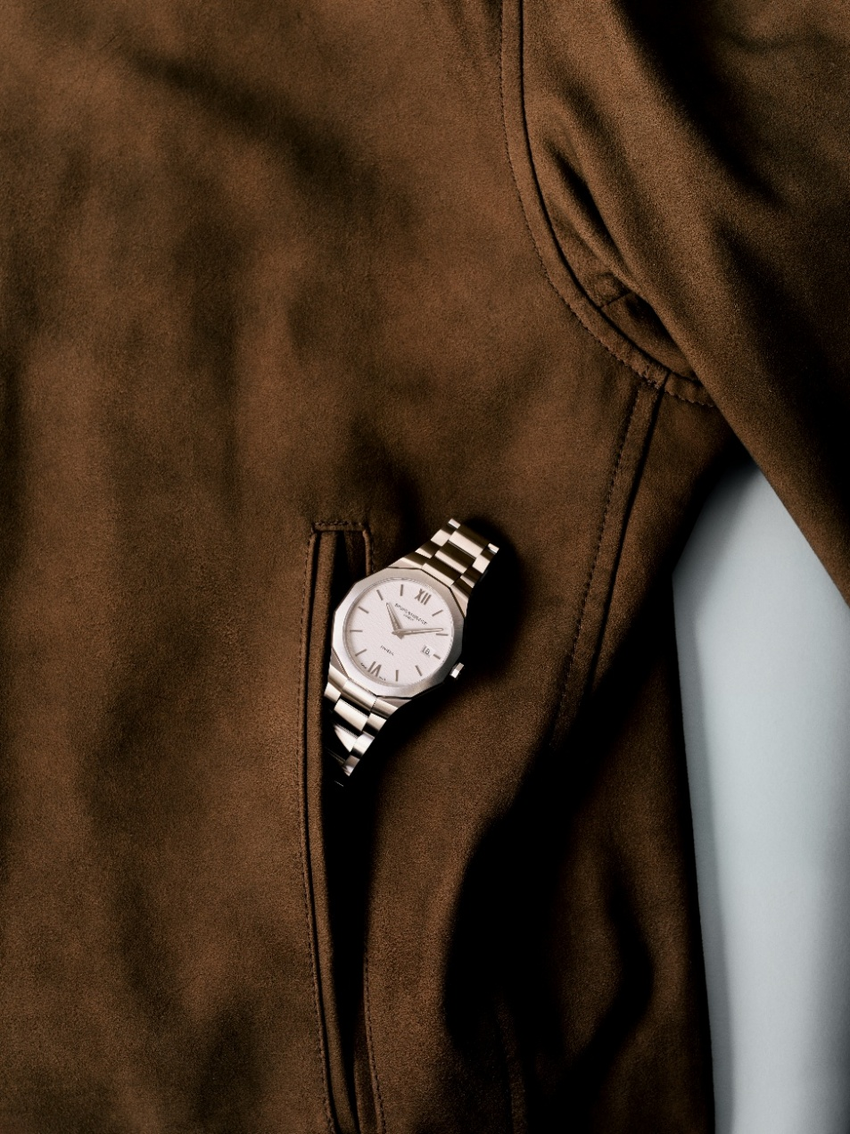
Riviera 73 M0A10845
RIVIERA 73 M0A10844: the complementary difference of blue and steel

Available from September 2026

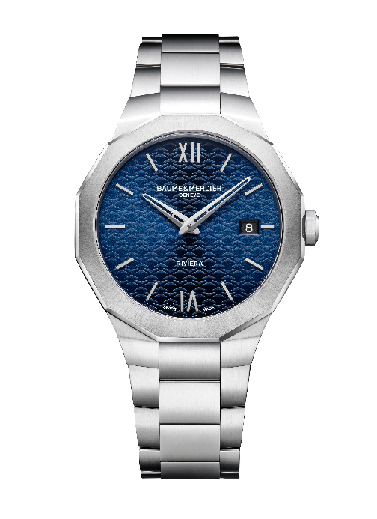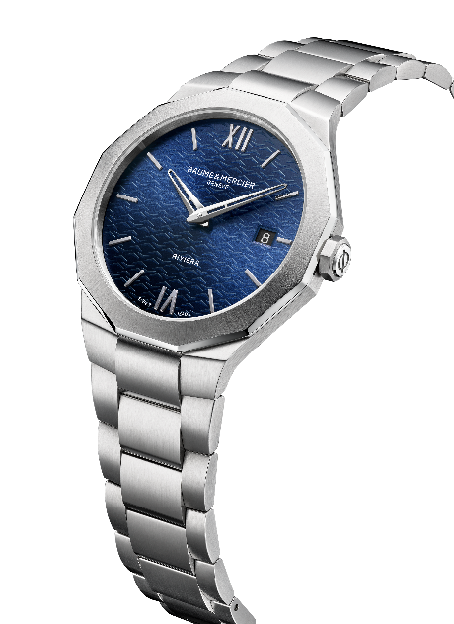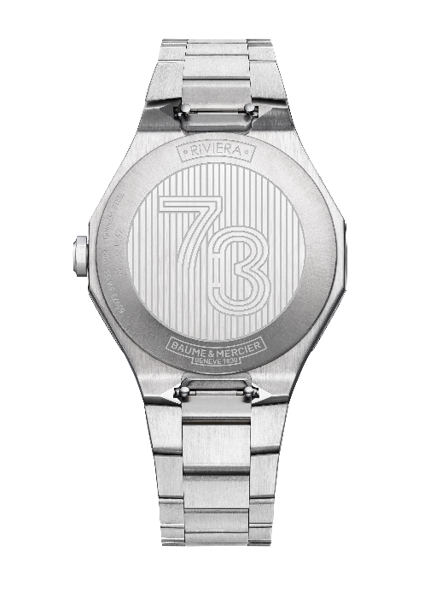

                - Movement
Quartz (ETA F06.115)
Autonomy: 5 years
                - Functions
H/M, date
                - Case
Dodecagonal
Dimensions: 39 mm
Thickness: 7.7 mm
Polished and satin-finished stainless steel case
Scratch-resistant, anti-glare sapphire crystal
Sun-satin and polished stainless steel bezel
Octagonal stainless steel crown with Phi logo
Solid round case back with special “73” engraving (may be custom engraved)
              - Dial
Blue sun-satin dial with wave design
Roman numerals and rhodium-plated riveted indexes
Openworked rhodium-plated H/M hands
Date aperture at 3 o’clock
              - Strap
Integrated three-row strap in satin-polished stainless steel
Interchangeable spring-bar system making it possible to change the bracelet without the need for tools
              - Clasp
Triple folding clasp in satin-polished stainless steel with security push-pieces
              - Water-resistance
5 ATM (approximately 50 m)

RIVIERA 73 M0A10845: Harmony and radiance

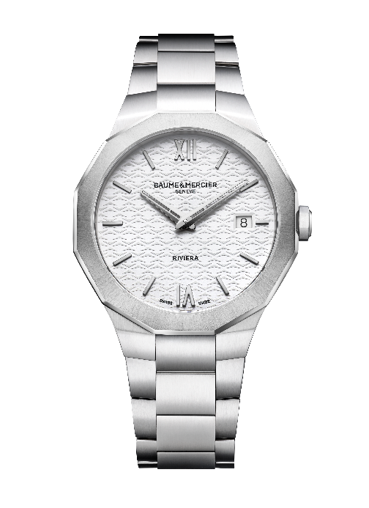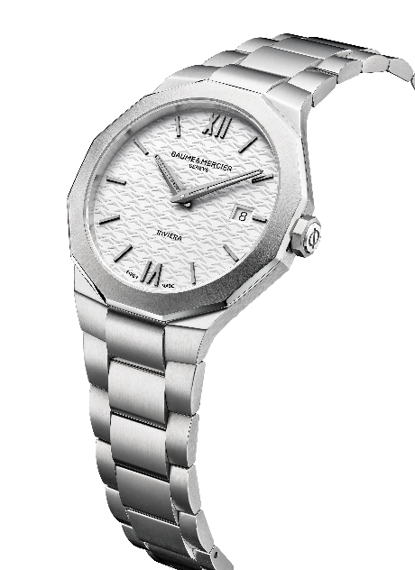

                - Movement
Quartz (ETA F06.115)
Autonomy: 5 years
                - Functions
H/M, date
                - Case
Dodecagonal
Dimensions: 39 mm
Thickness: 7.7 mm
Polished and satin-finished stainless steel case
Scratch-resistant, anti-glare sapphire crystal
Sun-satin and polished stainless steel bezel
Octagonal stainless steel crown with Phi logo
Solid round case back with special “73” engraving (may be custom-engraved)
              - Dial
White opaline dial and wave design
Roman numerals and ruthenium riveted indexes
Ruthenium H/M hands
Date aperture at 3 o’clock
              - Strap
Integrated three-row strap in satin-polished stainless steel
Interchangeable spring-bar system making it possible to change the bracelet without the need for tools
              - Clasp
Triple folding clasp in satin-polished stainless steel with security push-pieces
              - Water-resistance
5 ATM (approximately 50 m)

RIVIERA 73 M0A10846: an ode to texture and color

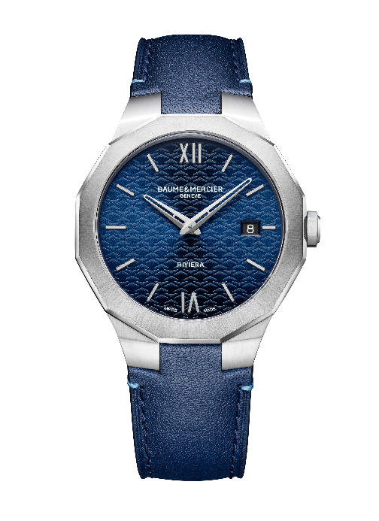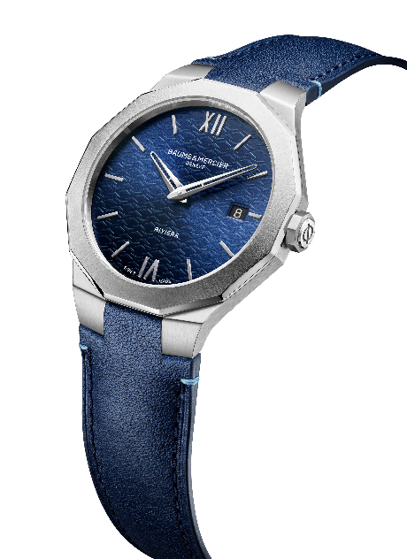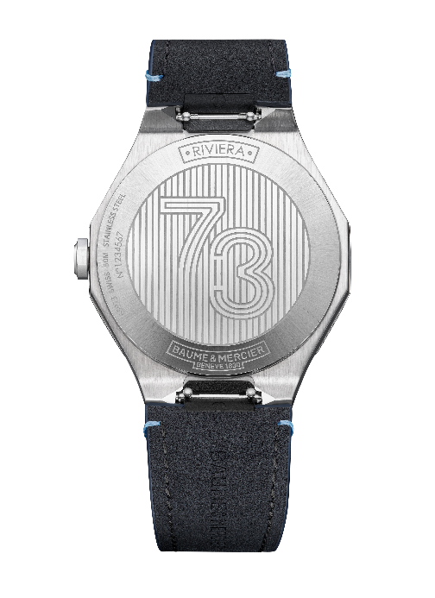

                - Movement
Quartz (ETA F06.115)
Autonomy: 5 years
                - Functions
H/M, date
                - Case
Dodecagonal
Dimensions: 39 mm
Thickness: 7.7 mm
Polished and satin-finished stainless steel case
Scratch-resistant, anti-glare sapphire crystal
Sun-satin and polished stainless steel bezel
Octagonal stainless steel crown with Phi logo
Solid round case back with special “73” engraving (may be custom-engraved)
              - Dial
Blue sun-satin dial with wave design
Roman numerals and rhodium-plated riveted indexes
Openworked rhodium-plated H/M hands
Date aperture at 3 o’clock
              - Strap
Midnight blue calfskin strap with contrasting light blue overstitching
Interchangeable spring-bar system making it possible to change the bracelet without the need for tools
              - Clasp
Polished stainless steel pin buckle
              - Water-resistance
5 ATM (approximately 50 m)

More than a watch, the Riviera is an icon of style and watchmaking savoir-faire. With Riviera 73, Baume & Mercier offers a refined, contemporary interpretation of its heritage: a watch with pure lines, balanced proportions, and a harmonious design, combining elegance and sophistication. Each detail reflects masterful design for a watch that naturally joins the lineage of this historical collection.

