THE GLAMOROUS AUTUMN OF THE HAMPTON
BY BAUME & MERCIER

This fall, the sculptural rectangular silhouette gets noticed with the unveiling of two utterly elegant women’s versions: one in rose gold (750/1000) with a black alligator strap, and the other in steel with a bicolor strap in steel and steel topped with rose gold.

Both assuredly assert the Baume & Mercier allure.

A dignified look, minimalist lines: sophistication at its finest

It is the incarnation of the Baume & Mercier designer spirit in its purest, most absolute form. A single glance captures the aesthetic strength that emanates from the Hampton watch: it imposes itself through its stylistic understatement while remaining a distinctive timepiece. The attention to detail so distinctive of the Brand is an invitation to carefully admire the finesse of the case, the slender curves, the softened corners, the rectangle-within-a-rectangle, the delicate minute track, and the perfect balance between the softness of the digits and the tension of the indexes. Each detail is graphic, expressing the mastery that only a keen sensibility could imagine and that only a talented savoir-faire could craft. This is the vision of watchmaking that Baume & Mercier has carried forward for nearly 200 years; the same that Paul Mercier brought about when he joined forces with William Baume in 1918. The Hampton collection, with its vintage Art Deco look, has been superbly sustaining this priceless creative heritage since 1994.

A collection recognized for its boldness since 1994

The illustrious HAMPTON collection marked another of the brand’s aesthetic breakthroughs in the history of steel shape watches when it was first released in 1994. The rectangular case, featuring pure lines and curves as well as softened corners, is inspired by an iconic model from the 1960s, and features an Art Deco style inspired by the 1920s. An artistic ode to the passage of time along a delicate minute track, this sober, elegant formal balance lends itself to all sorts of variations: cases in stainless steel or gold, dials of every color, in simple or diamond-studded jewelry versions. Graphic and chromatic effects bring new perspectives to its ideal proportions. For both men and women, this watch embodies absolute elegance and adapts to every trend, which it anticipates in the great Baume & Mercier timepiece tradition. Featuring high-tech materials and a sporty spirit, the Hampton “K” model, released in 1998, was mounted on a black Kevlar® fiber strap. The ever-more-curvaceous gold Hampton Milleis inaugurated the year 2000. It was followed by the Hampton Spirit, of which the panoramic case pays tribute to the omnipresence of screens and information; meanwhile, the Hampton City is inspired by contemporary urban architecture.

The Hampton watch is the perfect territory for artistic expression, with a rectangular shape that evokes a canvas. It became the showcase for a timekeeping transposition of the work of the great artist Pierre Soulages, creator of the Outrenoirs. The Hampton “Hommage à Pierre Soulages” watch exemplifies the interaction between watchmaking and design that Baume & Mercier has upheld since its origins. With its technical complexity and exceptional aesthetic, it renders the force of black – in keeping with the artist’s way of elevating its depth, light, and relief through subtle matte, semi-matte, shiny, and dull finishes – in a miniature version.

Hampton dresses up in finery

With their glamorous style, the Hampton M0A10752 and M0A10751 immediately establish the Baume & Mercier elegance with its affection for beautiful crafting and exquisite materials. That refinement captures the hearts of women sensitive to beauty for whom a watch is like a piece of jewelry that integrates and enhances their appearance.

The Hampton M0A10752 case is adorned with rose gold (750/1000), bringing the collection a luxurious, particularly elegant new expression. The Hampton M0A10751 case, with its bold contrasts, is crafted in steel. Both reveal luminous, refined finishes that demonstrate the careful work of the craftsmen at the Manufacture in Les Brenets: a grained opaline silver dial, Arabic numerals, riveted indexes, and gold-tone hands. The cabochon-shaped gold-tone PVD steel crown, adorned with black agate – a stone thought to stimulate one’s inner strength, pragmatic spirit, and motivation to change – perfects each one with an exquisitely elegant finishing touch.

The classical yet contemporary allure of the Hampton M0A10752 coordinates with the black alligator strap that flatters the beauty of this gold timepiece.

The integrated three-row strap of the Hampton M0A10751 plays on the very elaborate, harmonious alternation of steel links and rose gold-plated steel links. This bicolor combination of links is a historical characteristic of Baume & Mercier watches. This type of strap – already present in the Hampton collection – also adorned the 1973 Riviera, which featured a central gold link and two exterior steel links. The following generations of the collection perpetuated the bicolor strap. The Linea included one, as did the CapeLand, and it appeared in the Clifton, Classima, and Promesse collections, both for men and women.

Hampton M0A10752

The rectangle-in-a-rectangle that adorns its grained opaline dial highlights the very fine gray minute track. Along it, the Arabic numerals at 12 and 6 o’clock, riveted indexes, and faceted “glaive” hands – all gold-tone – indicate the hours and minutes. Their straight, neat, slender graphic allure is seductively dignified.



The polished (750/1000) rose gold and titanium case asserts the perfect proportions for a woman’s wrist according to Baume & Mercier, the brand that adopted the Greek letter Phi – a reference to the golden ratio – as its emblem: 35 x 22.2 mm. It is 6.9 mm thick, and is protected by a scratch-proof domed sapphire crystal. In gold-tone PVD steel, its cabochon-shaped crown is set with a black agate. The solid titanium case back may be engraved.

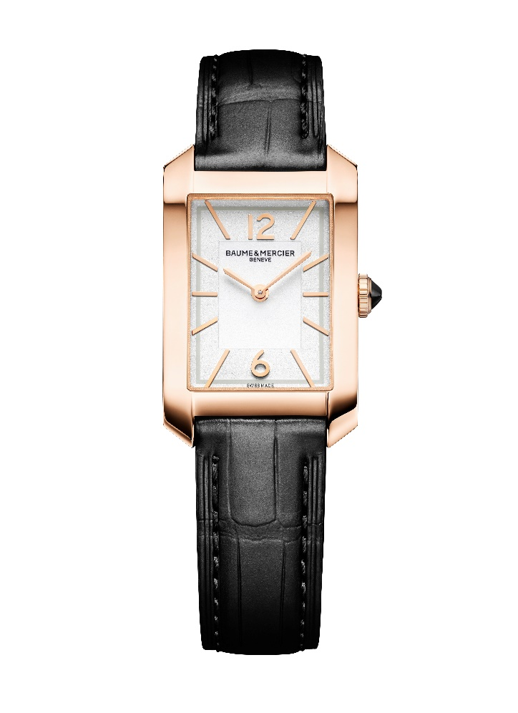

Its interchangeable black alligator strap, featuring all-square scales and tone-on-tone overstitching, may be removed and replaced without the use of tools thanks to a very reliable spring bar system.
It fastens with a gold-tone PVD steel pin buckle.

The model is driven by a quartz movement with an eight-year autonomy. The watch is water-resistant to 5 ATM (approximately 50 m).

Hampton M0A10751

The hours and minutes tick by, sweeping past Arabic numerals at 12 and 6 o’clock, gold-tone riveted indexes, gold-tone “glaive” faceted hands, and a gray minute track that perfectly harmonizes with the luminous grained and opaline adornment of the dial.

The gold-tone finishes and polished stainless steel of the case – measuring 35 x 22.2 mm and with a thickness of 6.9 mm – complement and flatter each other. The case is protected by a scratch-proof domed sapphire crystal. The gold-tone PVD steel crown is shaped like a cabochon and prettily adorned with an inset black agate. The solid case back may be custom-engraved.

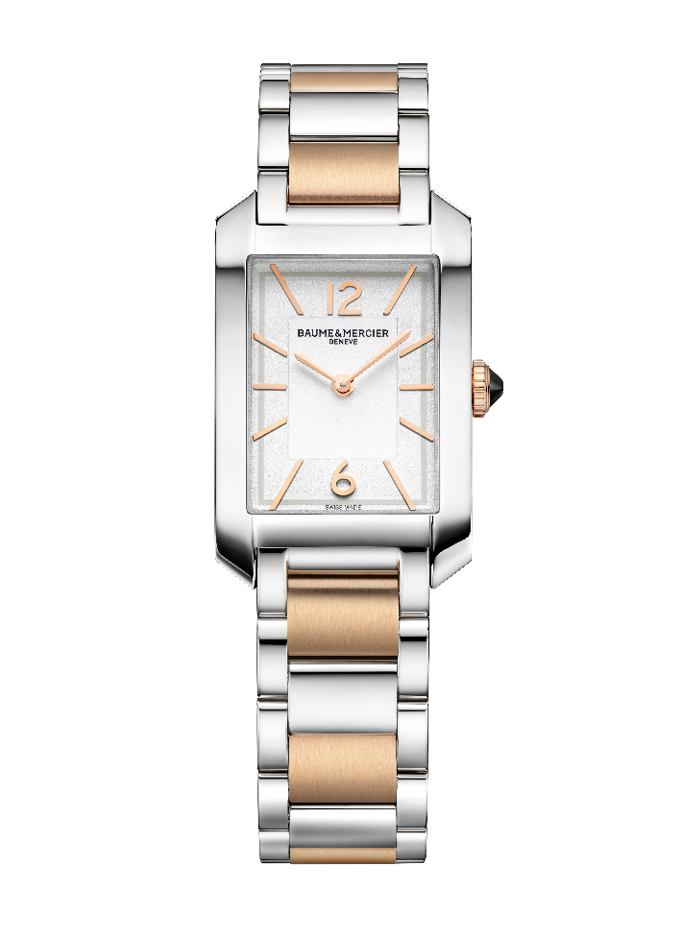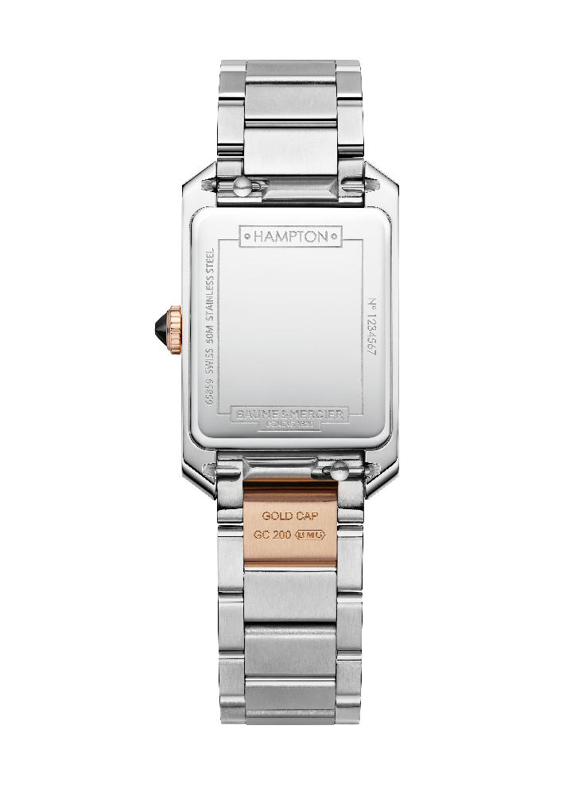

With a suppleness that offers optimal comfort, the three-row steel strap in stainless steel and satin-polished rose gold-tone steel (GC200) is interchangeable. It may be replaced without the use of tools thanks to a very reliable spring bar system.
The triple folding clasp with security push-pieces is crafted in stainless steel.

A quartz movement with an eight-year autonomy drives the mechanism of this timepiece, which offers water-resistance to 5 ATM (approximatively 50 m).

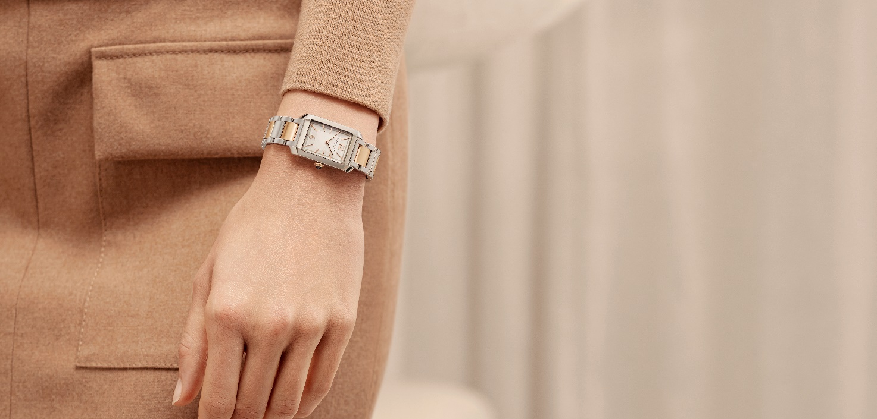

A first-rate shape watch, the Hampton once again illustrates the ease with which it can amaze us with the endless variations that sustain its historical creativity. These two ultra-elegant versions play on its shape with stylistic restraint, making them prodigious interpretations of this immensely refined Swiss watch.

Information:

Model: Hampton 10752
Availability: September 2024

Model: Hampton 10751
Availability: September 2024

ABOUT BAUME & MERCIER:

Founded in 1830 at the heart of Swiss Jura, the Baume & Mercier watch manufacture enjoys international renown. From its workshops at the heart of Swiss Jura to its headquarters based in Geneva, the Brand offers its clients the very finest timepieces. Borne by a complementary balance between an artistic approach to shape and watchmaking innovation in the service of the client, the Baume & Mercier House continues to mark the history of watchmaking by passing down the design and watchmaking expertise that is the Brand’s legacy. This savoir-faire perfectly corresponds with the spirit of cooperation between the Brand’s founders William Baume & Paul Mercier: where classicism meets creativity, tradition meets modernity, and elegance meets character... In a more contemporary way than ever.

www.baume-et-mercier.com

