THE COLORFUL SUMMER
OF THE BAUME & MERCIER RIVIERA

The saga of the Riviera collection continues, and so does the tribute that it pays to the various facets of the Côte d’Azur that inspired it. Its design and technical expertise – infused with the scenery, organic elements, and art of living along this coastline – make it both singular and diverse.

A casual atmosphere and ultra-feminine allure celebrate the summer through four new models in lively and pastel colors. Respectively in pearly white, candy pink, azure blue, and mint green, each timepiece offers a fresh take on the playful, lighthearted lifestyle that fuels the legend of this paradisaical resort destination, nestled between the sea and the mountains, bathed in sunshine.

More than a watch to wear, a Riviera watch is an experience to enjoy.

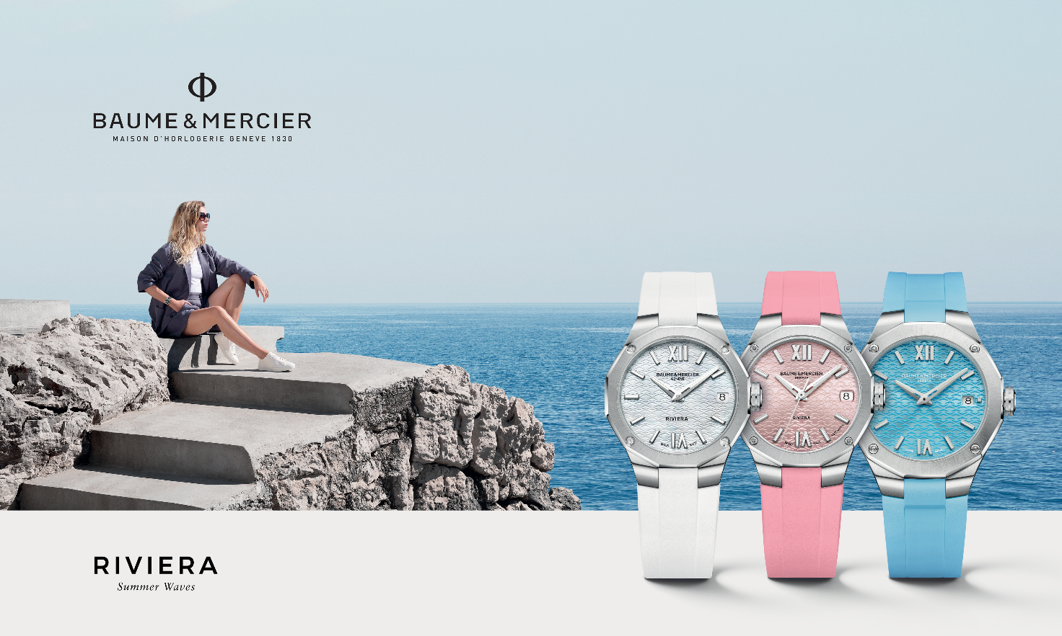

The Riviera spirit

From the Côte d’Azur to California, from islands to bays, and from promontories to marinas, the Riviera reflects a positive, chic, carefree bohemian spirit. As the day drifts by, nature reveals its spontaneous elegance of the invigorating coastline and wild foliage, and it scintillates when the festive evening rolls around. Sporty and celebratory, seaboards all over the world delight in underwater worlds filled with colorful forms of life, nautical races that surf on unchained waves, and splashy evening revelries.

The Riviera collection cultivates this way of life as an integral part of its neat, confident aesthetic. That expression takes the shape of a dodecagonal case and bezel which echo the twelve hours around its dial, considered revolutionary upon its launch in 1973. Its free spirit is chic yet casual, focusing on natural refinement, quality crafting, and comfort. These four watches put the emphasis on design in the respect of the formal principles of Baume & Mercier: perfect proportions and precise lines.

Fresh summer shades

Harmonious colors and materials are also de rigueur for the Brand. The summer season inspires four timepieces in sunny tones, revealing the purity of a cultured mother-of-pearl white, the sweetness of a candy pink, the limpidity of an azure blue, and the freshness of a minty green. Each cheerful shade brings positive energy to the mother-of-pearl or sun-satin dial and rubber strap, creating a play on contrast between finishes and textures. These bright, visually emphatic timepieces demonstrate the practiced savoir-faire and stylistic heritage of Baume & Mercier.

RIVIERA M0A10837: Pure white

Its delicate dial wavers between the subtle reflections of the cultured white mother-of-pearl that adorns it and the transparent wave transfers that decorate it. Timeless, minimalist, noble and pure, the color white radiates from its riveted Roman numerals and indexes, as well as from its faceted hands, all of which are rhodium-plated and coated with white Superluminova (which glows blue in the dark). An aperture at 3 o’clock reveals the date.

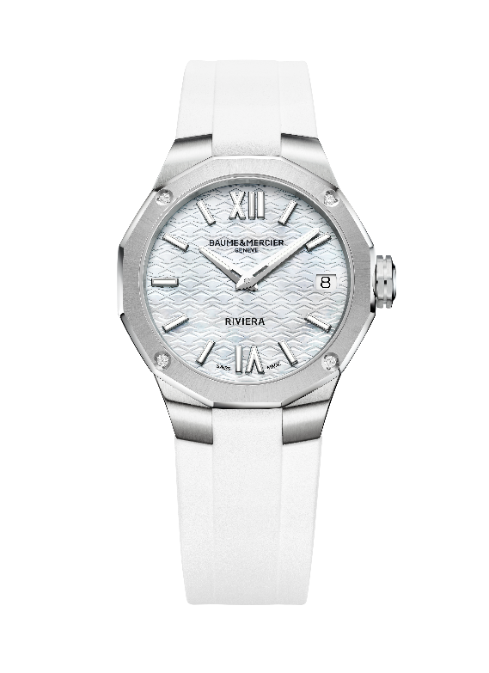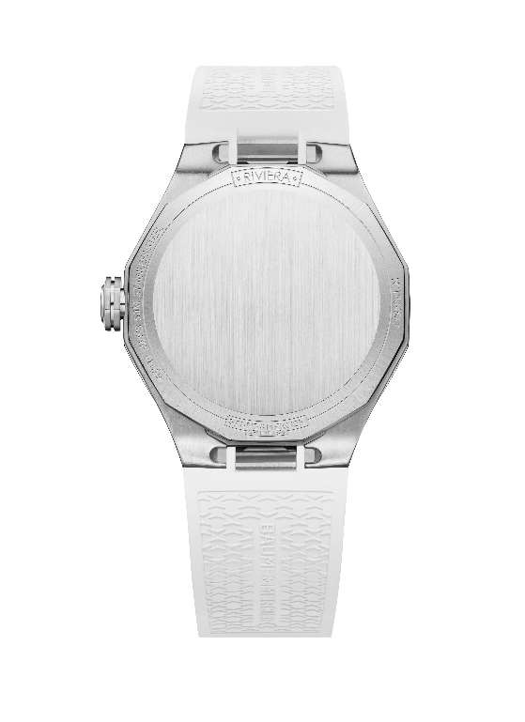

The polished and satin-finished stainless steel case forms a refined showcase with a diameter of 33 mm and a thickness of 9.6 mm. It is protected by a scratch-resistant sapphire crystal with an anti-glare coating on both sides. Its athletic elegance extends to the twelve-sided bezel in polished and sun-satin stainless steel, set with four brilliant-cut diamonds (Top Wesselton, quality VS, 0.05 carat). The dodecagonal case back is solid and may be custom-engraved. The free octogonal crown is engraved with the emblem distinctive of Baume & Mercier since 1964: the Phi logo, symbol of the golden ratio and its divine proportions.

The clean lines of this design stretch into the purity of its built-in strap, which is crafted in grained and satin-finished white rubber. The strap is interchangeable without the use of tools thanks to a very reliable, robust system. It fastens with a triple folding clasp in stainless steel with security push-pieces. Like all Riviera models, its strap may be adjusted for optimal comfort.

Hours and minutes flow by on this bright halo of understated luxury, powered by a quartz movement with a ten-year autonomy. The water-tightness of the timepiece is 5 ATM (approximately 50 m).

RIVIERA M0A10798: Candy pink

In the rosy hue of a sparkling summer day or that of an irresistibly sweet treat, this timepiece promises cheerfulness throughout the hours, minutes and seconds that it displays on its sun-satin and lacquered pink dial adorned with transparent wave transfers. Its Roman numerals and indexes are riveted, rhodium-plated, and coated with Superluminova (which glows blue in the dark). The hands are faceted and rhodium-plated. The date appears at 3 o’clock.

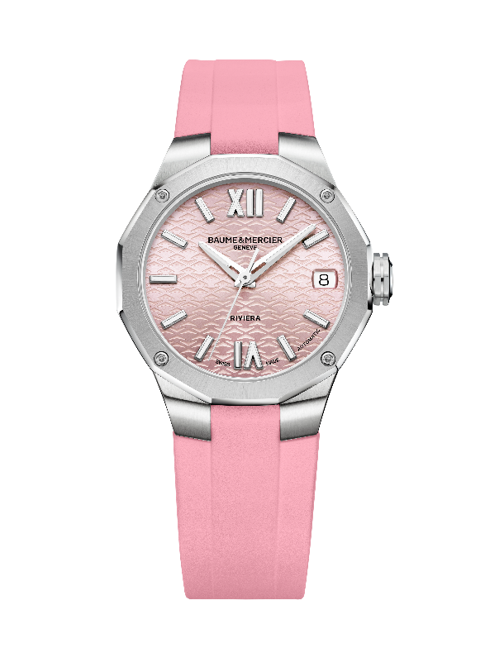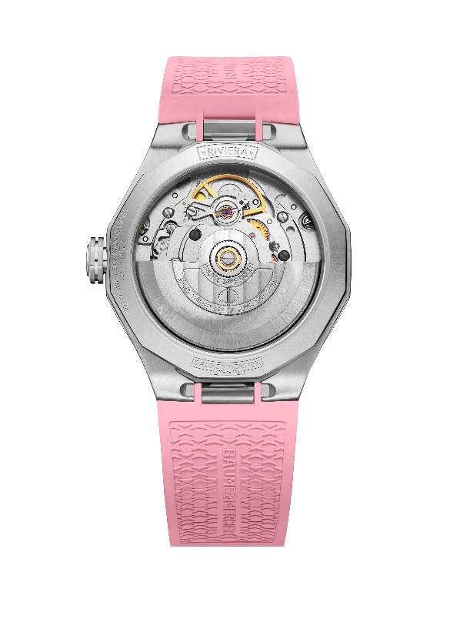

This chromatic variation brings dynamic energy to the case in polished and satin-finished stainless steel with a diameter of 33 mm and a thickness of 9.6 mm. It is protected by a scratch-resistant sapphire crystal with an anti-glare coating on both sides. Fastened by four polished steel screws, the bezel is crafted in polished and sun-satin stainless steel. The dodecagonal case back is itself protected by a sapphire crystal that can accommodate a custom engraving. The Phi logo is engraved in relief on the free octagonal crown.

The built-in strap, crafted in grained and satin-finished pink rubber, accentuates the fun chromatic effect for a particularly feminine appeal. A robust, reliable mechanism makes it possible to change the strap without the use of tools thanks. Its folding buckle is crafted in stainless steel, and it features security push-pieces and an easy adjustment feature.

This model is driven by a self-winding movement. It features a 38-hour power reserve, oscillates at a frequency of 4Hz (28,800 vph), and offers water-resistance to 5 ATM (approximately 50m).

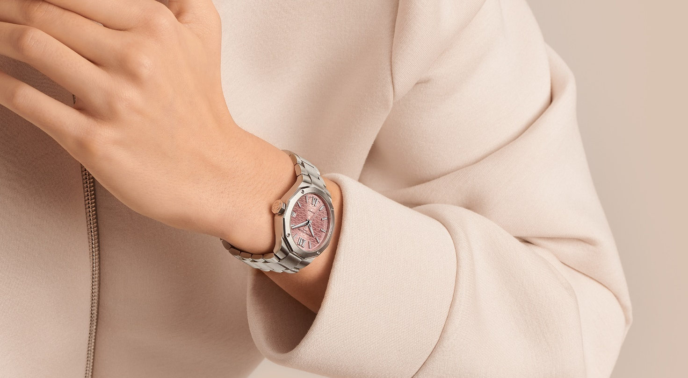

RIVIERA M0A10611: The freshness of mint green

From first glance, this minty-fresh green dial captivates the eye. Cool and clear like the world’s most limpid waters or the foliage of a pine grove overlooking the ocean, this watch is an ode to the beauty of nature. This dreamy landscape of sun-satin and lacquered finishes is adorned with transparent wave transfers. Here, riveted, rhodium-plated Roman numerals harmoniously take their place among riveted indexes and rhodium-plated faceted hands, all coated in white Superluminova (C1, which glows blue in the dark). An aperture at 3 o’clock reveals the date.

The iconic case in polished and satin-finished stainless steel has a diameter of 36 mm and a thickness of 9.5 mm. Protected by a scratch-resistant sapphire crystal treated on both sides with an anti-glare coating, it is topped with a polished and sun-satin stainless steel bezel held in place by four polished steel screws. The dodecagonal case back is fastened by four screws. The free octagonal crown is engraved with the Phi logo in relief.

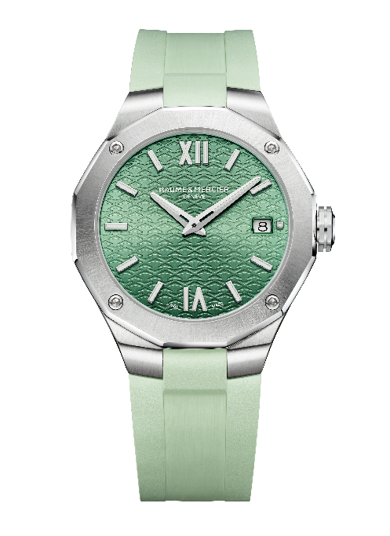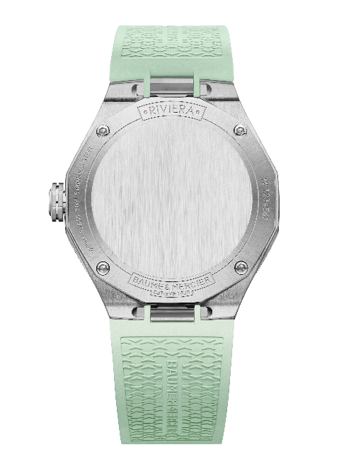

In grained and satin-finished light green rubber, the built-in strap is interchangeable. It may be removed and replaced thanks to an ingenious system that is very reliable and robust, and that requires no tool. It fastens with a triple folding clasp in stainless steel with security push-pieces and an easy adjustment feature.

The quartz movement that powers the timepiece offers a ten-year autonomy. The watch is water-resistant to 5 ATM (approx. 50 m).

RIVIERA M0A10800: The vibrancy of azure blue

The azure blue of this lacquered sun-satin dial, punctuated by a decoration of tone-on-tone wave transfers, immerses the eyes in a vivifying sea. The summer of the Riviera collection flows by on the riveted and rhodium-plated Roman numerals and indexes coated with white Superluminova. The faceted, rhodium-plated hands are also coated with white Superluminova (which glows blue in the dark). The date appears in an aperture at 3 o’clock.

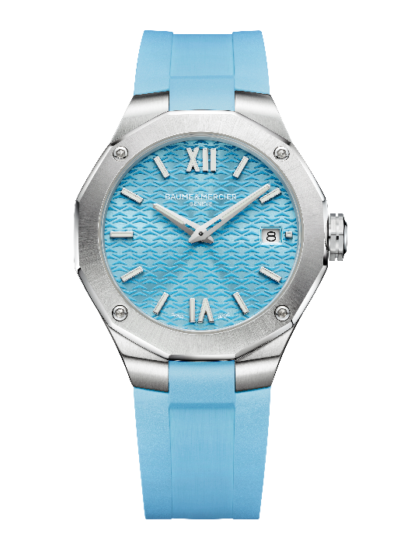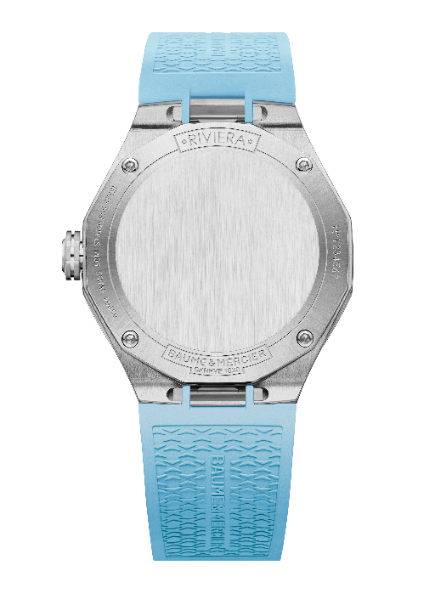
The dodecagonal case in polished and satin-finished stainless steel outlines this aquatic motif within a diameter of 36 mm and a thickness of 9.5 mm. It is protected by a scratch-resistant sapphire crystal with an anti-glare coating on both sides. In polished and sun-satin stainless steel, the bezel is fastened by four screws in polished steel. The solid case back, also dodecagonal and crafted in polished steel, can accommodate a customized engraving. The free, octagonal crown bears the signature of Baume & Mercier – the Phi logo – in relief.

The built-in strap in grained and satin-finished azure blue rubber reinforces the seaside spirit of this timepiece. It is interchangeable without the need for tools thanks to a very robust without, reliable mechanism. Its stainless steel triple folding clasp has security push-pieces.

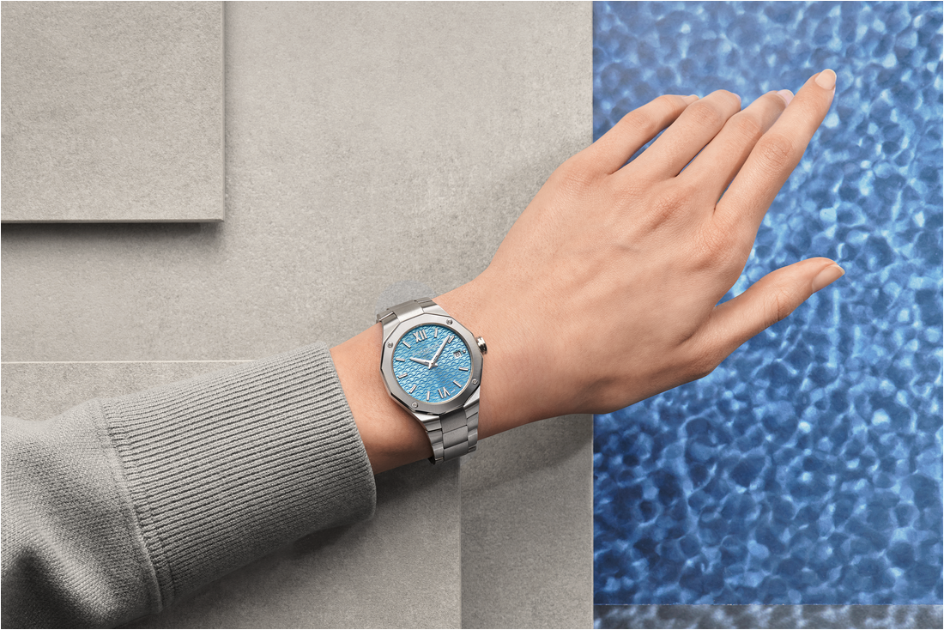

Powered by a quartz movement with a ten-year autonomy, this model is water-resistant to 5 ATM (approximatively 50m).

These four models, to become available in July, perfectly illustrate the designer spirit of Baume & Mercier. They playfully coordinate with a fresh summer wardrobe. This is the look that truly characterizes the Riviera collection. With it, the summer will always be bright and inspiring.

Information:

Model: Riviera 10837
Availability: June 2024

Model: Riviera 10798
Availability: June 2024

Model: Riviera 10611
Availability: June 2024

Model: Riviera 10800
Availability: June 2024

ABOUT BAUME & MERCIER:

Founded in 1830 at the heart of Swiss Jura, the Baume & Mercier watch manufacture enjoys international renown. From its workshops at the heart of Swiss Jura to its headquarters based in Geneva, the Brand offers its clients the very finest timepieces. Borne by a complementary balance between an artistic approach to shape and watchmaking innovation in the service of the client, the Baume & Mercier House continues to mark the history of watchmaking by passing down the design and watchmaking expertise that is the Brand’s legacy. This savoir-faire perfectly corresponds with the spirit of cooperation between the Brand’s founders William Baume & Paul Mercier: where classicism meets creativity, tradition meets modernity, and elegance meets character... In a more contemporary way than ever.

www.baume-et-mercier.com

