CLIFTON, ICE BLUE EDITIONS

Baume & Mercier unveils two new limited editions within its Clifton collection: a 39 mm Automatic, date and a 40 mm Automatic, Perpetual Calendar. Both creations are powered by the Maison’s Baumatic movement and feature an exclusive ice blue guilloché dial.
These two timepieces, central to the Clifton collection, expertly blend watchmaking heritage with a vintage aesthetic. Their exclusive new dial color introduces a distinctive look to the collection, further affirming the Maison’s contemporary watchmaking vision.

* * * * *

THE PERPETUAL MOTION OF LIGHT
Staying true to the defining features of the collection, the two limited editions combine elegant design with watchmaking expertise. An exclusive guilloché, dressed in ice blue, where every reflection reveals a new expression of light. The new details complement the redesigned case, refined proportions and carefully considered finishes, of the Clifton collection relaunched in 2025.
Powered by the Baumatic manufacture movement, renowned for its five-day power reserve, precision and resistance to everyday magnetic fields, Clifton combines lasting performance with elegant design. Available in two complementary interpretations - a 39 mm Automatic, date, and an exceptional 40 mm Automatic, Perpetual Calendar - these new creations present the Clifton collection in a new light.

THE COLLECTION’S VINTAGE INSPIRATION
Inspired by vintage aesthetic codes of the 1950s, the Clifton collection stands out for its attention to every detail: harmonious proportions, refined finishes, and clean readability. Echoing the watchmaking elegance of the 1950s inspirational model, the proportions have been refined with a more compact and balanced case, highlighting a silhouette that is both contemporary and timeless. The domed sapphire crystal, Arabic numerals positioned at key points, and the integrated crown perfectly following the lines of the case have also been introduced.
The ice blue hue serves as the ultimate detail, nodding to that particular design era of the 50s. It fully expresses the essence of Baume & Mercier where watchmaking savoir-faire and sophistication meet in a signature that is both discreet and assertive.
Since its redesign in 2025, Clifton has continued to evolve while remaining faithful to its original spirit. These two new limited editions further enrich the collection, reaffirming its place as the Maison’s watchmaking signature.

THE MOMENT ONLY YOU NOTICE
Life is about moments. The ones that stop you. The ones that stay with you.
The ones you didn’t know you were carrying – until something brings them back.
The moment you pause, when everyone else walks past.
A quality of light through a window. The worn edge of something made to last.
A detail so considered, it could only have been intentional.
Some moments belong entirely to the present, others carry the weight of another era - and refuse to be forgotten.
The rarest moments are both. When something stops time and you know, without knowing why, that you’ll remember this.

YOU DON’T CHASE THESE MOMENTS. YOU SIMPLY KNOW TO VALUE THEM.

That is your Clifton moment.

CELEBRATING MEANINGFUL MOMENTS since 1830

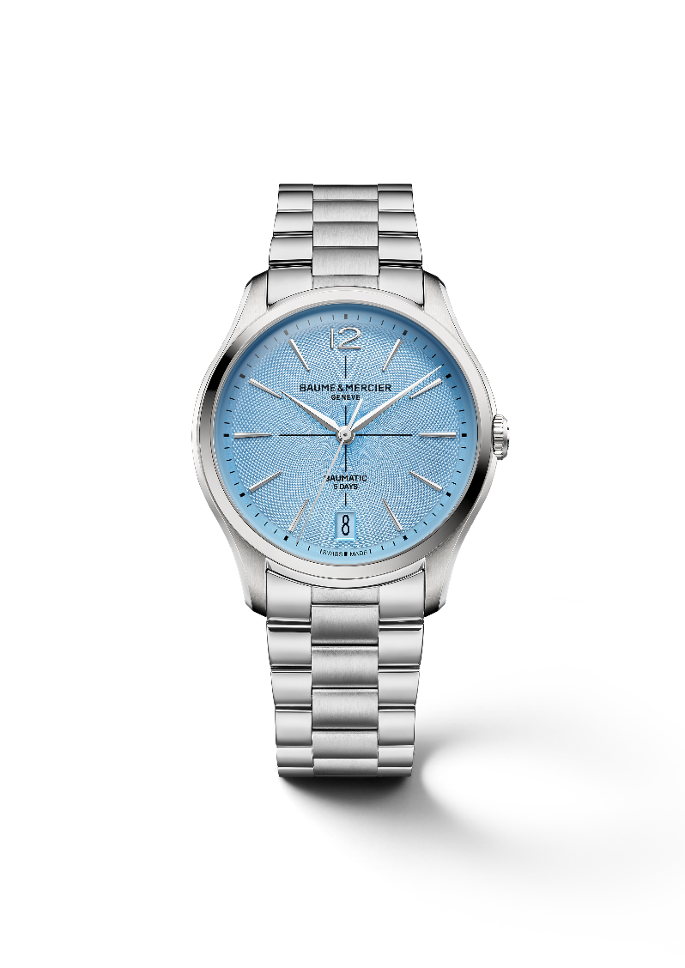

CLIFTON BAUMATIC 39MM M0A10870
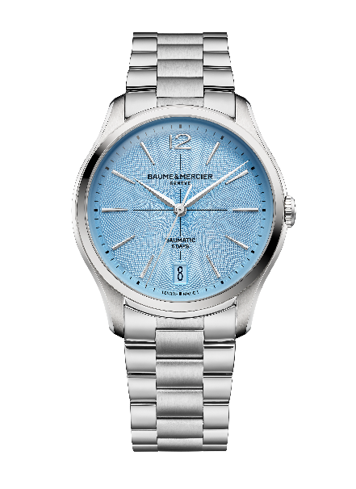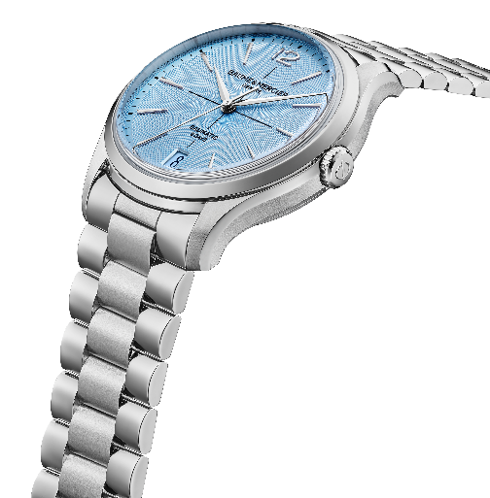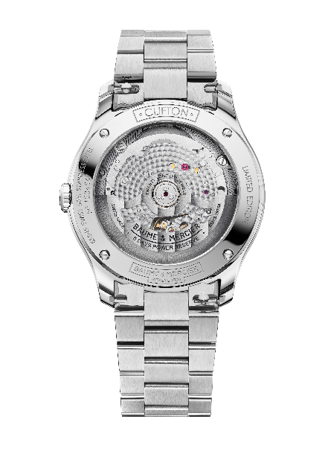
- Movement
Manufacture self-winding Baumatic (BM13-1975 A)
Bridges with circular-grained decor
Sandblasted plate with snailed decor
Open-worked oscillating weight adorned with “Côtes de Genève” and snailed decors
Specific Baume & Mercier engravings
Power reserve: 5 days (120 hours)
Jewels: 21
Frequency: 4Hz (28,800 vph)
Size: 12 ½ ’’’ / Thickness: 4.2 mm
- Functions
Hours, minutes, seconds, date
- Case
Round
Size: 39 mm
Thickness: 11.22 mm
Polished and satin-finished stainless-steel case and crown
Antiglare (2 faces) scratch-resistant domed sapphire crystal
Open sapphire case back secured with 4 screws and special engraving “Limited Edition” with possibility to engrave the case back
- Dial
Ice-blue dial with guilloché pattern
Black crosshair in the center
Snailed minute track
Riveted rhodium-plated trapezoid-shaped slightly elongated indexes and Arabic numeral at 12 o’clock
Faceted rhodium-plated alpha hour and minute hands
Rhodium-plated seconds hand
Tone-on-tone date display at 6 o’clock
- Bracelet
Integrated 3-row polished and satin-finished stainless-steel bracelet
Interchangeable bars system allowing bracelet changes without tools
- Buckle
Polished and satin-finished stainless-steel triple folding buckle with security push-pieces
- Water resistance
50m (approx. 5 ATM)

CLIFTON BAUMATIC PERPETUAL CALENDAR 40MM M0A10872
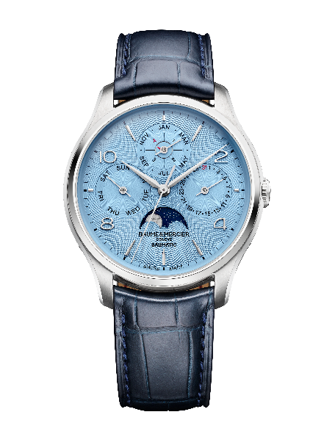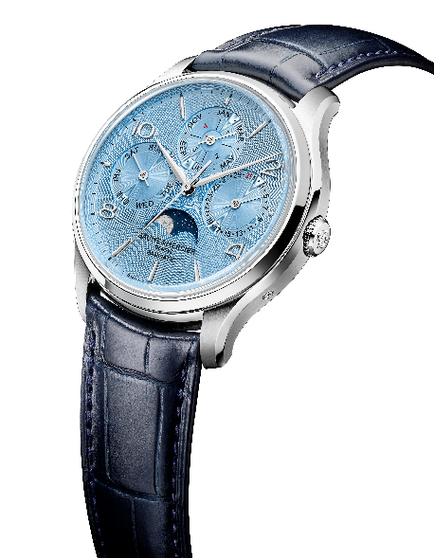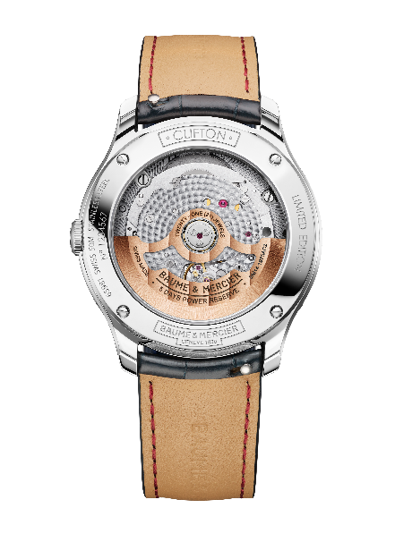
- Movement
Manufacture self-winding Baumatic movement with Dubois-Dépraz module (BM13-1975 AC2)
Bridges with circular-grained decor
Sandblasted plate with snailed decor
Gilded open-worked oscillating weight adorned with “Côtes de Genève” and snailed decors
Specific Baume & Mercier engravings
Power reserve: 5 days (120 hours)
Jewels: 21
Frequency: 4Hz (28,800 vph)
Size: 13 ¼ ’’’ / Thickness: 5.8 mm
- Functions
H/M/S, day, date, month, leap year indicator and moon-phase
- Case
Round
Size: 40mm
Thickness: 12.9 mm
Polished and satin-finished stainless-steel case and crown
Antiglare (2 faces) scratch-resistant domed sapphire crystal
Open sapphire case back secured with 4 screws and special engraving “Limited Edition” with possibility to engrave the case back
- Dial
Ice-blue dial with guilloché pattern
Snailed counters and minute track
Riveted rhodium-plated trapezoid-shaped slightly elongated indexes and Arabic numerals at 2, 4, 8 and 10 o’clock
Faceted rhodium-plated alpha hour and minute hands
Rhodium-plated seconds and counters hands
Leap year disc with red pointer
Blue moon-phase disc with polished rhodium moon
- Strap
Interchangeable blue all square scales alligator strap with tone-on-tone stitching
Interchangeable bars system allowing strap changes without tools
- Buckle
Polished and satin-finished stainless-steel pin buckle
- Water resistance
50 m (approx. 5 ATM)

