THE RIVIERA COLLECTION BY BAUME & MERCIER
CELEBRATES THE ARRIVAL OF THE SUMMERTIME

PASTEL-COLORED DIALS FOR THE WOMEN’S WATCHES
RETURN OF THE WHITE DIAL
A GOLD-TONE DIAL FOR AN EXQUISITELY REFINED BAUMATIC TIMEPIECE
A SPORT-CHIC SPIRIT INSPIRED BY THE FRENCH RIVIERA

Ever swift to capture the spirit of the times and become the companion for each of life’s occasions, the Riviera collection brings its enchantment to the summertime, celebrating the casual elegance and unparalleled conviviality of this season. The legendary dodecagonal silhouette of the timepiece lends itself to particularly radiant new versions. Pastel dials brighten three new women’s pieces: warm silver (Riviera M0A10810), light blue (M0A10811), and pink (M0A10812). The white dial (Riviera M0A10829) makes its big comeback since the reintroduction of the Riviera in 2021, joining the range of blues, blacks, and greens that have made the collection so successful. A gold-tone dial with a vintage aesthetic brings exquisite refinement to a men’s timepiece equipped with a Baumatic movement (M0A10822).

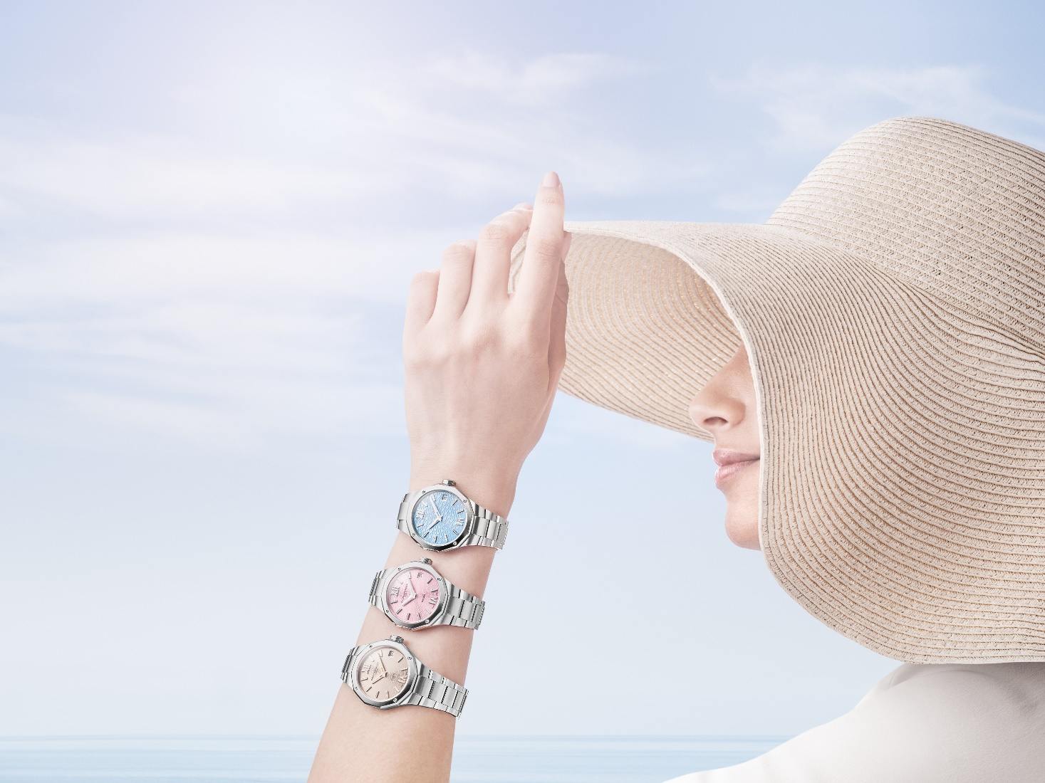

Each of these watches brilliantly embodies the sport-chic spirit of the collection, bringing with it the irresistible allure of the French Riviera, its organic beauty, and its liberating lifestyle where luxury meets indulgence. The passion for shape watches and the savoir-faire of Baume & Mercier are expressed in each surface, each angle, each material, and each shade of this high-contrast universe, reflecting the Riviera’s refined personality, natural elegance, and geographic versatility, from sea to land to mountains.

These five new watches are a lighthearted invitation to celebrate the summer season with the whimsical allure so distinctive of the Brand.

The art of crafting shape watches, magnificently exalted in summer colors

When the ultimate shape watch echoes a season as inspiring and expressive as the summer, the result is a bright aesthetic approach that unleashes lavish creativity. Since it was launched in 1973, the Riviera collection has delighted in endless reinventions while remaining forever loyal to itself. It plays on its own codes, lending the twelve sides of its atypical design to a variety of stylistic inspirations and watchmaking complications.

Meticulously crafted details, fresh tonalities, and refined textures sculpt the tight lines and precise angles of the new Riviera models, warming their dials with a sunny glow.

The three women’s pieces are an ode to color, bursting with crisp pastel tones. Their intensity is truly stunning. This chromatic palette will delight every woman, offering options for every taste and every moment of the day. The summer atmosphere radiates on each woman’s delicate wrist, where effortless style meets comfort and reliability.

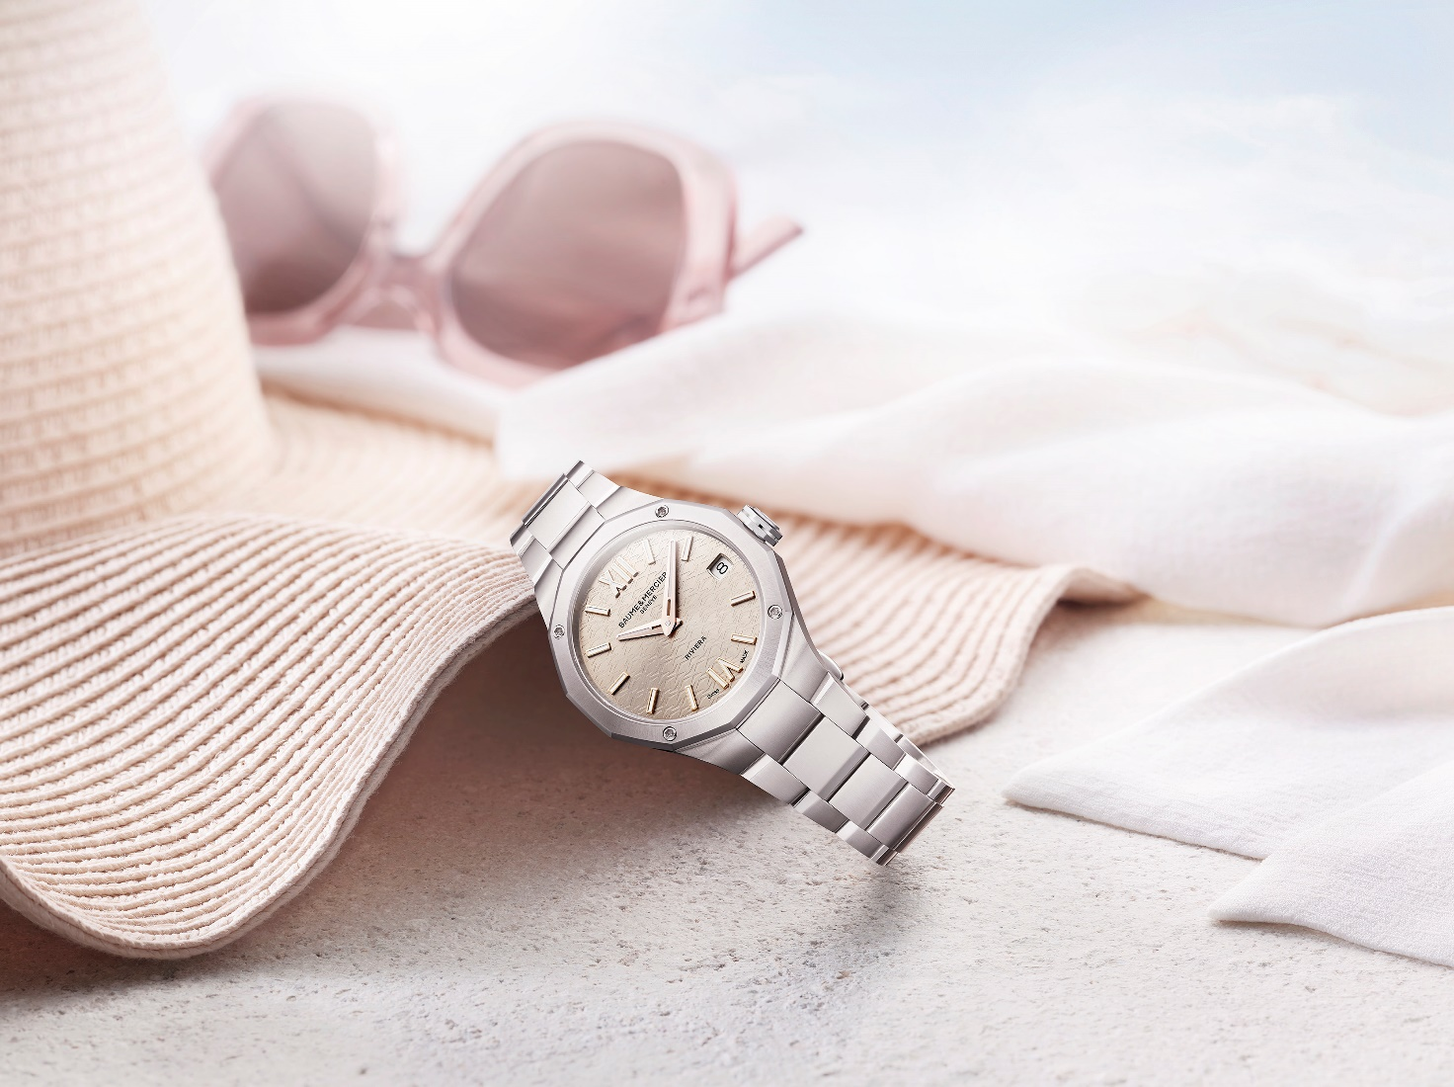

The Riviera M0A10810 has a warm silver dial that is one of the Brand’s signature tones, already available on a self-winding version and another with a gem-set dial. This hue evokes the radiant sun that brings a fiery, incandescent caress to the transparent wave and mountain patterns and sets ablaze the polished satin-polished steel of the case and bracelet. The Riviera M0A10811, with its azure blue dial, captivates the eye with its clear, fresh hue inspired by the rolling waves of the sea or the sparkling depths of a pool beckoning with refreshment. The Riviera M0A10812 is an irresistible temptation in playful, vibrant pink, setting the tone for the cheerful, sweet, carefree times to come.

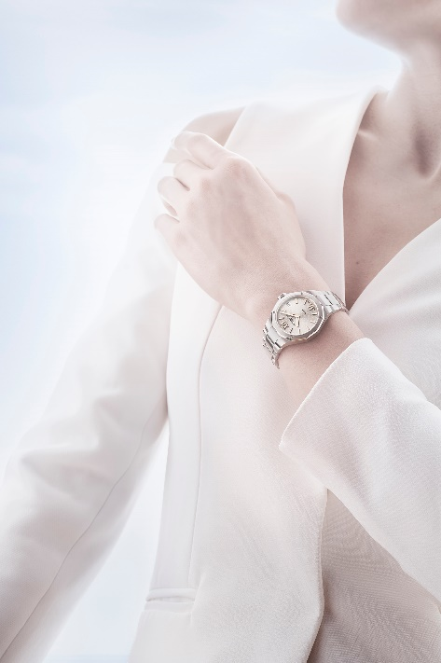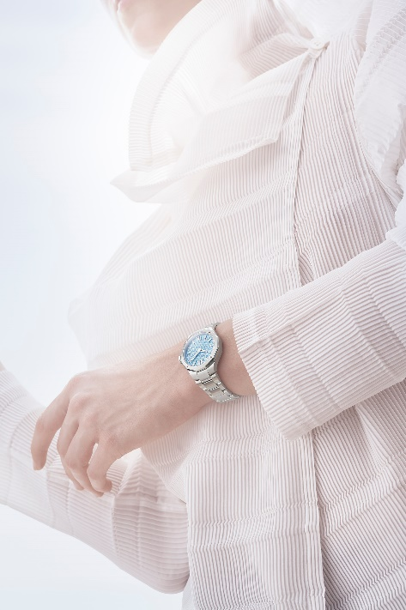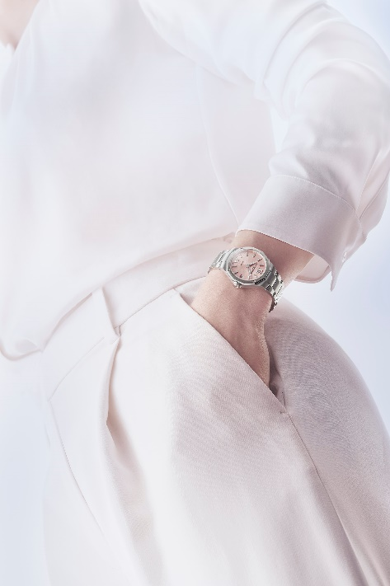

The summer takes on fresh white in the form of a men’s model for a clear, clean timepiece expressing serene simplicity and elite purity. Its black outer flange boldly frames it against its steel case, echoing the crisp contrasts of the Riviera Chronograph M0A10827 revealed at Watches & Wonders.

The quintessence of sophistication, a special men’s edition with a gold-tone dial offers a spectacularly glamorous vintage charm. This precious piece reverberates with the magic of the French Riviera’s festive summer nights and the opulence of its luxurious villas. It is powered by a self-winding Baumatic Manufacture movement, guaranteeing the precision and reliability that expresses the desire for excellence of the gentleman who wears it. This piece embodies prestige, success and elegance without ostentation.

Relaxing, festive moments with friends in the signature Baume & Mercier style

Baume & Mercier accompanies all of life’s occasions, making them unique, unforgettable sources of emotion. It dedicates its watchmaking expertise and designer savoir-faire to these precious moments of friendship and sharing. Ease and conviviality prevail, punctuated with laughter, leisure, and recreation. The French Riviera sets the scene with paradisaical coastlines, wild coves, and the streamlined architecture of its chic villas. Here, life drifts by in effortless leisure: warmed by the sun, shaded by a parasol, or stretched next to a sparkling blue pool where a pink float invites the swimmer to lounge and linger, or simply to plunge a hand into its placid surface for instant invigoration. The refreshment of an ice cream cone, the juicy red flesh of a watermelon, or a glass of homemade ice cream. A pink lounge chair welcoming relaxation. The amber scent of tanning oil mingling with the sun-drenched landscape in a sunrise palette of blue, pink, and warm silver. Pops of color flash from beach towels, sunglasses, and popsicles. A hymn to the summer in the hues of the new Riviera Summer watches by Baume & Mercier.

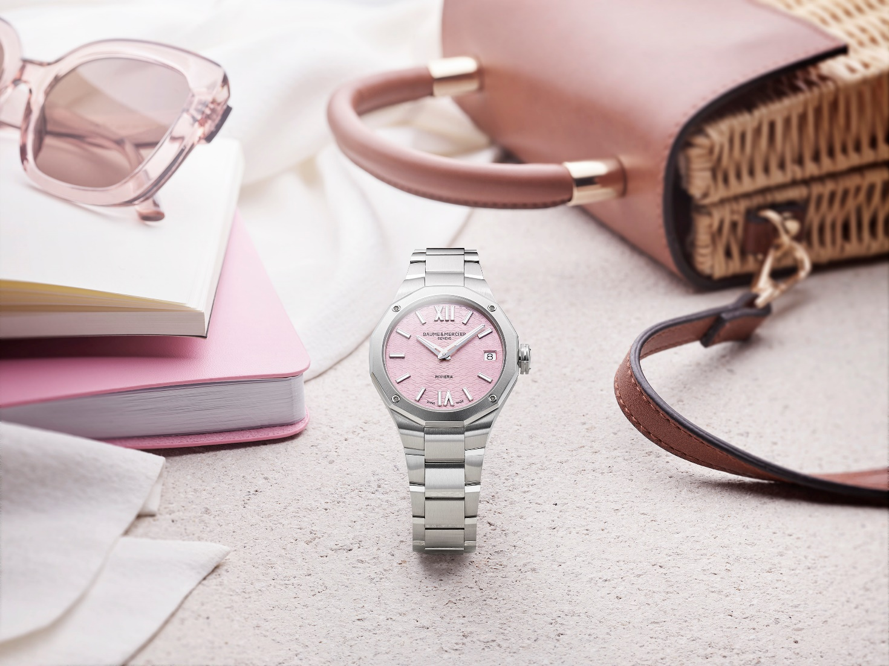

Both elegant and casual, the Riviera is also the perfect companion at sundown for even the most lavish evenings. Its pastel, white, or gold-tone allure and refined finishes bring each one that special aura which makes it so irresistible. More than a watch, it is the natural yet sophisticated expression of a unique style.

- RIVIERA M0A10810: the warm silver of a sun-drenched summer

The dial of this timepiece could be a dazzling tribute to Helios, the Ancient Greek sun god, known in Egypt as Ra and in Ancient Rome as Sol. The transparent wave-and-mountain transfer decoration against the warm tone of sun-satin silver and the scintillating gold-tone hour markers sweep the imagination away to an enthralling, incandescent French Riviera. The Roman numerals, riveted indexes, and faceted hands are adorned with a flamboyant 5N gold plating highlighted with white Superluminova (blue glow). The date clearly appears in a white aperture at 3 o’clock.

The refinement of this model extends to its perfectly proportioned case so distinctive of Baume & Mercier. Its 33 mm diameter and restrained thickness of 9.22 mm brilliantly reconcile the lightness and daintiness of this exquisitely feminine watch. This balance, emanating from the savoir-faire of master watchmakers, brings out the legendary beauty of the twelve-sided bezel. Protected by a scratch-resistant sapphire crystal with an anti-glare coating on both sides, it is crafted in satin-polished stainless steel, like its bezel, which is adorned with four screws. The solid case back, in the same dodecagonal shape, may be custom-engraved. The free octagonal crown is adorned with an embossed Phi logo.

This watch is mounted on an integrated three-row bracelet in satin-polished stainless steel. It is not only interchangeable: it may be easily removed and replaced without the need for tools thanks to a very reliable, robust system. It fastens with a triple folding clasp in stainless steel with security push-pieces.

The hours, minutes, and dates are driven by a quartz movement with a 10-year autonomy. The water-tightness of the timepiece is 5 ATM (approximately 50 m).

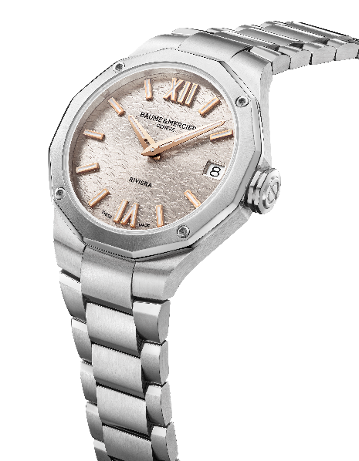
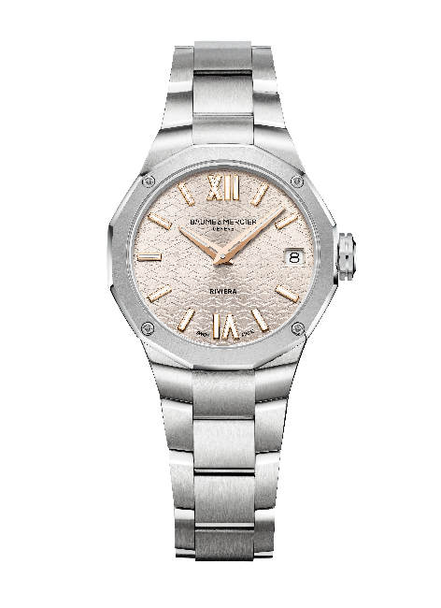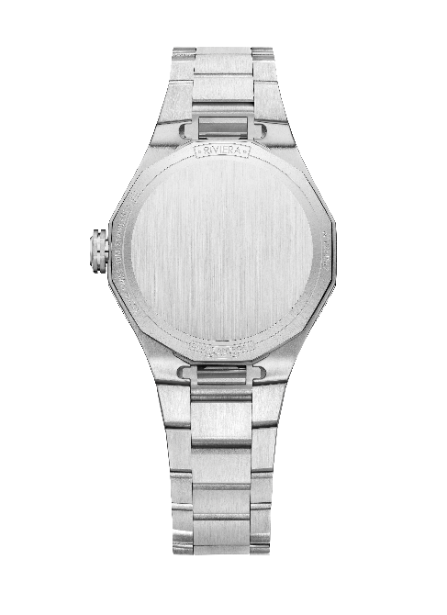

- RIVIERA M0A10811: the azure blue of a Mediterranean summer

Not to be missed this summer, the Riviera collection takes on a new blue timepiece inspired by the aquatic world. This Riviera offers a refreshing plunge into the waves of its transparent transfer decorations, sprinkled with Roman numerals, riveted indexes, and faceted hour and minute hands, all rhodium-plated and coated with white Superluminova (blue glow). An aperture at 3 o’clock reveals the date.

With a diameter of 33 mm and a thickness of 9.22 mm, the satin-polished stainless steel case highlights the chic side of this sporty watch, topped with a scratch-resistant sapphire crystal with an anti-glare coating on both sides. Fastened by four screws, the bezel is crafted in polished and sun-satin stainless steel. The solid dodecagonal case back may be custom-engraved. The free octagonal crown is adorned with the embossed Phi logo.

The integrated three-row bracelet in satin-polished stainless steel is interchangeable. A very reliable, robust system makes it possible to remove it and replace it without the need for tools. The triple folding buckle, featuring security push-pieces, is crafted in stainless steel.

Powered by a quartz movement with a 10-year autonomy, this model is water-resistant to 5 ATM (approximatively 50m).

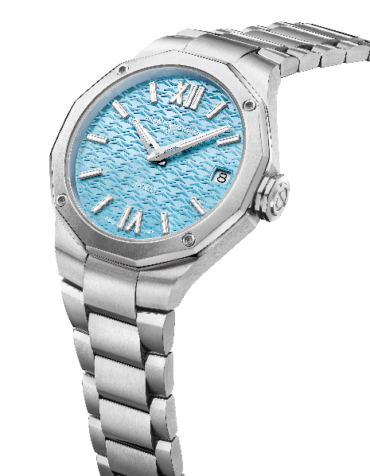
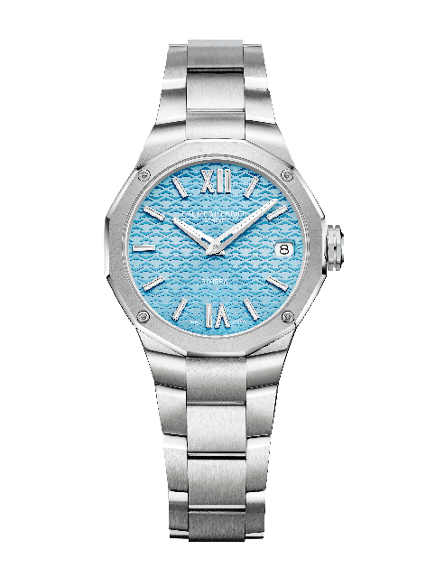

- RIVIERA M0A10812: the pink of summer sweetness

Summertime is even more irresistible with this cheerful, impish watch, featuring a sun-satin pink dial decorated with transparent transfers of waves and mountains. The designs appear to dance with peaks and valleys. The Roman numerals and riveted indexes are rhodium-plated and coated with white Superluminova (blue glow), like the faceted hour and minute hands. The date appears in a white aperture at 3 o’clock.

This particularly feminine pastel pink version brings a great deal of softness to the satin-polished stainless steel case with perfect proportions: 33 mm in diameter and 9.22 mm in thickness. It is protected by a scratch-resistant sapphire crystal with an anti-glare coating on both sides. Also crafted in polished and sun-satin stainless steel, the bezel is decorated with four screws; the solid dodecagonal back may be engraved. Adorned with the embossed Phi logo – the Brand’s symbol representing the Golden Ratio and its divine proportions –, the free crown is octagonal.

The integrated strap features three rows of satin-polished stainless steel links. It is interchangeable thanks to a very reliable, robust system. Featuring security push-pieces, the triple folding buckle is also crafted in stainless steel. Water-resistant to 5 ATM (approximately 50m), this timepiece, powered by a quartz movement, offers 10 years of autonomy.

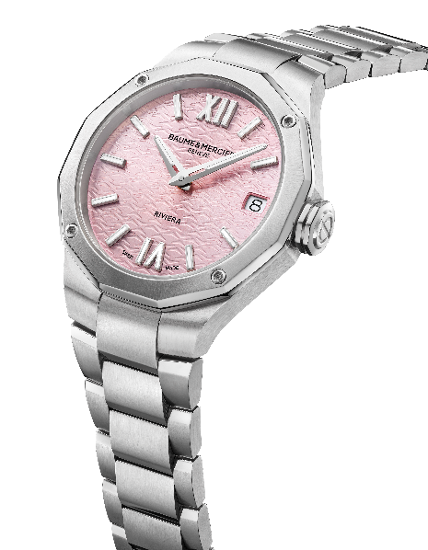
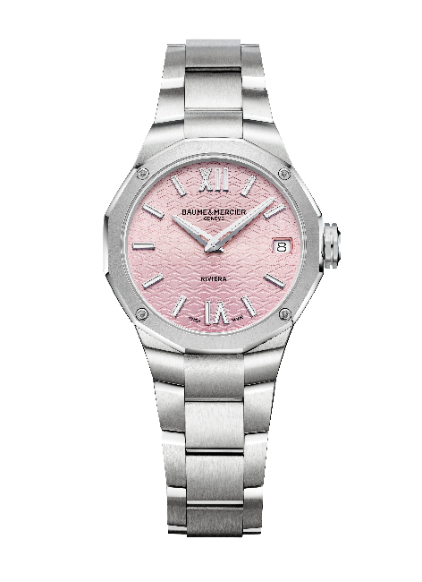

- RIVIERA M0A10829: the white of a radiant summer

Carrying the very essence of this collection with a subtle balance between its sparkling, pure white dial – perfect for the summer – and the black of the flange that surrounds it, this timepiece takes a very sought-after aesthetic approach for a beautifully contrasted effect. Against the decoration of waves and mountains, the time is displayed on rhodium-plated Roman numerals and indexes coated with white Superluminova (blue glow). The faceted hour and minute hands are also rhodium-plated and coated with white Superluminova (blue glow), offering a harmonious complement to the dial. Echoing the contrast of the black edge, the black seconds hand brings depth to this immaculate aesthetic. The Phi logo, the Brand’s emblem that represents its pursuit of perfection and fine crafting, appears as a counter-balance. An aperture at 3 o’clock reveals the date.

With a diameter of 42 mm and a thickness of 10.66 mm, the satin-polished stainless steel case frames this watch and its well-structured design. It is protected by a scratch-resistant sapphire crystal with an anti-glare coating on both sides. Fastened by four screws, the bezel is crafted in polished and sun-satin stainless steel. Four screws also appear on the back, where a sapphire crystal reveals the fascinating spectacle of the watch movement. The case back may be engraved. The octagonal steel crown is free and adorned with the embossed Phi logo and a black line.

The integrated three-row bracelet is crafted in satin-polished stainless steel. It features a very reliable, robust system that enables it to be changed without the need for tools. It fastens with a triple folding clasp in stainless steel with security push-pieces.

The self-winding movement offers a 38-hour power reserve and oscillates at a frequency of 4Hz (28,800 vph). It is water-resistant to 10 ATM (approximately 100 m).
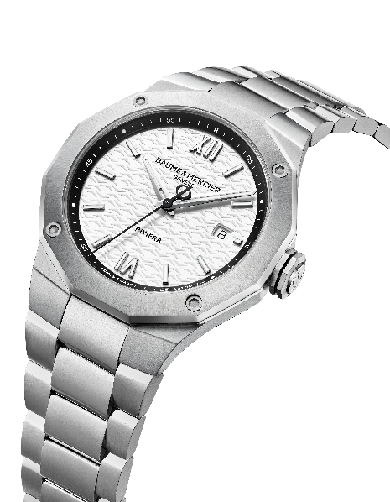
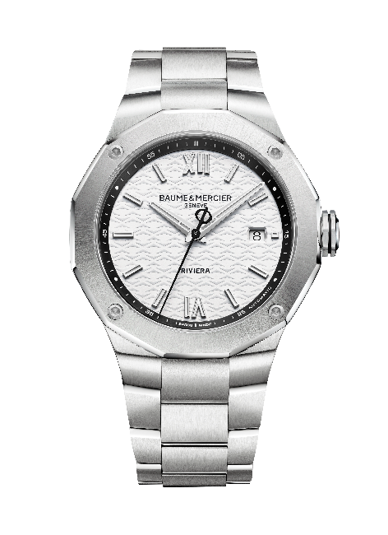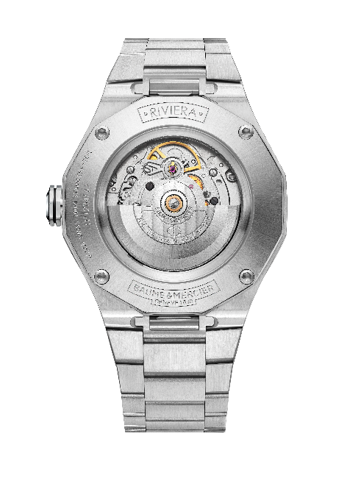

- RIVIERA M0A10822 - Special Baumatic Edition: the gold tone of a sunny summer

Its well-structured silhouette beautifully combines gold tone and steel; retro charm and contemporary appeal; and various delicately contrasted finishes, including vertical satin, satin polish, snailing, and rhodium plating. The summer dresses up in luxury and glamor for a style lesson in timeless, sophisticated elegance.

The dial asserts vertical satin effects that bring it a depth and texture that flatter its beauty. Its gold tone draws its warmth and softness from its vintage inspiration. The meticulous choice of colors masterfully balances the surge of invigorating energy with the restraint of sobriety. A snailed minute track sets the pace for the dial surround, dotted with riveted tone-on-tone golden indexes. The hours and minutes are displayed on rhodium-plated, openworked hands, while the seconds are indicated by a blued steel hand adorned with the Phi logo as a counter-balance. The date appears in a wide gold-tone aperture.

In satin-polished stainless steel, the case – with a diameter of 39 mm and a thickness of 10.2 mm – is protected by a scratch-resistant sapphire crystal with an anti-glare coating on both sides. The polished and sun-satin finishes of the bezel, secured by four screws, highlight the luminous aspect of its stainless steel crafting. A delicate “Special Edition” engraving adorns the dodecagonal back, which is topped with a sapphire crystal and fastened with four screws. Up until now, the Riviera Baumatic models have always been adorned with a transparent sapphire dial. This is the first Special Edition Riviera Baumatic to feature an opaque dial in order to flatter its golden color. The free octagonal crown is embossed with a Phi logo. It is decorated with a blue line, reflecting the blued steel of the seconds hand.

The integrated three-row bracelet in satin-polished stainless steel is a harmonious extension of the case. It features a very reliable, robust system that enables it to be changed without the need for tools. The triple folding buckle is crafted in stainless steel and features security push-pieces.

A self-winding Baumatic Manufacture movement (BM13-1975A) drives this exquisitely crafted watch, showcasing its elaborate watchmaking expertise. Its resistance to everyday magnetic fields reaches 1,500 Gauss; it oscillates at a frequency of 4Hz (28,800 vph); its power reserve lasts 5 days for 120 hours of autonomy; and it offers water-resistance to 10 ATM (approximately 100m).

Its magnificent finishes demonstrate the same refined details: the bridges are circular-grained; the baseplate is sand-blasted and snailed; and the oscillating weight is gold-tone and openworked with Côtes de Genève and snailed decorations. It also bears a unique Baume & Mercier engraving.

Furthermore, like all Baumatic models, it benefits from a warranty extension of 6 years in addition to the standard 2 years of the international warranty. Simply register the piece on the Baume & Mercier website within 60 days after purchase on www.baume-et-mercier.com and activate the extension.

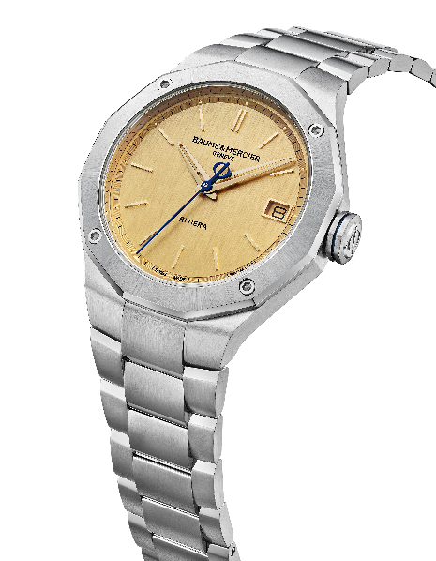
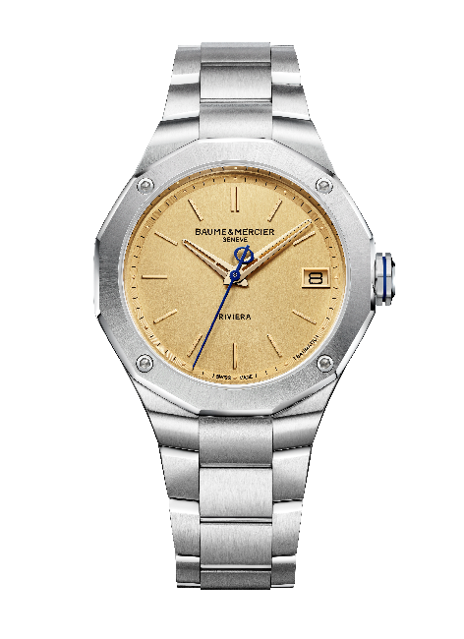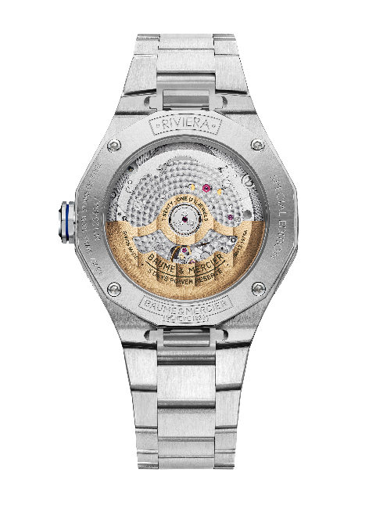

The new Riviera watches by Baume & Mercier are a clear invitation to fully embrace the summer and to bring each second the radiant dimension imbued by a pastel, white, or gold-tone dial.

