THE SHAPES OF LOVE

Baume & Mercier, the renowned Swiss watchmaking Maison, proudly unveils a unique creative concept to celebrate Valentine’s Day: The Shapes of Love. This poetic initiative harmoniously blends the Maison’s design mastery with its deeply rooted tradition of celebrating life’s special moments and connections.
At the heart of this concept is an elegant ribbon motif, symbolizing the fluidity of love and the precision of shape. This ribbon artfully morphs into iconic watch shapes—round, rectangular, and dodecagonal—while also forming a heart—an evocative symbol of love, bridging the themes of design and human connection.



THREE TIMELESS COLLECTIONS: ICONS OF SHAPE AND STYLE
The Shapes of Love concept highlights three emblematic watch collections that showcase the Maison’s commitment to watchmaking expertise and innovation:
Clifton - Both classic and modern, the Clifton collection carries forward the watchmaking tradition through shapely curves, meticulous crafting, ideal dimensions, and the discreet sophistication of a round case.
Riviera - Bold and daring, the Riviera collection features a unique dodecagonal case that embodies sporty elegance and avant-garde design. A statement of confidence for those who seek individuality.
Hampton - A tribute to artistic refinement, the Hampton collection’s rectangular silhouettes are adorned with meticulous finishes, making it the ultimate choice for connoisseurs of modern elegance.
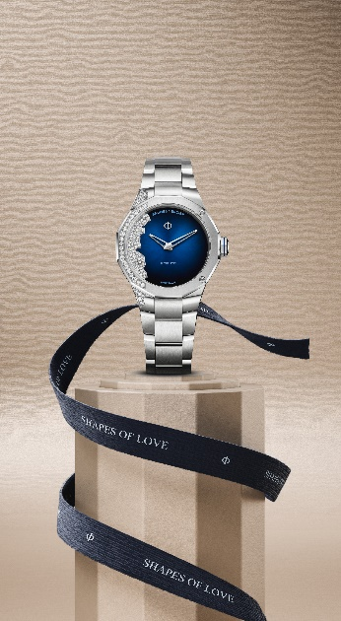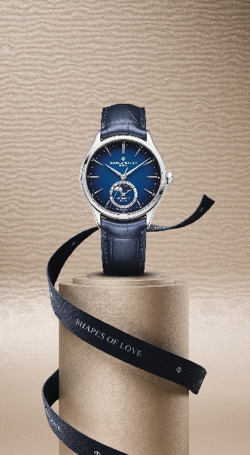

A CELEBRATION OF WATCHMAKING EXPERTISE AND CONNECTION
Through The Shapes of Love, Baume & Mercier invites watch enthusiasts to explore the artistry of form and the beauty of human bonds. This Valentine’s Day, the Maison’s creations become more than timepieces—they are tokens of love and expressions of timeless watchmaking expertise.

ABOUT BAUME & MERCIER
Founded in 1830 at the heart of Swiss Jura, the Baume & Mercier watch manufacture enjoys international renown. From its workshops at the heart of Swiss Jura to its headquarters based in Geneva, the Brand offers its clients the very finest timepieces. Borne by a complementary balance between an artistic approach to shape and watchmaking innovation in the service of the client, the Baume & Mercier House continues to mark the history of watchmaking by passing down the design and watchmaking expertise that is the Brand’s legacy. This savoir-faire perfectly corresponds with the spirit of cooperation between the Brand’s founders William Baume & Paul Mercier: where classicism meets creativity, tradition meets modernity, and elegance meets character... In a more contemporary way than ever.
www.baume-et-mercier.com

