THE NEW DESIGN
OF THE CLIFTON COLLECTION

THE EPITOME OF
BAUME & MERCIER HERITAGE

A REDESIGNED CASE
FOR A MORE VINTAGE LOOK
INSPIRED BY THE CODES OF A 1950s MODEL

The Clifton collection carries forward its quest for stylistic and technical excellence. Passion, imagination, ingenuity, precision and superb crafting are the creative forces behind Baume & Mercier, a legacy that has endured for 195 years. This unique style and watchmaking expertise – sought out and recognized by the modern gentleman who appreciates refinement and precision – is the focus of this collection, launched in 2013.

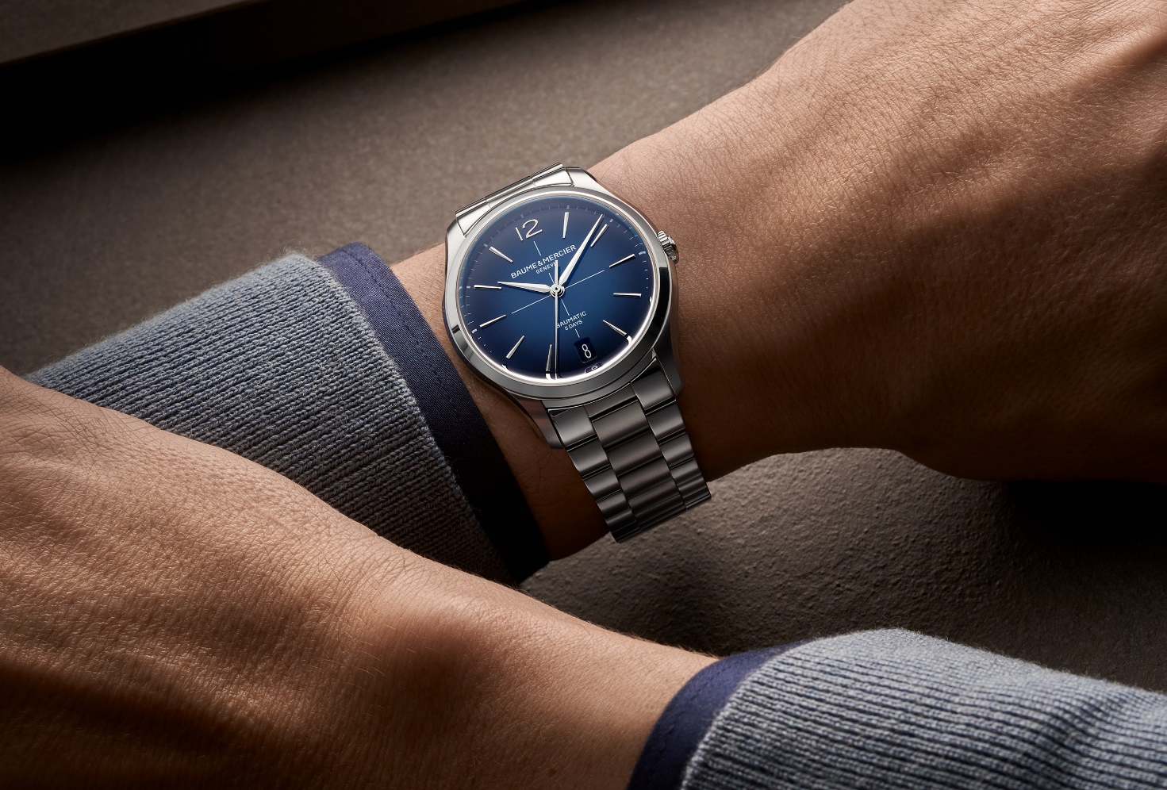
Clifton 10792

The models presented at Watches & Wonders 2025 (the Clifton Baumatic M0A10802, M0A10778, and M0A10771) reveal the new design of the iconic round case. The proportions have been slimmed down, the finishes reworked. Three other Clifton Baumatic watches (M0A10773, M0A10792, and M0A10793) complete the range, including two that feature an elegant and innovative metal bracelet specially designed to seamlessly integrate into the new case.

The launch of these three new pieces will take place in September. It is a prime time for renewal, like the spirit which animates the Clifton: inspired and driven by challenges. More luxurious, modern and trendy, these are the not-to-be-missed timepieces of the fall. With them, Baume & Mercier brings a new design to each of life’s little moments. It is a precious companion combining functionality, aesthetics, and emotion.
Timepieces conceived for the discerning, refined modern gentleman

His attraction to elegant, impeccably crafted fine mechanics draws him to these timepieces, and no refined feature of their artistry escapes his expert eye and technical knowledge. Much like an industrial designer who appreciates the beauty of a meticulously designed automobile with flawless mechanical precision, he is drawn to structured lines, clean cuts and curves, harmonious proportions and volumes, noble materials, exceptional performance, precision, and reliability. He knows how to recognize a perfectly executed object, placing great importance on even the slightest detail since he understands that each one makes a difference. Each demonstrates the distinction of Baume & Mercier and its remarkable, exacting watchmaking heritage.

This stylish man wears more than just a watch. He wears a signature, a story, a craft... and a status. The Clifton on his wrist is an object of desire, chosen with the eye of a true connoisseur. It gives him the quiet confidence and special presence to which he aspires: subtle yet unmistakable. He has an intimate bond with his timepiece: a shared sense of creativity, authenticity, and excellence. These very values were championed by William Baume, the brilliant watchmaker, and Paul Mercier, the art enthusiast who brought the Maison its stylistic vision. Since then, the Maison has offered high-end Swiss watchmaking: bold in design, sincere in craftsmanship, and innovative in technique. At once classic and contemporary, the Clifton collection has made its mark with a round case defined by taut lines, sculpted curves, and meticulously studied proportions. This refined showcase is inspired by the 1950s, echoing the discerning taste and polished manners of the true gentleman. It bears the signature of ideal proportions and natural balance symbolized by the Greek letter Phi, which the Brand adopted as its emblem in 1964.

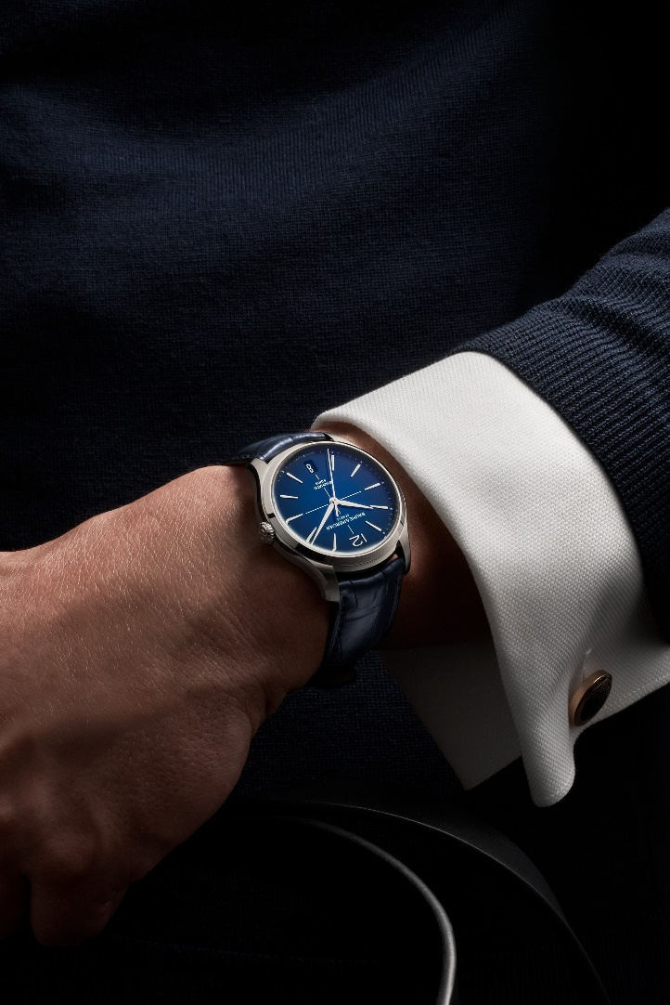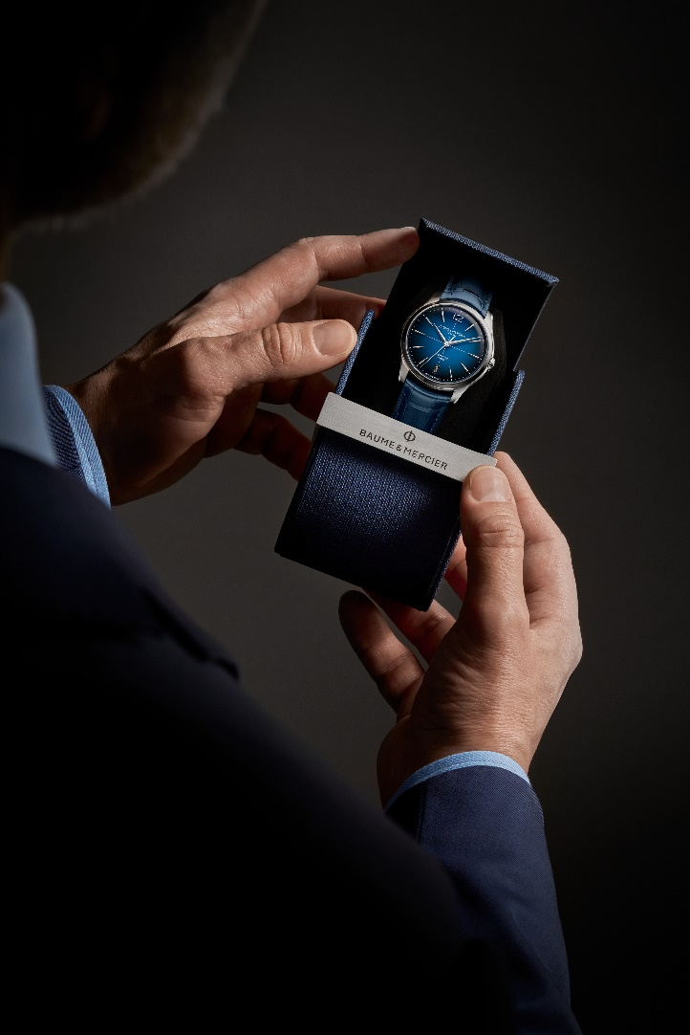
Clifton 10771 Clifton 10771

A redesigned case and a new metal bracelet in tribute to the timeless elegance of the 1950s

The Clifton collection returns in a new 39 mm size, a diameter previously reserved for models featuring a moon phase complication. Until now, Clifton three-hand watches were available in 40 mm, but they are now produced in a 39 mm version. This new iteration of the Clifton has been refined with polished and satin-brushed finishes. It introduces design elements that pay tribute to the timeless elegance of the historic 1950s model: a domed sapphire crystal, a discreetly integrated crown, the return of the Arabic numeral at 12 o’clock, a date aperture at 6 o’clock, and a crosshair design at the center of the dial.
The light-hued dials feature a new off-white grained finish complemented by 5N gold-tone accents.

Baume & Mercier has gone a step further in its client-centric approach to watchmaking which drives it to design and craft timepieces according to client expectations. The Clifton collection introduces a new metal bracelet, marking a significant evolution in both aesthetics and ergonomics. The bracelet, featuring three rows of short, semi-circular links, creates a fluid silhouette on the wrist while offering enhanced comfort. Its design draws inspiration from vintage watchmaking codes while maintaining a contemporary feel aligned with the collection’s identity. The updated construction and well-balanced proportions ensure seamless integration with the newly redesigned case, enhancing its overall visual harmony and reinforcing the Clifton signature look. The carefully calibrated interplay of polished and satin-brushed finishes preserves the refined sophistication and versatile character of this timepiece, while the interchangeable system adds extra flexibility for everyday wear.

The metal bracelet offers essential technical performance features. Crafted in stainless steel – a particularly durable material –, it is resistant to heat, humidity, scratches, impacts, and daily wear. A testament to longevity, it is easy to care for and remains radiant over time.

The new Clifton metal bracelet is interchangeable, featuring a system that allows it to be replaced without the need for tools. It fastens with a triple folding clasp in stainless steel with security push-pieces, ensuring both comfort and durability.

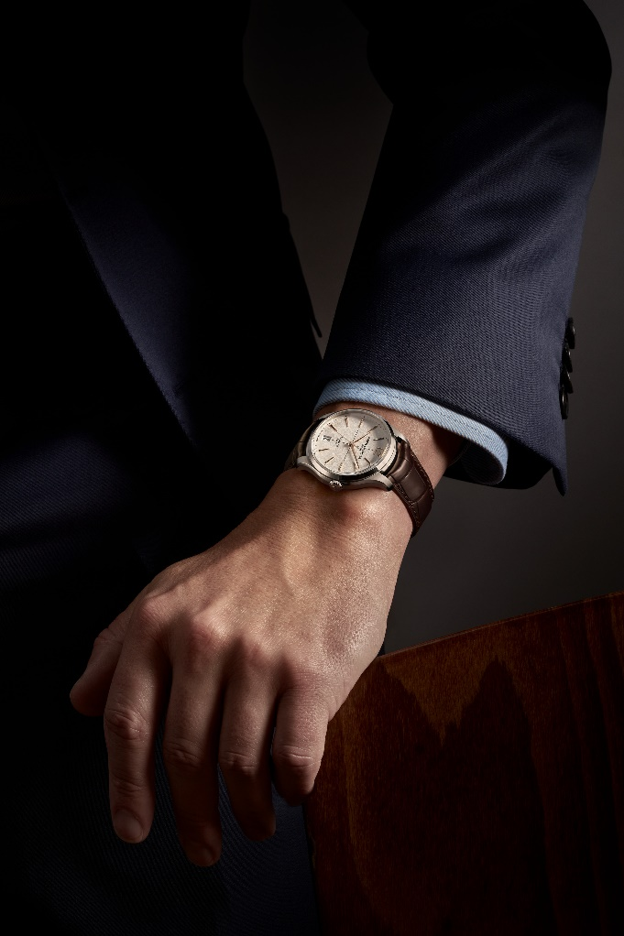
Clifton 10773 Clifton 10793

The models fitted with alligator leather straps now feature a new interchangeable triple folding clasp.

The harmony between case and strap, the attention to design and finishing, and the balance of proportions and volumes all illustrate Baume & Mercier’s fine watchmaking expertise in its most nuanced form. Inventiveness, thoughtfulness, pertinence, pragmatism, boldness, and passion lie at the heart of this creation.

A high-performance watchmaking mechanism

Developed at the Baume & Mercier workshops in Les Brenets, in the Swiss Jura, the Baumatic Manufacture movement was unveiled in 2018. It superbly embodies the Maison’s motto: "Accept only perfection. Only manufacture watches of the highest quality." Its cutting-edge technology, proven through rigorous testing, breathes life into the new Clifton Baumatic M0A10802, M0A10778, M0A10771, M0A10773, M0A10792, and M0A10793.

With resistance to everyday magnetic fields up to 1,500 Gauss, a frequency of 4Hz (28,800 vph), remarkable autonomy thanks to a 5-day (120-hour) power reserve, and water resistance up to 5 ATM (approximately 50 meters), these timepieces meet the highest standards of excellence sought by discerning connoisseurs for whom such performance features are essential expectations.

The sapphire crystal case back on each model reveals the magnificent beauty of the movement, including circular-grained bridges, a sandblasted and snailed baseplate, an openworked gold-tone oscillating weight with snailed Côtes de Genève decorations, and a unique Baume & Mercier engraving.

These six timepieces, like all Baumatics, benefit from a six-year warranty extension in addition to the standard 2 years of the international warranty. Simply register it on the Baume & Mercier website within 60 days after the purchase: www.baume-et-mercier.com.

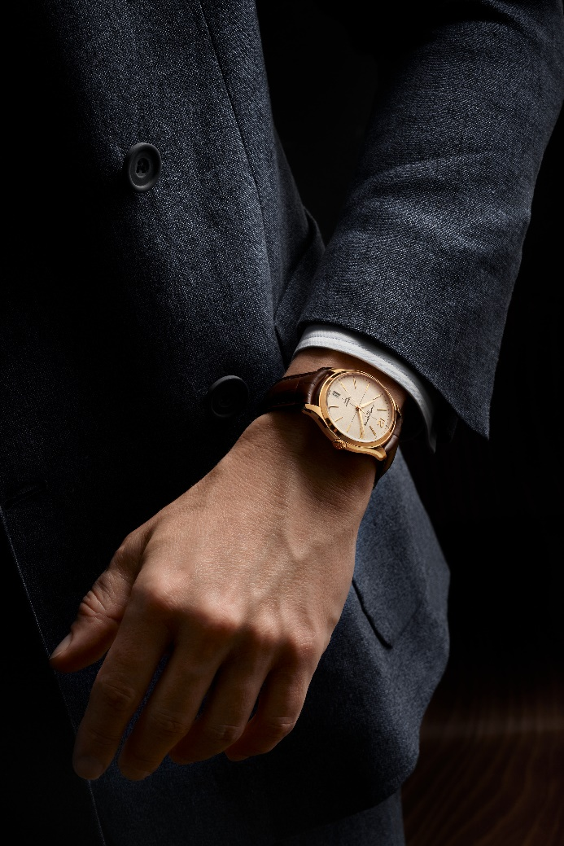
Clifton 10802

Clifton, the sought-after dandy chic lifestyle

Beyond the collection itself, the Clifton name evokes the renowned seaside destination in Cape Town, South Africa, and its elegant, laid-back spirit. Both embody the discerning, refined choices of an aesthete who carefully selects both the watch of his dreams and the idyllic escape that reflects his aspirations. He is captivated by this breathtaking natural setting where the Atlantic Ocean meets luxurious cliffside villas with sweeping panoramic views. He is drawn to the vibrant interplay of coastal and mountain landscapes; the gentle rhythm of life in this peaceful, cosmopolitan haven; and breathtaking escapades in the sea spray aboard sleek, boldly innovative yachts crafted by visionary designers. He savors time: his time.

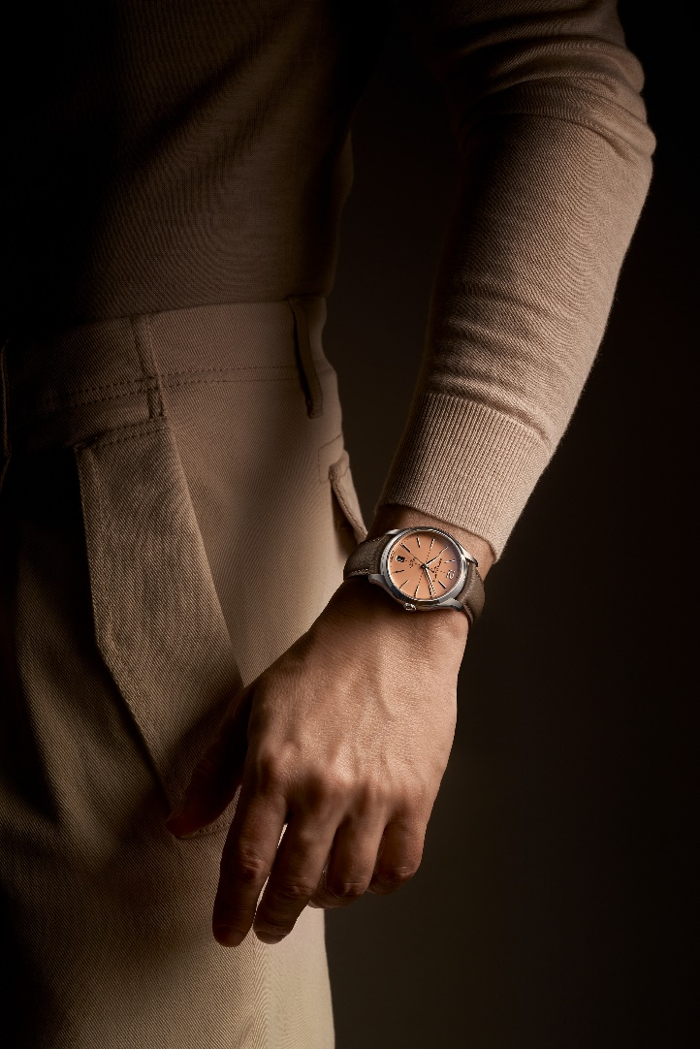
Clifton 10778 Clifton 10778

☐ Clifton Baumatic M0A10773
Its design, shaped by both softness and tension, plays on contrasting forms and complementary opposites. The pairing of steel and gold, off-white and black, underscores this duality for a dynamic, striking color composition.

The off-white dial, with its retro accents and grained texture, offers a particularly mellow time display, subtly textured to add depth and warmth to both the time and calendar indications. The slender, elongated black central crosshair alternates with the restrained black peripheral minute track, subtly accentuated at five-minute intervals. The trapezoidal hour markers are riveted, gold-toned, faceted, and slightly elongated. An Arabic numeral appears at 12 o’clock. The alpha-shaped hour and minute hands are gold-plated and faceted, and the seconds hand is also gold-plated. An aperture displays the date at 6 o’clock.

The sculptural round case measures an ideal 39 mm in diameter and 11.22 mm in thickness. Protected by a scratch-resistant domed sapphire crystal treated on both sides with an anti-glare coating, the case, like the crown, is crafted in polished and satin-finished stainless steel. The sapphire crystal case back, secured by four screws, may be custom-engraved.

The beautiful and precise Baumatic Manufacture automatic movement (BM13-1975A) beats at the heart of this timepiece.

The model features an interchangeable strap crafted in brown alligator leather with all-square scales and tone-on-tone overstitching on the top, a beige lining with ocher overstitching on the underside, and bar tacks around the buckle. It may be replaced without the use of tools thanks to a very reliable spring bar system. It fastens with a triple folding clasp in stainless steel with security push-pieces.

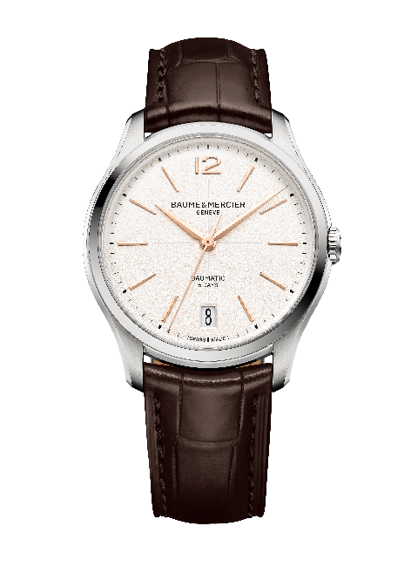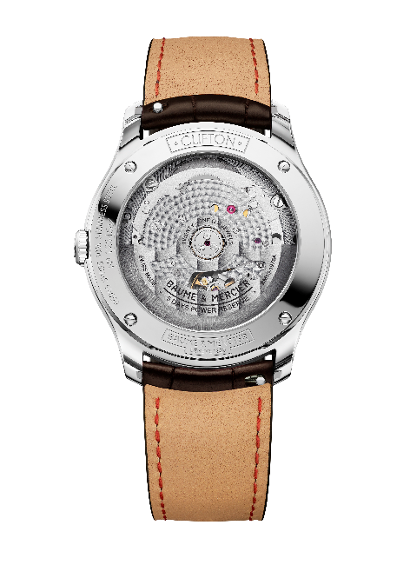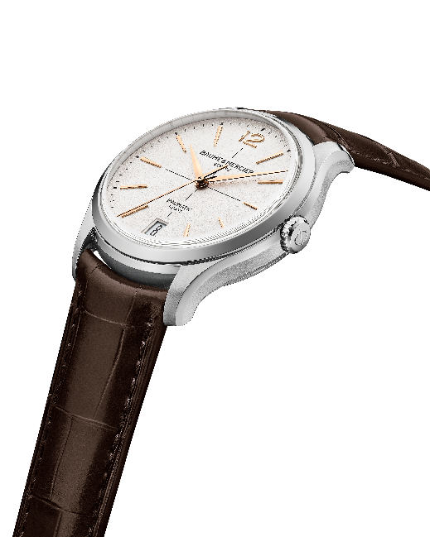

☐ Clifton Baumatic M0A10792
Its luminous dial is enhanced by subtle shades of blue in a gradation that is lighter at the center and darker around the perimeter of the watch. The lacquered finish adds a great deal of sophistication. Standing out in contrast against this deep, carefully crafted decoration are the slender, crisp white central seconds track; slightly elongated riveted, rhodium-plated, faceted trapezoidal indexes; faceted, rhodium-plated alpha-shaped hour and minute hands; and rhodium-plated seconds hand. The dial is framed by a white minute track. The date appears in a large aperture at 6 o’clock. The hour at 12 o’clock is indicated by an Arabic numeral in a more rounded shape reflecting that of the case.

Measuring 39 mm in diameter and 11.22 mm in thickness, the case, like the crown, is made of polished and satin-finished stainless steel. It is protected by a scratch-resistant sapphire crystal with an anti-glare coating on both sides. The case back is fastened with four screws and protected by a sapphire crystal. It may be engraved.

The high level of technical achievement for this timepiece culminates in the self-winding Baumatic Manufacture movement (BM13-1975A).

The integrated three-row bracelet in satin-finished stainless steel is a harmonious extension of the case. It is interchangeable and features a reliable spring bar system that allows it to be changed without the use of tools. It fastens with a triple folding clasp in stainless steel with security push-pieces.

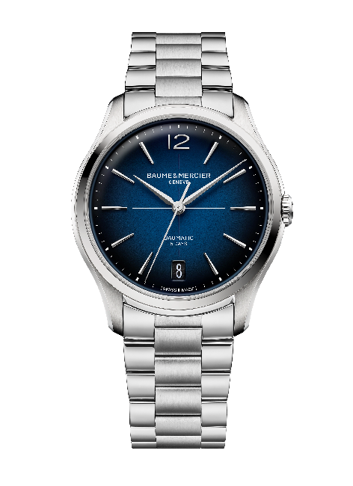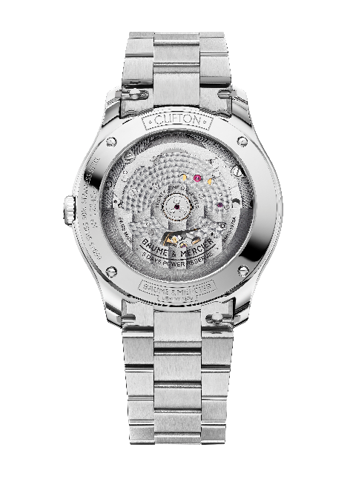

☐ Clifton Baumatic M0A10793
This model, in a version fitted with the new metal bracelet, is identical to the Clifton Baumatic M0A10773, which has an alligator leather strap.

It features the same beautifully styled design, delicately detailed down to the smallest elements. The off-white dial forms a harmonious backdrop with a textured finish that enhances its depth. Radiance and clarity characterize the time display, arranged around the slender central black crosshair and black minute track. Features include slightly elongated riveted, gold-toned, faceted trapezoidal indexes; an Arabic numeral at 12 o’clock; gold, faceted alpha-shaped hour and minute hands; and a gold seconds hand. The date is easy to read in an aperture at 6 o’clock.

The Clifton’s polished and satin-finished stainless steel case lends its curves and rounded contours to this timepiece with a 39 mm diameter and 11.22 mm thickness. Protected by a scratch-resistant sapphire crystal with an anti-glare coating on both sides, it features a sapphire case back which is secured by four screws and may be custom-engraved. The crown is also made of polished and satin-finished stainless steel.

The self-winding Baumatic (BM13-1975A) Manufacture movement is the driving force behind this luxury watch.

Perfectly suited to the case’s refined dimensions, the redesigned integrated three-row bracelet in polished and satin-finished stainless steel is interchangeable. A system allows it to be removed and reattached without tools. Its stainless steel triple folding clasp is equipped with safety push-pieces.
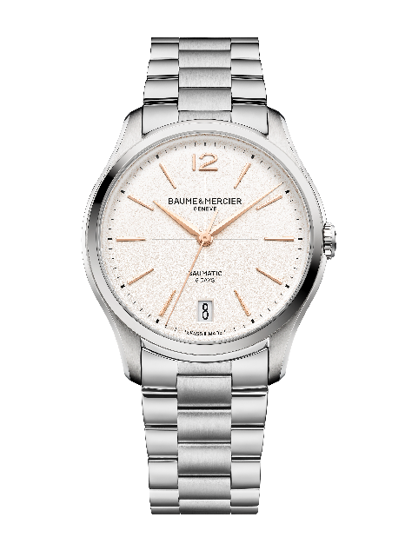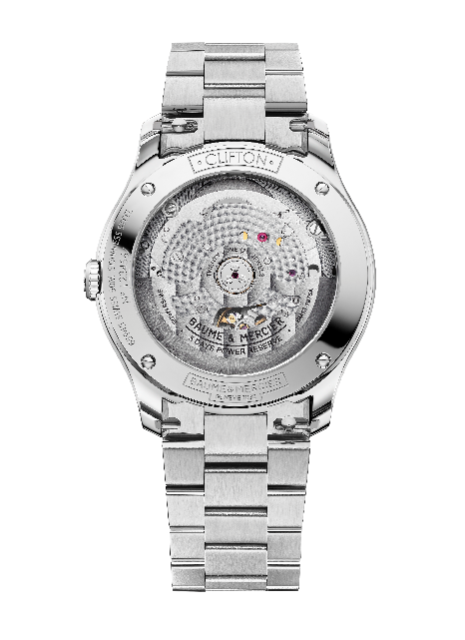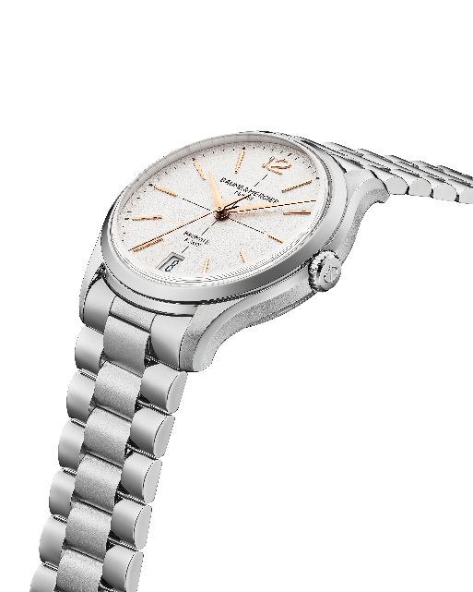

***************************************************************

THE MODELS PRESENTED AT WATCHES & WONDERS

☐ Clifton Baumatic M0A10802
With a diameter of 39 mm and a thickness of 11.2 mm, the iconic domed round case is crafted in satin-finished rose gold (750/1000). It is protected by a scratch-resistant domed sapphire crystal treated on both sides with an anti-glare coating. The crown is crafted in rose gold (750/1000). The sapphire crystal back may be engraved upon request.
The subtle off-white hue adds to the more retro inspiration of the dial. The grained finish confers a special texture, intensifying the radiance of the color and the depth of the decor, offering even more warmth. The finesse of its finish brings it to life. Edged by a black minute track and criss-crossed by black crosshairs in the center, the dial reveals 5N gold-plated, riveted, faceted, slightly elongated trapezoidal indexes, and is topped with an Arabic numeral at 12 o’clock. The alpha-shaped hour and minute hands are 5N gold-plated and faceted. The seconds hand is gold-tone. A wide aperture at 3 o’clock displays the date.
The self-winding Baumatic (BM13-1975A) Manufacture movement is the driving force behind this luxury watch. It is water-resistant to 5 ATM (approximately 50 m).
The strap is crafted in brown alligator leather with all-square scales and tone-on-tone overstitching on the top, a beige lining with ocher overstitching on the underside, and bar tacks around the buckle. This interchangeable strap is equipped with a very reliable spring bar system that makes it possible to change it without the use of tools. It fastens with a 5N gold-tone PVD steel pin buckle.
The gold of this model weighs an estimated 23.20 g.
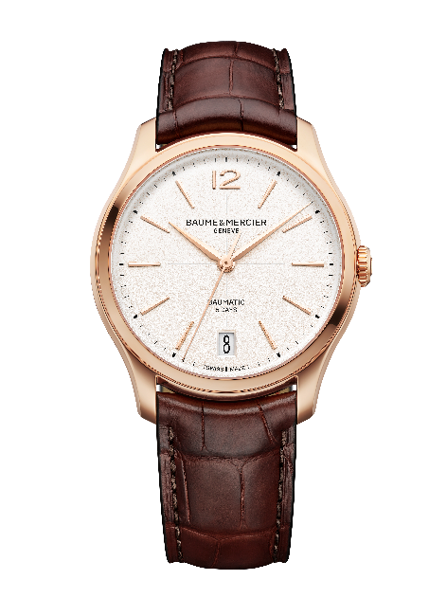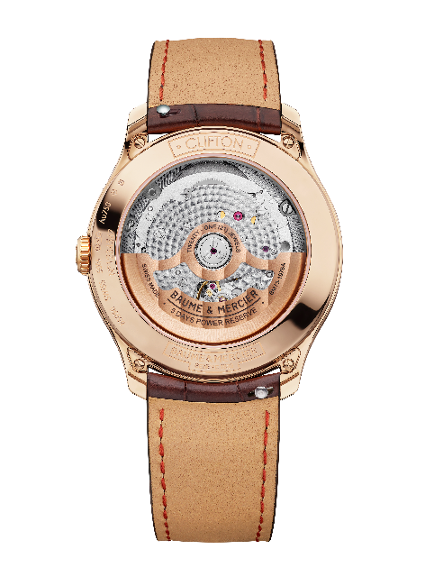

☐ Clifton Baumatic M0A10778 - Limited edition of 350
The bright opaline salmon-hued dial sculpts each hour and calendar indication. This shade has a vintage charm filled with softness and warmth that was very sought-after in the 1930s and 1940s. The meticulous color work in pursuit of the ideal tone between rose and peach, and the perfect intensity between radiance and depth, reveals a timepiece with timeless refinement that immediately captivates the eye. The riveted, faceted, rhodium-plated indexes are shaped like elongated trapezoids. An Arabic numeral appears at 12 o’clock. The faceted, rhodium-plated hour and minute hands are alpha-shaped. The oxidized black seconds hand offers a delicate contrast. The date appears in a wide aperture at 6 o’clock. The black minute track frames the dial.
The new proportions – a diameter of 39 mm and a thickness of 11.2 mm – bring finesse to the round case, crafted in satin-finished stainless steel like the crown. It is protected by a scratch-resistant sapphire crystal with an anti-glare coating on both sides. Fastened with four screws and covered by a sapphire crystal, the case back bears the special engraving “Limited Edition One Of 350.” It may be engraved.
The high level of technical achievement for this timepiece culminates in the self-winding Baumatic Manufacture movement (BM13-1975A). It is water-resistant to 5 ATM (approximately 50 m).
The interchangeable strap is crafted in black calfskin with tone-on-tone overstitching on the top. It may easily be changed without the need for tools thanks to a very reliable spring bar system. The watch comes with an additional interchangeable strap in beige calfskin. Both straps feature an interchangeable triple folding clasp in stainless steel with security push-pieces.
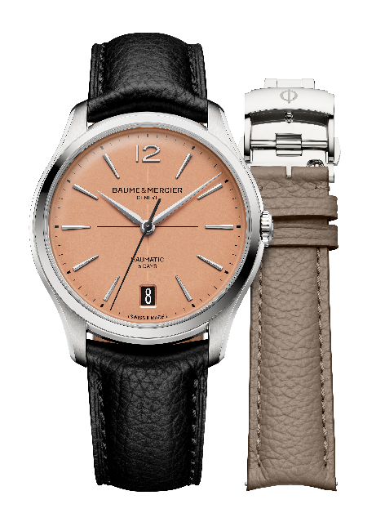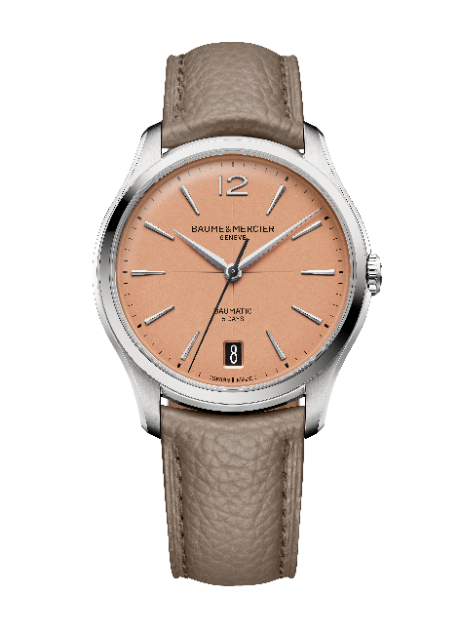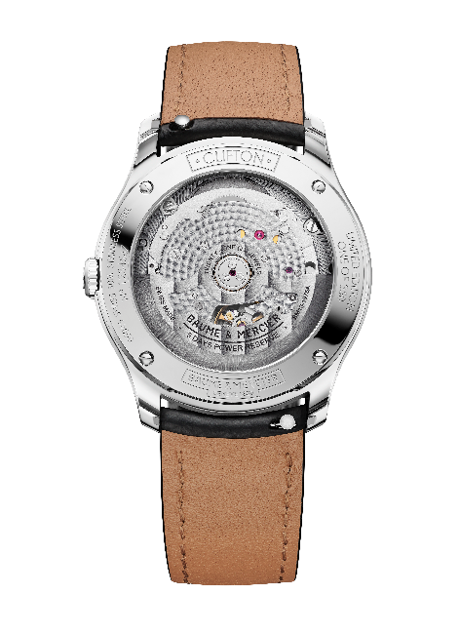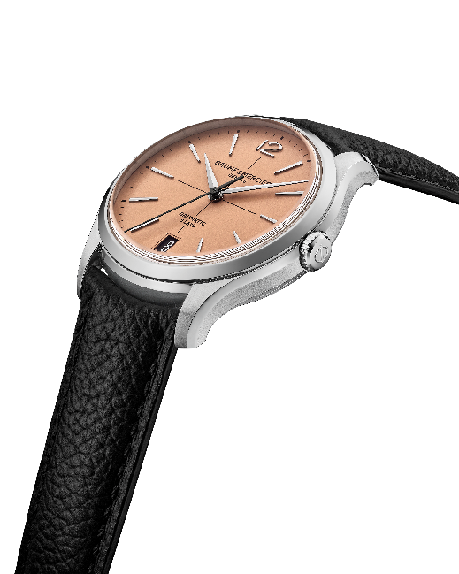

☐ Clifton Baumatic M0A10771
The blue dial of this timepiece, with its subtle gradation – darker around the edges and lighter in the center – emanates character, depth and refinement. A lacquered finish enhances its nuances. This gleaming blue decor creates a striking background for the contrasting white crosshairs, hour markers, and date indications. The riveted, faceted, rhodium-plated indexes are shaped like elongated trapezoids. An Arabic numeral appears at 12 o’clock. The alpha-shaped hour and minute hands are faceted and rhodium-plated. The seconds hand is oxidized black. The dial is framed by a white minute track. The date appears in a wide aperture at 6 o’clock.
With a diameter of 39 mm and a thickness of 11.2 mm, the round case – like the crown – is crafted in satin-finished stainless steel. It is protected by a scratch-resistant domed sapphire crystal treated on both sides with an anti-glare coating. The case back is fastened with four screws and protected by a sapphire crystal. It may be custom-engraved.
A self-winding Baumatic Manufacture movement (BM13-1975A) powers this particularly durable, reliable timepiece. It is water-resistant to 5 ATM (approximately 50 m).
The interchangeable strap is crafted in blue alligator leather with all-square scales, tone-on-tone overstitching on the top, a beige lining with bordeaux overstitching on the underside, and bar tacks around the buckle. It may be replaced without the use of tools thanks to a very reliable spring bar system. The interchangeable triple folding buckle in stainless steel is equipped with security push-pieces.
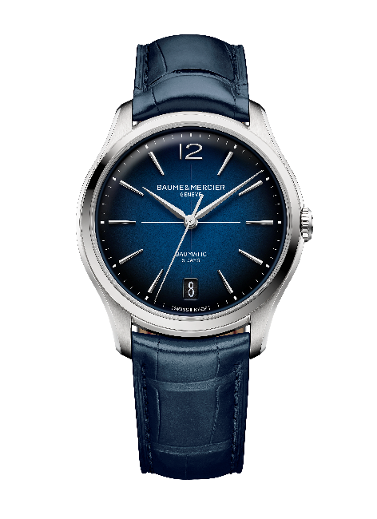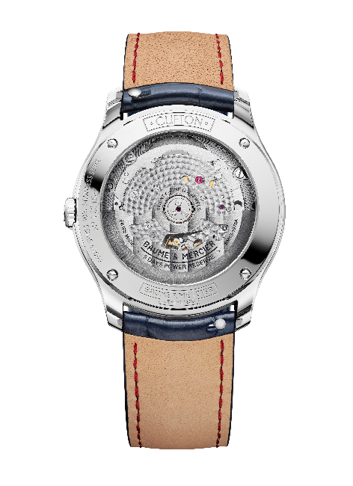

The Clifton collection is writing a new chapter in its story. Through this new aesthetic, it masterfully carries forward the spirit and design of Baume & Mercier.

