THE RIVIERA, OVER THE MOON

First released in 1973, the Riviera expresses the Brand’s expertise in design and exquisite use of materials. A Baume & Mercier icon, this classic timepiece with pure, slender lines is immediately recognizable with its twelve-sided bezel. It rises to new heights this year with two versions of the Baumatic “Moonphases” manufacture caliber. A harmonious combination of watchmaking tradition and casual elegance. To assert a lifestyle like none other.

It was first developed in 1973 and has adapted to every era, year after year, while staying true to its special style. Its steel adornments and strong shape have always represented a form of freedom, an offbeat elegance, and a unique art of living. In 2021, Baume & Mercier presented the fifth-generation Riviera with respect for the Brand’s savoir-faire, capturing the signs of our modern times to better revisit them. Next in line for this destiny, two new 43-mm “Moonphases” Riviera models conveying Baume & Mercier’s expertise in design, shapes, and bold expression.

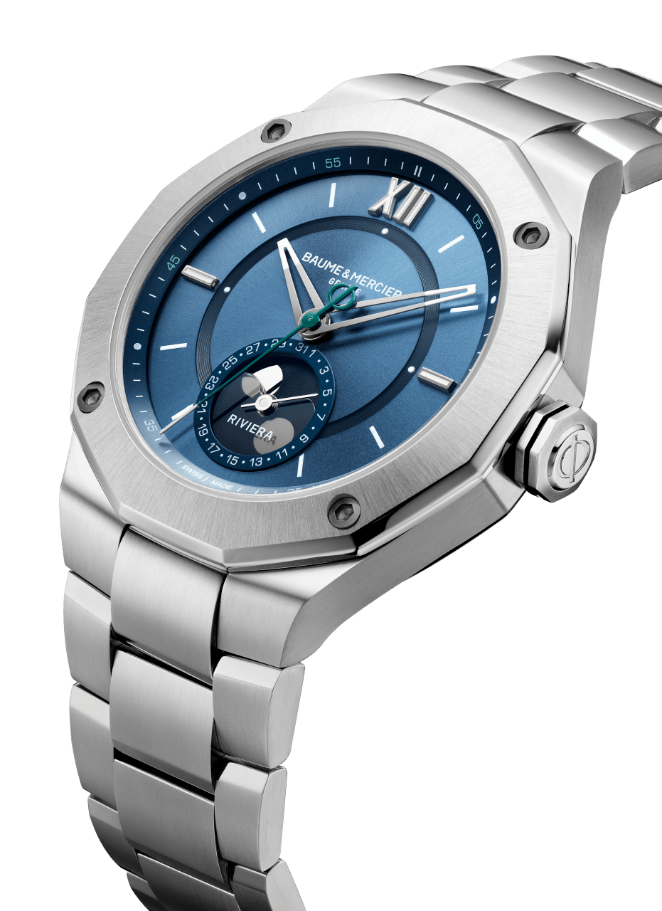

Riviera 10682

Riviera Baumatic (M0A10681):
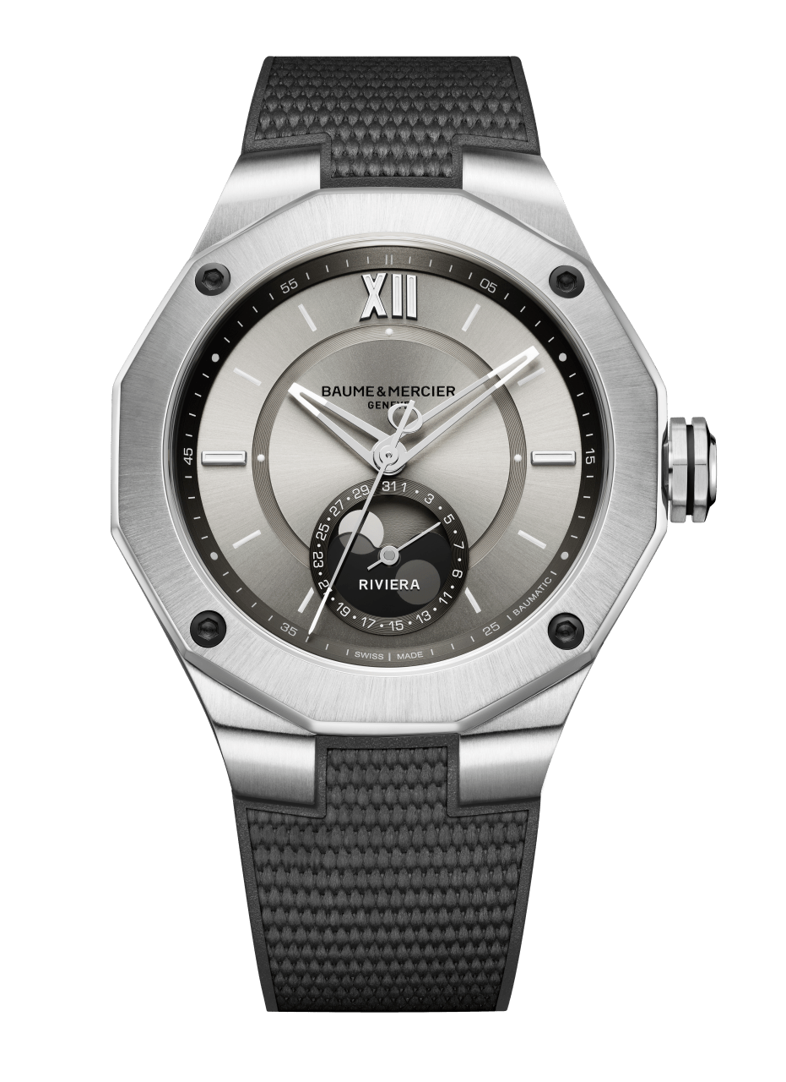
At first sight, this timepiece represents a heavenly body in its lunar mysteries and diaphanous hues. The new “Moonphases” Riviera Baumatic plays on restraint in its version adorned with a gray rubber strap, topped with a canvas decoration. Its light sand-colored dial brings to mind the vast silvery deserts of the poetic landscapes that we associate with the moon. Sun satin and lacquered, its dial is both beautiful and complex, enhanced by a dark gray flange in a hue that subtly reflects the auxiliary dial located at 6 o’clock to display the date and moon phases. With an efficient design and a distinctive look, the new “Moonphases” Riviera Baumatic asserts its personality in a steel case with a diameter of 43 mm. It upholds the characteristic codes of the Riviera family: a steel dodecagonal bezel fastened with four steel screws (black sand-blasted ADLC treatment), a Roman numeral at 12 o’clock, and riveted indexes at 3 and 9 o’clock. The dodecagonal case back is equipped with a sapphire crystal that offers a view of the self-winding mechanical Baumatic manufacture movement, which ensures exceptional performance: a five-day power reserve, a daily precision of -5 s/+10 s, and a magnetic resistance of 1500 Gauss, providing solid protection against magnetic fields. With a 120-hour power reserve, the new “Moonphases” Riviera Baumatic may be forgotten on a night table from a Thursday evening to a Tuesday morning and still be full of energy. Equipped with a triple folding buckle with security push-pieces and the “Fast Strap” easy adjustment system, the rubber strap features a very reliable interchangeability framework which makes it possible to change it on a whim without the need for tools. Renewal is in the air at Baume & Mercier. The new “Moonphases” Riviera Baumatic expresses that in the most eloquent way possible.
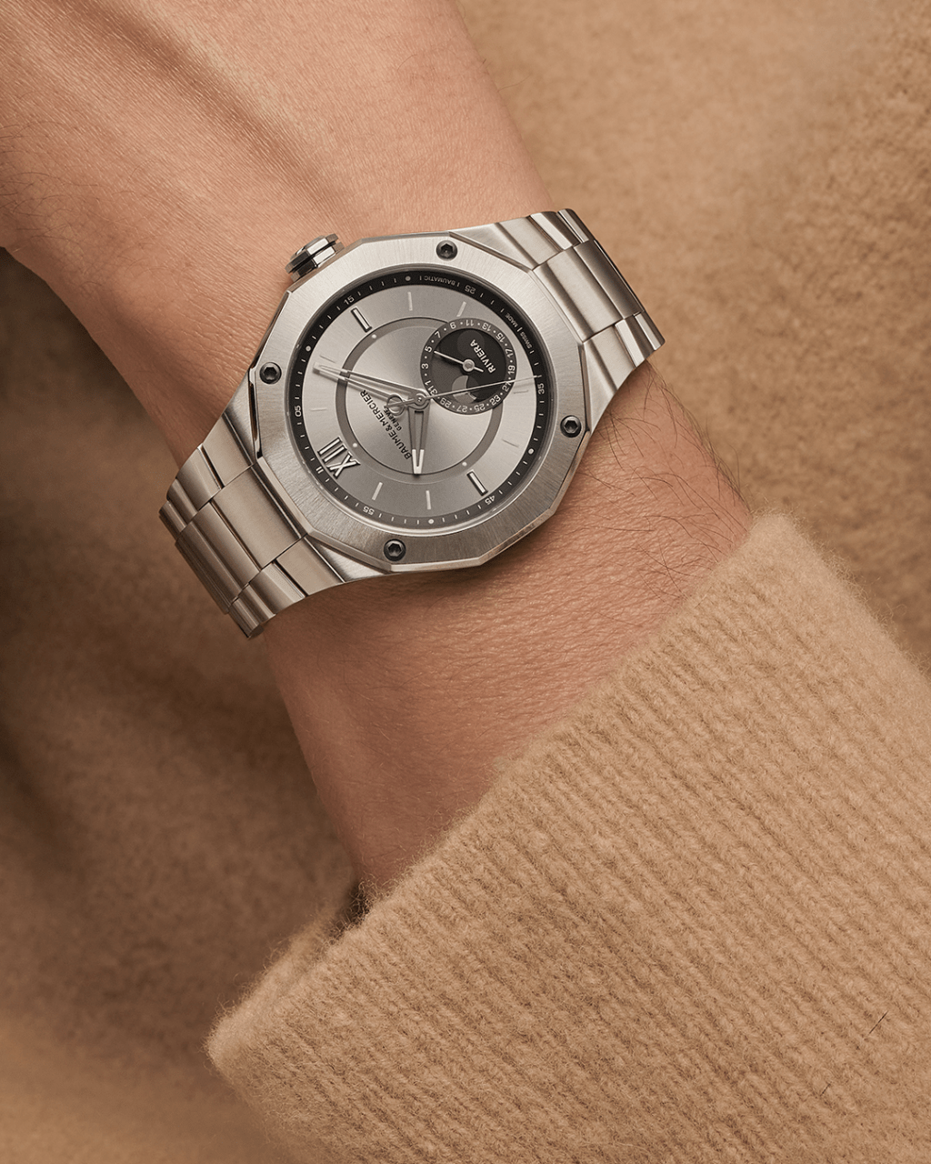

Riviera 10681

Riviera Baumatic (M0A10682):

With almost fifty years behind it, the Riviera is no newcomer. Inspired by the carefree lifestyle of the French Riviera, this is the watch of casual elegance, symbolizing an easygoing view of refined watchmaking. In this version with a steel strap and a blue dial, the new “Moonphases” Riviera Baumatic once again irrefutably captures that spirit. With a comfortable 43 mm diameter, its steel case features all the technical and artistic distinguishing marks that have made this model a success: a dodecagonal bezel fastened with four screws, riveted indexes at 3 and 9 o’clock, and a Roman numeral at 12 o’clock. In this version, the sun satin, lacquered, tinted dial and flange asserts a bright azure blue. That same blue, which brings to mind the view of the Earth from the Moon, also appears on the frame of the auxiliary date dial located at 6 o’clock that displays the moon phases. The seconds hand is adorned with an elegant green color, while the Phi logo – the Brand’s symbol – appears on its counterweight. With its three-row steel strap, triple folding buckle, and simple, robust interchangeability system, the new “Moonphases” Riviera Baumatic features a look that is both athletic and refined, for everyday use in any situation. It is powered by a self-winding mechanical Baumatic manufacture movement that offers exceptional performances: a daily precision of -5 s/+10 s, a five-day power reserve, an anti-magnetic resistance of 1500 Gauss, and a five-year warranty. The tried-and-true quality of the manufacture caliber may be appreciated through the dodecagonal case back, equipped with a sapphire crystal. Waterproof to 100 meters, the “Moonphases” Riviera Baumatic is the quintessence of the sport chic that has always characterized Baume & Mercier.

Riviera 10682

ABOUT BAUME & MERCIER:

Founded in 1830 at the heart of Swiss Jura, Baume & Mercier enjoys international renown. From its workshops at the heart of Swiss Jura to its headquarters based in Geneva, the Maison offers its clients the very finest timepieces. Born by a complementary balance between an artistic approach to shape and watchmaking innovation in the service of the client, the Baume & Mercier House continues to mark the history of watchmaking by passing down the design and watchmaking expertise that is the Brand’s legacy. This savoir-faire perfectly corresponds with the spirit of cooperation between the Brand’s founders William Baume & Paul Mercier: where classicism meets creativity, tradition meets modernity, and elegance meets character... In a more contemporary way than ever.

www.baume-et-mercier.com

