HAMPTON XS, A NEW DIMENSION OF FEMININITY

Baume & Mercier introduces Hampton XS, a new interpretation of its distinctive rectangular watch. Presented in a miniaturized 28 x 17.75 mm format, Hampton XS preserves the Art Deco spirit and architectural character that has defined the collection since its creation.
With its sculpted dial, refined geometry and unmistakable rectangular silhouette, Hampton XS brings a fresh perspective to one of the Maison’s most distinctive designs. Smaller and graphic in expression, it reinterprets Hampton with contemporary elegance.

* * * * *

MINI SIZE, UNMISTAKABLY HAMPTON
For the first time, the Hampton collection is available in an XS format. Reduced to 28 x 17.75 mm, the new case introduces a new silhouette while preserving the balance and delicate proportions that define the collection.
Designed to accompany everyday life with instinctive elegance, Hampton XS offers minimalist modernity and desirable proportions.

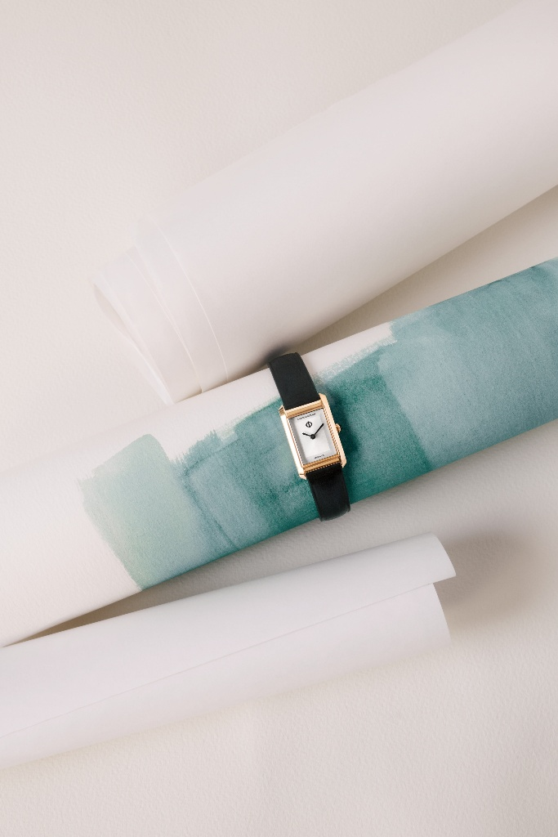
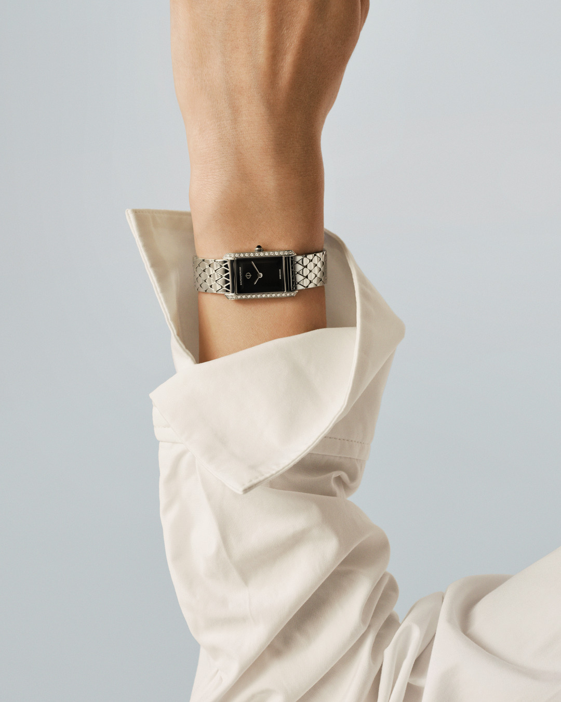

A SCULPTED DESIGN
The newly designed dial is one of Hampton XS’s defining features. Faceted on all four sides like a finely cut stone, it creates subtle depth while catching and reflecting the light throughout the day. Free of indexes, the composition highlights the purity of the rectangular case and reinforces the watch’s graphic identity.
Another signature element is the new diamond-shaped metal bracelet. Its repeating geometric motif extends the architectural language of the case while offering remarkable flexibility and comfort on the wrist.
Available in stainless steel, 4N PVD or a diamond-set interpretation, Hampton XS expresses the same design through different finishes while remaining unmistakably in Hampton.
THE ENDURING LANGUAGE OF ART DECO
Since its creation, Hampton has been defined by its iconic rectangular silhouette and structured line. Inspired by the geometric language of Art Deco, the collection has always expressed a refined vision of watchmaking, where proportion, symmetry, and graphic refinement come together.
Hampton XS remains faithful to this design heritage while introducing a contemporary new scale. Every detail has been carefully thought to preserve the collection’s unmistakable identity in a mini format.
Through these new timepieces, Baume & Mercier celebrates a new generation of femininity: free, contemporary and refined, where elegance is expressed through the mastery of detail and the confidence of personal style.

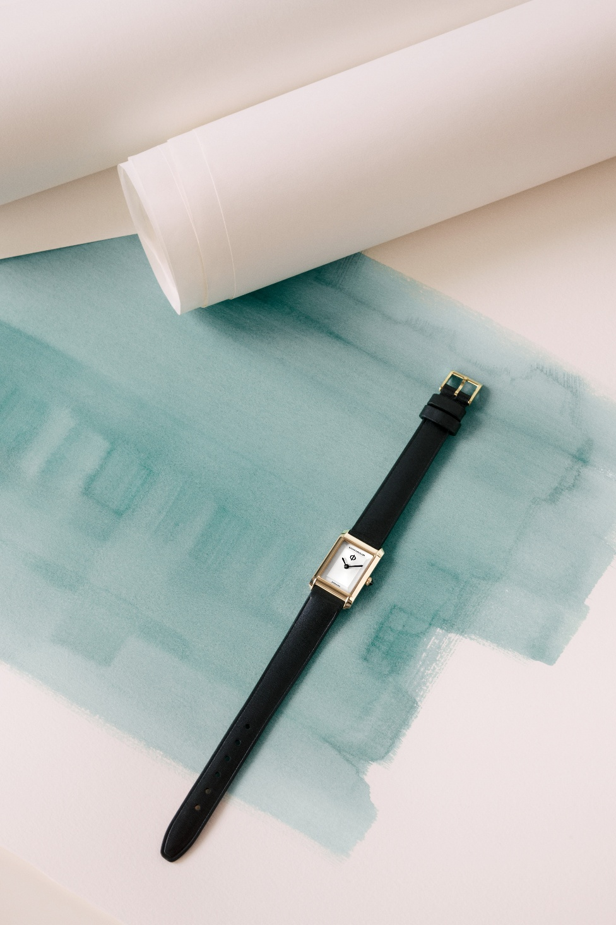
HAMPTON M0A10859, EVERYDAY ELEGANCE REIMAGINED
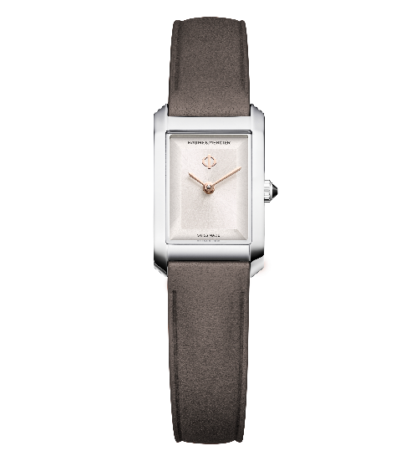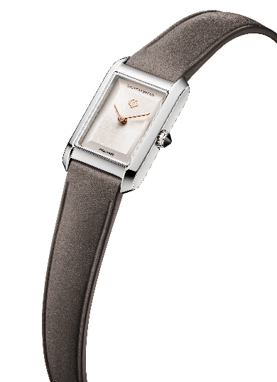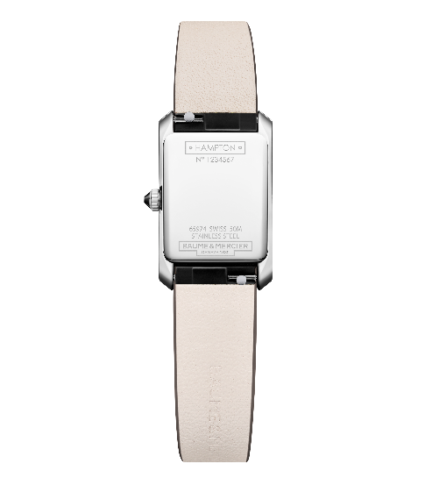
- Movement
Quartz movement (Ronda 751)
Autonomy: 5 years
- Functions
Hours, minutes
- Case
Rectangular
Size: 28 x 17.75 mm
Thickness: 6.3 mm
Polished stainless-steel case
Scratch-resistant sapphire crystal
Cone-shaped stainless-steel crown set with black agate
Full polished stainless-steel case back with the possibility the engrave the case back
- Dial
Stepped warm silver sunray satin-finished dial
4N gilded fan-shaped sword hands
4N gilded Phi logo at 12 o’clock
- Strap
Grey taupe calfskin strap
Interchangeable bars system allowing bracelet changes without tools
- Buckle
Polished stainless-steel pin buckle
- Water resistance
50m (approx. 5 ATM)

HAMPTON M0A10860, THE SIGNATURE BRACELET
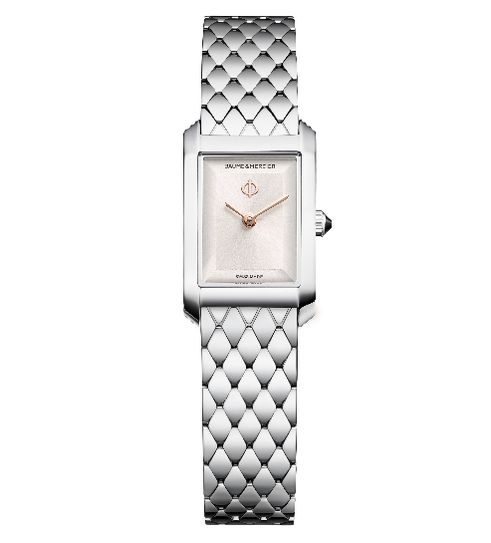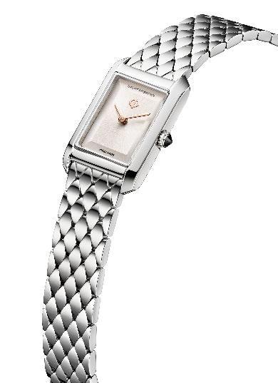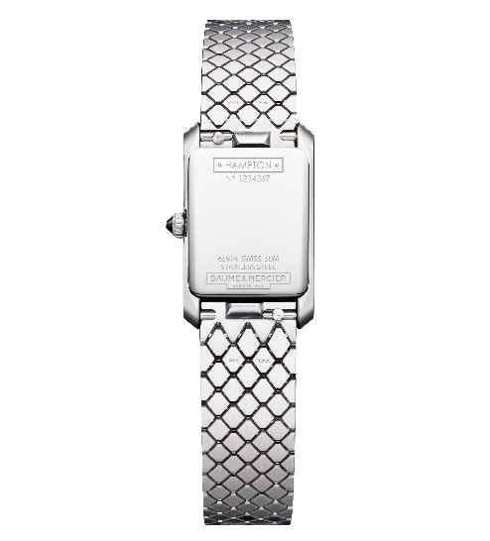
- Movement
Quartz movement (Ronda 751)
Autonomy: 5 years
- Functions
Hours, minutes
- Case
Rectangular
Size: 28 x 17.75 mm
Thickness: 6.3 mm
Polished stainless-steel case
Scratch-resistant sapphire crystal
Cone-shaped stainless-steel crown set with black agate
Full polished stainless-steel case back with the possibility the engrave the case back
- Dial
Stepped warm silver sunray satin-finished dial
4N gilded fan-shaped sword hands
4N gilded Phi logo at 12 o’clock
- Bracelet
Interchangeable polished and satin-finished diamond-shaped steel bracelet
Interchangeable bars system allowing bracelet changes without tools
- Buckle
Polished and satin-finish stainless-steel triple folding buckle
- Water resistance
50m (approx. 5 ATM)

HAMPTON M0A10861, THE WARM INTERPRETATION
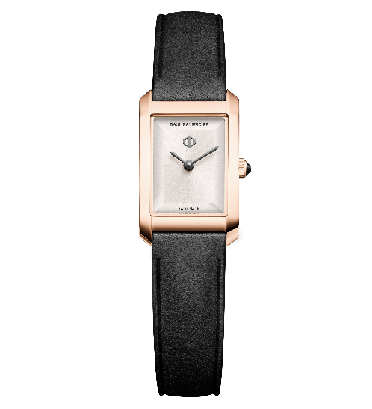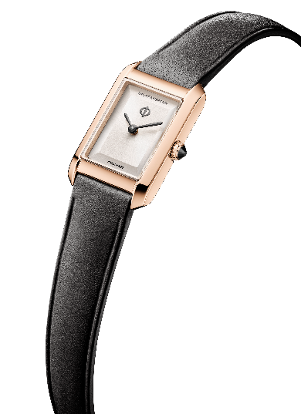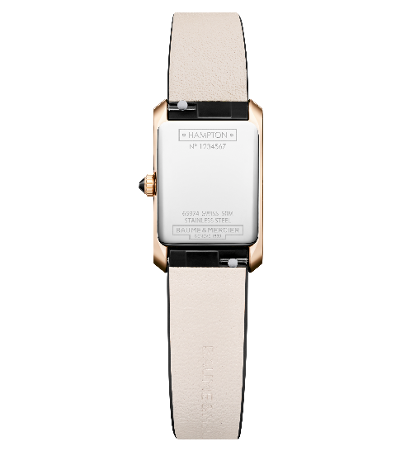
- Movement
Quartz movement (Ronda 751)
Autonomy: 5 years
- Functions
Hours, minutes
- Case
Rectangular
Size: 28 x 17.75 mm
Thickness: 6.3 mm
PVD 4N polished stainless-steel case
Scratch-resistant sapphire crystal
PVD 4N stainless-steel cone-shaped crown set with black agate
Full polished stainless-steel case back with the possibility to engrave the case back
- Dial
Stepped warm silver sunray satin-finished dial
Ruthenium fan-shaped sword hands
Ruthenium Phi logo at 12 o’clock
- Strap
Black calfskin strap
Interchangeable bars system allowing bracelet changes without tools
- Buckle
PVD 4N polished stainless-steel pin buckle
- Water resistance
50m (approx. 5 ATM)

HAMPTON M0A10862, THE EVENING EXPRESSION
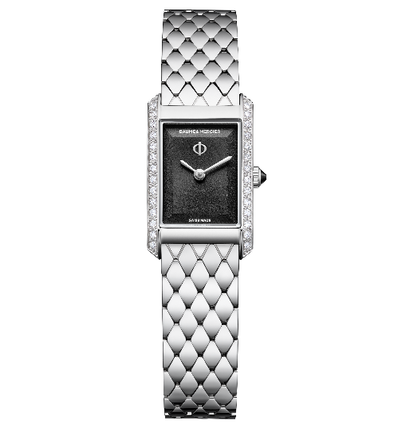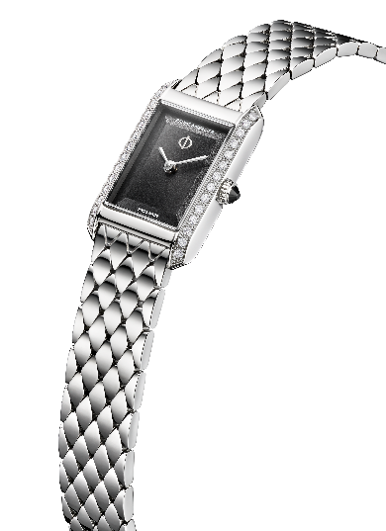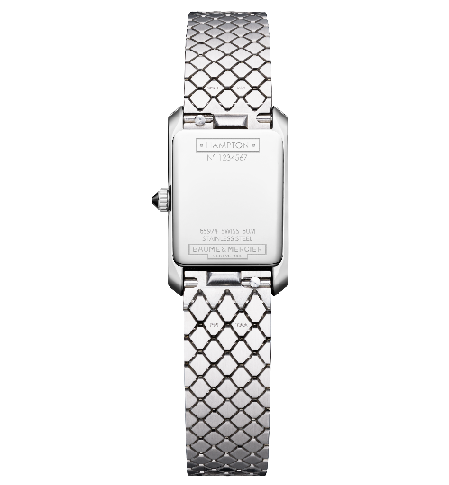
- Mouvement
Quartz movement (Ronda 751)
Autonomy: 5 years
- Functions
Hours, minutes
- Case
Rectangular
Size: 28 x 17.75 mm
Thickness: 6.3 mm
Polished stainless-steel case set with 28 diamonds (brilliant-cut, Top Wesselton, VS quality, 0.22 cts)
Scratch-resistant sapphire crystal
Cone-shaped stainless-steel crown set with black agate
Full polished stainless-steel case back with the possibility the engrave the case back
- Dial
Stepped black sunray satin-finished dial
Rhodium fan-shaped sword hands
Rhodium plated Phi logo at 12 o’clock
- Bracelet
Interchangeable polished and satin-finished diamond-shaped steel bracelet
Interchangeable bars system allowing bracelet changes without tools
- Buckle
Polished and satin-finish stainless-steel triple folding buckle
- Water resistance
50m (approx. 5 ATM)

With Hampton XS, Baume & Mercier introduces a new interpretation of one of its most distinctive collections. Defined by its Art Deco inspiration, sculpted dial and architectural silhouette, Hampton XS brings the enduring character of the rectangular watch into a new format, where timeless design is expressed with clarity, balance and refinement.

