BAUME & MERCIER
THE RIVIERA CELEBRATES ITS 50TH ANNIVERSARY
WITH A NEW 39-MM DIAMETER

The Riviera watch – created in 1973 and emblematic of the Baume & Mercier spirit – is set to celebrate its half-century of existence this year. Reinterpreted in 2021 with a versatile fifth generation, Baume & Mercier’s signature collection continues, year after year, to express its savoir-faire through design, plays on materials, and a keen understanding of its times. Immediately recognizable with its twelve-sided bezel, the piece has pure, taut lines and is available for the first time in three 39-mm Baumatic versions, proving once again that it has never ceased to reinvent itself. The Riviera has made its way through fifty years without missing a beat. Inspired by the carefree lifestyle of the French Riviera, this is the watch of casual elegance, symbolizing an easygoing view of refined watchmaking. It was first developed in 1973 and has adapted to every era, year after year, while staying true to its special style. This year marks a gentle-yet-assertive evolution, continuing to bring distinctive Baume & Mercier expertise to the design through its elaborate shapes and bold statement. Available for the first time in a 39-mm version for both men and women, the new Riviera embodies, now more than ever, a form of freedom, an offbeat elegance, and an authentically positive outlook on life. With the same design and sport-chic spirit, this new 39-mm diameter adapts to the times and today’s aesthetic.

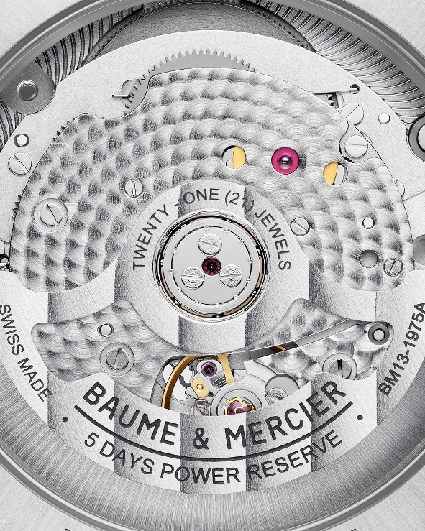
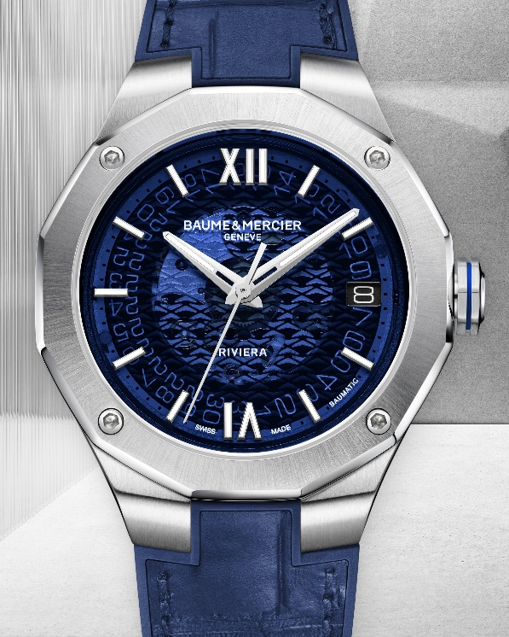

Riviera 39mm – 10714

Three 39-mm Baumatic versions to carry forward the spirit of the Riviera

More than any other, the Riviera Collection’s athletic shapes demonstrate the design expertise of Baume & Mercier in the field of watches. Its uncompromisingly creative approach and recreational aspirations – which are the essence of the Brand’s style – are still in the minds of those who love this model. For its 50th anniversary, the Riviera is back once again this year with three unprecedented 39-mm versions. Each one features that distinctive dodecagonal shape with twelve sides and four screws. Each continues to convey a perennially fashionable sport-chic allure. Each one is powered by the Baumatic manufacture movement, which has demonstrated its performance since it was launched in 2017, and which may be admired through the smoked sapphire dial so symbolic of the Riviera Baumatic. The original design is still there, but the desire to adapt to our times is clear. As the latest additions to the Riviera collection, these three new 39-mm variations carry the evocative power of the original 1973 model in their DNA.

The first version, Riviera M0A10714, is crafted in polished and satin-finished stainless steel, and it features a smoked blue sapphire dial with a transparent wave transfer decoration. It is mounted on an integrated interchangeable blue rubber and alligator strap with tone-on-tone overstitching.

The second 39-mm model, the Riviera M0A10715, asserts a smoked gray sapphire dial with a transparent wave transfer decoration and an integrated strap with three rows of polished and sati-finished links.

The third variation, the Riviera M0A10720, is characterized by a sand-blasted titanium bezel with a central bezel ring in 5N gold-plated PVD steel, a smoked gray sapphire dial with a transparent wave transfer decoration, and an integrated gray rubber strap with a canvas texture.

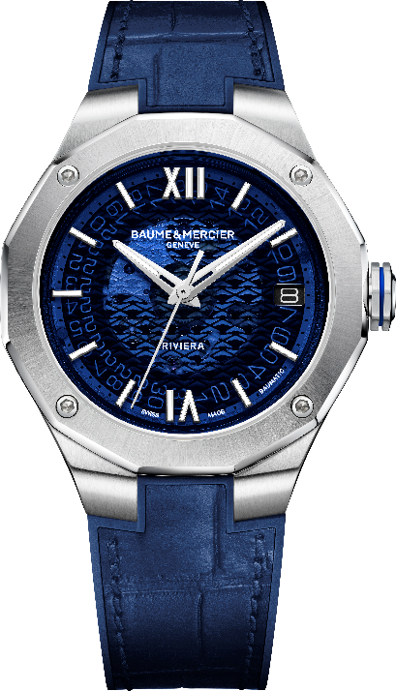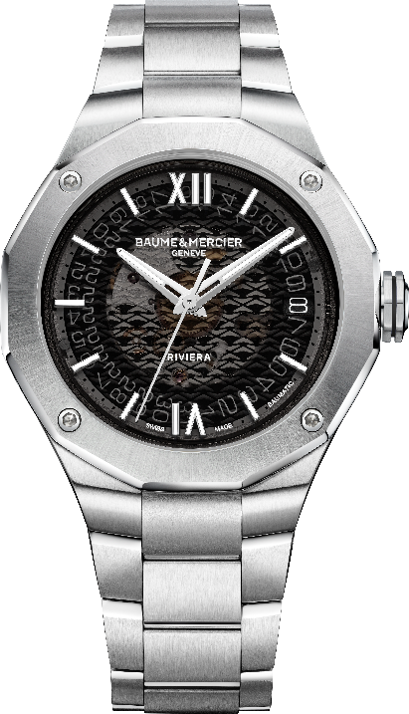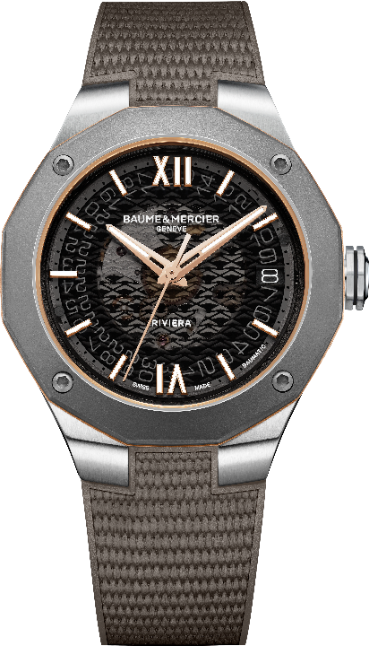
Riviera 39mm – 10714 / 10715 / 10720
Each of the three models is water-resistant to 10 ATM, and each is powered by the Baumatic manufacture movement, a five-day power reserve, a daily precision of -5 s/+10, and up to 1500 Gauss of solid resistance against everyday magnetic fields. With a 120-hour power reserve, the new 39-mm Riviera Baumatic may be forgotten on a night table from a Thursday evening to a Tuesday morning and still be full of energy. The three models feature a reliable interchangeability system which makes it possible to change styles in a single click without the need for tools. Moreover, in the purest Baume & Mercier spirit, the new 39-mm Riviera Baumatic models feature a dodecagonal case back featuring a sapphire crystal fastened with four screws to reveal the captivating mechanics of the self-winding movement. These three new models herald a new era, showing that the Riviera is multi-faceted and endlessly versatile. It encapsulates so much: high watchmaking, family vacations, improvised excursions with friends, and diving off the coast of the French Riviera. In 2023, the Riviera continues to surprise and show itself to its advantage.

The Riviera: An incredible 50-year adventure in the name of design

In 1973, Baume & Mercier dropped a bombshell on watch style with the Riviera. Its distinctive design went on to make it the Brand’s iconic model for the following fifty years. This watch was unique, different and spectacular. First of all, the silhouette of its steel body and twelve-sided bezel had never been seen before. These specificities broke with the conventions of classical watchmaking. Second of all, the avant-garde design of the Riviera immediately seduced a new type of client seeking a form of uniqueness and casual elegance.

Almost all “dress” watches were made of gold at the time, and the Riviera stood out in that regard. The visionary Baume & Mercier brand had opted for steel. The style was chic and sporty, so that the Riviera could be worn in the city or to the beach, to the office or on a weekend. It is the work of Jean-Claude Gueit, a watch designer who was a contemporary of Gérald Genta. Jean-Claude Gueit created a different, unique, new kind of watch. He called himself a “watch stylist” rather than a designer. That statement makes sense. The Riviera is his creation. Like a clear, bright line, the complex design of its bezel connects each hour segment to the others, visually offering a nearly natural sensation of perfection.

Its internationally recognized name brings to mind the water sports and sophisticated festivities of the French Riviera. A great commercial success, the Baume & Mercier’s 1990 Riviera collection took the entire world by storm. In France, Italy, the United States, Hong Kong, and elsewhere, this unmistakable watch transcended all frontiers and adapted to every culture. In some ways, the Riviera was one of the first sport-chic watches to be worn universally. For that reason, it challenged popular misconceptions. Presenting it as a sports watch, the brand found an unusual way of demonstrating its sturdiness in a live experiment: fastened to the wheel of a sportscar for the 24 Hours of Le Mans, the timepiece endured the effects of speed, acceleration, weather conditions, and heat radiating off the brakes. After the 24-hour competition, it was revealed to be in mint condition! Initially equipped with a transistor movement in 1973, the Riviera lost no time becoming available with quartz and self-winding movements by the mid-1970s. Since then, it has continued to evolve without ever losing its distinctive identity.

To demonstrate the extreme reliability of its manufacture movements, Baume & Mercier now offers a comprehensive eight-year warranty for any model equipped with a Baumatic caliber: Two regulatory years and a six-year extension are made available to watch owners simply by registering on the Baume & Mercier website when activating the warranty.



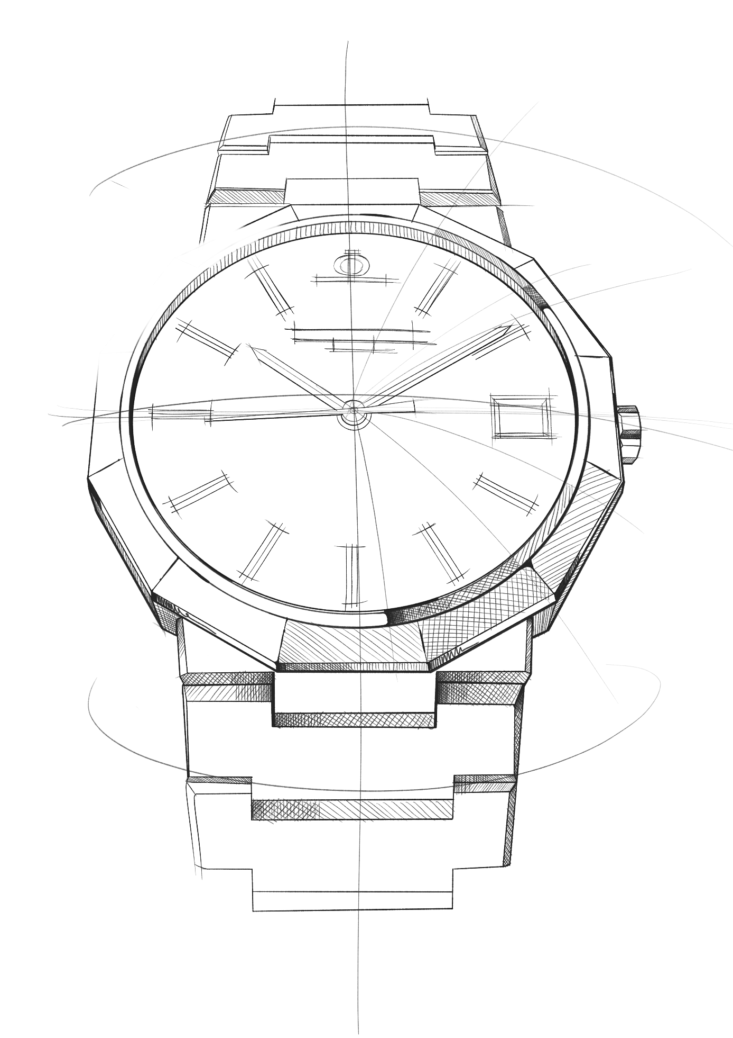
The Riviera collection: five generations, one legend

This is the story of an illustrious watch: one like none other, one that has always been ahead of its time. The Riviera has been redesigned several times through the years, not only keeping up-to-date but truly setting the pace.

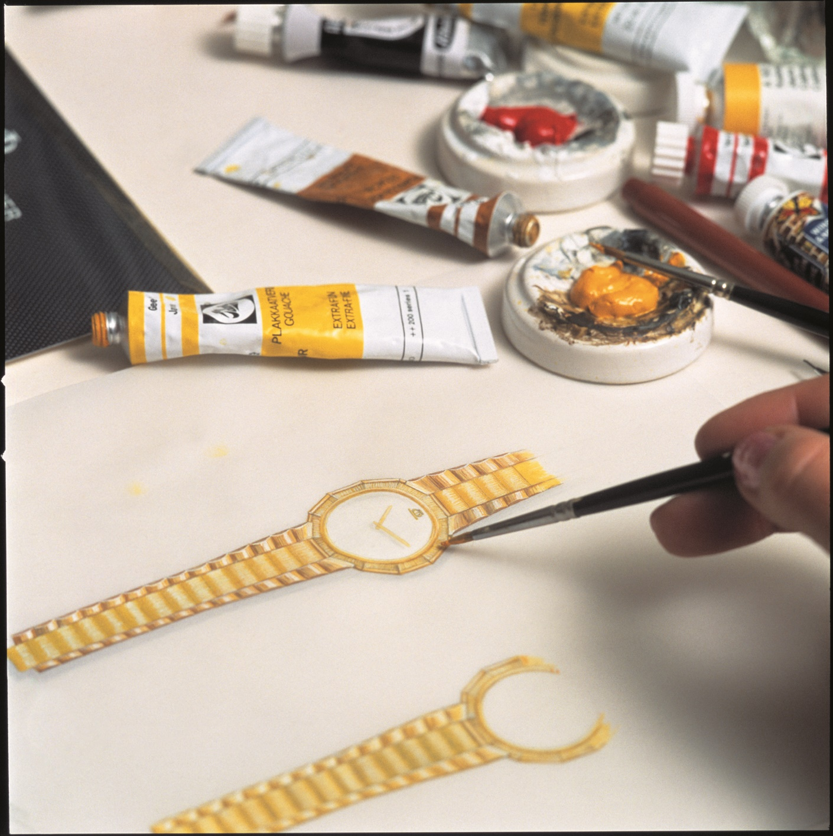

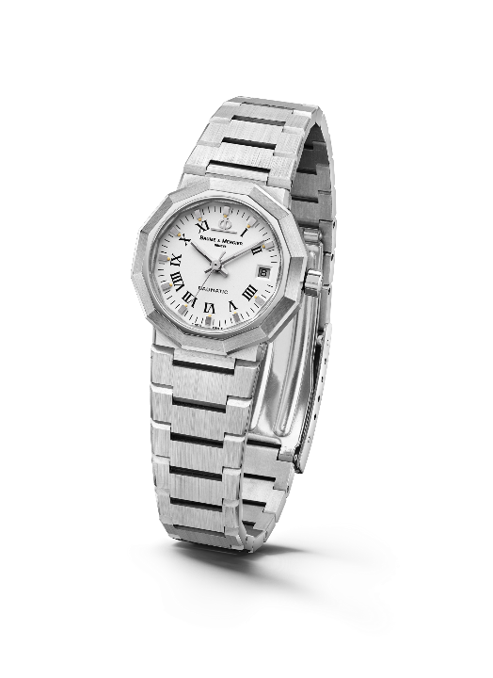
Launched in 1973, the Riviera immediately made a splash with its dodecagonal case and its slimline metal strap. It was already avant-gardist, though the Riviera name had yet to appear on the dial. In 1975, the concept was updated and made available with both self-winding and quartz movements: small, medium and large models were produced in steel, gold/steel, and solid gold.

A new generation was unveiled in the 1980s. The newly bicolor Riviera pursued its technical and aesthetic maturation, with its unmistakable name now appearing at 6 o’clock.

Riviera – 1st Generation - 1975

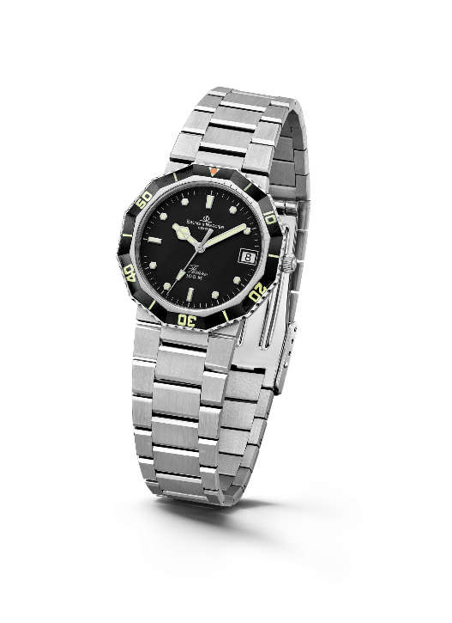

For the first time in 1981, it was made available as a diving watch in a style-pioneering sport-chic spirit. Its success was immediate.

Four years later, in 1985, the third generation of the collection was released. The bezel was reworked for a softer, less angular approach. The case and strap were also overhauled, and their polished and brushed surfaces helped create a more rounded look. The Riviera thus marked a turning point in terms of sophistication and reliability, including – among other features – a miniaturized screwed crown designed to improve its water-resistance. For its 20th anniversary in 1993, it strutted its style with a one-of-a-kind chronograph model. At the time, Baume & Mercier even created an unprecedented full-calendar Riviera in bicolor and solid gold versions, demonstrating its exceptional watchmaking savoir-faire. The Brand also introduced a version of the bicolor edition in a smaller diameter for ladies.
Riviera - 2nd Generation - 1981

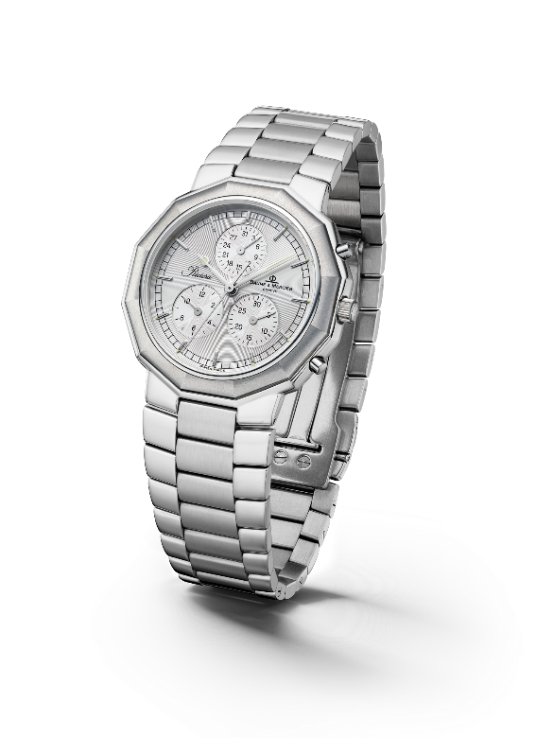
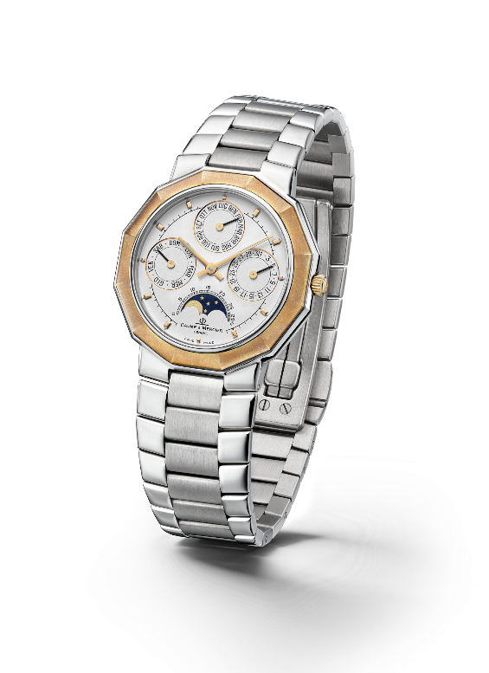

Riviera - 3rd Generation – Complication 1985 & Chrono 1993

In 2004, the Riviera collection took on a twofold approach for its fourth generation with two variations, one classic and the other more athletic. For the “Classic” line, Baume & Mercier maintained the dodecagonal shape of the case, interpreting the dial with a variety of materials and configurations. As for the “Sport” range, the Riviera featured four screws on its bezel for the first time, asserting an athletic look that would stand the test of time.

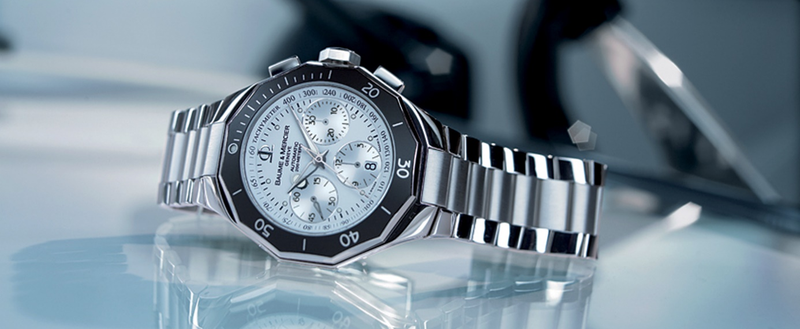

The fifth generation, launched in 2021, carried forward its perennially fashionable sport-chic personality with a number of variations that only added to its character.

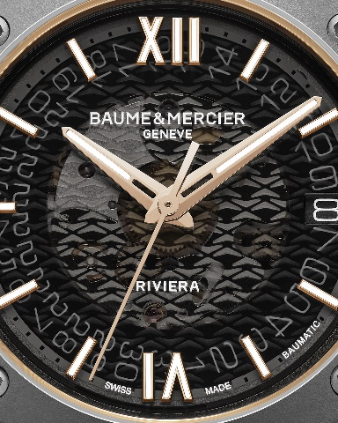
Information:

Model: Riviera 10714
Availability: April 2023

Model: Riviera 10715
Availability: April 2023

Model: Riviera 10720
Availability: April 2023

ABOUT BAUME & MERCIER:

Founded in 1830 at the heart of Swiss Jura, Baume & Mercier enjoys international renown. From its workshops at the heart of Swiss Jura to its headquarters based in Geneva, the Maison offers its clients the very finest timepieces. Born by a complementary balance between an artistic approach to shape and watchmaking innovation in the service of the client, the Baume & Mercier House continues to mark the history of watchmaking by passing down the design and watchmaking expertise that is the Brand’s legacy. This savoir-faire perfectly corresponds with the spirit of cooperation between the Brand’s founders William Baume & Paul Mercier: where classicism meets creativity, tradition meets modernity, and elegance meets character... In a more contemporary way than ever.

www.baume-et-mercier.com

