THE CLIFTON PATINA LINE BY BAUME & MERCIER,
DEDICATED TO THE MODERN GENTLEMAN

Launched in 2013, the Clifton collection was designed for the elegant man with a contemporary urban style whose lifestyle and tastes reveal great refinement. "To highlight the allure of this consummate gentleman, Baume & Mercier offers, until the end of this year, a patinated leather strap available in a choice of colors, for the purchase of any Clifton watch.

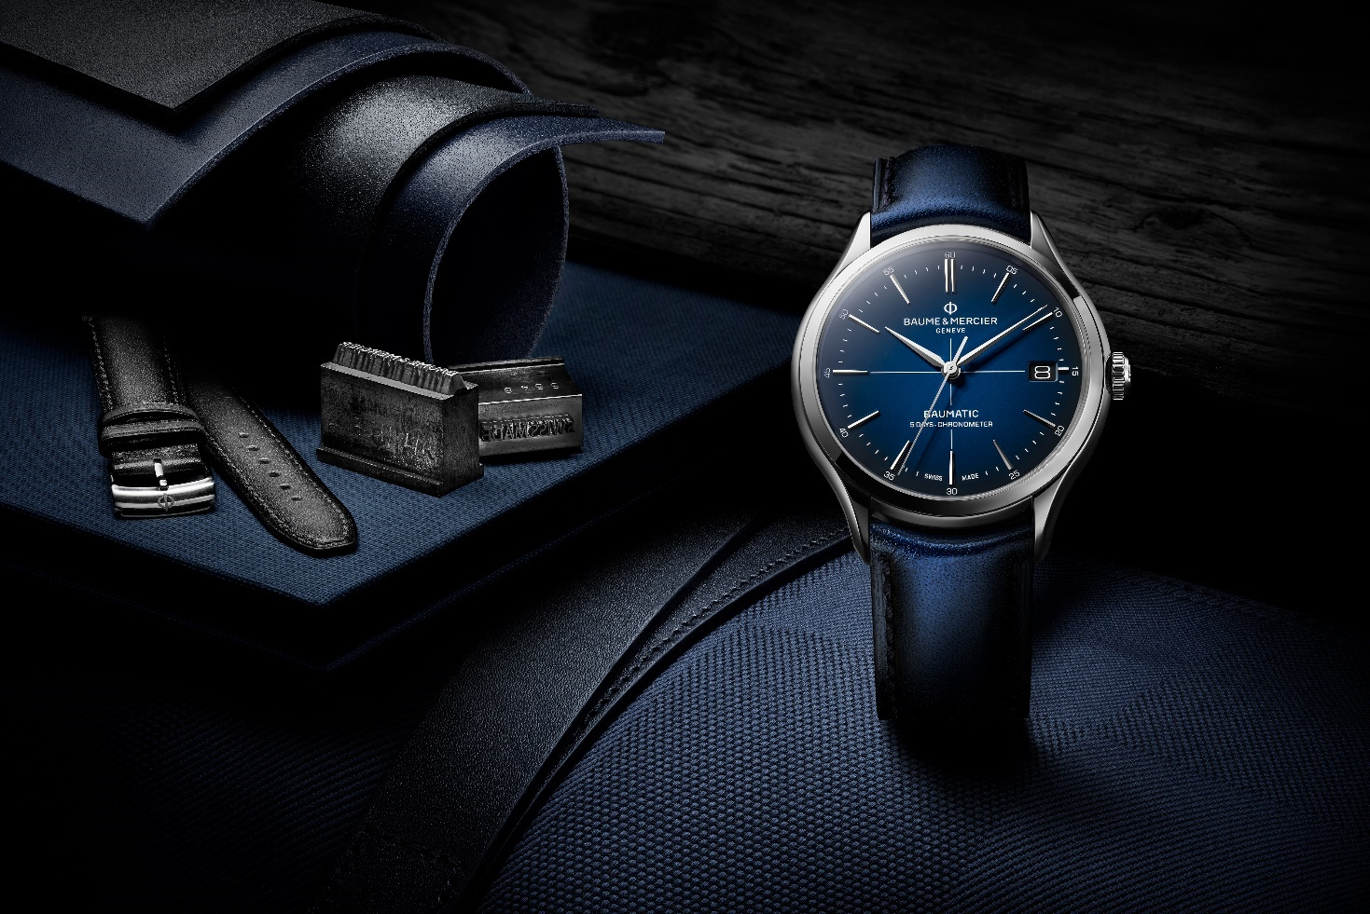

The Clifton collection, or the legacy of elegance

The history of Baume & Mercier has been profoundly rooted in the continual interaction between crafting excellence and stylistic research, ever since Paul Mercier brought a distinctively aesthetic orientation to the High Watchmaking mechanics developed by William Baume. An elegant aesthete who dedicated his leisure time to studying and learning languages – he spoke seven fluently –, Paul Mercier was an art aficionado with a natural charm. He himself exemplified the perfect gentleman for whom he designed timepieces that gained international acclaim.

Both classic and modern, the Clifton collection carries forward this tradition through shapely curves, meticulous crafting, ideal dimensions, and the discreet, natural sophistication of a round case. The models – from the most casual to the most formal – address the various expectations of their admirers, who eagerly claim their exquisitely understated elegance and their calendar and moon phase complications.

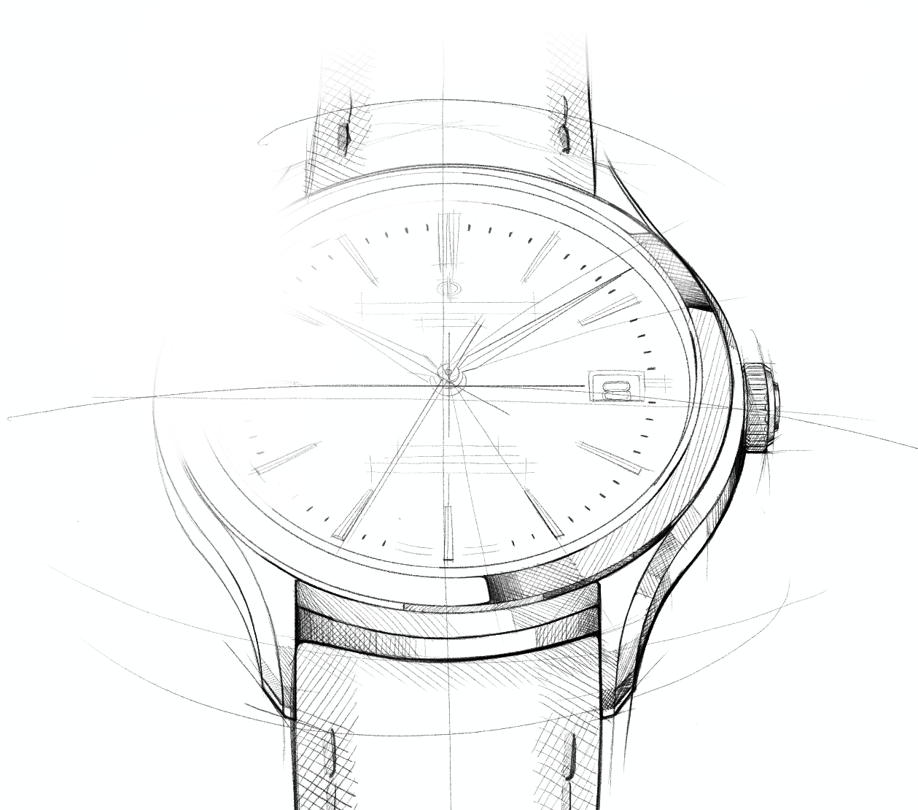

The focal point of this virtuosity, the manufacture Baumatic movement – of which certain models are COSC-certified – is the heir to the watchmaking excellence that guarantees precision and reliability. Its resistance to everyday magnetic fields reaches 1,500 Gauss. Its outstanding precision makes this timepiece a daily ally to wear on the wrist. It also features a remarkable autonomy thanks to its five-day (120-hour) power reserve and water-resistance to 5 ATM (approximately 50 m).

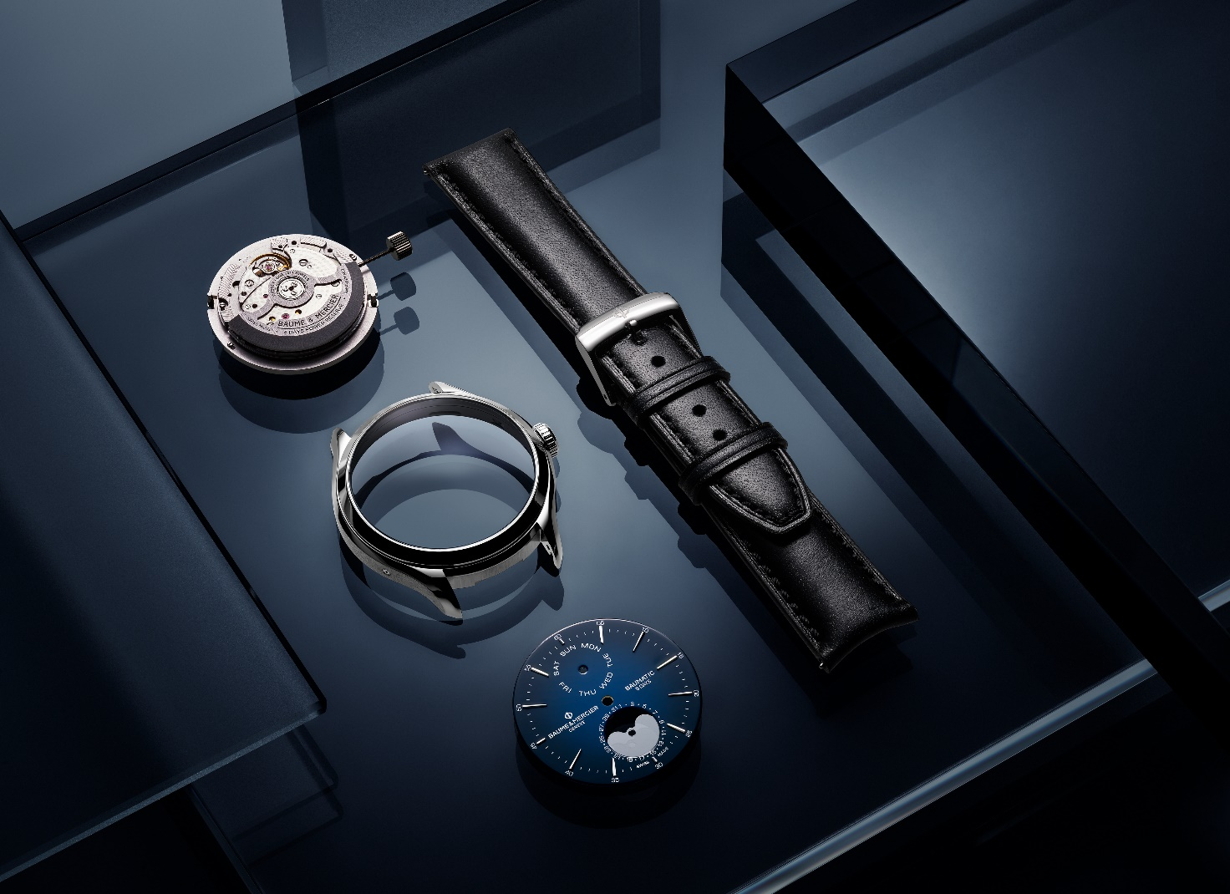

Aesthetically, the scrupulous finishes of this movement heighten the polish of its circular-grained bridges, its sand-blasted and snailed baseplate, and its openworked oscillating weight with a snailed “Côtes de Genève" decor which may be admired through the sapphire case back.

Like all Baume & Mercier watches, the Clifton is an object of design based the careful consideration of its shape and cut; the balance of its structure and proportions; the crafting of its texture and colors; and the revelation of its impeccable Swiss savoir-faire.

These values represent everything that a gentleman expects from a watch: history, culture, excellent quality, beauty, and prestige as a status symbol of success.

The art and manner of the perfect gentleman

The Clifton collection evokes the spirit of a gentleman from the 1950s, highlighting the utmost refinement in attitude and dress code. Menswear of the time was dominated by close-fitting suits, fitted jackets and pleated trousers, often tailor-made. Like watches, other accessories such as shoes, hats and ties became the focus of fashionable polish. While this wardrobe remained compulsory, more “casual” sportswear also appeared, winning over gentlemen who delighted to the appeal of these alternatives. The emblematic figures of the time include Cary Grant and Steve McQueen with their inspiring sartorial looks.

For Baume & Mercier, the 1950s were prolific in technical and creative terms. Just after WWII, the brand produced some of the first calendar watches to display the date, day of the week, and month, as well as water-resistant models, which were innovative at the time. Around 1955, Baume & Mercier gained a reputation for its chronographs, which were some of the most stylish and flawless on the market. Equipped with movements crafted in Le Brassus, these included elaborate complications: complete date functions – including day and month apertures and a date hand display –, moon phases, and totalizers for short intervals. Some, very sought-after by businessmen, were designed to time telephone conversations. Others, created with doctors in mind, featured a pulse measurement scale.

These chronographs from the 1950s are now among the Baume & Mercier collector’s pieces. Functional, precise, and elegant, they embody the values of the brand, which enjoys a reputation comparable to the one it enjoyed in the beginning of the last century. Considered one of the most prominent watchmakers of the 1950s and 1960s, Baume & Mercier flourished in the United States, which became its second most prominent market after Italy. In 1955, the brand inaugurated a branch in New York City.

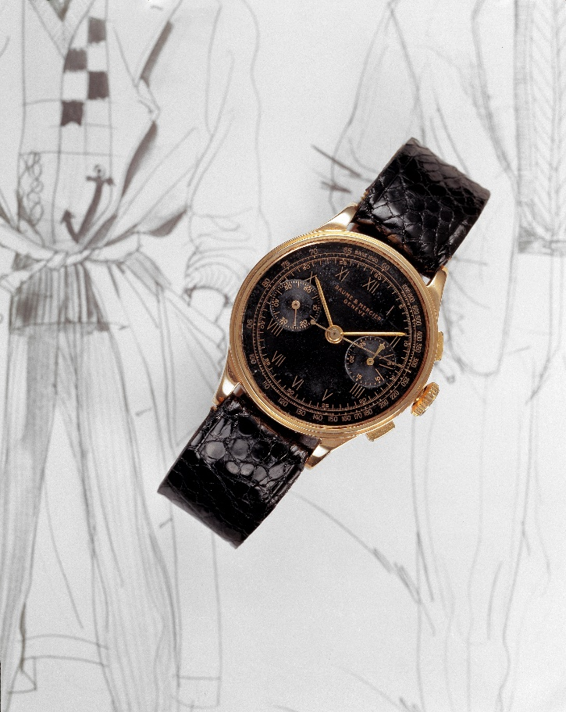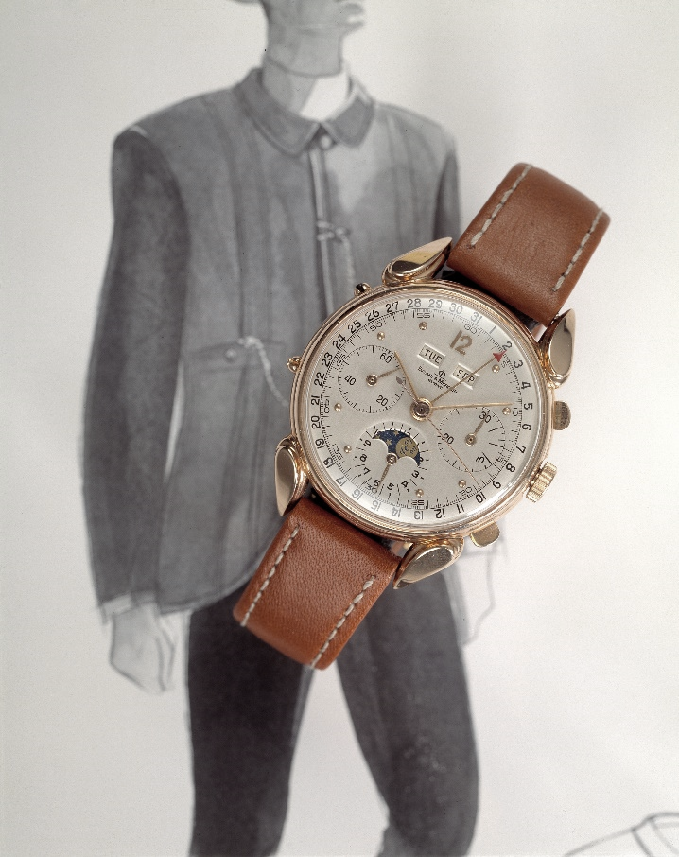

Under the influence of the stylistic codes of the times, round timepieces represented the height of refinement that gentlemen sought after. Typically crafted in gold and mounted on a leather strap, the fine case generally revealed a light-colored dial punctuated with Arabic numerals beneath a delicately domed crystal. The design was streamlined and sophisticated.

Since then, the 1950s have represented the golden age of vintage style. That spirit is making a remarkable comeback in 2024. Clothing designers are bringing it back into fashion, reinterpreting the silhouettes and fabrics of that period to launch new trends. Likewise, the watchmaking world is highlighting the emblematic models of the time, bringing life to creative contemporary representations.

More than an allure, the vintage spirit embodies a deeper identity. Like the Clifton man, the 2024 version of this gentleman cultivates an art of living with razor-sharp elegance and decorum: the discreet luxury distinctive of Baume & Mercier. This connoisseur appreciates fine materials, tailored cuts, and impeccable finishes, and considers each detail to be important. Like the Baume & Mercier brand, he effortlessly navigates retro charm, boldness and innovation, and focuses on timeless allure. Sensitive and exacting, he seeks out emotion and excellence, fascinated by technology and touched by sophistication. Courteous, upstanding and cultured, he exudes confidence and a considerate open-mindedness.

To him, watchmaking is as much a playground as a territory of knowledge, and he enthusiastically explores its mechanisms. Just as he enjoys the rich flavors of a few cigars or vintage whiskeys, he delights in delving into their secrets.

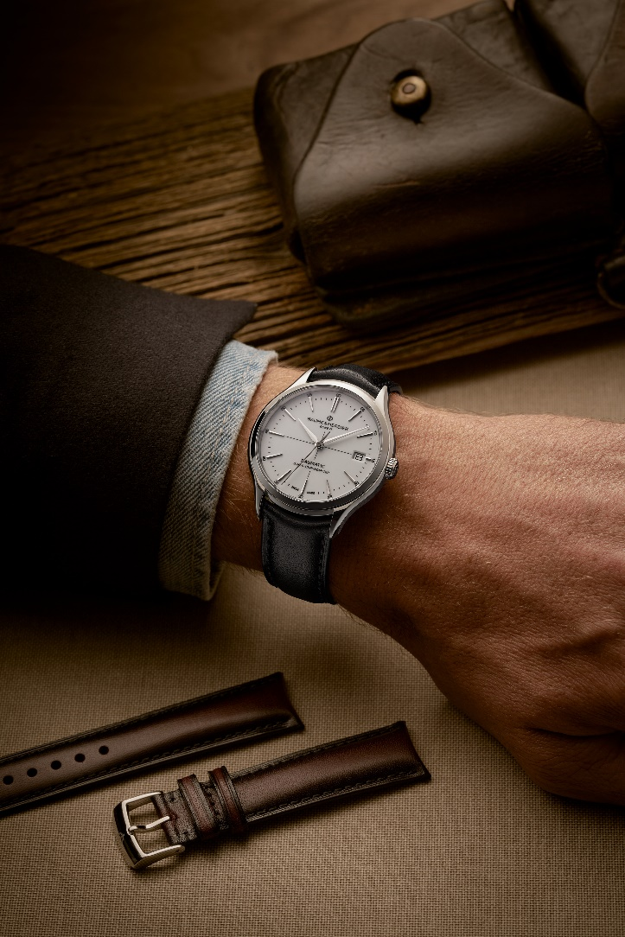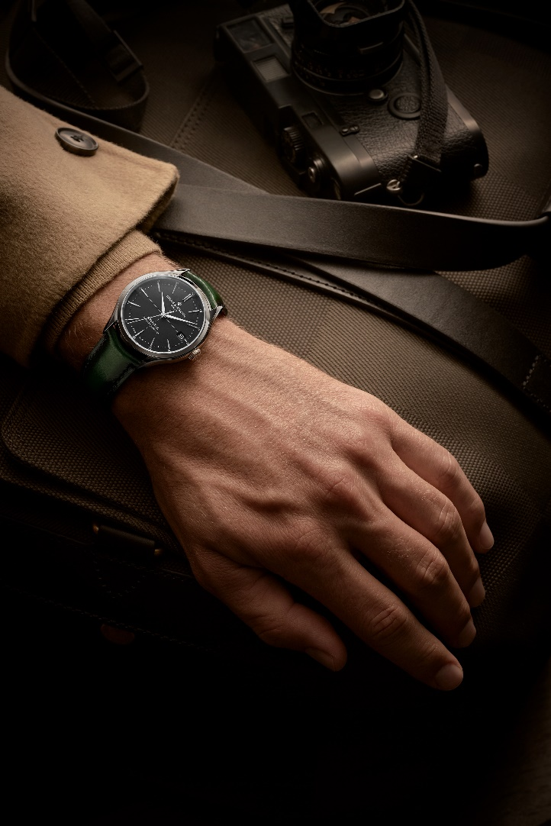

The natural elegance of patinated leather

Through the Baume & Mercier offer, the Clifton watch invites aficionados to a new lesson in style based on materials and color.

In smooth calfskin adorned with tone-on-tone overstitching, the straps are adorned with glowing, subtly wrought patinas that bring them that vintage appearance so coveted by today’s stylish men. The aesthetic effect evokes the majesty of passing time and reveals the nuanced beauty of leather.

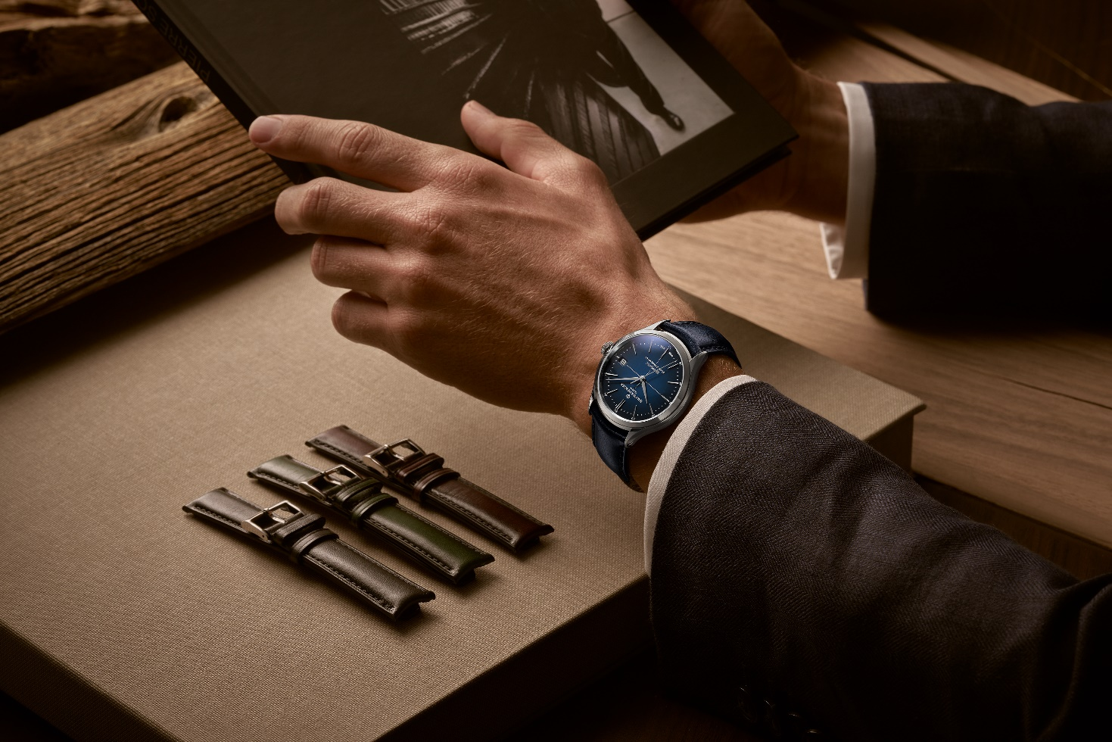

The straps are available in grayish black, blue, green, burgundy, brown, and purple: six traditional hues that perfectly flatter the gentleman’s wardrobe. This extensive color scheme lends itself to harmonious coordination with the broadest possible range of clothing. They accompany various times of the day, adapt to special occasions, and provide for a change of look on a whim.
The coordination between the collection’s straps and its many dials – white, blue, black, gray, chocolate, or green – offer endless possibilities. Each individual is free to find the combination of his dreams, choosing the watch that makes it possible.

The interchangeable straps may be changed without the need for tools, thanks to a very reliable, solid curved spring bar system. Each is topped with a folding clasp featuring security push-pieces or a pin buckle, crafted in stainless steel or rose gold (750/1000).

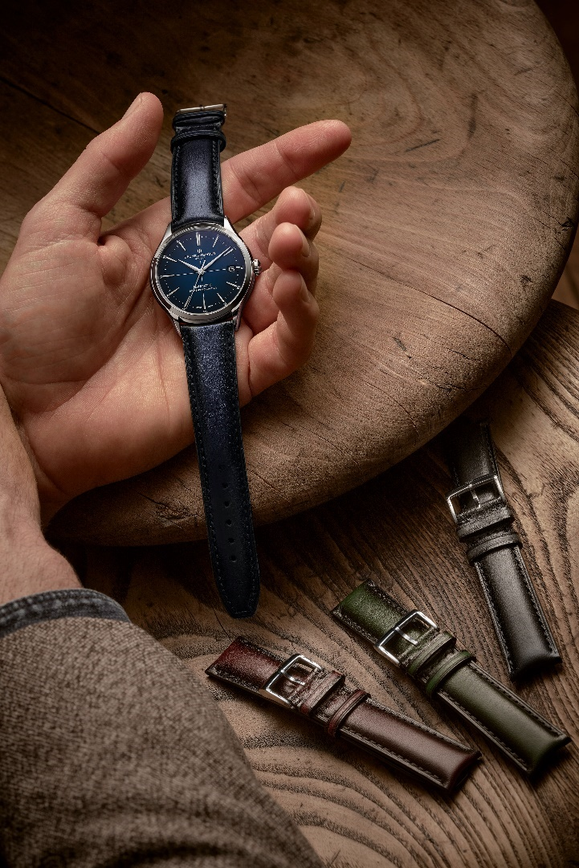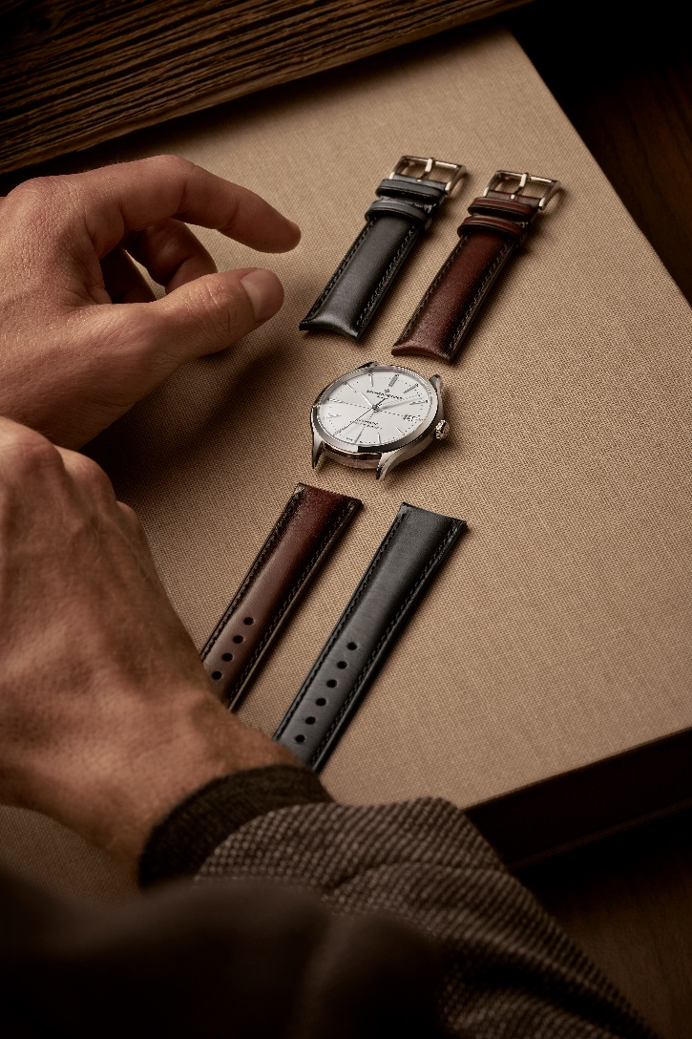

His wrist adorned with any of these new Clifton looks, the gentleman shows off a timepiece that enhances his allure. And if accuracy – meaning punctuality – is a mark of nobility, it is also characteristic of such a man, in his devotion to precision in all that he possesses and undertakes.

ABOUT BAUME & MERCIER:

Founded in 1830 at the heart of Swiss Jura, the Baume & Mercier watch manufacture enjoys international renown. From its workshops at the heart of Swiss Jura to its headquarters based in Geneva, the Brand offers its clients the very finest timepieces. Borne by a complementary balance between an artistic approach to shape and watchmaking innovation in the service of the client, the Baume & Mercier House continues to mark the history of watchmaking by passing down the design and watchmaking expertise that is the Brand’s legacy. This savoir-faire perfectly corresponds with the spirit of cooperation between the Brand’s founders William Baume & Paul Mercier: where classicism meets creativity, tradition meets modernity, and elegance meets character... In a more contemporary way than ever.

www.baume-et-mercier.com

