THE NEW RIVIERA AURÉLIEN GIRAUD
SPECIAL EDITION BY BAUME & MERCIER

A collaboration that began three years ago between Baume & Mercier and the young French world champion skateboarder Aurélien Giraud brought forth a limited edition of the Riviera Collection.

Baume & Mercier takes an approach to watchmaking that remains open to other spheres and in step with the times. The interaction between watchmaking and the world of skateboarding naturally fits in among the inspirations that are important to the Brand. Creativity, aesthetic, precision, technical achievement and transcending one’s limits are values that the watchmaker shares with high-level athletes. Sealing the special relationship that precisely connects the Riviera watch – showcase for the new edition illustrating this collaboration – and Aurélien Giraud is a daring spirit. The collection expresses a sporty yet chic energy that dared to break with convention when it was first created in 1973, with a design asserting a dodecagonal case and bezel. Its innovative look defied the trends then and has been overhauled several times since while remaining faithful to its own essence, similarly to the young skater who performs acrobatic stunts, taking risks with each trick that he executes. Both have risen to legendary status to the great delight of their admirers. After the Baume Skate - Aurélien Giraud Special Edition, which featured distinctive skateboard materials, the Riviera has now taken on the codes and spirit of this fearless discipline to design a new edition.



A deep love for skateboarding

Born in Lyon on February 3, 1998, Aurélien Giraud began to skate at the age of four when his father gave him his first board. The young beginner immediately fell in love with the sport and revealed a natural talent for it. He got noticed at the V7 Teenage Tour three years later and went on to win a number of international competitions, becoming amateur world champion at the age of 15. That was when his career really took off. He concentrated on his objectives, worked hard, and faced off with prodigious competitors, particularly in 2019 at the Californian Dew Tour. In 2022, his efforts earned him the gold medal at the FISE World Montpellier, a silver medal at World Street Skateboarding Rome, and a gold medal at the French Championship in Hyères. His crowning achievement occurred on February 5, 2023, in the United Arab Emirates, when he triumphed at the World Street Skateboarding Championships, a feat that no Frenchman had ever accomplished before. His consecration was confirmed in April 2024 in Paris, where he won first place at the Street League Skateboarding Championship. Believing in himself and in his dreams, and putting in the work to achieve them: such is his leitmotiv.



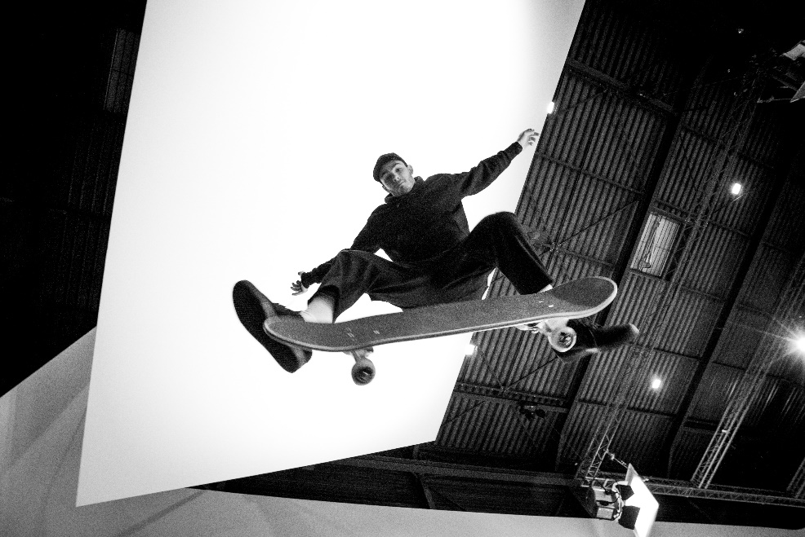



A dynamic design for a limited edition of 100

The Riviera Aurélien Giraud Special Edition watch asserts a young, dynamic aesthetic with a red central seconds hand. The same energetic color coats the letter Phi, extends along one of the ends of the hand, and appears on the strap. In a reference to the golden ratio, the Greek letter Phi became the emblem of Baume & Mercier in 1964. It symbolizes the Brand’s attention to the perfect proportions, precise lines, and harmonious materials and colors of its timepieces.

The very graphic strap is crafted in a combination of rubber and Alcantara and topped with white overstitching which reflects the digits, indexes, and hour and minute hands, all coated with white Superluminova. The time stands out in stark contrast, capturing the eye for easy readability. A special engraving, created for the occasion – representing the logo of Aurélien Giraud and the limited number of the piece – appears on the back of the case.

The edition is limited to 100 watches, just like 100 points: the perfect score to achieve during a run at an official skateboard competition. Even in the number of this limited series, the Riviera Aurélien Giraud Special edition demonstrates the pursuit of excellence.

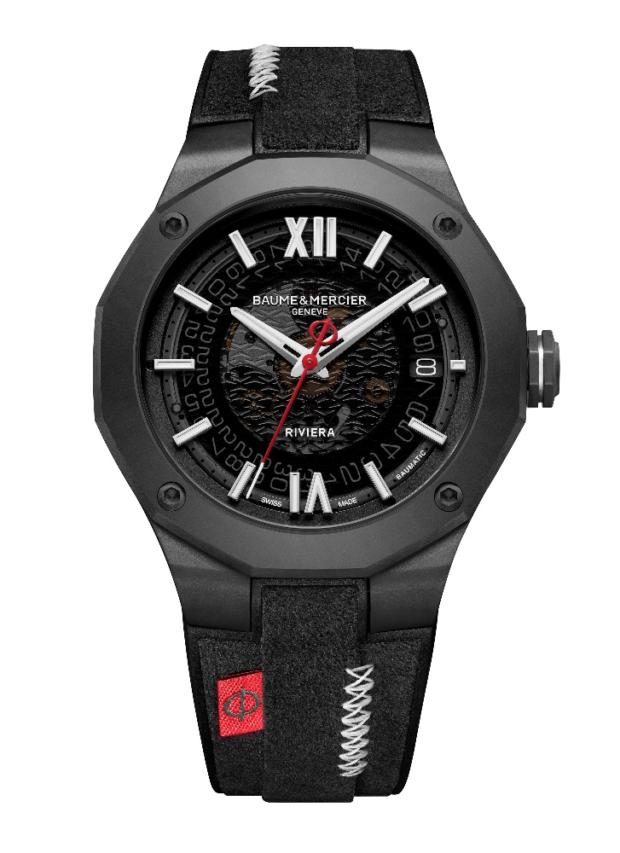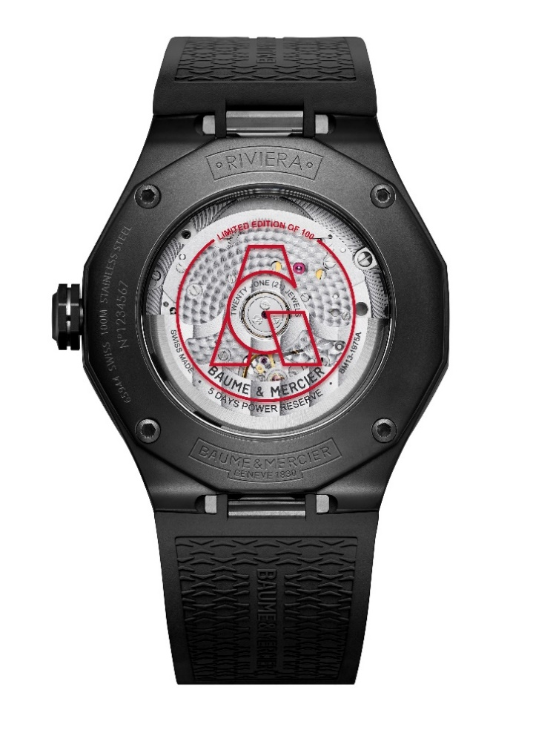

The technical exploits of the Baumatic movement

This timepiece with sophisticated finishes is driven by the manufacture Baumatic movement. This high-tech caliber guarantees reliability, precision and comfort. Its proven durability enables it to resist everyday magnetic fields of up to 1,500 Gauss. With a great precision and a frequency of 4Hz (28,800 vph), it offers remarkable autonomy thanks to its five-day (120-hour) power reserve. Completing its technical assets, it is water-resistant up to 10 ATM (approximately 100 m).

Like all Baumatic models, its components benefit from an extended warranty of six years in addition to the standard two years of international warranty. To activate this guarantee, simply register the piece on the Baume & Mercier website within 60 days after purchase: www.baume-et-mercier.com.

Riviera M0A10789

The luminous dial in smoked gray sapphire subtly unveils the transparent transfer wave decoration characteristic of the Riviera Collection. In an accentuated chromatic alternation, the Roman numerals and riveted indexes are rhodium-plated and coated with white Superluminova (blue glow). The faceted rhodium-plated hour and minute hands are also coated with white Superluminova, offering a blue glow. The bright red seconds hand is strikingly slender. An aperture displays the date at 3 o’clock.

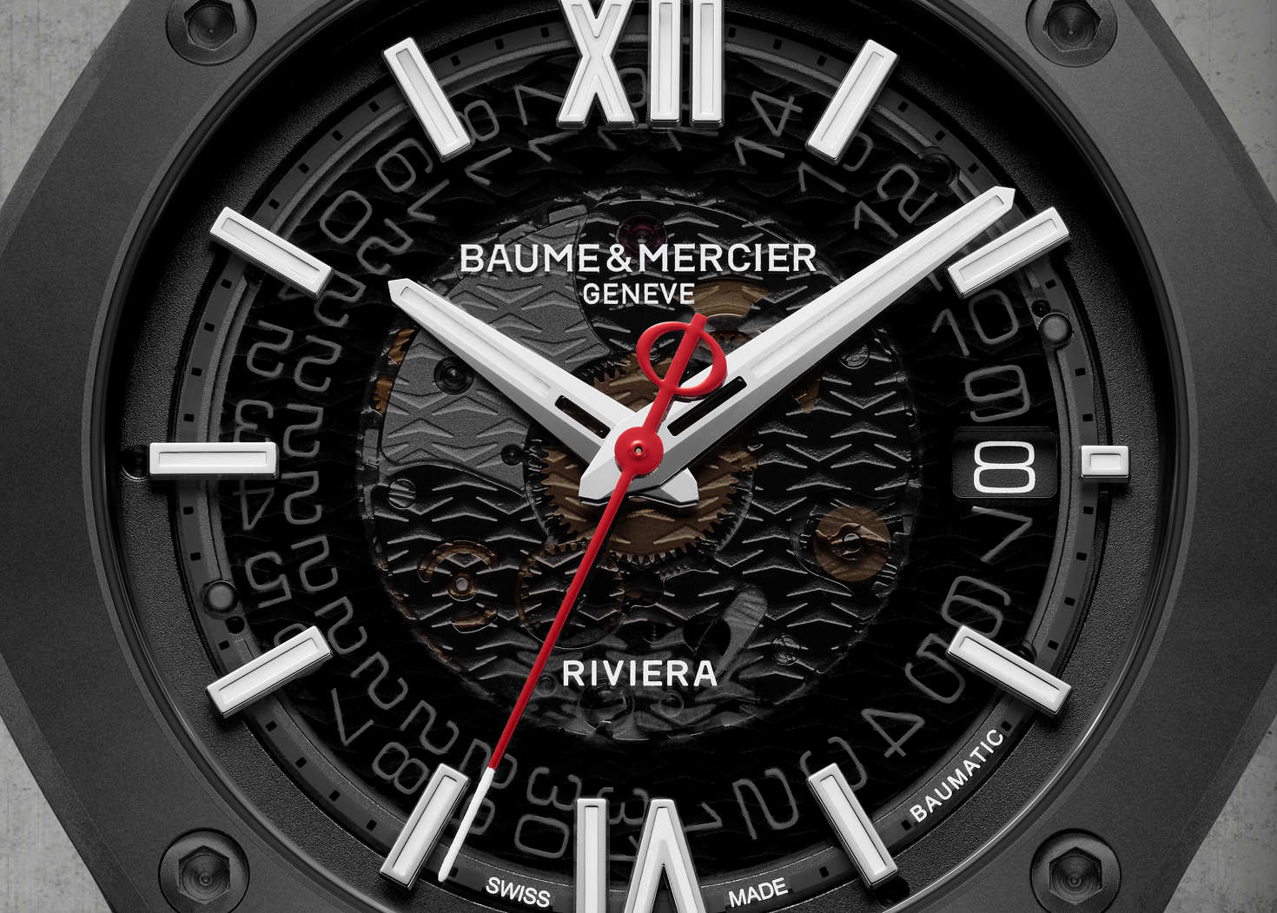

With a diameter of 42 mm and a thickness of 10.6 mm, the iconic dodecagonal case of the Riviera is crafted in sand-blasted ADLC-coated steel. It is protected by a scratch-resistant sapphire crystal with an anti-glare coating on both sides. Fastened by four screws in ADLC-coated steel, the bezel is crafted in sand-blasted ADLC-coated steel. The dodecagonal case back is also fastened with four screws and topped with a sapphire crystal that reveals the watch mechanism. The free octagonal crown in sand-blasted ADLC-coated steel bears the embossed Phi logo in red with a steel outline.

The self-winding Baumatic manufacture movement reveals magnificent beaded-finish bridges, a sand-blasted and snailed baseplate, and an openworked oscillating weight with "Côtes de Genève" and snailed decorations. This timepiece features a five-day (120-hour) power reserve, oscillates at a frequency of 4Hz (28,800 vph), and offers water-resistance to 10 ATM (approximately 100 m).

The very original, integrated strap is crafted in black rubber and Alcantara with white overstitching, playing on the concept of overlapping layers for a different, modern appearance. It is interchangeable and may be removed and replaced thanks to a very reliable, robust mechanism that makes it possible to change the strap without tools.
Its sand-blasted ADLC-coated steel triple folding buckle is equipped with security push-pieces and an easy adjustment feature.

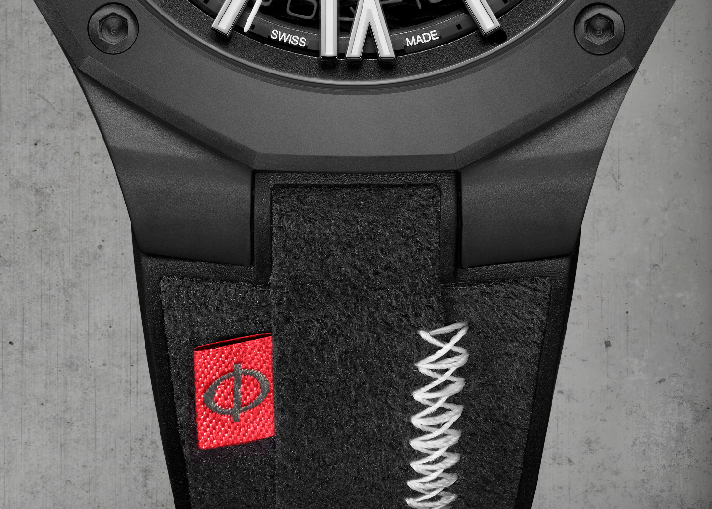

This expression of the Riviera is a moving tribute to time. Time is precious for both Baume & Mercier and Aurélien Giraud. Taking control of it to move ever forward is an everyday challenge for both. The two combine their shared enthusiasm and expertise in the form of this intense, radiant timepiece.

Information:

Model: Riviera 10789
Availability: June 2024

ABOUT BAUME & MERCIER:

Founded in 1830 at the heart of Swiss Jura, Baume & Mercier enjoys international renown. From its workshops at the heart of Swiss Jura to its headquarters based in Geneva, the Maison offers its clients the very finest timepieces. Born by a complementary balance between an artistic approach to shape and watchmaking innovation in the service of the client, the Baume & Mercier House continues to mark the history of watchmaking by passing down the design and watchmaking expertise that is the Brand’s legacy. This savoir-faire perfectly corresponds with the spirit of cooperation between the Brand’s founders William Baume & Paul Mercier: where classicism meets creativity, tradition meets modernity, and elegance meets character... In a more contemporary way than ever.

www.baume-et-mercier.com

