THE CLIFTON COLLECTION FOR WOMEN:
UNCOMPROMISING WATCHMAKING PERFORMANCE

FEMININE TIMEPIECES ARE EQUIPPED WITH THE BAUMATIC MOVEMENT FOR THE FIRST TIME

Baume & Mercier is deeply committed to offering the same level of watchmaking excellence to everyone, regardless of gender. This modern and forward-thinking approach is rooted in the Brand’s heritage. From the moment Paul Mercier partnered with William Baume in 1918, he championed this visionary philosophy. He combined elegance and performance, designing exceptional timepieces for women that were both aesthetically refined and technically accomplished. Over a century later, the Brand reasserts, more than ever, its conviction that the best of fine watchmaking should not be reserved for men alone. It embodies this certitude by meeting the expectations of today’s confident, independent woman for a watch that is both elegant and technically sophisticated: one admired for its complexity, precision, reliability, and longevity. The Clifton collection now speaks to this vision through two new models that unite delicate design and advanced technology. For the first time in the collection’s history – not to mention Baume & Mercier’s –, these timepieces introduce a 34mm case, and both are equipped with the self-winding Baumatic Manufacture movement, previously reserved for men’s models.

The Clifton Baumatic M0A10831 and M0A10833 carry forward the Brand’s prestigious legacy.

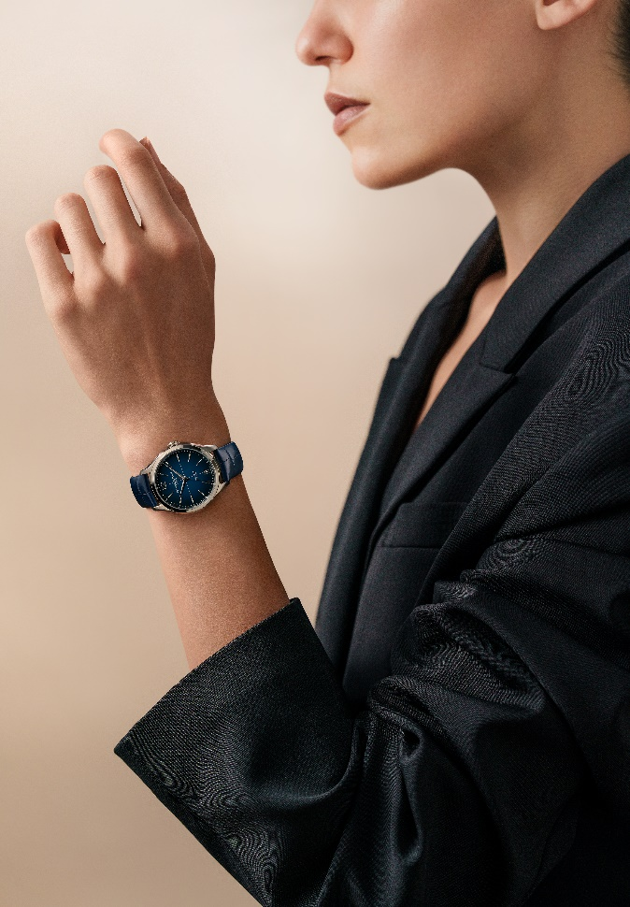
Clifton 10833 Clifton 10831

Avant-garde women’s watchmaking

When Paul Mercier stepped into William Baume’s office at 2 Rue Céard in Geneva on December 16, 1918, he knew that this meeting would change the course of his life. At 39, he was already well-traveled, having had a life filled with bold experiences; but the idea of a new beginning inspired him. Within minutes, the brilliant watchmaker William Baume said to him: “Do you know what sets us apart, you and me? You are a visionary; a man of perspective.”
In Paul Mercier’s vision of watchmaking, women were just as important as men. In addition to creating sensational jewelry watches that would earn the Brand a spotlight in the 1920 Davoine General Indicator of Watchmaking, praising its “haute Fantaisie pour Dames” (“high fantasy for women”), Mercier also recognized women as an emerging and influential market. He understood that women were not only drawn to the beauty and flair of timepieces, but also to their technological appeal. “We are finally talking about watchmaking as if there were more to this world than men. They do not want to be relegated to the simple task of setting their husbands’ watches! They also want to be able to master time, and not simply by carrying a ridiculous men’s ‘turnip watch’! Look at how women are becoming liberated today!” he exclaimed, referring to the English suffragettes and the 1910 International Women’s Conference in Copenhagen which advocated for the creation of International Women’s Day.
He saw the miniaturization of movements and new technologies as tools to serve his creativity and daring spirit, which he dedicated as much to women as to men.

During the Roaring Twenties and the Art Deco period, Baume & Mercier brought forth some of the slimmest extra- and ultra-thin watches in the world. In particular, the Brand specialized in what were known as “baguette” movements, ideal for original women’s watch cases in rectangular, square, barrel, and cushion shapes.

Baume & Mercier was among the first to spotlight the active, independent woman: one who is unafraid to break the rules, defy convention, and influence fashion, while embracing her femininity. In the 1950s, the Brand portrayed this ideal in a campaign featuring a female doctor. This was the portrait of a client who cared about more than just the beauty of a watch. She saw beyond appearances to take an interest in the movement and was willing to invest in a high-end mechanism. For her, it would be essential for her timepiece to be precise and reliable.

That same spirit lives on in the new Clifton Baumatic M0A10831 and M0A10833. Their elegant 34mm size is an ode to femininity. Their vintage aesthetic channels the timeless elegance of the 1950s. Their cutting-edge Baumatic Manufacture movement reinforces Baume & Mercier’s commitment to go one step further, offering women not just jewelry watches or quartz pieces like most of brands, but truly cutting-edge Swiss watchmaking at its finest. Always in step with the times – and indeed often ahead of them –, the Maison honors strong, independent women for whom time is both an expression of aesthetic seduction and technical excellence, a mirror of their success and empowerment.


Clifton 10831 Clifton 10831
The refinement of a 34mm case

Design is a cornerstone of the watchmaking approach of Baume & Mercier. When the Brand chose the Greek letter Phi in 1964, in a reference to the Golden Ratio, it signaled a dedication to perfect proportional balance as a structural, stylistic principle in every timepiece. The smallest Clifton case was previously 39mm, but the collection begins a new chapter with the introduction of the 34mm case.

This size offers a refined, comfortable fit ideal for women.

It will also appeal to men seeking more understated dimensions. The Clifton 34mm models will naturally suit them, too. Elegance is fundamental to the collection’s identity, dedicated to the modern gentleman for whom style is more than fashion, but a way of life.

The new design codes of the Clifton collection

The Clifton Baumatic M0A10831 and M0A10833 illustrate the new face of the collection. The case, with polished and satin-brushed finishes, has been reworked with a more vintage look, inspired by a 1950s archival design of timeless elegance. A domed sapphire crystal enhances the silhouette, while the crown is seamlessly integrated into the caseband. An Arabic numeral makes its return 12 o’clock,while the date aperture is positioned at 6 o’clock. Crosshairs adorn the center of the dial. A beaded minute track – unique to the Clifton 34mm – gracefully frames the dial. The Clifton Baumatic M0A10831 features a luminous new off-white dial with a subtle grain finish that adds depth and dimension. Its 5N gold-plated accents further heighten its sophistication.

True to the Maison’s signature aesthetic – and its renown for shape watches –, both pieces highlight precise lines, clean angles, elegant curves, meticulous detailing, and harmonious finishes. Their refinement is paired with the understated elegance that defines Baume & Mercier.


Clifton 10833

Feminine timepieces equipped, for the first time, with the Baumatic movement

Baume & Mercier reaches a new milestone in its watchmaking savoir-faire by incorporating the Baumatic movement into a 34mm case for the first time in the history of the Clifton collection. This high-tech movement, developed in-house and rigorously tested, offers everyday magnetic resistance up to 1500 Gauss and oscillates at a frequency of 4Hz (28,800 vph).
Its 5-day (120-hour) power reserve ensures remarkable autonomy, another promise of enduring precision and excellence. It is water-resistant to 5 ATM (approximately 50 m).

The beauty of this movement can be admired through the sapphire crystal caseback, which reveals its circular-grained bridges, sandblasted and snailed baseplate, openworked oscillating weight adorned with Côtes de Genève and snailed decorations, and unique Baume & Mercier engraving.

Like all Baumatic watches, the Clifton M0A10831 and M0A10833 benefit from a 6-year extended warranty in addition to the standard 2-year international warranty. Simply register it on the Baume & Mercier website within 60 days after the purchase: www.baume-et-mercier.com

- Clifton Baumatic M0A10831

The particularly luminous new off-white hue of the dial subtly enhances the vintage appeal of the watch. Its finely grained finishes accentuate the black crosshair at the center and the surrounding hour and calendar indications. The indexes are slightly elongated, trapeziodal, faceted, gold-plated, and riveted. The gold-plated, faceted alpha-shaped hour and minute hands extend this exquisitely refined graphic dynamic, joined by the slender gold-plated seconds hand. A gold-plated, beaded minute track in gold encircles the dial, punctuated by an Arabic numeral at 12 o’clock and a date aperture at 6 o’clock.

The 34mm diameter and 10.5mm thick case, like the crown, is crafted in satin-finished stainless steel. It is protected by a scratch-resistant domed sapphire crystal treated on both sides with an anti-glare coating. The back is also protected by a sapphire crystal and may be custom-engraved.

The self-winding Baumatic Manufacture movement (BM13-1975A) brings this timepiece to life.

It is mounted on a taupe-colored alligator strap with all-square scales. This interchangeable strap is equipped with a very reliable spring bar system that makes it possible to change it without the use of tools. The pin buckle is crafted in steel.

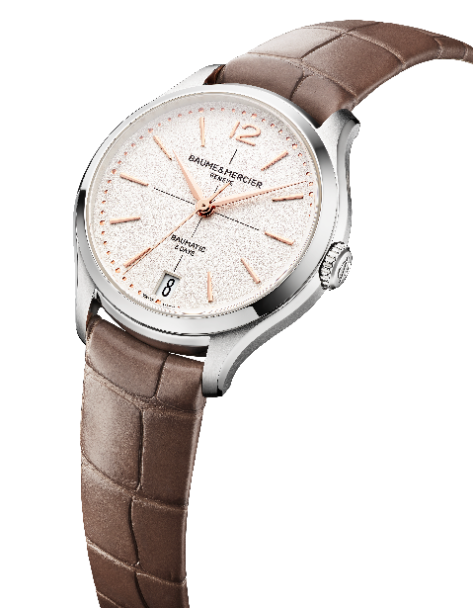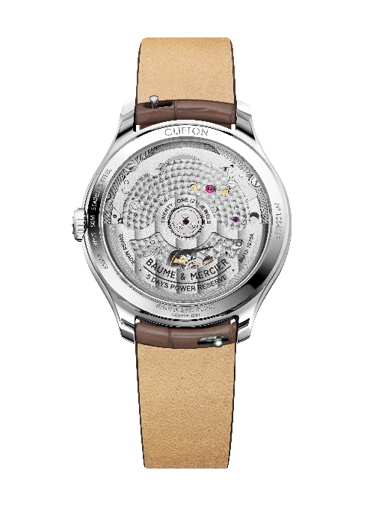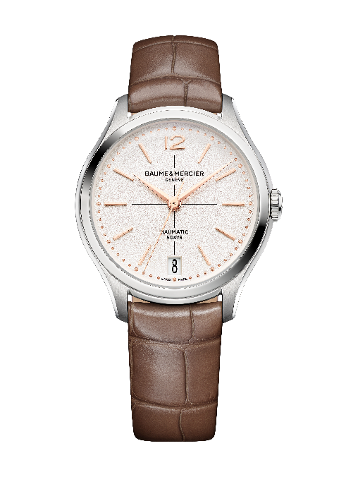

- Clifton Baumatic M0A10833

The brilliance and depth of this model speak of the meticulous craftsmanship of its dial. The subtle shades of its gradient blue lacquered finish, darker along the edges and gradually brighter toward the center, draw the eye with a captivating effect. This interplay of color and texture enhances legibility with elegant sophistication. The slightly elongated, faceted, rhodium-plated trapeziodal indexes stretch gracefully across the dial. The faceted, rhodium-plated, alpha-shaped hour and minute hands mirror this elegance. The rhodium-plated seconds hand follows the same dynamic along the beaded silver minute track. A date aperture at 6 o’clock and an Arabic numeral at 12 o’clock complete the display.

The case – 34mm diameter and 10.5mm thick – and the crown are both crafted in polished and satin-finished stainless steel. The watch is protected by a domed scratch-resistant sapphire crystal with an anti-glare coating on both sides. The sapphire crystal case back, which may be custom-engraved, reveals the watch movement.

The self-winding Baumatic Manufacture movement (BM13-1975A) drives this watch.

This model features a strap in blue alligator with all-square scales. Thanks to its reliable curved spring bar system, it is easily interchangeable without the need for tools.
It fastens with a stainless steel pin buckle.

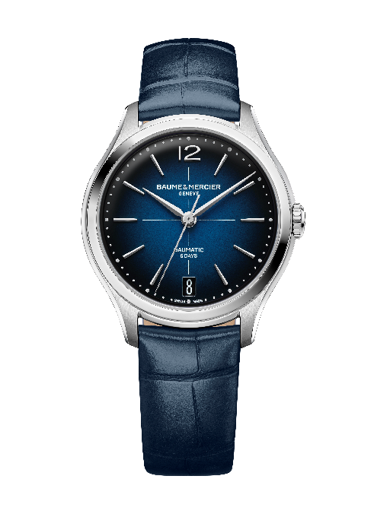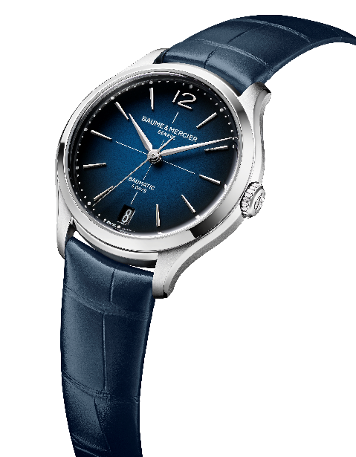

This celebration of feminine watchmaking, initiated by the Clifton collection, paves the way for more exceptional Baume & Mercier timepieces to come that are sure to delight the Brand’s admirers.

