EMBARGO DATE: RELEASE at 8:30 a.m. on April 1st

THE NEW CLIFTON COLLECTION
BY BAUME & MERCIER

THE ART OF ENHANCING THE BALANCE BETWEEN MODERN AND VINTAGE STYLE

Through timepieces combining technical performance and remarkable aesthetics, Baume & Mercier captures the exhilaration of periods of renewal that mark the year: each one a unique moment, an emotion, a magical memory. Through the Clifton collection, the House crafts life’s moments like an architect: a designer of precision and fine craftsmanship, merging functionality with beauty. Technical mastery, balanced volumes and proportions, and precise lines and angles are the building blocks of dreams into which that master pours imagination, savoir-faire, and bold artistry. Like the Clifton collection, such a man is the guardian of a patrimony, the keeper of a heritage; and yet he is a visionary who pushes the limits back ever further to challenge the established codes and innovate. Since it was founded in 1830, Baume & Mercier has been dedicating its technical savoir-faire and designer spirit to each of life’s moments. By redesigning the Clifton watch, it redesigns existence. For Baume & Mercier, this new beginning powerfully reveals the art of balance between a quest for modernity and an aspiration for vintage, with elegance as its highlight.

The three new Clifton Baumatic watches – M0A10802, M0A10778 and M0A10771 –, unveiled at Watches & Wonders 2025 as a sneak preview of the entire collection which will be launched in September, embody the creative duality that has been emblematic of the House since it the partnership between William Baume and Paul Mercier.

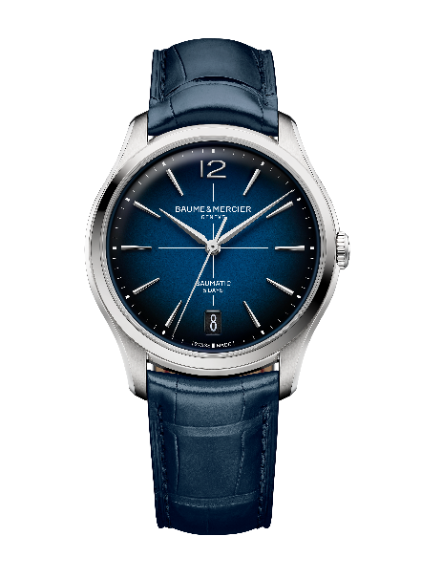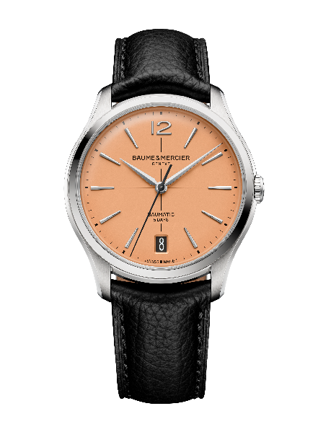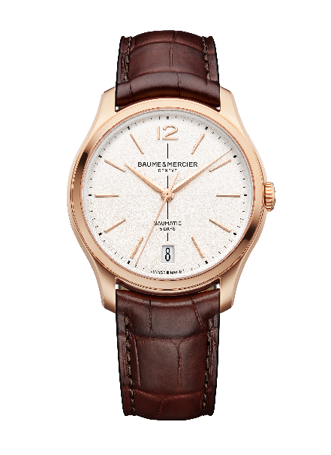

The watchmaking heritage of the 1950s

The Clifton collection carries forward the heritage of round, slender watches that were very fashionable in the 1950s. Those timepieces embodied the pinnacle of refinement as statement pieces of a refined, curated look. Their thin cases, most of which were crafted in gold, revealed most often a light-colored dial punctuated with Arabic numerals beneath a slightly domed crystal. These pieces demonstrate an admirable artisanal savoir-faire. The 1950s marked a renewal in watchmaking history and were prolific times for Baume & Mercier, the House that made shape watches its style signature.

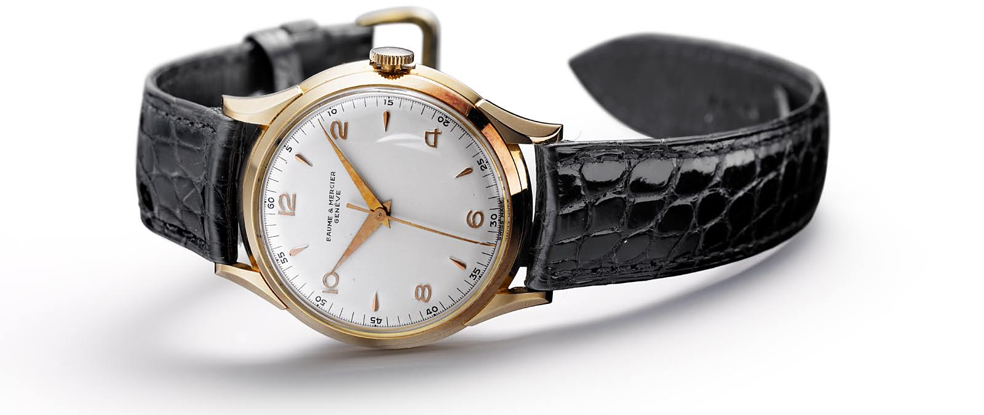


The watches of the 1950s also stand out for the simplicity of their design. The fashions of the time tended towards minimalist dials, clean lines, structured shapes, and noble materials for timeless elegance. These codes of discreet luxury characterize the Baume & Mercier approach which, since its beginnings, have seamlessly combined creativity and originality, understatement and authenticity.

In this pursuit of exquisite refinement, fine crafting is central to the House creations, which highlighted the words “Finely Crafted” in the 1940s and 1950s. The watchmaking art that it demonstrates is a focus on fine craftsmanship; details and finishes that reveal the beauty and strength of a timepiece and its movement. In the name of this commitment, the House chose its motto: "Accept only perfection. Only manufacture watches of the highest quality." The 1950s particularly focused on these values of quality, precision, reliability, and sophistication in watchmaking.

The Baumatic Manufacture movement that powers the Clifton collection, which Baume & Mercier developed and presented in 2018, joins this trend through its technical excellence and delicate finishes. It carries forth the expertise, discipline and passion of traditional Swiss savoir-faire.

Timepieces dedicated to moments of life evoking the gentleman’s art of living

The new Clifton Baumatic models reflect the gentleman’s world in all its splendor. This man cultivates a way of life reminiscent of the one that brought renown to a luxurious seaside resort of Cape Town, South Africa: Clifton. With an atmosphere reflecting the elegance, insouciance, and cosmopolitan spirit of the House, this destination is a sun-drenched haven of peace with an exceptional natural environment nestled between the mountains and the sea. Along a hillside, luxurious villas sculpt the cliff and offer a breathtakingly sweeping view of the Atlantic Ocean. In the distance, elegant sailboats and modern yachts with genteel details are rocked by the waves in a delightful reflection of the rolling rhythms that set the pace for this residential area overlooked by the Table Mountain massif, one of the world’s oldest mountain ranges and one of the seven greatest natural wonders listed in 2011. Time slows to sway to the cadence of this beautiful, peaceful, paradisaical spot.

Each new Clifton Baumatic watch reproduces these moments with masterful, poignant authenticity. Each one interprets this state of mind, defining it with a structural and chromatic vibrancy that places its perfection in the service of an ever-greater presence.

The Clifton collection or the quintessence of vintage elegance

The Clifton collection beautifully demonstrates the perfect balance of contemporary and classic inspiration in a timepiece. It is created for the modern man: an aesthete, a lover of beautiful things and fine craftsmanship who is captivated by an elegance and refinement that traces its roots back to the 1950s.

Choosing vintage style with “retro” accents means choosing elegance.

Its round, slim case all in carefully sculpted curved lines and delicately domed glass contains all the nobility of fine craftsmanship, marked by precise lines, ideal proportions, and perfect finishes. All these qualities characteristic of the Golden Ratio are symbolized by the Phi logo, which Baume & Mercier has claimed as its emblem. Each detail reveals the eloquence of this timelessly elegant watch.

The new Clifton Baumatic M0A10802, M0A10778 and M0A10771 go one step further in expressing discreet, understated luxury with the reworking of multiple details that add an even more prominent distinction to these new editions. The proportions and finishings of the case have been overhauled. With a diameter of 39 mm, this new case has a thickness of 11.5 mm, whereas the precedent models measured 12.2 mm and even 12.6 mm. This slim profile reinforces comfort in wear and enhances the refinement of these pieces, asserting an ever more contemporary aesthetic. Arabic numerals have been reintroduced at 12 o’clock. The indexes are longer. The date disk appears in a large aperture at 6 o’clock and features a new font. The upper sapphire crystal is domed in the spirit of the model that inspired the collection. The crown is integrated and slenderer. The strap buckle is interchangeable.

The man who admires the Clifton watch is a tasteful aficionado in search of history: that of an authentic, enduring watchmaking House whose expertise has been passed down for nearly 200 years. He claims that history to better write his own: the saga of a gentleman for whom the chosen timepiece is an integral part of his deepest identity, comforting him in what he is and distinguishing him from others. The unique, original vintage aesthetic is unmistakably distinctive.

Technical virtuosity dedicated to modernity

Finesse reigns supreme: the refinement of the Clifton collection extends to every detail. The beauty and strength of the Manufacture Baumatic movement that drives these three new watches is a masterpiece of technology and sophisticated finishes. This caliber, developed by Baume & Mercier, offers resistance to everyday magnetic fields up to 1500 Gauss, oscillates at a frequency of 4Hz (28,800 vph), has a remarkable autonomy with a 5-day power reserve (120 hours), and boasts a water resistance of up to 5 ATM (approximately 50 meters).

Aesthetically, this is a spectacular movement: the bridges are circular-grained, the baseplate is sandblasted and snailed, and the oscillating weight, with snailed “Côtes de Genève” decors, is gold-plated and openworked. It also bears a unique Baume & Mercier engraving.

Like all watches equipped with a Baumatic manufacture movement, these three timepieces benefit from an extended 6-year warranty in addition to the standard two years of international warranty. To activate this guarantee, simply register the piece on the Baume & Mercier website within 60 days after purchase: www.baume-et-mercier.com.

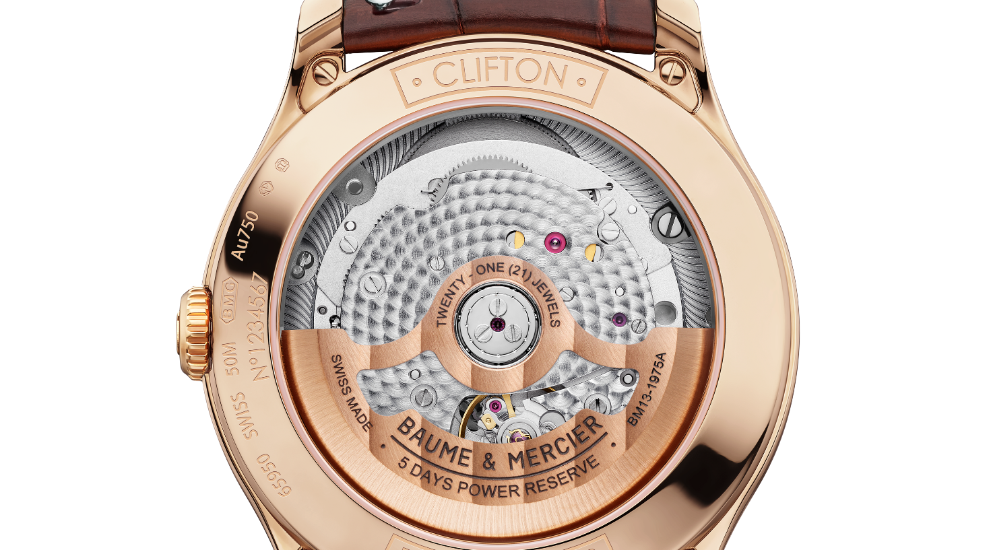

- Clifton Baumatic M0A10802

With a diameter of 39 mm and a thickness of 11.22 mm, the iconic domed round case is crafted in satin-finished rose gold (750/1000). It is protected by a scratch-resistant domed sapphire crystal treated on both sides with an anti-glare coating. The crown is crafted in rose gold (750/1000). The sapphire crystal back may be engraved upon request.

The subtle off-white hue adds to the more retro inspiration of the dial. The grained finish confers a special texture, intensifying the radiance of the color and the depth of the decor, offering even more warmth. The finesse of its finish brings it to life. Edged by a black minute track and criss-crossed by black crosshairs in the center, the dial reveals 5N gold-plated, riveted, faceted, slightly elongated trapezoidal indexes, and is topped with an Arabic numeral at 12 o’clock. The alpha-shaped hour and minute hands are 5N gold-plated and faceted, and the seconds hand is also gold-plated. A wide aperture at 3 o’clock displays the date.

The self-winding Baumatic (BM13-1975A) Manufacture movement is the driving force behind this luxury watch. It is water-resistant to 5 ATM (approximately 50 m).

The strap is crafted in brown alligator with all-square scales and tone-on-tone overstitching on the top, a beige lining with ocher overstitching on the underside, and bar tacks around the buckle. This interchangeable strap is equipped with a very reliable spring bar system that makes it possible to change it without the use of tools. It fastens with a 5N gold-tone PVD steel pin buckle.

The gold of this model weighs an estimated 23.20 g.

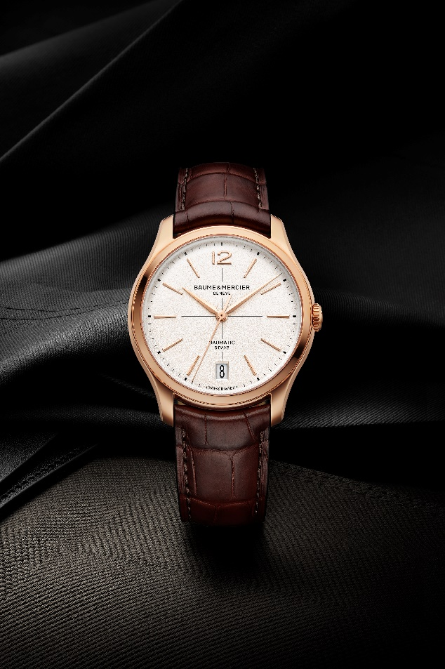

- Clifton Baumatic M0A10778 - Limited edition of 350

The bright opaline salmon-hued dial sculpts each hour and calendar indication. This shade has a vintage charm filled with softness and warmth that was very sought-after in the 1930s and 1940s. The meticulous color work in pursuit of the ideal tone between rose and peach, and the perfect intensity between radiance and depth, reveals a timepiece with timeless refinement that immediately captivates the eye. The riveted, faceted, rhodium-plated indexes are shaped like slightly elongated trapezoids. An Arabic numeral appears at 12 o’clock. The faceted, rhodium-plated hour and minute hands are alpha-shaped. The oxidized black seconds hand offers a delicate contrast. The date appears in a wide aperture at 6 o’clock. The black minute track frames the dial.

The new proportions – a diameter of 39 mm and a thickness of 11.22 mm – bring finesse to the round case, crafted in satin-finished stainless steel like the crown. It is protected by a scratch-resistant sapphire crystal with an anti-glare coating on both sides. Fastened with four screws and covered by a sapphire crystal, the case back bears the special engraving “Limited Edition One Of 350.” It may be engraved.

The high level of technical achievement for this timepiece culminates in the self-winding Baumatic Manufacture movement (BM13-1975A). It is water-resistant to 5 ATM (approximately 50 m).

The interchangeable strap is crafted in black calfskin with tone-on-tone overstitching on the top. It may easily be changed without the need for tools thanks to a very reliable spring bar system. The watch comes with an additional interchangeable strap in beige calfskin. Both straps feature an interchangeable triple folding clasp in stainless steel with security push-pieces.

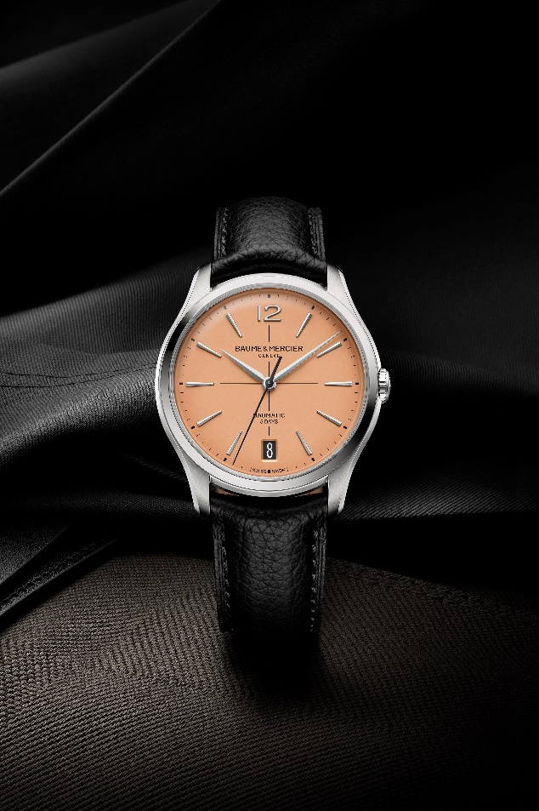

- Clifton Baumatic M0A10771

The blue dial of this timepiece, with its subtle gradation – darker around the edges and lighter in the center – emanates character, depth and refinement. A lacquered finish enhances its nuances. This gleaming blue decor creates a striking background for the contrasting white crosshairs, hour markers, and date indications. The riveted, faceted, rhodium-plated indexes are shaped like elongated trapezoids. An Arabic numeral appears at 12 o’clock. The alpha-shaped hour and minute hands are faceted and rhodium-plated, while the seconds hand is rhodium-plated. The dial is framed by a white minute track. The date appears in a wide aperture at 6 o’clock.

With a diameter of 39 mm and a thickness of 11.22 mm, the round case – like the crown – is crafted in satin-finished stainless steel. It is protected by a scratch-resistant domed sapphire crystal treated on both sides with an anti-glare coating. The case back is fastened with four screws and protected by a sapphire crystal. It may be custom-engraved.

A self-winding Baumatic Manufacture movement (BM13-1975A) powers this particularly durable, reliable timepiece. It is water-resistant to 5 ATM (approximately 50 m).

The interchangeable strap is crafted in blue alligator with all-square scales, tone-on-tone overstitching on the top, a beige lining with bordeaux overstitching on the underside, and bar tacks around the buckle. It may be replaced without the use of tools thanks to a very reliable spring bar system. The interchangeable triple folding buckle in stainless steel is equipped with security push-pieces.

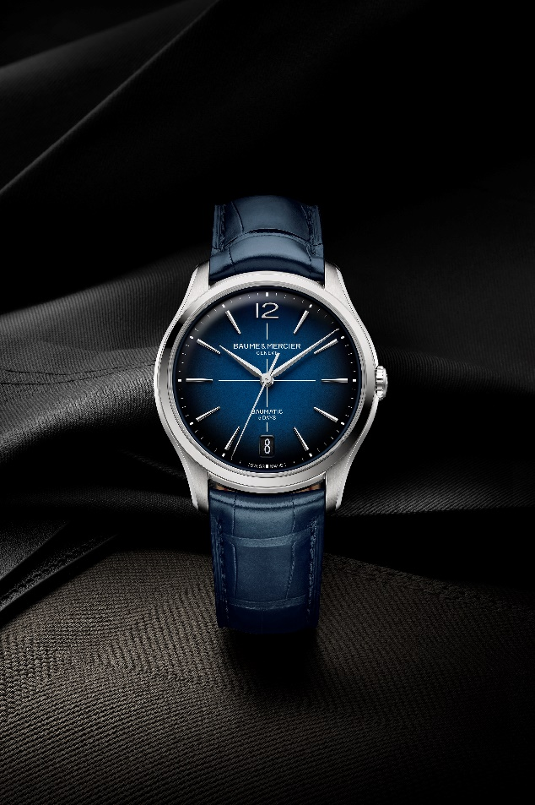

This more luxurious Clifton collection is epitomized by the domed roundness of its redesigned case, demonstrating the absolute refinement of a watchmaking approach that is both traditional and innovative. It is a companion for life’s little moments where the past and future meet and complete each other, as in the vintage vogue of 2025. For Baume & Mercier, it’s about making the House heritage a precious foundation that continues to evolve.

ABOUT BAUME & MERCIER:

Founded in 1830 at the heart of Swiss Jura, the Baume & Mercier watch manufacture enjoys international renown. From its workshops at the heart of Swiss Jura to its headquarters based in Geneva, the Brand offers its clients the very finest timepieces. Borne by a complementary balance between an artistic approach to shape and watchmaking innovation in the service of the client, the Baume & Mercier House continues to mark the history of watchmaking by passing down the design and watchmaking expertise that is the Brand’s legacy. This savoir-faire perfectly corresponds with the spirit of cooperation between the Brand’s founders William Baume & Paul Mercier: where classicism meets creativity, tradition meets modernity, and elegance meets character... In a more contemporary way than ever.

www.baume-et-mercier.com

