RIVIERA CHINESE NEW YEAR LIMITED EDITION
- YEAR OF THE SNAKE WATCH

From ancient mythology to classical poetry, snakes have always run through the imagination and philosophy of Chinese culture. They are mysterious and spiritual, combining strength and grace. As the Year of the Snake approaches, Baume & Mercier is delighted to present the Riviera Chinese New Year Limited Edition – Year of the Snake, paying tribute to the transformation and vitality in the never-ending cycle of life.


The Riviera Chinese New Year Limited Edition – Year of the Snake Baumatic Date 10785, available in limited quantity of 200 pieces worldwide, is not only a celebration of the Chinese New Year but also a witness to every significant moment in the wearer’s life, engraving precious memories. A low-profile yet vivacious snake can spark golden beams of luck. On the eve of the Year of the Snake, Baume & Mercier proudly presents this special limited edition, seamlessly blending the refined imagery of the snake with the mastery of Swiss watchmaking. This timepiece represents a unique understanding of the flow of time and the transformative nature of life. With a harmonious fusion of eastern inspiration and modern aesthetics, it extends wishes for a year of smooth and successful, embracing change and growth with confidence.

RIVIERA Chinese New Year Limited Edition – Year of the Snake Baumatic Date 10785
The Riviera Chinese New Year Limited Edition features a sandblasted titanium bezel that mimics the texture of natural rock, harmonizing with the signature mountain and ocean wave of the Riviera series to create a vast and majestic landscape. According to legend, the divine creature Tengshe(螣蛇) , which symbolizes protection and wisdom, usually appears with auspicious clouds. It is capable of bringing rain and safeguarding peace. Baume & Mercier incorporates a snake totem within the dial, creating a mysterious and profound landscape within the space of 39 millimeters. The black snake begins at the southeastern direction, which is the traditional position of the snake in the Chinese zodiac, and its head extends toward the 9 o’clock position. In Chinese culture, the appearance of a snake during the ‘chen’(辰时, refers to 7 - 9 a.m.), is considered as an auspicious sign. The serpent-shaped gilded seconds hand, mirroring a snake's flickering tongue, symbolizes vigilance and heralds auspicious events or the arrival of benefactors. As the serpentine seconds hand moves steadily with time, it symbolizes unending wisdom and vitality, reflecting the idea that embracing change leads to growth.
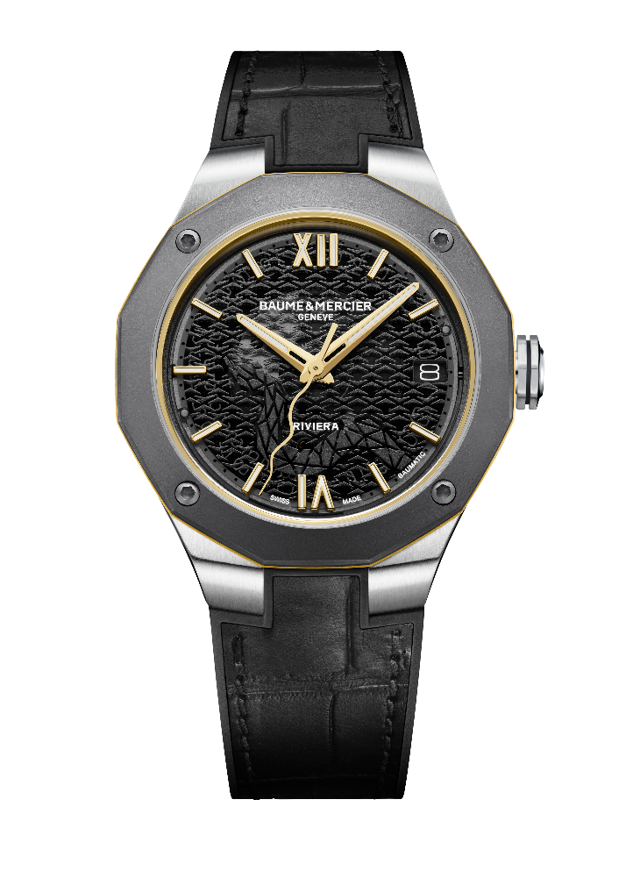
The iconic dodecagonal case of the Riviera series represents both the 12-hour clock format and the 12 earthly branches of the Chinese lunar calendar. The stainless-steel octagonal crown is adorned with black engraved lines and the PHI emblem. In Chinese culture, the number eight is considered auspicious, symbolizing prosperity and stability. The sandblasted titanium bezel, combined with gold-plated hands, numerals, and indexes, imparts a sense of noble sophistication and dynamic charm. The ‘golden belt’ inner ring and waistline are integrated into the watch's geometric design. The riveted, gold-plated Roman numerals, indexes and hour/minute hands are coated with white Superluminova (C1, blue glow). At 3 o’clock, an enlarged date window presents the consistent and exquisite balance that Baume & Mercier has always adhered to.
The sapphire crystal case back, secured with four stainless steel screws, features a gold-plated snake motif. The majestic golden snake, traditionally symbolizing wealth and prosperity, coils in a posture that representing resilience, wisdom, and protection. Combined with a concealed auspicious red circle, it conveys wishes for peace and prosperity in the new year.
Beneath the motif lies the meticulously finished Baumatic movement. Circular-grained bridges, a sand-blasted and snailed baseplate, an openworked weight adorned with snailed and “Côtes de Genève" designs, and a unique Baume & Mercier engraving, highlighting the finesse of the piece. The Baumatic movement delivers exceptional precision and reliability, offering a 5-day (120-hour) power reserve. With its robust performance and timeless elegance, the Riviera Year of the Snake Limited Edition Watch becomes a trusted companion for every precious moment of life.

INFORMATION:

Model: Riviera 10785
Availability: January 2025

ABOUT BAUME & MERCIER:

Founded in 1830 at the heart of Swiss Jura, the Baume & Mercier watch manufacture enjoys international renown. From its workshops at the heart of Swiss Jura to its headquarters based in Geneva, the Brand offers its clients the very finest timepieces. Borne by a complementary balance between an artistic approach to shape and watchmaking innovation in the service of the client, the Baume & Mercier House continues to mark the history of watchmaking by passing down the design and watchmaking expertise that is the Brand’s legacy. This savoir-faire perfectly corresponds with the spirit of cooperation between the Brand’s founders William Baume & Paul Mercier: where classicism meets creativity, tradition meets modernity, and elegance meets character... In a more contemporary way than ever.

www.baume-et-mercier.com

