BAUME & MERCIER OPENS A NEW BOUTIQUE AT VILLAGGIO MALL IN DOHA, QATAR
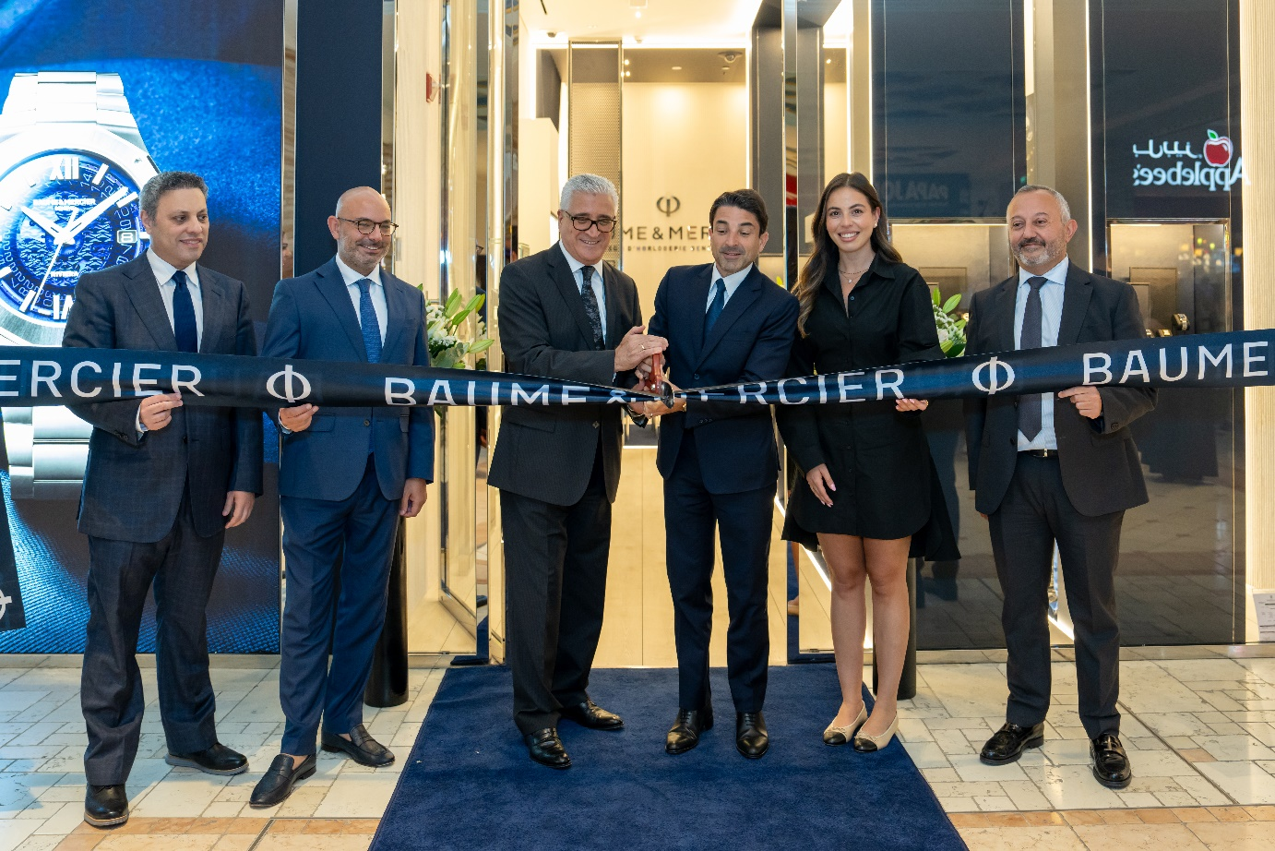
Doha, Qatar – May 14th, 2025 – Baume & Mercier, the esteemed Swiss watchmaking Maison known for its timeless elegance and masterful craftsmanship, proudly announces the inauguration of its newest boutique at Villaggio Mall in Doha, Qatar, with its local partner Ali Bin Ali. This new location is the first to feature the Maison’s refreshed look in the region, ushering in a new era for Baume & Mercier. Reflecting the Maison’s commitment to evolving with the client needs and expectations, the boutique provides a modern, immersive experience while maintaining its signature elegance and tradition.
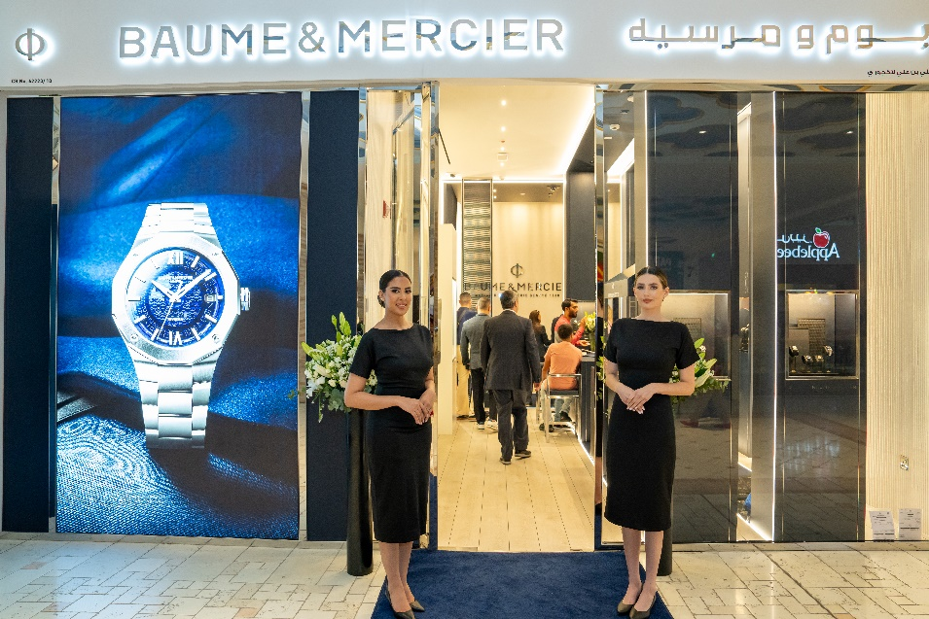
Situated in the heart of Doha, the Baume & Mercier boutique in Villaggio Mall showcases the Maison’s prestigious collections Riviera, Classima, Clifton and Hampton, as well as its latest novelties. Clients also have the opportunity to explore exclusive, limited-edition models, offering a unique chance to discover pieces that exemplify Swiss precision, elegance, and innovation. Adding to the immersive experience, clients will be able to view a historical wall featuring several vintage Baume & Mercier timepieces, serving as a testament to the Maison's rich heritage. The boutique's sleek and contemporary design combines the Maison’s rich heritage with modern elements, ensuring an elevated experience for every client.
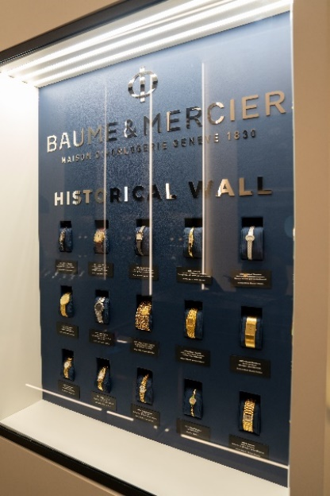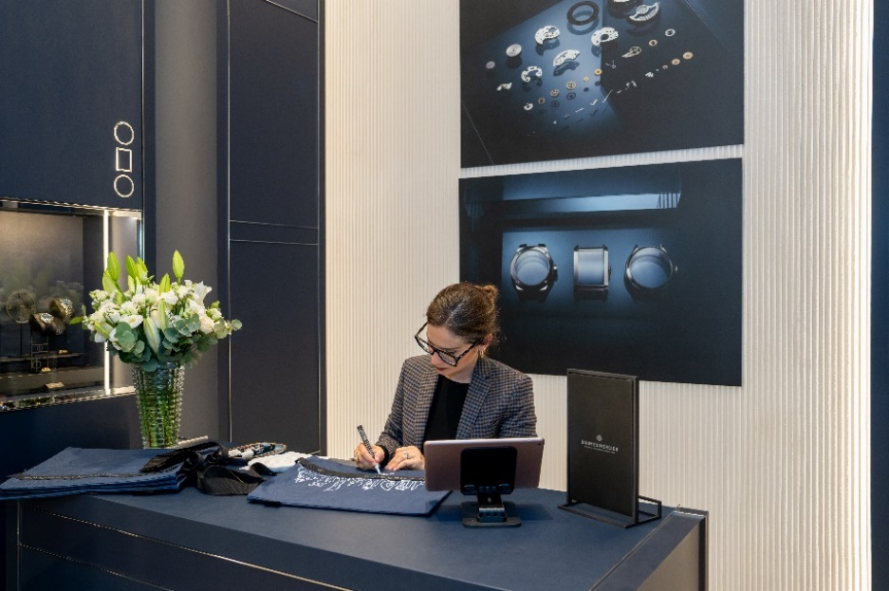
"Opening our new boutique in Villaggio Mall in DOha is a significant step in expanding our presence in Qatar. The new boutique is designed to offer a personalized and engaging experience, allowing watch enthusiasts to discover Baume & Mercier’s commitment to quality and refinement", said Michael Guenoun, CEO of Baume & Mercier.
The new boutique reinforces Baume & Mercier’s commitment to craftsmanship and enhances its ability to serve a diverse and sophisticated clientele. This opening marks an exciting chapter for Baume & Mercier as it continues to deepen its roots in the Gulf region, catering to a growing community of luxury aficionados and watch collectors.
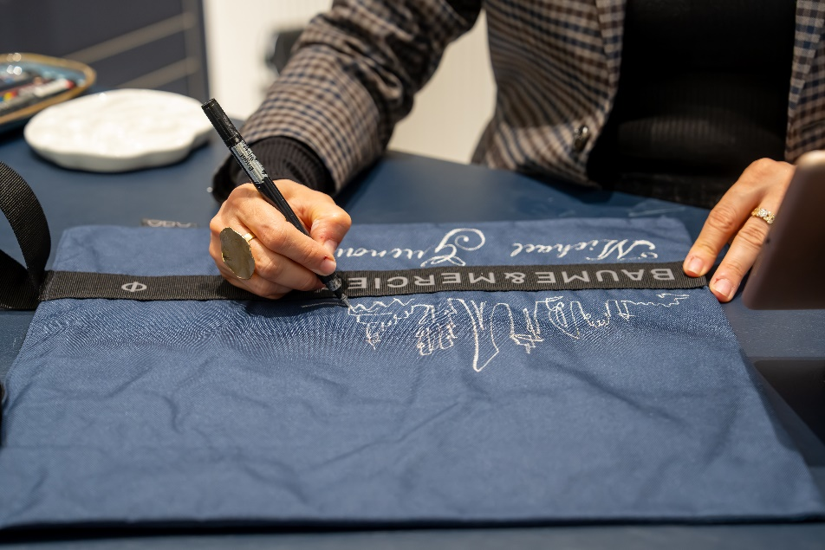

About Baume & Mercier
Founded in 1830 at the heart of Swiss Jura, the Baume & Mercier watch manufacture enjoys international renown. From its workshops at the heart of Swiss Jura to its headquarters based in Geneva, the Brand offers its clients the very finest timepieces. Borne by a complementary balance between an artistic approach to shape and watchmaking innovation in the service of the client, the Baume & Mercier House continues to mark the history of watchmaking by passing down the design and watchmaking expertise that is the Brand’s legacy. This savoir-faire perfectly corresponds with the spirit of cooperation between the Brand’s founders William Baume & Paul Mercier: where classicism meets creativity, tradition meets modernity, and elegance meets character.

www.baume-et-mercier.com

-

About Ali Bin Ali Luxury
A subsidiary of Ali Bin Ali Holding – one of the conglomerates in the Gulf region, Ali Bin Ali Luxury is Qatar’s leading luxury goods retailer with a passion to deliver an unparalleled experience to those who appreciate the finer things in life.
Established in 1945, Ali Bin Ali Luxury is Qatar’s oldest and most trusted international business partner. The brand also enjoys a strong presence in KSA and Kuwait.
Ali Bin Ali Luxury offers an exquisite collections include luxury jewels, classical and sporty time-keeping instruments, writing accessories, luxury leather goods, men’s apparel and objets d'art. Unique in its design and undeniably desirable in its appeal, our collection of fine jewelry and timepieces is symbolic of style, status and sophistication.

-

For more information, please contact:
Aman Sankarin, Baume & Mercier Regional Band Manager
Email: aman.sankari@baume-et-mercier.com
Phone: +971508238931
Clarisse Dumont-Girard, Baume & Mercier Press Relations Specialist
Email : clarisse.dumont-gir@baume-et-mercier-com
Phone : +41 22 999 8888

Follow Baume & Mercier on Social Media
Instagram: @baumeetmercier
Facebook: Baume & Mercier Official

