DATE EMBARGO: RELEASE at 8:30 a.m. on April 1st

THE NEW HAMPTON BY BAUME & MERCIER

PURE EVERYDAY
ELEGANCE

Through its timepieces combining technical performance with remarkable aesthetics, Baume & Mercier strives to capture the beauty of life’s moments with artistic sensibility, bringing out what makes each one unique and magical with emotion. The mechanical achievement of each watch is matched only by its exquisite beauty. With the Hampton collection, the House depicts the occasions of a lifetime like an artist creating a masterpiece, portraying a certain perception of existence through expert flourishes and inspiration sustained by intense sensitivity. It sculpts the light, brings vibrancy to color, plays with textures and materials, and brings out contrasts between matte and shine, abstraction and figuration. It forever engraves the expression of beauty and calls forth strong emotions like none other. Since it was founded in 1830, Baume & Mercier has been dedicating its technical savoir-faire and designer spirit to each of life’s moments. With its vintage 1920s look, the Hampton collection – first launched in 1994 – symbolizes the House’s uncompromising approach to design.

The new Hampton M0A10795, unveiled at Watches & Wonders 2025 and available from May, carries forward this architectural representation of time. Its “small” size makes it a delicate, feminine piece that nestles ideally against a woman’s wrist. Such a slender silhouette and fine proportions magnificently enhance its distinctive elegance.

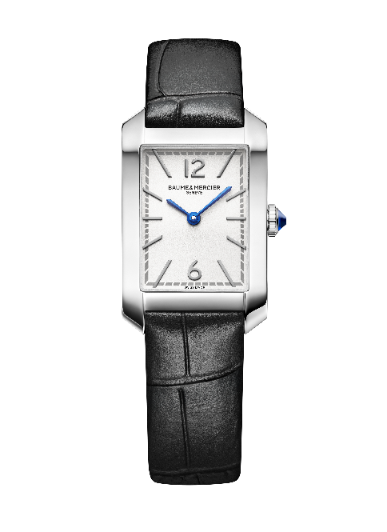
An ode to femininity

The recent models of the Hampton collection continue to explore the expression of its femininity, lending its iconic rectangular case to a great stylistic diversity. With a strikingly radical minimalism, the all-black version (Hampton M0A10760) – featuring a black lacquered dial, a crown topped with a black cabochon, and black strap – evokes French-style chic in the spirit of the little black dress, a legendary couture essential. A more luxurious version (Hampton M0A10752) asserts a rose gold case (750/1000), a grained opaline dial, and a black alligator strap. The same glamorous inspiration shines through the Hampton M0A10751, combining gold finishes, a stainless steel case, and a three-row stainless steel strap in bicolor Milanese mesh, alternating steel links and steel links capped with rose gold (GC2000). Chromatic effects enhance the feminine touch of the collection, appearing variously in the dial, crown, and strap depending on the design. The bordeaux case of the Hampton M0A10673 and the blue of the Hampton M0A10674 are adorned with a delicately scintillating varnish. Intense blue dials illuminate the Hampton M0A10732 and Hampton M0A10709, set with diamonds for a most precious effect. Sparkling against the midnight blue tone, the gems shimmer like stars in a vast night sky.

Women have always been muses for Baume & Mercier. Beginning in 1918, Paul Mercier dedicated bold and whimsical pieces to them, including certain jewelry watches which bore the distinction “Haute Fantaisie pour Dames.”

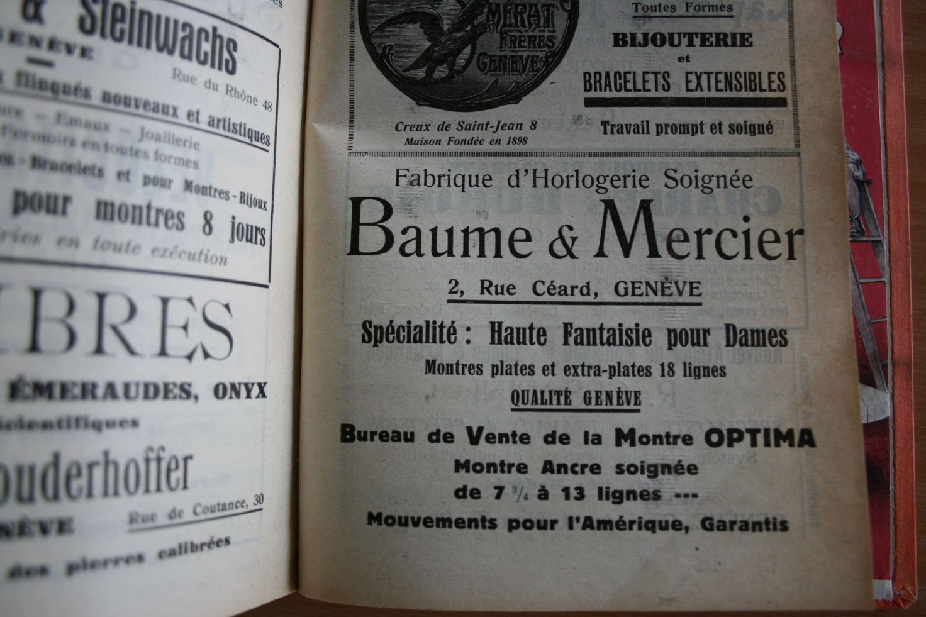

The 2025 Watches & Wonders event marks the return of the Hampton Classique, an extension of the first Hampton family initiated in 1994. The classical yet contemporary timepiece is fascinatingly well-crafted, demonstrating a watchmaking savoir-faire that dedicates its discipline and enthusiasm to shaping elegance and femininity.

Embodying an assertive vintage aesthetic

Since Paul Mercier began to conceive of the watch as an object of design in 1920, Baume & Mercier has been setting itself the challenge of freely forming the features of time and even flying in the face of fashion to better set the pace for it. Down through the decades, the timepiece has been a territory for artistic expression, giving rise to bold, innovative choices that are brought to life through exquisite mechanical expertise. When it took the Greek letter Phi as an emblem in 1964, the House confirmed this pursuit of the Golden Ratio through perfect proportions; precise, balanced lines; and harmonious relationships among volumes, curves, and shapes.



When it launched the Hampton collection in 1994, Baume & Mercier made its rectangular case the symbol of an aesthetic breakthrough. The model immediately surprised and enthralled. Its clean lines, soft corners, and curved horns all bring to mind an iconic model of the 1960s, asserting a vintage Art Deco look from the 1920s characterized by geometrical and symmetrical designs, a streamlined allure, fine materials, and refined details.

Today, the Hampton collection upholds this commitment to uncompromising design and timeless elegance inherent to the vintage aesthetic. The recent models added to the collection illustrate the creative abundance that it inspires, as well as the pertinence of its architecture.

A new high-contrast version

In keeping with the refined minimalism of its collection, based on a very understated graphic allure, the Hampton M0A10795 features a silvery opaline dial which forms the backdrop for a bright, contrasting dynamic. This emphasizes the rhodium-plated Arabic numerals placed at 12 and 6 o’clock, riveted rhodium-plated indexes, blue “glaive” hands, and gray minute track.

The hours and minutes sweep along in a rectangular case crafted in polished stainless steel, asserting refined proportions: 35 x 22.2 mm and a thickness of 6.92 mm. A scratch-proof domed sapphire crystal protects it. The solid case back may be engraved. The elegant steel cabochon crown is set with a synthetic blue spinel, harmoniously reflecting the hue of the blue hands. This stone is associated with the concepts of wisdom, protection, trust, respect, and sincerity.

The timepiece is driven by a quartz movement with six years of autonomy and is water-resistant to 5 ATM (approximately 50m).

It is mounted on an interchangeable bracelet in black calfskin with an alligator pattern. The strap may be changed without the need for tools thanks to a very reliable spring bar system.
The pin buckle is crafted in stainless steel.

The Hampton collection showcases the fascinating crossroads between technical mastery and aesthetic research, the cornerstone of this watchmaking work of art.

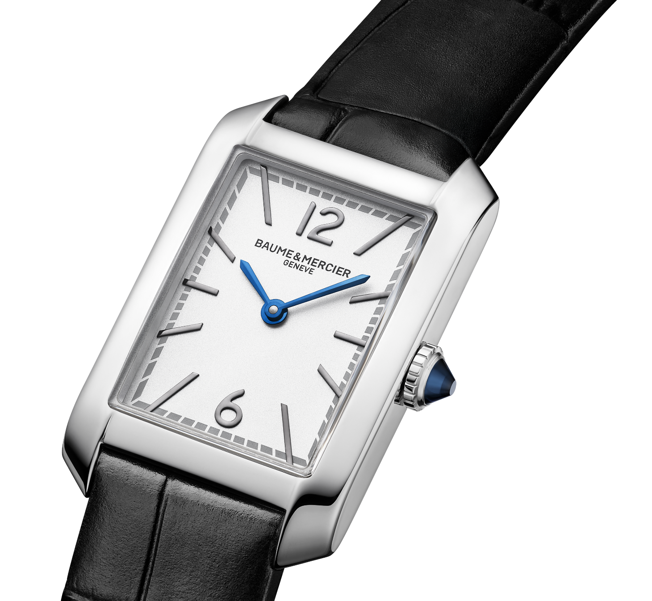
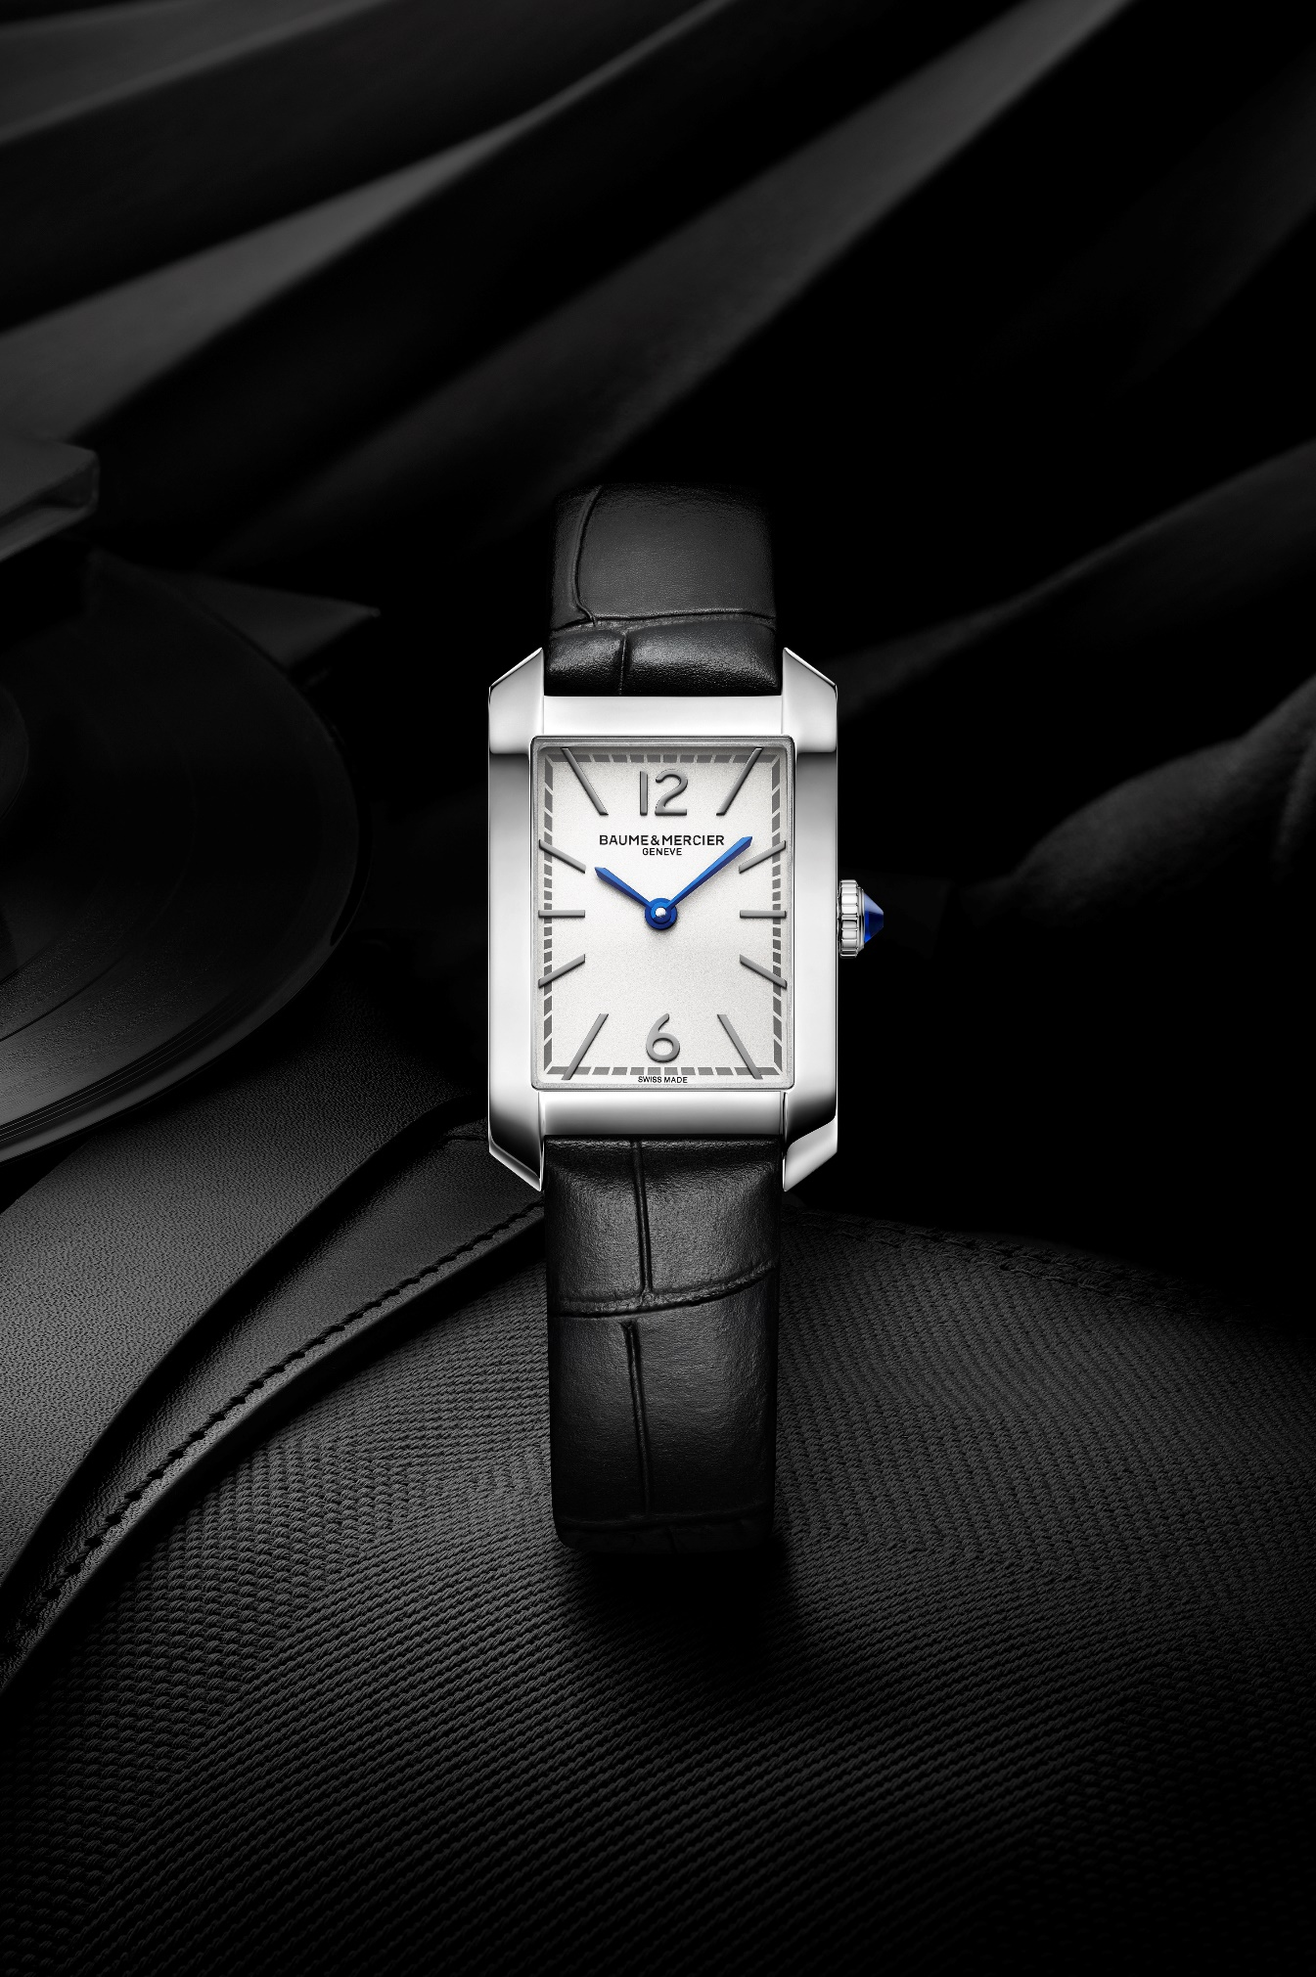
The expression of a casual-chic art of living and exclusive experiences

The Hampton collection demonstrates the sought-after elegance of the American elite, and specifically the lifestyle of New Yorkers who have made the Hamptons an exceptional resort. This sanctuary, sheltered from the hustle and bustle of the city, stretches for miles in New York state northwest of Long Island, with its main hub being the South Fork Peninsula. A casual-chic atmosphere reigns here, from the streets lined with luxury boutiques in Southampton and East Hampton to the untamed land’s-end spirit of Montauk and on to the picturesque fishing port of Sag Harbor. These codes of a privileged art of living, expressed with effortless understatement, define the lifestyle of those who inhabit these opulent villas, historical manor houses, and typical timber homes. Laughter rings through these impeccably landscaped properties with private swimming pools. Polo and other equestrian sports abound inland. Along the coast, the ocean with its broad fine-sand beaches and windswept dunes, offer a poetic backdrop for sunrise strolls warmed by the soft, unique quality of light only found in this little corner of paradise. Stylish, high-society gatherings sparkle as the purple glow of evening falls. Nature and sophistication mingle until the wee hours.

The Hampton collection – of which the very essence lies in its rectangular shape and studied design, and whose variations are an absolute expression of pure beauty – celebrates these exclusive moments in life. These occasions are naturally accompanied by a pursuit of grace, reflected in the refinement of good manners, the allure of an elegant wardrobe, and the beauty of a preserved environment. Hampton time is shaped by an exquisite sensibility, like time spent in this exceptional destination.

ABOUT BAUME & MERCIER:

Founded in 1830 at the heart of Swiss Jura, the Baume & Mercier watch manufacture enjoys international renown. From its workshops at the heart of Swiss Jura to its headquarters based in Geneva, the Brand offers its clients the very finest timepieces. Borne by a complementary balance between an artistic approach to shape and watchmaking innovation in the service of the client, the Baume & Mercier House continues to mark the history of watchmaking by passing down the design and watchmaking expertise that is the Brand’s legacy. This savoir-faire perfectly corresponds with the spirit of cooperation between the Brand’s founders William Baume & Paul Mercier: where classicism meets creativity, tradition meets modernity, and elegance meets character... In a more contemporary way than ever.

www.baume-et-mercier.com

