FOR ITS 50TH ANNIVERSARY,
THE RIVIERA WATCH TAKES THE PLUNGE

Emblematic of the lifestyle spirit of Baume & Mercier, the Riviera watch celebrates a half-century of existence this year. Reinterpreted in 2021 with a versatile fifth generation, the Brand’s signature collection continues to express, year after year, the distinctive Baume & Mercier savoir-faire in its design, choice of materials, and pertinency to the present times. Available this year in two versions, it remains recognizable with its pure, taut lines, a twelve-sided bezel, and a perennially fashionable sport-chic look designed in the early 1970s by the watch stylist Jean-Claude Gueit. Taking the plunge, these new Riviera Azur 300m watches are equipped with a Baumatic manufacture movement which expresses, now more than ever, Baume & Mercier’s characteristic elegance with a unique bezel that connects each hour segment to the others, visually offering a nearly natural sensation of perfection.

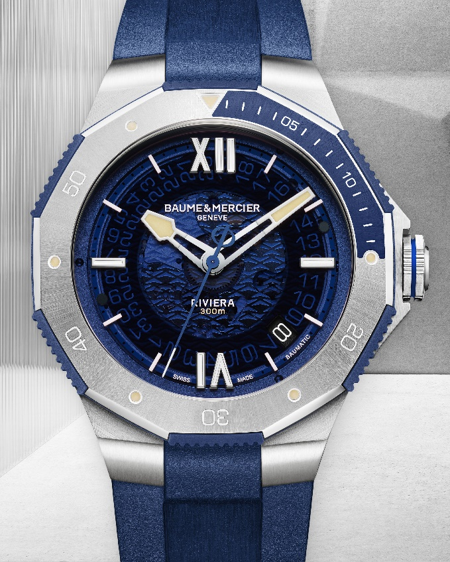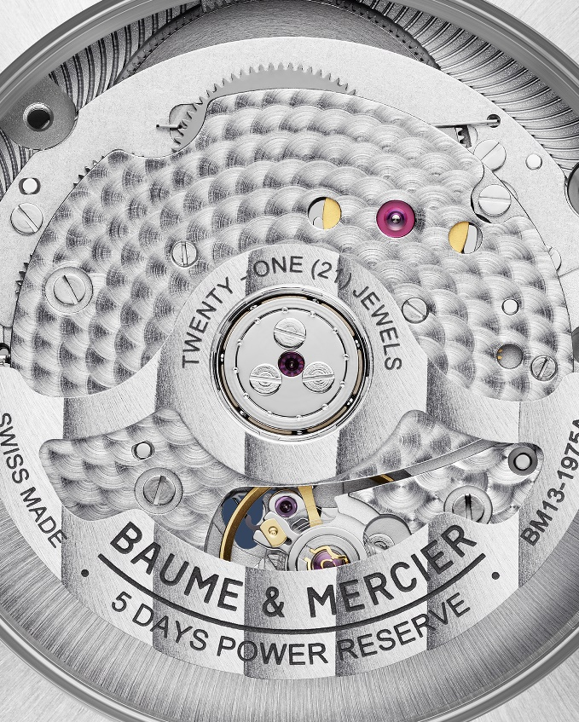

Riviera – 10716

Two versions of the Riviera Azur 300m that encapsulate the spirit of the French Riviera

It was born in 1973. At the time, it broke the codes of watchmaking design, beginning a new story for the Brand. A compact watch case, a twelve-sided bezel, and an unmistakable look. In 1981, Baume & Mercier unveiled the first Riviera specially designed for divers. It encapsulated the aesthetic of the times without sacrificing an ounce of its personality. Its dial and bezel are both black. It also displays the date at 3 o’clock, and its luminescent hands are extremely easy to read. The Riviera thus marks a turning point as a diving watch. This year, for its 50th anniversary, it takes the plunge off the coast of the French Riviera, which has marked its entire history. In a 42-mm stainless steel case, it reinvents itself while upholding the integrity of the stylistic codes that built its reputation.

The new Riviera Azur 300m is water-resistant to 30 ATM – 300 meters, or 984 ft – and is available in two versions to become your elegant sports companion of the summer. Its look is forthright, assertive, and impactful. In order to calculate diving times, the two new models – M0A10716 and M0A10717 – are suitably topped with a unidirectional rotating bezel in polished and sun-satin stainless steel. The bezel features a design like none other with a (blue or black) lacquered treatment that marks the gradation of the first fifteen minutes. Whether for swimming, jet-skiing, sailing, snorkeling or surfing, the Riviera is ready for offshore adventure. This is the ideal watch for water sports, a companion in every leisure activity. Another detail that makes all the difference is that the bezel is equipped with a blue or black anodized aluminum ring to guarantee optimal use and precise handling. Its luminescent indexes are coated in SuperLuminova to increase their visibility underwater.

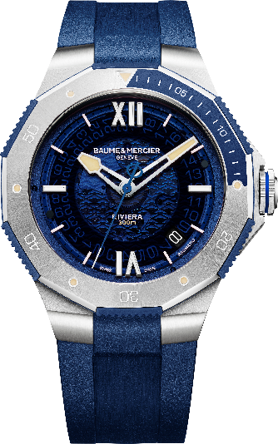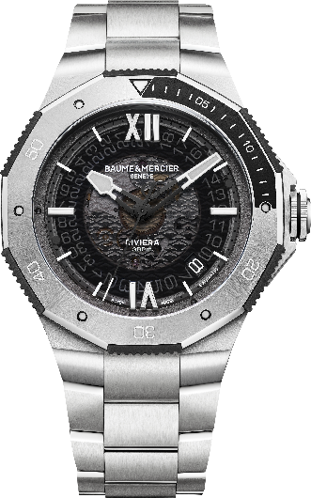

Riviera – 10716 / 10717

The appearance of each blue or black dial – in smoked blue or gray sapphire with a transparent wave decoration – immediately brings to mind the Mediterranean seafloor, as refreshing as a dip in the sea at the heart of the summer, with the refined sports watchmaking vision distinctive of Baume & Mercier. Offering a glimpse of the movement’s mechanism, these smoked sapphire dials are a characteristic feature of all the Riviera models equipped with the Baumatic calibers that Baume & Mercier manufactures in-house.

The athletic allure and unprecedented shape of the new hour and minute hands evoke the brand’s love of design. The exceedingly easy-to-read hands on the blue model are partially coated with beige-colored SuperLuminova – and those on the black model with gray-colored SuperLuminova – to provide a very balanced contrast of light. Each model is powered by the manufactured Baumatic movement, offering tried-and-true performance: a five-day power reserve, a daily precision of -5 s / +10 s, and a magnetic resistance up to 1500 Gauss, which provides solid protection against magnetic fields on an everyday basis. With a 120-hour power reserve, either model of the new Riviera Azur 300m watch may be forgotten on a night table from a Thursday evening to a Tuesday morning and still be full of energy.

Suitable for all water sports, both new Riviera Azur 300m watches are water-resistant to 300 meters. They also feature a wider screwed crown and a crown cover that perfectly fits into the body in a visual extension of the case to provide shock-resistance.

These multi-purpose models may be mounted on a steel or rubber strap for a variety of looks and purposes. They feature Baume & Mercier’s own very strong, reliable “Fast Strap” interchangeability system that makes it possible to change straps without the need for tools. We like to think that neither of these new Riviera Azur 300m will get left on the night table!

To demonstrate the extreme reliability of its manufacture movements, Baume & Mercier now offers a comprehensive eight-year warranty for any model equipped with a Baumatic caliber: Two regulatory years and a six-year extension are made available to watch owners simply by registering on the Baume & Mercier website when activating the warranty.



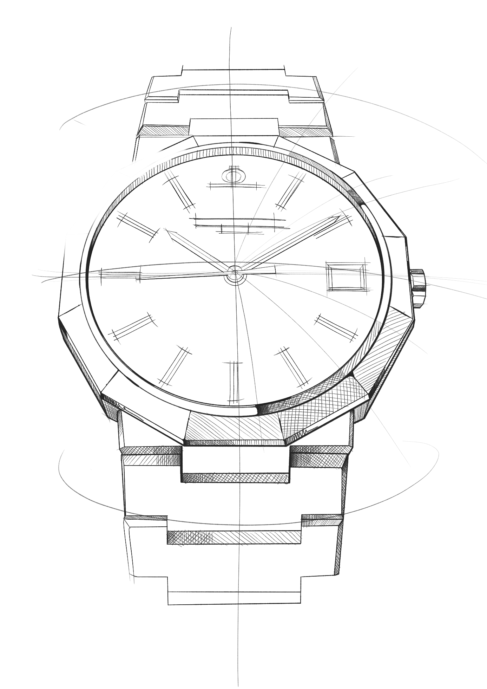
The Riviera collection: five generations, one legend

This is the story of an illustrious watch: one like none other, one that has always been ahead of its time. The Riviera has been redesigned several times through the years, not only keeping up-to-date but truly setting the pace.

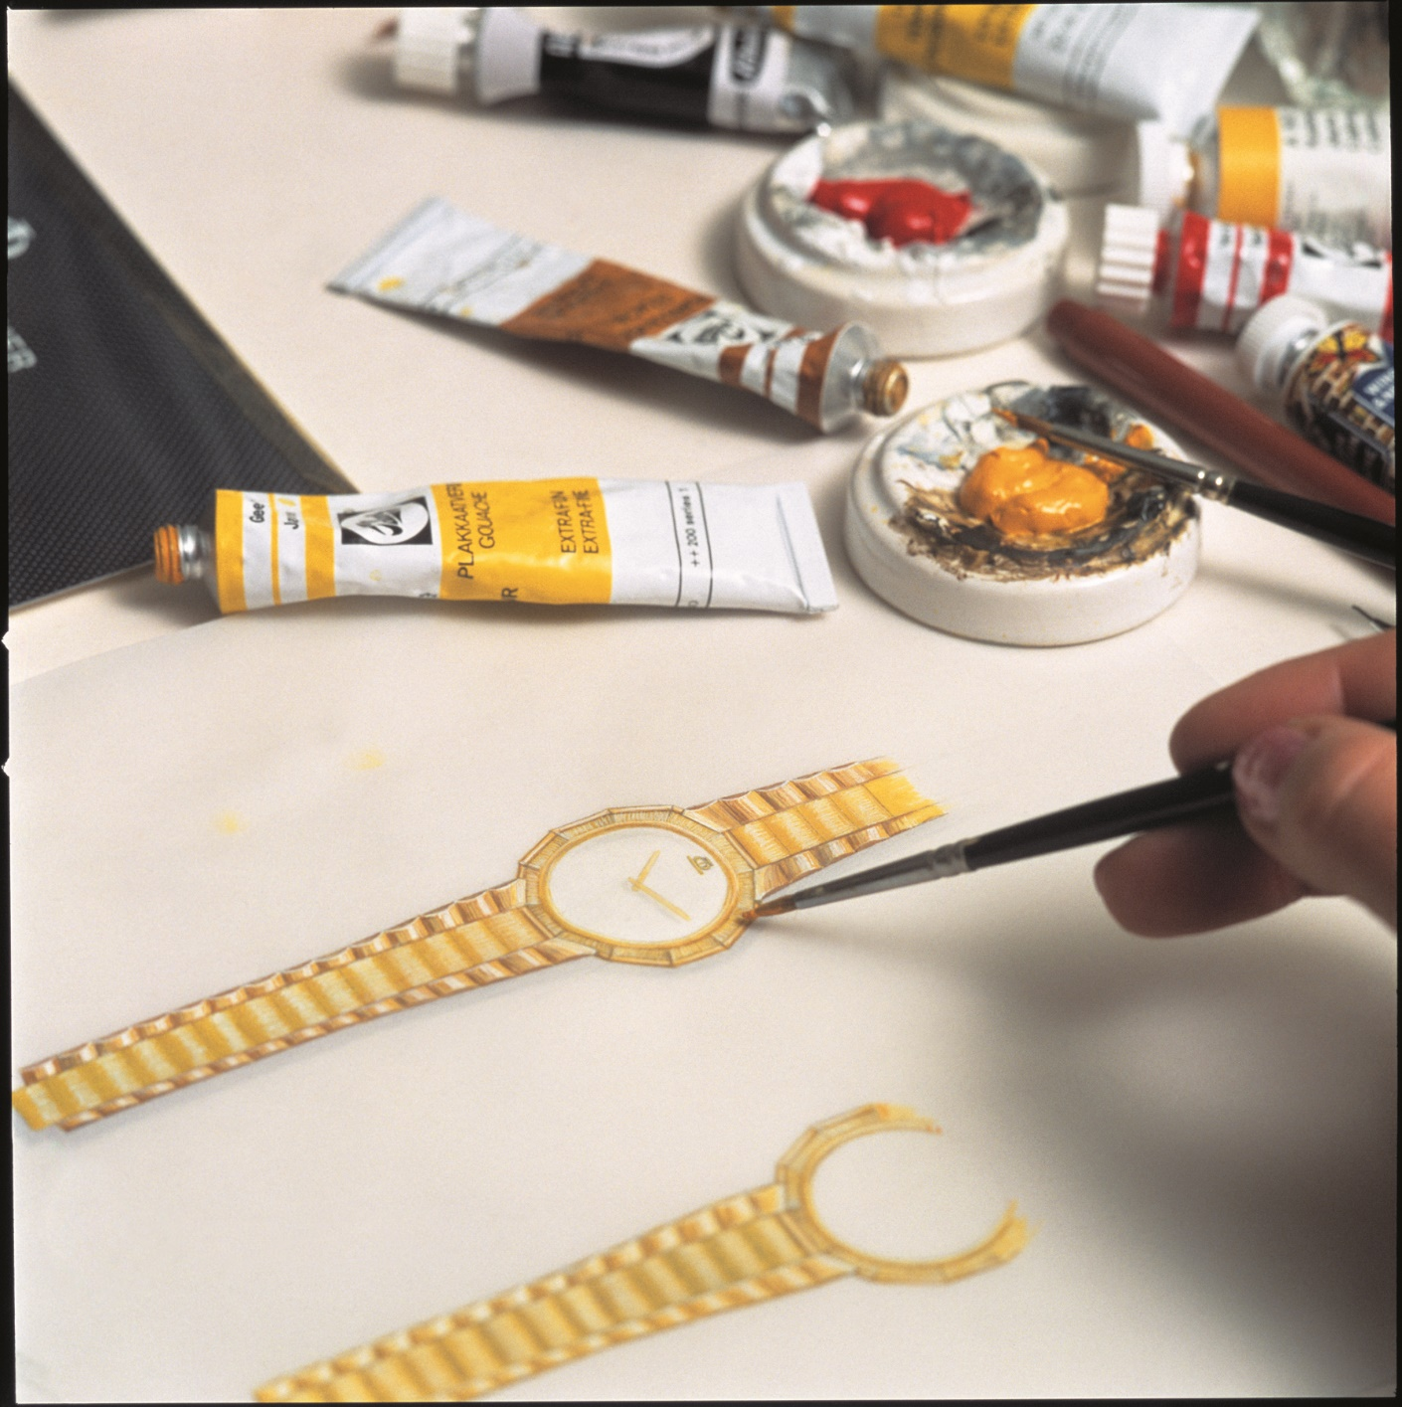

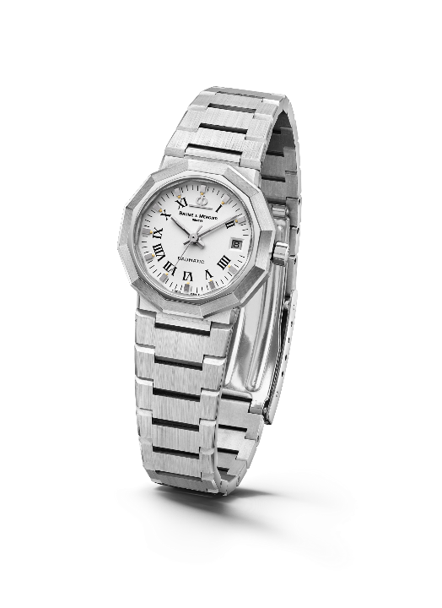
Launched in 1973, the Riviera immediately made a splash with its dodecagonal case and its slimline metal strap. It was already avant-gardist, though the Riviera name had yet to appear on the dial. In 1975, the concept was updated and made available with both self-winding and quartz movements: small, medium and large models were produced in steel, gold/steel, and solid gold.

A new generation was unveiled in the 1980s. The newly bicolor Riviera pursued its technical and aesthetic maturation, with its unmistakable name now appearing at 6 o’clock.

Riviera – 1st Generation - 1975

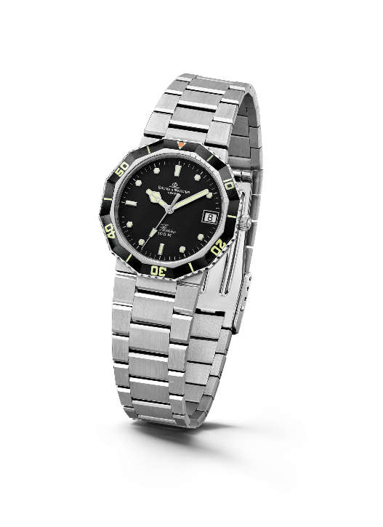

For the first time in 1981, it was made available as a diving watch in a style-pioneering sport-chic spirit. Its success was immediate.

Four years later, in 1985, the third generation of the collection was released. The bezel was reworked for a softer, less angular approach. The case and strap were also overhauled, and their polished and brushed surfaces helped create a more rounded look. The Riviera thus marked a turning point in terms of sophistication and reliability, including – among other features – a miniaturized screwed crown designed to improve its water-resistance. For its 20th anniversary in 1993, it strutted its style with a one-of-a-kind chronograph model. At the time, Baume & Mercier even created an unprecedented full-calendar Riviera in bicolor and solid gold versions, demonstrating its exceptional watchmaking savoir-faire. The Brand also introduced a version of the bicolor edition in a smaller diameter for ladies.
Riviera - 2nd Generation - 1981

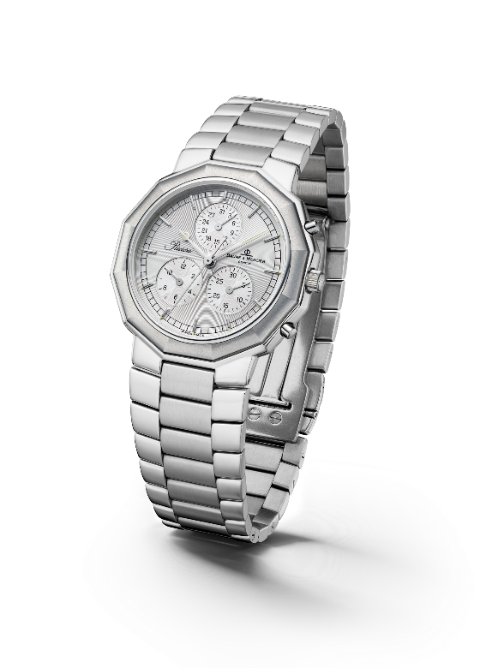
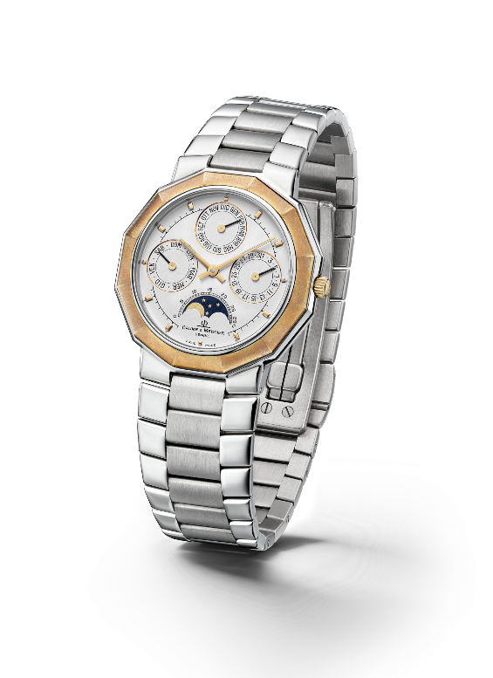

Riviera - 3rd Generation – Complication 1985 & Chrono 1993

In 2004, the Riviera collection took on a twofold approach for its fourth generation with two variations, one classic and the other more athletic. For the “Classic” line, Baume & Mercier maintained the dodecagonal shape of the case, interpreting the dial with a variety of materials and configurations. As for the “Sport” range, the Riviera featured four screws on its bezel for the first time, asserting an athletic look that would stand the test of time.

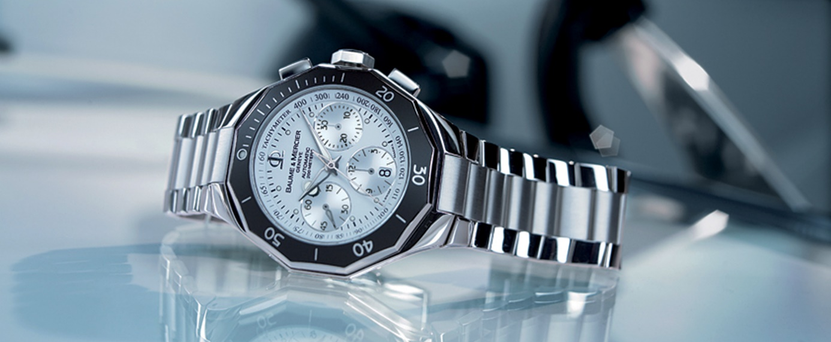

The fifth generation, launched in 2021, carried forward its perennially fashionable sport-chic personality with a number of variations that only added to its character. In 2023, it celebrates its 50th birthday. It is still a trendsetter.

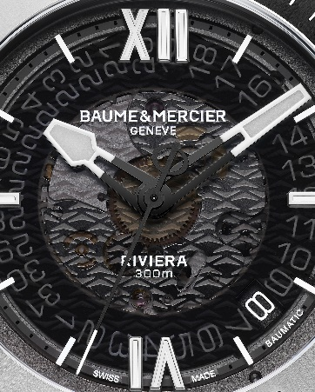

Information:

Model: Riviera 10716
Availability: June 2023

Model: Riviera 10717
Availability: June 2023

ABOUT BAUME & MERCIER:

Founded in 1830 at the heart of Swiss Jura, Baume & Mercier enjoys international renown. From its workshops at the heart of Swiss Jura to its headquarters based in Geneva, the Maison offers its clients the very finest timepieces. Born by a complementary balance between an artistic approach to shape and watchmaking innovation in the service of the client, the Baume & Mercier House continues to mark the history of watchmaking by passing down the design and watchmaking expertise that is the Brand’s legacy. This savoir-faire perfectly corresponds with the spirit of cooperation between the Brand’s founders William Baume & Paul Mercier: where classicism meets creativity, tradition meets modernity, and elegance meets character... In a more contemporary way than ever.

www.baume-et-mercier.com

